Up-Rising: A Phonological and Phonetic Study of Intonation in Derry City English

Antoin Eoin Rodgers

Thesis for the Degree of Doctor of Philosophy

Phonetics and Speech Laboratory

School of linguistic, Speech, and Communication Sciences

Trinity College Dublin

September 2022

Declaration

I declare that this thesis has not been submitted as an exercise for a degree at this or any other

university and it is entirely my own work.

I agree to deposit this thesis in the University’s open access institutional repository or allow

the Library to do so on my behalf, subject to Irish Copyright Legislation and Trinity College

Library conditions of use and acknowledgement.

I consent to the examiner retaining a copy of the thesis beyond the examining

period, should they so wish (EU GDPR May 2018).

|  |  |
| --- | --- |
| Signature of author: |  |

Antoin Eoin Rodgers

September 2022

|  |
| --- |
| “Men call him Procrustes, or the Stretcher,” said the girl–and she talked low and fast. “He is a robber. He brings hither all the strangers that he finds traveling through the mountains. He puts them on his iron bed. He robs them of all they have. No one who comes into his house ever goes out again.”  “Why do they call him the Stretcher? And what is that iron bed of his?" asked Theseus, in no wise alarmed.  “Did he not tell you that it fits all guests?” said the girl; “and most truly it does fit them. For if a traveler is too long, Procrustes hews off his legs until he is of the right length; but if he is too short, as is the case with most guests, then he stretches his limbs and body with ropes until he is long enough. It is for this reason that men call him the Stretcher.”  James Baldwin  Old Greek Stories |

Summary

Acknowledgments

Table of contents

1 Introduction 1

2 Theoretical Context: Intonation 5

2.1 What is intonation? 5

2.1.1 Functions of Intonation 6

2.1.2 Acoustic Measurement of Intonational events 7

2.2 Theoretical Frameworks for Intonation Analysis 8

2.2.1 The British Tradition 8

2.2.2 The Autosegmental Metrical Approach to Intonation 9

2.3 AM studies of Intonation 11

2.3.1 Pierrehumbert (1980b) 11

2.3.2 Critique of Pierrehumbert’s (1980) Upstep and Downstep 13

2.3.3 Modifications to PA structure: a more hierarchical approach 13

2.3.4 Gussenhoven 14

2.3.5 Linguistic and paralinguistic uses of pitch 16

2.3.6 Labelling in Contemporary AM analyses of English Intonation: ToBI and IViE 17

2.3.7 Phonetic analysis of Intonation in AM: tones and tonal targets 19

2.4 Issues for AM analysis of the phonology and phonetics of intonation 20

2.4.1 Tonal targets and implementational domains 20

2.4.2 Form-function mismatches and failures in phonological and phonetic analysis 21

2.4.3 Contours versus Targets 23

2.5 Summary and conclusion 25

2.5.1 Labelling choices for research 26

2.5.2 Strategy for identifying tonal targets 27

2.5.3 Analysis of form and function 27

3 Local Context: northern Irish English and Derry City 28

3.1 Derry City and northern Irish English 28

3.2 British Tradition analyses of northern Irish English Intonation 30

3.3 AM Studies of northern Irish English Intonation 31

3.3.1 Phonological analysis of Belfast English 31

3.3.2 Alignment, compression and Truncation in nIE 32

3.3.3 Proposed source of declarative L*H dominance in nIE and elsewhere 33

3.3.4 Quantitative analysis of intonation in Belfast 34

3.4 Implications for an AM analysis of intonation in DCE 34

3.4.1 Does nIE provide evidence for the special status of H targets [AND NUCS?] 34

3.4.2 Is there evidence for a register-tier in nIE 35

3.5 Conclusions 37

4 Prospectus 38

4.1 Research Questions 38

4.1.1 Descriptive Concerns: form and function 38

4.1.2 Theoretical concerns: H tones and register tiers 39

4.1.3 Phonology-first, Phonetics-first, and the final research question 40

5 Methodologies 42

5.1 Corpus Development 42

5.1.1 Task design 42

5.1.2 Piloting and Refinement 43

5.1.3 Read speech stimuli 43

5.1.4 Recruitment and Participants 44

5.1.5 Recording 45

5.2 Annotation and Data Processing 47

5.3 Visual analysis of count data 50

5.4 Inferential statistical methods: Linear Mix Effects models 50

5.4.1 Analysing continuous parameters with linear mixed-effects models (LMEMs) 51

5.4.2 BGLMMs and the analysis of discrete categories 53

5.4.3 p values and confidence intervals **Error! Bookmark not defined.**

5.4.4 Procedures used in both LMEMs and BGLMMs 54

6 Analysis of Form: Metrical and Lexical Effects 56

6.1 Hypotheses and expectations 56

6.2 Materials 58

6.2.1 Annotation and data extraction 60

6.2.2 Data extraction, pruning, and preparation 60

6.3 Methods 61

6.4 Phonological labelling 62

6.5 Phonological analysis and results 63

6.5.1 Phonology of nuclear pitch contours 64

6.5.2 foot-size and anacrusis effects on prenuclear pitch accent phonology 66

6.5.3 Word boundary effects in prenuclear pitch accents 69

6.5.4 Mixed-effects modelling of effects on PN pitch accents 70

6.6 Phonetic analysis and results 74

6.6.1 Distribution and temporal alignment of PN peaks in the H-Corpus 74

6.6.2 Mixed-effects modelling of prenuclear pitch accents 80

6.6.3 Mixed-effects modelling of nuclear pitch accents and contours 97

6.6.4 Comparing of metrical and lexical effects in prenuclear and nuclear PAs. 110

6.6.5 Analysis of H alignment as a proportion of foot size 112

6.7 Summary and discussion 116

6.7.1 Pitch Accent Labelling 117

6.7.2 Metrical and lexical effects on prenuclear and nuclear pitch accent phonology 117

6.7.3 Metrical and lexical effects on phonetic PA parameters 119

6.7.4 Truncation and compression effects 121

6.8 Conclusion 123

6.8.1 Descriptive concerns 123

6.8.2 Theoretical Concerns 124

6.8.3 Relevance 125

7 Analysis of Function: Sentence Modes 126

7.1 Expectations 127

7.1.1 Phonological analysis 127

7.1.2 Phonetic analysis of tonal targets 129

7.1.3 Phonetics and phonology of Utterances 130

7.2 Materials 130

7.3 Methods 132

7.4 Phonological labelling 132

7.4.1 Interpreting initial boundaries and prenuclear pitch accents 136

7.5 Phonological results and analysis 141

7.5.1 Non-register-tier analysis 141

7.5.2 Register-tier-analysis 144

7.5.3 Comparing the non-register-tier analysis and the register-tier analysis 144

7.5.4 Utterance-wide Phonology and Mode 151

7.5.5 Combining IP-wide and nuclear PA strategies 154

7.5.6 Summary 155

7.6 Phonetic results and analysis 156

7.6.1 Mode and phonetic parameters of nuclear pitch accents 157

7.6.2 Phonetic parameters of nuclear pitch accents 166

7.6.3 Mode and global phonetic parameters 169

7.7 Summary and discussion 174

7.7.1 Phonological analysis 175

7.7.2 Phonetic analysis 178

7.8 Conclusion 180

8 From Phonology-First to Phonetics-First Analysis 181

8.1 Critical reflection on Chapter 6 (Maybe this belongs in chapter 6 itself!) 181

8.2 Critical reflection on Chapter 7 182

8.3 General Critique of peaks and valleys analysis 183

8.4 A phonetics First Analysis 184

8.4.1 Elbows rather than minima and maxima 184

8.4.2 Secondary targets rather than single PA and boundary targets 184

8.5 Secondary Target Hypothesis 184

8.5.1 Implementing STH (K-max) 186

9 STH experiments 187

9.1 STH and TCoG 187

9.2 PN plateaux in the A and H corpus 187

9.3 Downstepped PNsL L_H* 187

9.4 Nuclear L_L*H 187

9.5 Focus 187

10 Summary and Conclusion 189

References 190

Appendix A. Participant Information Leaflet 197

Appendix B. Consent Form 203

Appendix C. Corpus Stimuli 204

Appendix D. PN analysis presented at BAAP2018 (Rodgers, 2018) 205

Appendix E. Github Folder Structure 206

Appendix F. A-Corpus, Summary of Raw Counts 207

Appendix G. Syllable-normalised and grand mean-syllable normalised time 209

Appendix H. BGLMM models for PN phonology in A- and H-Corpora. 210

Appendix I. LMEMs of PN phonetic parameters in A- and H-Corpora 216

Appendix J. LMEMs of nuclear phonetic parameters in A- and H-Corpora 236

Appendix K. Summary of pitch accent phonology in sentence mode in M-Corpus 257

Appendix L. BGLMM models of phonology and sentence mode in M-Corpus. 258

Appendix M. LMEMs of nuclear phonetic parameters in M-Corpus 259

Appendix N. LMEMs of global phonetic parameters in M-Corpus 260

List of Tables

List of Figures

# Introduction

This dissertation provides an account of the phonology and phonetics of intonation in Derry City within the Autosegmental Metrical (AM) framework. Derry City is located in the northwest of Northern Ireland near the border with Donegal in the Republic of Ireland and is the second largest urban area in Northern Ireland. Derry City English (DCE) belongs to the northern Irish English variety (nIE), which is spoken across most of Northern Ireland, in Donegal, and in northern parts of counties Monaghan and Cavan. The AM framework views the pitch contour as the systematic implementation of a sequence of underlying phonological primitive tones (L for low and H for high) inside an intonational phrase (IP). The majority of AM research on northern Irish English has focused on Belfast English, with a much smaller body of research on Donegal English. Only one study of intonation in Derry City has been carried out in the last forty years, and that presented an analysis of two speakers within the framework of the British Tradition of intonational analysis. There has until now, been no larger scale research on Derry City intonation, nor any research conducted within the AM framework, even though this approach has been the dominant mode of intonational analysis for the last thirty years.

The first broad aim of this work, therefore, is to offer a description of Derry City English within the AM framework so that it is amenable to comparison with other studies of nIE intonation, with the intonation of other varieties of English, and with intonation in other languages. It catalogues the phonological inventory and phonetic features of pitch events in relation to a variety of formal and functional conditions. On the formal side, it analyses intonation in unmarked declaratives under a range of metrical conditions, namely variation in foot size, anacrusis (unstressed content before the first stressed syllable), and lexical boundary conditions. On the functional side, it analyses intonation across sentence modes (declaratives, binary questions, wh-questions, and declarative questions) and under different of focus conditions. In this context, focus refers any semantic element which the speaker brings to prominence in an utterance, through linguistic and implementational strategies.

The second key aim of the research is theoretical in nature. It originates in questions raised by the pervasive use of rising intonation in unmarked contexts in northern Irish English, while most other varieties of English (and other languages) tend to have a fall in pitch. Firstly, this raises questions about the phonology and the phonetics of intonation, in terms both of description and function. For example, within AM, it is common to divide the pitch contour into a linguistic component which can be described in terms of intonational phonology, and a paralinguistic component which exists (quasi-)independently of the linguistic element. The linguistic/paralinguistic distinction may be easy to maintain when unmarked declaratives and binary question use pitch accents involving different pitch trajectories, i.e., a falling pitch in the nuclear contour (H*L %) and binary questions use a rising pitch (L*H % or L*H H%). However, if the same rising contour dominates both in declaratives (L*H %) and binary questions (L*H %), one might ask if intonation has any linguistic function at all in nIE. Alternatively, one might wonder if the AM description of the phonology fails to provide a sufficient account of the linguistic component.

A standard AM explanation would be that phonetic traces in the pitch contour reflect attitudinal shifts across sentence modes, with question forms exploiting progressively higher pitch registers as the amount of grammatical or semantic question marking decreases. Such changes would be identified as paralinguistic. However, this would imply that nIE speakers use pitch paralinguistically for questions forms while speakers of other varieties use pitch linguistically. This would in turn imply a major typographic distinction, which feels intuitively implausible. A more plausible explanation may be that there exists a separate (linguistic) register tier which the speaker employs to shift overall pitch range upward under certain grammatical conditions. This could apply both to question forms and the narrow focus. Do note that evidence for a register tier would not rule out the presence of paralinguistic pitch effects nor would it suggest that the register tier is unique to nIE.

The second theoretical concern relates to the primacy of the H tone in the analysis of intonation in English (and other languages). Issues such as peak alignment, peak drift, and peak identification have surfaced frequently in AM research. For English, this is due largely to the fact that pitch accents are most typically associated with peak prominence (H*) in the two most widely studied varieties of English, Southern British English and General American English. This tonal element of the pitch accent is commonly called the starred tone. In nIE, however, L*H dominates in the nuclear contour of unmarked declaratives, with L being the starred tone. The formal analysis of intonation in DCE will allow us to see if there are any systematic changes to the pitch accent which provide evidence for the special nature of the H tone, or if the attention accorded to the H tone may simply be due to its dominance in other varieties of English.

In order to deal with the two key aims, two different approaches to the analysis have been adopted. The second approach is motivated in large by a reflection on the insights gained from the first approach.

The first approach is, in essence a phonology-first approach, and might also be viewed as a top-down approach. It assumes that there is previously established set of phonological pitch events and pitch accents which can be labelled using the established system. As such, the first pass of this analysis involves evaluating the pitch accents and boundary tones in each utterance, while the second pass involves identifying tonal targets associated with those pitch accents for the phonetic analysis. The phonetic analysis of the phonology-first approach adopts an understanding of tonal targets in terms of the local *f*0 minima and maxima. The phonology-first approach is more orthodox and establishes baseline phonological and phonetic features of DCE, thus facilitating cross-variety comparisons with other AM analyses of intonation.

The second approach is a phonetic-first approach, which might also be described as a bottom-up approach. The first pass here involves identifying the minimal number of H and L turning points required to resynthesize the contour so that it is perceptually identical to the original. Having identified the turning points, they are then associated with intonational events, such as pitch accents and boundary tones. This analysis proposes an extra pitch event, the secondary tone. A secondary tone is an optional tonal event associated with another tone, typically indicating the onset or extent of the primary tone (Secondary Tone Hypothesis or STH). This analysis revisits and reanalyses some of the data from the formal analysis and the analysis of sentence modes to test the extent to which this alternative form of analysis can account more fully for DCE within the AM approach. The second approach also adopts a more rigorous definition of the tonal target. Here, it is viewed as the intended target of a pitch trajectory and is associated with an elbow (or turning point) in the contour rather than simply *f*0 minimum or maximum. Of course, minima and maxima can themselves also be elbows. Given time constraints, the analysis of focus is conducted using the second approach alone.

The issues raised above have been distilled into the research questions (RQs) outlined in Table 1.1. Note that the first three RQs focus largely on descriptive concerns, while RQs four to six relate to theoretical concerns.

Table .Research Questions

|  |
| --- |
| **Descriptive Concerns**   1. What are the phonological and phonetic characteristics of pitch accents in DCE in unmarked speech under variations in metrical (anacrusis and foot size) and lexical structure? 2. What are the phonological and phonetic characteristics of nuclear pitch contours in DCE across sentence modes?   **Theoretical concerns**   1. Is there evidence in the realisation of PN pitch accents in DCE for the special status of H tones? 2. Does a register tier provide a plausible phonological explanation for variation across sentence modes in DCE? 3. Does the Secondary Tone Hypothesis provide a more stable analysis of the phonology and phonetics of Intonation in DCE? |

Overall, it is hoped the phonology-first and phonetics-first approaches to the analysis of DCE will offer further insight into the nature of nIE rises while at the same time providing a critique of and advancing our understanding of both the phonology and phonetics of intonation within an AM framework. Moreover, if the Secondary Tone Hypothesis provides meaningful insight into intonation structure within AM, it may aid to the effective use of AM analysis in the field of speech synthesis, helping generate natural-sounding pitch movements generated from a parsimonious set of pitch parameters. Finally, it will be argued that the STH approach can help resolve—or at least provide a bridge between—some disagreements within AM

In order to answer these questions, the dissertation has been organized as follows. Chapters 2 and 3 provide an overview of the literature while Chapter 4 introduces the research questions and modes of thought stemming from the literature review. Chapter 5 focuses on methodologies, specifically in relation to corpus development and statistical methods. 6 provides an analysis of Metrical and Lexical effects on intonation form (RQ1) and also provides insights relating to the status of H targets (RQ4). 7 analyses the function of intonation in sentence modes (RQ2) and the issue of a register tier (RQ5). 8 represents a turning point from the phonology-first to the phonetics-first approach. It offers critical analysis the phonology-first approach from the previous chapters and introduces the Secondary Tone Hypothesis (STH) along with the tools employed for the analysis. Chapter 9 then uses the STH to re-evaluate some of the problematic data from Chapters 6 and 7 along with focus data and in the process trials the effectiveness of the STH. Finally, Chapter 10 provide a short critical summary of the research, considers its significance with the AM approach and nIE studies, and suggests directions for future research.

# Theoretical Context: Intonation

This chapter focuses on the theoretical framework governing the analyses described in this dissertation. It provides a summary of the two main approaches to Intonation studies in English, before delving into more detail on the Autosegmental Metrical (AM) approach, the framework which is adopted for this study. The discussion of AM focuses on its core principles and accounts for the development of divergent views within AM itself. These different views affect core issues, including the structure of the Intonational Phrase, the underlying phonology, and its phonetic implementation.

## what is Intonation?

Following Ladd (2008, p. 4), intonation is understood here as the post-lexical linguistically structured use of pitch to convey meaning, and is expanded upon in the following paragraphs. It is post-lexical in that it may be implemented across a domain larger than the individual word. This distinguishes it from other linguistic uses of pitch, such as lexical pitch (e.g. in Japanese or Swedish) and lexical tones (e.g. in Chinese or Thai), where pitch is a property of the word and so helps distinguish between lexical items. It is linguistically structured in that its components can be categorised into discrete linguistic entities (high or low), with meaningful intonational events referred to as *pitch accents* (Cruttenden, 1997; Ladd, 2008). This distinguishes it from gradient, indexical, and paralinguistic uses of pitch. However, as paralinguistic uses of pitch and linguistic uses of pitch operate largely along a single phonetic dimension (*f0*), it can be difficult to distinguish between them (see 2.3.5 below). For the purposes of the research outlined here, I have attempted to maintain the linguistic/paralinguistic distinction, both in terms of the theoretical framework and data collection. Finally, intonation is meaningful in the sense that it forms part of a language’s grammar, helps signal affect, and contributes towards information structure in discourse (Cruttenden, 1997; Tench, 1996).

Intonation needs to be considered independently of other prosodic features with which it is sometimes confused, namely prominence and stress. Throughout this dissertation, prominence refers to any phonetic effect which causes a syllable to stand out in an utterance. This could be a function of pitch, loudness, length, or voice quality. Stress refers exclusively to lexical stress, which is viewed as a component of the lexical word encoded in the lexicon along with its phonemic structure. Lexical stress may be associated with a prominence, but this is not necessarily the case, especially in continuous speech. [example?]

Like stress, pitch accents are associated with prominence, but they are not simply manifestations of prominence. The view taken here is that, by and large, pitch accents occur in association with prominent syllables and thus may operate as *cues to prominence*. This view originates from Ladd (2008, pp. 50–54), who argues that pitch does not itself lend prominence to a syllable—as per ’t Hart et al.(1990, p. 96)—but that, because pitch accents are associated with prominent stressed syllables, they help cue the percept of prominence. Effectively, this allows the linguistic function of the pitch accent to be viewed independently of prominence signalling. This distinction may, however, breakdown when considering the topic of narrow focus, in which a specific semantic element within the IP is given greater prominence than other elements. In narrow focus, accentuation and de-accentuation are understood to assist in the manifestation of narrow-focus process [REFs]. (See also section 2.2.2.)

### Functions of Intonation

We can identify two key linguistic functions of intonation in speech: grammatical and discoursal.

In English, the grammatical function is typically reflected in the tendency of intonation contours to contrast binary questions, typically with rising intonation, and statements, typically with falling intonation. However, as we shall see in 3, this distinction does not always hold. The discourse functions can be understood in terms of information structure and speaker interaction.

In terms of information structure, intonation can be used to signal completeness or incompleteness. Typically, completeness is indicated with a low boundary (or fall) while incompleteness is indicated using a high (or rising) boundary [REF?]. The pitch movement associated with incompleteness is typically referred to as the ‘continuation rise’ [REF?].

Intonation can also be used to select specific semantic content for focus. This can be understood in several ways. The semantic content under focus may be understood as new information for the listener—and may be accented—while the other content may be viewed as old, shared, or given information, and thus may be deaccented. This can be described as narrow focus. Alternatively, the focus may be corrective, in that the speaker wants to correct or alter the listener’s knowledge about a shared topic. Focus can also be achieved through semantic and syntactic means, e.g., with implicitly corrective adverbials such as “actually” or via cleft structures such as “It was X who did Y”, as in the phrase, “It was actually John who rescued the children.” However, even when semantic and syntactic features are employed, so too is pitch [REF].

Given the inherently communicative function of language, both of these discourse functions—completeness and focus—can be related to interaction. Signalling incompleteness and completeness helps signal to the listener when it is appropriate to initiate a turn, while the selection of semantic components for focus depends on the speaker inferences about listener knowledge and the extent to which they share the same information. As such, functions of intonation have also been generalised in the form of abstractions, so that distinctions between grammatical and discourse functions may be collapsed into more abstract categories.

Brazil, Gussenhoven, and Cruttenden all offer more abstract views of intonation function. Brazil (1995), focusing on functional uses of intonation in social interactions, defines two broad types of meaning: proclaiming and referring, where referring intonation references given information (rise, or fall-rise) and proclaiming intonation references new information (fall, rise-fall). Brazil also includes a second dimension, that of dominance. He argues that dominance is a function of asymmetry in spoken interactions, and that a speaker can assert current control over the discourse using a dominant tonal pattern or cede control using a non-dominant pattern (referring fall-rise and the proclaiming fall). This discourse approach can be generalised to show how so-called continuation rises can assert dominance and present information as given (note: presented ***as*** given) while a final fall can cede control (of which the sense of finality is a by-product). Cruttenden adopts an even more abstract distinction between open rises and closed falls. This allows for a generalisation in which continuation rises and YNQ rises are collapsed into the open category, while proclaiming falls and completion falls are collapsed into the clossed one (Cruttenden, 1997, p. 119). Gussenhoven’s abstractions relate to the origins of intonation functions, specifically the argument that universal tendencies in intonation arise from the phonologization of biological codes. These are considered in more detail in section 2.3.5.

It should be noted that these abstractions invoke the sense that there is (quasi-)universal link between the pitch movement and meaning. Gussenhoven, however, does observe that biological codes subjected to phonologization become part of an arbitrary linguistic system, and so the meaning of the linguistic form is no longer constrained by its biological progenitor.

### Acoustic Measurement of Intonational Events

Pitch is very strongly correlated with the fundamental frequency (*f*0) of the speech waveform, which reflects the rate of vibration of the vocal folds, the source of voicing, and thus *f*0 is the main parameter used in the acoustic analysis of pitch. At the same time, there is also a psychoacoustic component to pitch. For example, *f*0 is subject to segmental effects from consonants and vowels (Ohala, 1976) [REF] but listeners tend to filter out these effects as they interpret the pitch contour. This reinforces that fact that pitch and *f*0 do not correlate completely.

It is also important to remember that even though *f*0 is very strongly correlated with pitch, it is only a measurement of first harmonic in the rich spectrum of voiced speech, and that other harmonics repeat throughout the spectrum multiples of *f*0. Thus, the acoustic information which is interpreted as pitch is not simply encoded in the spectrum at the fundamental frequency, rather it is present throughout the spectrum [REF].

The SI unit for frequency is Hertz, which measures the number of oscillations per second of a periodic waveform. However, our perception of pitch is largely logarithmic, meaning that we hear each doubling of the frequency (in Hertz) as representing an equal ‘distance’ in terms of pitch. For example, in music, each doubling of *f*0 represents an increase of one octave. Even though our perception of individual frequencies up to about 500 Hz is roughly linear rather than logarithmic [REF], we need to remember that *f*0 is only one—albeit a very important one—of a rich combination of harmonic frequencies contributing to our perception of pitch. Therefore, it is not surprising that Nolan (2003) found that logarithmic or quasi-logarithmic frequency scale better reflected intuitions about pitch equivalence in an imitation experiment. As a result, *f*0 will be analysed in terms of semitones (ST), a log 2 measurement of frequency reflecting the twelve-tone equal temperament found in most Western music styles, wherein each octave comprises twelve perceptually and logarithmically equidistant tones. Given the general familiarity with this system, the description of *f*0 in ST units is also more likely to be easily interpreted.

## Theoretical Frameworks for Intonation Analysis

There are a large number of different models of intonation, but this section summarises the two approaches which have most influenced the study of intonation in English, namely the British tradition (Arnold & O’Connor, 1973; Cruttenden, 1997; Halliday, 1967; Tench, 1996) and the Autosegmental Metrical (AM) approach (Gussenhoven, 2004; Ladd, 2008; Pierrehumbert, 1980b). After a brief overview of both, focus will shift back to the AM approach, since it is adopted in this study.

### The British Tradition

The British tradition posits the existence of an intonation group (or tone group) (Cruttenden, 1997). The intonation group must have at least a nucleus—or tonic syllable—which contains the most prominent pitch movement, also known as a pitch accent, of the phrase. A nucleus may have a tail, which is a sequence of syllables following the nucleus. In addition, there may also be a pre-tonic segment with a pre-head and/or a head. The pre-head is the stretch of unstressed syllables before the first stressed syllable, i.e., anacrusis, while the head is the stretch from the first stressed syllable up to (but not including) the nucleus. The intonation group structure is summarised in Table 2.1 (after Tench, 1996, p. 14). Within this framework, the nucleus is described in terms of tone height (high, low) and pitch glide (rising, falling, and sometimes level). Thus, one might describe the nucleus as a high-fall or a rise-fall.

|  |  |  |  |  |  |  |  |  |  |  |  |  |  |  |  |  |
| --- | --- | --- | --- | --- | --- | --- | --- | --- | --- | --- | --- | --- | --- | --- | --- | --- |
| Table . Formal structure of the intonation group   |  |  |  |  | | --- | --- | --- | --- | | pre-tonic segment | | tonic/nuclear segment | | | pre-head | head | tonic/nucleus | tail | | (P) | (H) | N | (T) | |  |  |  |  | |

It should be noted that the intonation group fuses prominence, pitch, and lexical stress features and analyses them on a syllable-by-syllable bases. For example, Cruttenden (1997) identifies four degrees of accent/stress. Only the first two of these contain pitch movements, and so only they can be described as (pitch) accents. These are the primary stress/accent, which contains main prominence of the intonation group, i.e., the nucleus, and the secondary stress/accent, which contains a non-nuclear pitch movement. The other two degrees of accent/stress are tertiary stress—indicating a loudness or length related prominence—and the unstressed syllable. The visual implementation of this approach can be seen in the use of interlinear tonetic transcription, also known as tadpole diagrams, as shown in Figure 2.1 below. This represents a fall-rise nuclear contour, where the high fall nucleus occurs in *thought* and identified by the large black dot and its falling tail, with the rise represented by the sequence of rising dots for each syllable through the rest of the phrase. The lexically stressed syllable in *married* (also marked by a large black dot)only contains a tertiary stress, and so does not carry a pitch accent. All the other syllables are identified as unstressed using the small dots.

|  |
| --- |
| Figure . Example of interlinear tonetic transcription of intonation. (Cruttenden, 1997) |

One criticism of the British tradition is that by dividing the intonation unit into a distinct hierarchical structure, it creates a level complexity which requires a separate description of each intonational phrase, and that the structurally large intonation group suggests a degree of planning which may not be psychologically plausible (Taylor, 1992). Another criticism of the British tradition is that it makes assumptions about form-function relationships, thus excluding patterns *a-priori* which do not fit the assumptions (Ladd, 1983). This second criticism, however, as we shall see later, cannot be aimed exclusively at the British tradition [SECTION].

A criticism perhaps even more pertinent to the current study is that the British tradition bundles prominence, stress, and pitch accent into a single structural unit. This may obscure the way in which functionally equivalent pitch accents can be implemented across a wide range of utterances containing very different stress patterns, or alternatively it may obscure ways in which speakers can vary the location of prominence in phrases which are otherwise structurally equivalent. Thus, the following section introduces the AM approach, which—among other things—separates the strands of (lexical) stress, pitch movement, and prominence.

### The Autosegmental Metrical Approach to Intonation

The Autosegmental Metrical (AM) approach to intonation has its origins in work by Liberman (1975) and Pierrehumbert (1980b), and has become the most widely used approach in the description and analysis of intonation in English varieties both within and beyond Europe. We will briefly outline the four core tenets of the AM approach, as summarised by Ladd (2008, pp. 44–45), while also indicating how it differs from the British tradition.

1. **Sequential tone structure**. Intonation is viewed as a string of tonal targets rather than a series of dynamic pitch movements as in the British tradition. Thus, pitch glides are considered epiphenomenal transitions occurring in between target tones, so pitch accents are important *tonal* events[1]. The string of tones occurs within an intonational phrase (IP) and may be marked by initial or final edge tones at prosodic boundaries. Pitch accents are ‘associated with prominent syllables in the segmental string’ (Ladd, 2008, p. 44). This means that there is a tone tier independent of but still linked to the segmental string. Moreover, there can be a one-to-many or a many-to-one association of tone to units on the segmental string. The autonomy of pitch and the segmental string distinguishes AM from the British tradition, which—as previously noted—fuses degrees of stress, prominence, and pitch movements into a single structure.
2. **Distinction between pitch accent and stress***.* Pitch accents are separate phenomena from stress and prominence (underscoring the distinction made in section 2.1); however, as their location is associated with stressed syllables, they may serve as cues to prominence. Again, this facilitates an analysis of the intonational structure of a phrase independently of the segmental string and stress tier.
3. **Analysis of pitch accents in terms of level tones**. Tones are analysed as intonational primitives, i.e., either high (H) or low (L) tonal targets. This reinforces the point, that the intonational contour is a manifestation of a string of tonal primitives rather than a sequence of both tones and glides.
4. **Local source for global trends**. The phonetic realisation of H and L targets across an utterance is accounted for by a variety of local factors, such as downstep. This contrasts with the idea, for example, that individual pitch events are superimposed over a global downward trend, as in the Fujisaki model (Fujisaki, 2004)[2]. The crucial point here, however, is that there are rules governing the phonetic realisation of the underlying phonological sequence of tones, and these account for differences in the scaling and timing of H and L tones.

The AM approach has been adopted for this research project for several reasons. Firstly, as the dominant approach to the study of intonation in English, it facilitates comparison with recent and contemporary studies, including those on nIE, such as Lowry (Lowry, 2001, 2002, 2011), Dorn (2006) Sullivan (Sullivan, 2007, 2010, 2012), or Jespersen (2018). Secondly, the view that intonational structure can be analysed independently of—or at least discretely from—segmental and metrical structure is appealing in that it lends itself to a scientific approach which isolates and manipulates target variables[3]. Finally, there is much to be said for viewing contours as epiphenomena associated with a string of phonological tones. This is not least because it helps reduce much of the noise in the signal—of which there is always a considerable amount in the *f0*—and offers a more parsimonious account of the intonational events. It also, in principle at least, provides insight into how an underlying phonological structure may be accounted for via a set of implementational rules. Such rules—among other things—help explain how the string of tones is linked to the segmental string at different locations without compromising the underlying intonational structure and, as a corollary, why otherwise functionally identical pitch events may seem superficially different.

## AM Studies of Intonation

While the AM approach is very appealing, it is not without its own internal divisions and issues. Therefore, this section outlines the development the AM approach, highlights disagreements within AM, offers a critique, and explains how these issues have contoured the research presented in the subsequent chapters. Much of the description and critique which follows is indebted to the monographs by Ladd (2008), Cruttenden (1997), and Gussenhoven (2004).

### Pierrehumbert (1980b)

Pierrehumbert’s (1980b) doctoral thesis is a seminal work in the AM tradition of intonation analysis, and the labelling system it used has provided the basis for AM labelling systems since. Within Pierrehumbert’s original framework, an intonational phrase (IP) comprises a sequence of high and low tones (H and L) which are associated with three different structural units. These are the pitch accent, the boundary tone, and the phrase accent. A pitch accent is an intonational pitch event within the IP and is associated with the metrically strongest syllable in the foot in which it occurs. (Note that Pierrehumbert points out the there is disagreement about how pragmatic and syntactic considerations may affect the strength of syllables in the foot.) Both the phrase accent and boundary tone are edge tones. Boundary tones can occur at the beginning or end of the IP, while the phrase accent occurs before the final boundary tone of the IP.

Pierrehumbert (1980b) uses a range of symbols after the tone to show how the tones are associated both with each other and with the text. Boundary tones are indicated by a percentage sign (L%, H%), while a macron indicates a phrase accent (H¯, L¯). An asterisk indicates which tone in a pitch accent which is associated with the metrically strongest syllable in the foot (H*, L*). In Pierrehumbert’s analysis, pitch accents can be monotonal or bitonal, and bitonal pitch accents can be either left- or right-headed, and a plus sign links leading and trailing tones to the pitch accent with which they are associated. The macron is also used for these tones, as in L¯+H* or L*+H¯. The conventional use of the asterisk and the percentage sign continues today; however, the macron is no longer used, and—where they are used [SEE XX]—phrase accents are indicated with a hyphen instead. The plus sign is still in use, but not in all labelling systems or AM analyses [SEE XXX].

Pierrehumbert views the intonational grammar as a finite state, shown in the schematic in Figure 2.2. Note that the empty line on the left boundary tone indicates that an initial boundary tone it is optional. The leftward-pointing arrow at the top of the Pitch Accents section indicates that PAs are iterative.

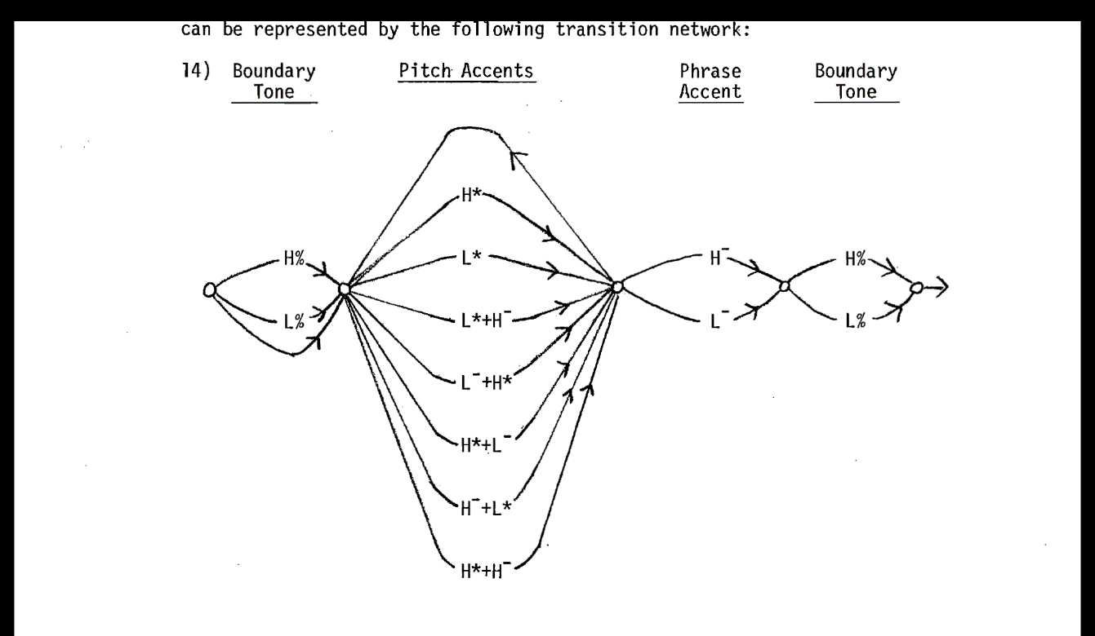

Figure . Pierrehumbert’s (1980b) finite state grammar of the intonational phrase.

In addition to the structural component of the PA and its tune-to-text associations, Pierrehumbert (1980b) also posits rules that governed the phonetic implementation of the tones within the IP, three of which will be covered here. Firstly, the gradual reduction in pitch scaling across an utterance is motivated by downstep, a lowering of the phonetic realisation of the H tone as an automatic consequence of an HL or LH sequence of pitch accents, examples of which are shown in Figure 2.3, panels a. and b. Secondly, the height of the final boundary is determined by the preceding phrase tone. That is, after a H¯ phrase accent, the H% boundary tone is up-stepped; however the L% essentially becomes null in such cases, representing no to little lowering of *f*0 in the contour. The contrast between H¯L% and L¯H% can be seen clearly in panels b. and c. of Figure 2.3.

|  |  |  |  |
| --- | --- | --- | --- |
| |  |  |  | | --- | --- | --- | | a. | b. | c. |   Figure . Examples of pitch contours and tonal targets from Pierrehumbert (1980) |

It should also be remembered that Pierrehumbert’s system only allows for two tone states, H or L. However, it needs to account for at least three different boundary phenomena: the final fall of the unmarked declarative (panel a), the down-stepped plateau of the calling contour (panel b.), and the high boundary of the binary question (panel c.). As such, the phrase accent and boundary tone rules are required to permit the two-tone system to account for such phenomena.

Finally, Pierrehumbert accounts for stretches of contour between boundary tones and pitch accents by viewing them as linear interpolations between pitch events.

### Critique of Pierrehumbert’s (1980) Upstep and Downstep

Several problems with this analysis have been identified in Pierrehumbert’s analysis both of downstep and upstep.

Firstly, it has been noted that Pierrehumbert’s account of downstep means that wherever downstep is observed [REF], an intervening L target must be posited to motivate—or justify—it, even if there is little evidence of one in the surface realisation. This can be seen in Figure 2.3, panel a., where the second PA must be described as H*+L¯ in order to explain why the final H* is downstepped. Ladd (1983) comments on this issue and also notes that sometimes the same phonological structure appears to give rise to very different surface contours. He suggests that the surface phenomena can be represented more sensibly if downstep is viewed as a speaker-motivated phenomenon (labelled as !H) rather than an obligatory implementational feature.

A similar problem may also be seen in relation to the phrase accent in panels a. and c. In panel a., the final pitch accent is H* followed by the edge-tone sequence L¯L%. The phrase accent L¯ is required in order to explain the fall from the H* to the boundary, since, without the intervention of the phrase accent, the boundary L% would not trigger a fall, but would reflect be a continuation of the H*, since boundary L% essentially represents a null state. Thus in order to show the phrase final fall, L% must—by virtue of the argument Pierrehumbert presents—be accompanied by a phrase accent, leading to L¯L%. Unfortunately, there seems to be little phonetic evidence to indicate that there are indeed two tones here. Rather, it is the theory which requires the presence of the L¯ rather than the data which suggests it. Grabe (1998a) presents an alternative solution to this, which is to suggest that the final boundary tone is fully relational and does not need to be specified at all. In this way, a final H% always triggers up-step, L% always indicates final lowering, while the unspecified final boundary (or 0%) indicates a continuation of the final tone in the pitch accent. In effect, this obviates the need for the phrase boundary at all.

Together, Ladd’s proposal for a motivated rather than obligatory downstep (!H) and Grabe’s proposals for boundary tones make it is possible to describe the sequence of tones in an intonational contour more parsimoniously, and without the need for injecting extra tones into the tonal string for which there may be insufficient empirical evidence.

### Modifications to PA Structure, a More Hierarchical Approach

Two modifications to PA structure as originally proposed by Pierrehumbert have also been suggested. Firstly, Pierrehumbert and Beckman (1986) propose that an intermediate phrase (small *ip*) can be embedded within the IP, wherein each *ip* ends with a phrase accent, but only the IP has a boundary tone. In this way, a hierarchical component is added to the IP, wherein the final accent of the IP becomes more akin to the nuclear tone of the British tradition, while the intermediate phrase is similar to the head of the tone group. Within AM approaches, it is now standard to view the final PA as the nuclear pitch accent, and the preceding pitch accents as prenuclear [REF]. This too reflects a more hierarchical structure. Moreover, the final pitch accent plus the final edge tones may be described as the nuclear contour (c.f., Gussenhoven, 2004, chapter 11). Such evolutions represent a partial synthesis of the original AM approach with the British tradition of a hierarchically structured Intonation Group.

Despite these modifications, it should still be borne in mind that the tonal string still belongs fundamentally to a separate tier (autosegment), the tones of which are associated with events in the segmental string, which itself is organized within a metrical hierarchically. After all, this is still the underlying view that led to the Autosegmental Metrical approach.

### Gussenhoven

A different approach to AM analysis is presented by Gussenhoven (1983, 2004, 2016). Reflecting this difference, Gussenhoven’s analysis of Standard Southern British English diverges from the Pierrehumbert school of thought in several key areas. Aside from a few notational differences[4], Gussenhoven’s analysis differs in many fundamentals, summarised as follows:

1. **Off-ramp analysis**. All pitch accents are left-headed, following the British Tradition (c.f. Gussenhoven, 1983), unlike Pierrehumbert’s approach which permits both left- and right-headed PAs.
2. **IP boundary constituents**. The initial IP boundary (Lι, Hι) is obligatory but—similar to the IViE approach—the final IP boundary is optional (Lι, Hι, Øι) and the height of Hι is relative to the preceding tone. Although obligatory, initial L*ι* refers to a mid to low tone.
3. **Absence of phrase accents**. There is no phrase accent tone since the off-ramp analysis accounts for pitch movements which are otherwise required by the phrase-accent analysis [SEE XXX?].
4. **Double alignment**. Initial boundary and monotonal pitch accents extend rightwards towards the onset of the next pitch event, so that each Lι, Hι, L*, and H* tone has both a left-hand tonal target and a right-hand one (Gussenhoven, 2016). This means that, in effect, this tone continues rightward until the next tonal event. Trailing tones also display double alignment, but this is only typically seen before a final Tι. Final Tι is not double aligned, and only represents a single event.
5. **Intra-accentual interpolation.** Interpolation only occurs within the pitch accent, not across pitch accents. This in stark contrast to Pierrehumbert’s view of interpolation, which occurs between PAs.
6. **Rightward displacement**. Within a pitch accent, the trailing tone can drift rightwards towards the next tonal event, although the timing and scaling of the drift may be variable. This implementational feature is not a feature of Pierrehumbert’s approach.
7. **Morphological and PA-internal downstep**. Downstep applies only to H* and can be motivated by a [downstep] morpheme applying to every H in the IP, or it can be triggered PA-internally when the H* is prefixed by an H tone. (See 9 below.) Note that this essentially accommodated both Ladd’s speaker-motivated and Pierrehumbert’s obligatory downstep.
8. **Tri-tonal prenuclear pitch accents**. Prenuclear pitch accents can take the form H*LH, wherein the L will be implemented as a fall after the H* but final trailing H tone can drift rightwards towards the next pitch event. While the use of tritonal pitch accents is not in itself of great note, what is more note-worthy is that prenuclear pitch accents and nuclear pitch accents do not have access to the same inventory. Again, this reinforces a hierarchy in which the final (nuclear) pitch accent has special status.
9. **Tone prefixation**. All pitch accents can be prefixed with an L tone, while nuclear pitch accents can also be prefixed by an H tone or a HL sequence. Gussenhoven argues that this can explain the contrast between scooped rise, sometimes labelled L+H*, and the unscooped H* [REF?]. For example, if an H*L tone is prefixed with an L*, the H* is displaced with L* takings its place as the starred tone, thus becoming L*HL. Again, the final L in the PA is free to drift rightwards. Similarly, an H prefixed to a nuclear pitch accent leads to obligatory downstep of the H* tone. This equates to the H+!H* of the ToBI-style analysis (see section 2.3.6 below).
10. **noSlump**. This is an obligatory feature of SSBE, which prevents the final Lι from exhibiting the kind of slump found in other varieties of English, including nIE (Lowry, 2001, 2002)

Gussenhoven’s intonational grammar of Standard British English is summarised in (1) below. Note that, there are only four pitch fundamental accents: L*, H*, L*H, and H*L. All other features are functions of implementation and the effect of prefixal tones. Even the “interloper” prenuclear H*LH, Gussenhoven argues, is likely an artefact of an earlier IP form H*L Hι (2004, pp. 302,  305–306).

$\begin{matrix}\text{([}\text{downstep}\text{]) }\left\{\begin{matrix}{\text{H}}_{\text{ι}} \\ {\text{L}}_{\text{ι}}\end{matrix}\right\}\text{ (L) }{ \left\{\begin{matrix}\text{H*}\left(\text{L}\left(\text{H}\right)\right) \\ \text{L*}\left(\text{H}\right)\end{matrix}\right\}}_{\text{0}}^{\text{n}}\text{ (H+)(L) }\left\{\begin{matrix}\text{H*}\left(\text{L}\right) \\ \text{L*}\left(\text{H}\right)\end{matrix}\right\} \left\{\begin{matrix}{\text{H}}_{\text{ι}} \\ {\text{L}}_{\text{ι}} \\ \text{∅}\end{matrix}\right\} \\ \text{noSlump}\end{matrix}$

While the formalization of the Grammar is relatively succinct, Gussenhoven’s analysis of English intonation appears considerably more complex overall, requiring the inclusion of the double alignment and rightward displacement rules as well as the noSlump rule, delay triggered by prefixal L*, prefixal tones in general, and both morphological and PA-internal downstep. At the same time, it should be noted that Gussenhoven’s approach aims to integrate a limited PA inventory into a more complex set of implementations reflecting the complexity of pitch contours as they are realised.

### Linguistic and Paralinguistic Uses of pitch

The matter of linguistic versus paralinguistic use of pitch is important in the study of intonation. The most common distinction between paralinguistic and linguistic use of pitch is, as noted in section 2.1, between the gradient and categorical. For example, the paralinguistic use may be observed in the indexical relationship between the affect of surprise and the height of the pitch excursion, with higher excursions indicating greater surprise. In contrast, a linguistic use may be found in the categorical distinction between the falling intonation of declarative statements and the rising intonation of binary questions (H*L % and L*H H% or H* H% respectively). Unfortunately, this distinction can be hard to maintain, since the paralinguistic use of pitch height appears to bleed into to the linguistic, especially in cases where the size of the excursion or overall height of *f*0 may vary depending on the grammatical, semantic, or pragmatic context as well as on affect and attitude.

Building on Ohala (1983), Gussenhoven (1999, 2004) proposes a framework aimed at accommodating both the phonological elements of pitch and the paralinguistic component. Ohala proposed that the near universal use of high or rising pitch has evolutionary biological origins, in which low pitch is associated with dominance and larger size while high pitch indicates smallness. He described this as a Frequency Code, which this leads to the tendency for low or falling pitch to be associated with statements (indicting certainty) and high or rising pitch with questions (indicating uncertainty and deferring to the listener). Expanding on this, Gussenhoven argues that there are three biological codes which do indeed motivate the apparent aforementioned universality of pitch movements. These are the Effort Code and the Production Code. The Effort Code associates greater overall effort in speech with an increase in *f*0 while the Production Code reflects the gradual decrease in *f*0 overtime during sustained voicing.

Gussenhoven argues that such codes may be phonologized in an otherwise arbitrary system of linguistic symbols. Thus, the frequency code, associated with size, may have a universal informational interpretation contrasting certainty with uncertainty, but lead to a phonologization which associates H% boundaries with questions and L% boundaries with statements. The effort code, where higher pitch may be universally associated with a greater sense of urgency, may lead to phonologization wherein H* is associated with focus and L tones with backgrounding or prominence loss. The production code, where pitch gradually decreases, may be associated universally with a movement from newness or towards completion, may be phonologized so that a high final boundary H% indicates continuation or incompleteness while a low L% boundary is associated with completion. Because these universal tendencies have been phonologized, there is also the potential that the phonological units may change their associations and thus subvert the putative universality of function of pitch in terms of biological codes. In addition to phonologization, however, Gussenhoven also argues that a parasitic phonetic trace often remains, meaning that an utterance may still contain an indexical paralinguistic element in the pitch contour.

An example of this interpretation might be found in Haan’s (2002) PhD dissertation on the intonation of question forms in Dutch, in which she provides evidence of linguistic and paralinguistic components in question intonation. She finds that H% boundaries are associated systematically with question forms; however, she also finds paralinguistic effects in their implementation. She notes that declarative questions have the highest average *f*0, polar questions lower average *f*0, and wh-questions the lowest. This, Haan notes, confirms her hypothesis that there is an inverse correlation between pitch height and the amount of non-acoustic—i.e., lexical, semantic, or morphological—marking in the utterance.

In addition to the issue of pitch height is the alignment of tonal targets. For example, Gussenhoven refers to an observed distinction between the later less precise alignment of pitch peaks and an earlier more precise alignment inside stressed syllables in the Zagreb variety of Serbo-Croat, where the more precise alignment occurs when the lexical word is in focus. He notes that this may reflect a difference in the selection of pitch accent (L+H* v H*) to reflect different kind of focus, or it may simply be the implementational effect of a tendency to align the peak more precisely when speaking more carefully, such as might happen when a word is in focus. In other words, he points out that the distinction may reflect a phonological choice or be an effect of implementation, and that it may be difficult to decide between the phonological and the implementational interpretations. Whether this is viewed as phonological or paralinguistic, the more precise alignment of the peak with the stressed syllable might be understood as originating from the effort code[5]. (Gussenhoven, 2004, pp. 60–60, in reference to Smiljaníc and Hualde, 2000)

### Labelling in Contemporary AM Analyses of English Intonation: ToBI[6] and IViE

It is clear that the labelling of PAs and boundary tones within an IP ought not be viewed merely as a matter of convention or an arbitrary selection of pre-determined pitch accent types. Rather, it is driven by underlying principles, beginning with the understanding that tones are sequences of Hs and Ls in an autonomous tonal tier.

Currently, within the AM research on English, there are two main different approaches to intonational labelling, and they depend largely on whether or not one accepts the existence of and need for phrase accents. In a closely related manner, they also depend on whether the pitch accent is analysed as being right-headed or as left-headed, or—as Gussenhoven (2004, p. 128) puts it—whether the analysis of the pitch accent follows and on-ramp or an off-ramp approach. Broadly, the phrase accent on-ramp approach is mostly followed in ToBI (Tone and Breaks Index) labelling and labelling systems derived from it (Beckman et al., 2005; Beckman & Gayle, 1997). On the other hand, the phrase-accent-free off-ramp approach is adopted in studies associated with the Intonational Variation in English (IViE) project. The IViE project was developed to collect corpora from several urban areas in Britain and Ireland, including Belfast (Grabe et al., 1998; Gussenhoven, 2004), and the labelling system bears some principles in common with Gussenhoven’s analysis.

ToBI analyses pitch accents as monotonal or bitonal, with bitonal pitch accents being either left- or right-headed, e.g., L+H* or L*+H. It takes a more theory-neutral approach to down step triggers, and uses downstepped H tones (!H* and H+!H*) in pitch accents (Beckman et al., 2005). However, downstep is still, as elsewhere, understood to trigger an overall reduction in scaling of H in the IP. Because downstepped H is available in ToBI, there is no need for the H*+L PA used in Pierrehumbert (1980a) since the trailing +L was essentially viewed as a downstep trigger. Further, H+!H* replaces the H+L* originally proposed by Pierrehumbert. In line with Pierrehumbert and Beckman (1986), ToBI also includes an obligatory phrase accent, occurring at the right edge of each *ip* and before the final boundary tone. In this way, the edge tones combined resemble the tail of the British Tradition. The final boundary tone retains the same features as the original Pierrehumbert analysis, with H% reflecting an upstep after H- and a high after L-, while L% represents a null state, with little to no downward drift in *f*0.

IViE labelling, like ToBI, has both monotonal and bitonal pitch accents and permits the use of downstepped !H. However, IViE also permits tritonal pitch accents, L*HL and H*LH, where the first two targets occur on the stressed and following syllable, with the third target following. This is similar to Gussenhoven, although Gussenhoven only permits tritonal pitch accents in prenuclear positions. Further, like Gussenhoven, IViE rejects the phrase accent hypothesis, and instead adopts the fully relational approach to boundary tones suggested by Grabe (1998a). This is in part motivated by the observation that ToBI cannot effectively represent some contours commonly found in nIE, most noticeably the nuclear rise-plateau-slump [see XXX later] (Grabe et al., 1998). Moreover, it allows for a more parsimonious labelling system which can facilitate the identification and comparison of parallel pitch accents and boundary structures across varieties of English.

### Phonetic Analysis of Intonation in AM: Tones and Tonal Targets

In addition to the phonological analysis of intonation, AM analyses also generally evaluate the phonetic implementation of tones, or tonal targets. In its simplest formulation, a tonal target is a surface realisation of an underlying phonological tone, described in terms of both its *f0* and its temporal alignment in relation to a segmental landmark, frequently the onset of the vowel in the lexically stressed syllable [REFS – explanation needed?].

As discussed in section 2.3.5, the alignment and scaling of tonal targets may be influenced by the pragmatic or linguistic function of an utterance. However, formal structure features are also understood affect the *f*0 scaling and temporal alignment of tonal targets. These include compression and truncation effects, tone drift, and tonal crowding.

|  |  |  |
| --- | --- | --- |
|  |  |  |
| a. L*H realised fully. | b. L*H realised with compression effects. | c. L*H realised with truncation effects. |

Figure . Three Stylisations of L*H pitch accents reflecting truncation and compression effects. The grey area on the right of each box can represent unvoiced segmental material or simply the end of speech.

It has been argued that a pitch contour may be truncated or compressed as a function of available voiced material (Grabe, 1998a, 1998b). In cases of compression, the tonal target may be fully realised but within a shorter time window to compensate for the reduced amount voiced segmental material, as shown in Figure 2.4, panel b. With truncation, however, the pitch movement may be foreshortened, as represented in panel c. [REFS?], so the tonal target is not realised fully. It also possible that pitch contours can be subject to truncation and compression effects simultaneously, such as those found for Belfast English in Sullivan (2012). Truncation/compression trends vary across English dialects, so one cannot assume that effects which in one variety will hold in another (Grabe, et al., 2000; Ladd, 2008).

It also appears that tonal targets may also be fixed or subject to drift. When a target is fixed, it is typically anchored to a specific landmark in the phrase, typically associated with a stressed syllable or the foot [REFS], or sometimes with lexical boundaries [REF]. However, it has been found that, given enough segmental material, and conditions by foot size and anacrusis, a tonal target may drift rightwards or leftwards [REFS]. Analysis of variation in peak alignment strategies has shown that they can be a marker of dialect differentiation, both in English (Arvaniti & Garding, 2007; Kalaldeh et al., 2009) and other in languages (Atterer & Ladd, 2004; Bruce & Thelander, 2001; Dalton & Ní Chasaide, 2007).

The third formal effect is tonal crowding (Arvaniti et al., 1998; Ladd et al., 2009; Silverman & Pierrehumbert, 1990). This occurs when tonal targets must be realised in close proximity to each other, such as when two starred tones occur in adjacent syllables. It has been found that in such cases, there can be interactions affecting the alignment or the alignment and scaling of targets, most likely as adjustments must be made to accommodation both tones within a small window of time.

Without consideration for Truncation/compression effects, the effects of tonal drift, and tonal crowding, it may be possible to misidentify fundamentally identical pitch accents as different. Through systematic analysis of pitch accent timing and scaling under different segmental and/or metrical conditions—longer feet meaning more segmental material—one can assess whether truncation or compression effects are in operation, if targets are subject to drift under different formal conditions, or if (and how) tonal crowd affects the realisation of tonal targets.

## Issues for AM Analysis of the Phonology and Phonetics of Intonation

So far, the main difficulties discussed regarding AM analysis have focused on the theoretical divisions motivating ToBI-style and IViE-style analysis. However, there are a few other fundamental issues which need to be considered in relation to AM analysis. The following section describes three of them, indicating why they matter, and explaining how they have influenced the research project.

### Tonal Targets and Implementational Domains

Within the AM approach, the domain of the starred tone is, by definition, the metrically stressed syllable since the star simply represents the stressed syllable which links the segmental string to the tonal sequence. There are however, several problems with this assumption, one of the most significant being that the starred tone does not in fact always align with the stressed syllable (e.g. Nolan and Farrar, 1999; Arvaniti, Ladd and Mennen, 2000). For example, Arvaniti, Ladd, and Mennen analysed prenuclear tones in Greek, which appear to have a low tonal target before the stressed syllable and a high tonal target after it, making it difficult to identify a single tone associated with the stressed syllable, and this make it difficult to land on an appropriate label (L*H, L+H*, [LH]*, H*, etc.).

The failure of starred tones to align consistently and neatly with the metrically stressed syllable could stem from several sources. It could be an effect of segmental pressure, i.e., it might sometimes be difficult to coordinate pitch targets with metrical targets when there is less segmental material available in which to implement the pitch movement [REFS]. Alternatively, it could be that tonal targets are subject to leftward (or rightward) drift when there is an excess of segmental material before the metrically stressed syllable, as in the case of anacrusis [REFS]. Or it could be pragmatic, where the speaker aligns the target only as precisely as they believe necessary for the speaker to interpret the intended pitch accent correctly. Of course, it could well be a combination of all of these, wherein the speaker may be more or less likely to cede to segmental pressure or to let the target drift based on the perceived need to realise the pitch accent.

A closely related issue is the implementational domain of the pitch accent. This is generally taken to be the foot. However, as Arvaniti, Ladd, and Mennen (2000) point out, it is not always clear how the trailing tone is supposed to be aligned. There is evidence that starred tones and trailing tones in English may be aligned partially according to the left and right boundaries of lexical word in which foot stress occurs rather than the foot alone (Silverman & Pierrehumbert, 1990). There is also evidence that pitch alignment may be partially lexically motivated in that it plays a role in the segmentation of words (Ladd & Schepman, 2003).

There is also debate as to how to identify tonal targets in the first place. The simple view takes the local *f0* maxima and minima as the tonal targets. However, while this seems sensible at first, there can be complicating factors. For example, a study of British English by Knight and Nolan (2006) found that the most stable landmark of the H tone was not the peak but the end of the H plateau 4% below the *f0* maximum (i.e. the end of the effective duration of the H tone). Greater consistency in the alignment of the end of the plateau rather than that of peak *f*0 may suggest that the speakers too may intuitively aim at a target near the end of the plateau rather than simply the peak itself. In other cases, the listener may be able to identify the percept of an L target but there may not be an easily identifiable local *f0* minimum in the contour. A Stylised example of this problem is shown in Figure 2.5. In such cases, the point in the contour where a distinct change in *f0* trajectory may be selected, as shown in the first panel of Figure 2.5. Such points are described as *elbows* or *turning points*, and have been used to identify L targets in several studies (D’Imperio, 2000; Shosted et al., 2006; Welby, 2003). In fact, the use of turning points can be generalised to interpret all tonal targets in this manner. Frequently, as in the second panel of Figure 2.5, *f*0 maxima and minima do align with turning points but this is not always the case. The topic of elbows is taken up further in Chapter 8.5**Error! Reference source not found.**, which outlines a technique for identifying turning points.

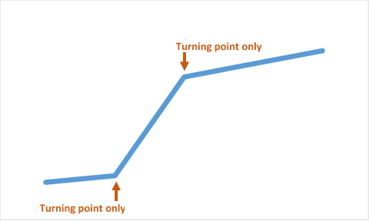 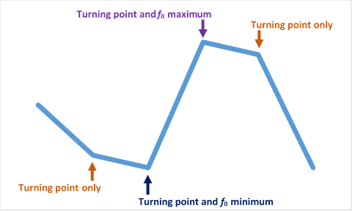  
**A B**

Figure . Stylised representations of an f0 contour, indicating turning points (elbows) and f0 minima and maxima. Note that an f0 minimum or maximum may also be a turning point.

In summary, we can see that neither the identity implementational domain of the turning point nor its most salient identifier be taken for granted.

### Form-Function Mismatches and Failures in Phonological and Phonetic Analysis

AM analysis of intonation typically involves identifying functions associated with intonation and then describing them in terms of intonation structure. Examples of this can be found in the analysis of Eastern European Question Intonation [REF], question types in Dutch [REF], Greek [REF], German [REF], and Italo-Romance varieties [REF]. In English, this can be seen around the discussion of question modes, calling contours, and focus [REFS]. However, as noted above in section 2.3.5, pitch contours sometimes vary according to function in a manner which cannot easily attributed to different combinations of pitch accents and edge tones. Such variation is often viewed as gradient and is typically attributed to a paralinguistic effect. However, there is a very clear methodological problem with this approach. In essence, it means that pitch features associated with functions are identified as linguistic only in so much as they fit the theory. When the pitch contours do not fit the theory, they are in effect cordoned off as paralinguistic. This occurs even in cases where there is a clear and consistent correlation between grammatical function and the pitch contour, which suggests that the different contours do in fact serve a linguistic function too. While there is clearly a paralinguistic component to pitch, the problem here lies in the fact that the theory is essentially prioritised over the data, when in fact it may be that the theory needs to be adapted or reimagined so that it can explain the data. In short, the availability of the paralinguistic ‘out’ may hinder progress in the AM analysis of intonational function.

Grice et al. (2017) illustrates and deals with the problems of discreteness, gradience, and function in a particularly insightful manner. In an analysis of narrow and corrective focus in Standard German, the researchers found—as they expected—a relatively low correlation between intended focus type and the pitch accent employed, but they found that the focus type was still more likely to be interpreted as intended. More importantly, however, they found that, despite the lack of consistency in pitch accent choice, speakers did still employ similar implementational strategies. Specifically, peaks were aligned later and with higher *f*0 in contrastive focus when compared to narrow focus, and in narrow focus when compared to broad focus. The authors note the difficulties their results pose for linguistic traditions based on discrete categories of analysis, since their research identifies a mismatch between the phonological categories and their function while at the same time identifying clear patterns and gradient shifts associated with changes in function. They argue that there is a need to integrate discrete and continuous features in an intonational grammar, since both belong to one single system.

As the authors suggest, it may well be necessary to carefully consider both discrete and gradient features in a systematic analysis of function in intonation. However, it is also necessary to consider possible limitations to the phonological framework within which the analysis is conducted and to consider possible adjustments to it. For example, in the study described above, discrete categories were generally poor predictors of function, but an overall systematic trend was found in the alignment and scaling of *f*0 targets from broad to narrow and from narrow to contrastive focus. This should, perhaps, not only signal the importance of assessing both categorical and gradient patterns in the analysis of intonation, but it should also signal that the current phonological description may not adequately identify and reflect phonological features which are easily interpreted by listeners during conversion.

In short, it is important to avoid the temptation to simpy perform a phonological analysis which dismisses some phenomena as paralinguistic [i.e. scaling in declaratives and questions] rather than linguistic. Therefore, if one identifies a systematic relationship between function and an ostensibly gradient feature, one must consider if such a feature can in fact be accommodated by adjusting the phonological theory instead excluding it from the phonological.

### Contours Versus Targets

At its core, the AM framework relies on the assumption that the pitch contour is the physical manifestation of an underlying sequence of tonal primitives. As such, glides and curves should be understood as side effects of this implementation. However, this does not always appear to be the case. For example, D’Imperio (2000) found that the perception of peak alignment—and thus of pitch accents—can be influenced by the shape of the contour rather than tonal target alignment alone, while Knight (2008) found that the perception of pitch height and pitch prominence is influenced by the shape of the pitch accent, specifically the duration of the plateau associated with the target pitch accent.

Building on such insights, Barnes et al.(2012, 2021) argue that the perception of tonal targets may not be associated so much with turning points but with a global measurement, Tonal Centre of Gravity (TCoG). TCoG abstracts away from the alignment and scaling of *f*0 by integrating them into a single function which calculates the time point which the authors describe as the “centre of gravity” of the contour. It is in effect an integral function which calculates the time at which the area under the curve is balanced on either side of the curve, described more precisely as TCoG-t in Barnes et al.(2021). Figure 2.6 helps illustrate this point. Each shaded area represents half the area under the curve between the onset and offset of the pitch movement. The frequency domain equivalent of TCoG-t is TCoG-*f*0, which measures the mean *f*0 across the contour. Whenever the glide to the peak is more domed, TCoG-*f0* is higher and TCoG-t is earlier. Conversely, whenever the glide to the peak is more scooped, TCoG-*f0* is lower and TCoG-t is earlier. These effects are reflected by the different positions of the dots in Figure 2.6.

|  |  |  |
| --- | --- | --- |
|  |  |  |
| a. $$\frac{A}{2}$$ | b. $$\frac{A}{2}$$ | c. $$\frac{A}{2}$$ |

Figure . Schematic representations of different pitch curves with different TCoG. Adapted from Barnes et al. (2021) to illustrate how TCoG-t reflects timing of the balance of the area under the curve.

In their 2012 paper, the authors were able to demonstrate that the TCoG-t was a better predictor of annotators’ PA categorisation choices than turning point timing and scaling parameters. In the 2021 paper, the authors used forced choice match-to-sample tasks with utterances containing resynthesized pitch contours. They demonstrated that the shape of both the rise and fall influenced listeners’ categorical judgments.

The alignment effects predicted by TCoG appear to reflect the findings of D’Imperio (2000), in that a domed rise leads to the perception of an earlier peak. Similarly, *f*0 effects of TCoG appear to reinforce the findings of Knight (2008), where the more plateau-like domed contours are associated with a higher TCoG-*f*0.

Both papers present a serious challenge to the AM approach. They use AM conventions to describe the PAs, which appears to validate the fundamental principle of the AM framework and the importance of underlying L and H primitives along with their associated tonal targets. However, the analyses suggest that listeners do not categorise pitch accents based on the implicit identification of tonal targets, but rather on the interpretation of the tonal centre of gravity. If this is indeed the case, i.e., that listeners use TCoG rather than tonal targets to identify and categorise pitch accents, then it stands to reason that the interpretation of intonation events in terms of L and H primitives is wrong-headed. As such, it brings into question the whole AM project and might suggest that the use of terms such as L+H* or L*+H are useful only in so far as they are convenient placeholders for PA categories, while the L and H terms themselves hold little theoretical merit. [Could there be an underlying LH phonology with a realisation in contour shape]

This train of thought is not merely a panicked catastrophizing, since the TCoG analysis does indeed appear to reflect listener’s ability to categorise pitch contours without recourse to tonal targets or the underlying primitive with which they are associated. However, there are two major considerations which may help ease the distress of such catastrophic thinking.

The first consideration relates to the psychological plausibility of TCoG. It would require a set of complex cognitive processes from the listener for it to work:

1. Continuous summation of *f*0 over time (a cognitive integral function);
2. Retrospective assessment of the timing of the onset and offset of the complete contour;
3. Retrospectivecalculation of the time at which the area under the curve can be divided equally in half.

In addition, the speaker would need a complementary set of production strategies, including the planning of the contour so as to calculate the area under the *f*0 curve and an implementation strategy to generate the target TCoG so that it can be interpreted correctly by the listener. While, such cognitive processes *may* occurin the production and perception of PAs, it feels more practical to assume a simpler process in which the pitch contour is produced through the implementation of a linear sequence of L and H primitives. In short, it is unlikely that the predictive value of TCoG is due to the fact that it directly represents the underlying phonology. Rather, it is more likely that it is an epiphenomenon which works as an effective heuristic in the categorisation of pitch contours.

The second consideration is the way in which tonal targets are identified. In Barnes et al.(2012), tonal targets are associated with *f*0 minima and maxima. The authors explicitly reject the use of elbows as tonal targets. They argue that, since the most common algorithm for estimating elbows is sensitive to the contour shape much in the same was as TCoG, the use of elbows “in essence amounts to smuggling global contour shape in through the model’s back door.” (Barnes et al., 2012, p. 379). However, it is very possible that this observation, relegated to a footnote, explains the apparent effectiveness of TCoG. That is, TCoG may appears so effective is that it reflects the way in which tonal targets are realised: as elbows rather than as *f*0 minima and maxima. In this case, the apparent challenge to the AM framework might be an artefact of the methodology. In other words, the problem might lie in the technique used to identify tonal targets.

The same concern arises in Barnes et al.(2021). Because the study described in this paper used synthesized *f*0 contours, low *f*0 targets could easily be measured at the point at which the synthesized contour began to rise and at the point at which it was complete, while high *f*0targets were measured at the *f*0 peak. Considering that the scooped rise begins gradually, it is possible that the *f*0 minima is not as immediately salient as in the domed rise, where *f*0 rises suddenly and dramatically. Again, the experimental method for identifying the tonal target may not accurately reflect the listener’s percept.

The conclusion one might draw from this discussion of TCoG is that tonal targets are best measured in terms of elbows rather than *f*0 minima and maxima. However, it was not until later in the project—once I had designed the methodology, conducted the analyses, and was reflecting on the results—that I began to consider more fully the implications of TCoG and the limitations of using *f*0 minima and maxima as proxies for tonal targets. As such, the issue of turning points and TCoG is given fuller consideration in Chapters 8 and 9.

## Summary and Conclusion

The dominant mode of intonation analysis in English is the Autosegmental Metrical (AM) approach, and it has been adopted for the current project. In essence, there are two main schools of thought in AM research. This first is a direct descendent of Pierrehumbert’s original (1980b) approach, and has been propagated though ToBI and its offshoots (Beckman et al., 2005). The second is more closely aligned with the work of Gussenhoven (1983, 2004), Grabe (1998a), and the IViE project (Grabe et al., 1998; Grabe & Post, 2002). The features for each approach are summarised in Table 2.2. The terms ToBI-like and IViE-like are used for convenience, and it should also be noted that while both ToBI and IViE are intended as largely theory-neutral approach, both are still influenced by competing theoretical perspectives.

|  |  |  |  |  |  |  |  |  |  |  |  |  |  |  |  |  |  |  |  |  |  |
| --- | --- | --- | --- | --- | --- | --- | --- | --- | --- | --- | --- | --- | --- | --- | --- | --- | --- | --- | --- | --- | --- |
| Table . Comparison of ToBI-like and IViE-like analysis   |  |  |  | | --- | --- | --- | | Features | ToBI-like | IViE-like | | Onramp PA | ✓ | ✗ | | Offramp PA | ✓ | ✓ | | Phrase accent | ✓ | ✗ | | Intermediate phrase | ✓ | ✗ | | Obligatory final boundary | ✓ | ✗ | |  |  |  | |

Fundamentally, both approaches analyse the same set of phenomena, follow the same overall theoretical framework, and share the same general understanding of the relationship between the underlying phonology and the surface form. Both approaches agree that there is a string of underlying tones which are linked to the segmental string through metrical events. The key difference lies in how the events in the tonal string are associated with events within the IP. As can been seen from Table 2.2, this comes down to whether or not the approach uses an exclusively offramp approach, whether it accepts the existence of the phrase accent and the intermediate phrase, and whether or not the final boundary tone is obligatory.

### Labelling Choices for Research

ToBI-style analysis requires the labelling of the PA final edges in terms of phrase-accents and boundary tones, even in cases where there is little evidence for one whereas the solution adopted by Grabe, Gussenhoven, and the developers of the IViE project feels intuitively more appealing. It does away with phrase accent, allows for an optional the final boundary (L, H, Ø), and includes an off-ramp only approach. This creates an overall more economic labelling system and appears more suited to capturing parallelisms across pitch accent and boundary conditions than the obligatory phrase-accent and boundary tone approach, which can lead to fundamentally similar tunes being analysed as if they are very different.

Gussenhoven (2016) argues that an off-ramp analysis which does away with the phrase accent and permits optional phrase-final boundary tones is able to capture a wider range of attested nuclear contours than ToBi-like annotation. However, if one is to adopt Gussenhoven’s approach, it is also necessary to accept a long list of additional claims about the nature of the implementation of the phonology. These may be absolutely correct; however, in terms of analysis, it feels unwise to adopt, wholesale, Gussenhoven’s approach, as this could, again, lead to a prioritisation of the theory over the data.

For the purposes of labelling, the IViE system seems preferable overall compared to ToBI. After all, IViE was designed for labelling varieties of English, including nIE, which is the focus of this dissertation, whereas ToBI (specifically MAE_ToBI) was designed with North American English in mind. The fact that IViE has a more flexible approach to final boundaries also makes it more amenable to the analysis of northern Irish English, as shall be seen in 3. Finally, like Gussenhoven, there is no phrase accent in IViE, which means that there is no need to include labels for tones for which there may not be empirical evidence.

For the reasons outlined above, IViE labelling is used for the analyses reported in Chapters 6 and 7, described in the introduction as the phonology-first approach.

### Strategy for Identifying Tonal Targets

For the purposes of identifying tonal targets, the analyses in Chapters 6 and 7 use *f*0 maxima and minima rather than *f*0 turning points. This decision was based on three things. Firstly, minima and maxima are intuitively easier to reconcile with concepts of High and Low than turning points. Secondly, they are commonly used in the AM literature [REFS]. Lastly, they are much easier to identify than turning points. As mentioned in 2.4.3 above, however, it was only on reflection and with the benefit of experience that the potential advantage of using turning points over *f*0 maxima and minima became apparent.

### Analysis of Form and Function

As noted in 2.4.1, the alignment of tonal targets may not always reflect the theoretical ideal, i.e., starred tones may not be realised in the stressed syllable and trailing tones may sometimes be associated with lexical boundaries rather than metrical ones. This demonstrates the need for an analysis of formal (metrical and lexical) effects on the implementation of pitch accents. Chapter 3 will outline some of the formal effects found on the realisation of pitch accents in nIE, while Chapter 6 offers an analysis of the metrical and lexical boundaries effects on pitch accent inventories and the alignment and scaling of tonal targets in DCE.

Section 2.4.2 points out that the partitioning of pitch events into phonological/linguistic and paralinguistic categories may mean that some intonational phenomena are inadvertently dismissed as paralinguistic because they do not ‘fit’ the theory, even though they still systematically reflect a communicative function. To avoid such a Procrustean trap, it is suggested that one must consider the limitations of the theory and see if reasonable accommodations can be made to the theory so that it can explain systematic patterns in the data more completely. [REGISTER!] Chapter 3 will indicate how a strict AM analysis of sentence modes in nIE might lead to phonological differences being ascribed to paralanguage. In such cases, adjustments to the theoretical approach may demonstrate how they too are, in fact, phonological. Potential adjustments to the phonology are considered in the analysis of sentence modes in chapter 7.

# Local Context: northern Irish English and Derry City

This chapter focuses on Derry City and northern Irish English (2.4), outlining the geopolitical and linguistic contexts, and summarising previous research on Intonation in northern Irish English and Derry City. It begins by presenting some general background information about Derry City, and northern Irish English, before moving on to discuss a British Tradition analysis of DCE intonation and AM studies of nIE intonation. It ends with a consideration of how the issues within AM discussed in the previous chapter (section 2.4) related to the current study of DCE intonation.

## Derry City and northern Irish English

Derry City is located in the Northwest of Northern Ireland, close to the border with Donegal in the Republic of Ireland (see Figure 3.1). It has a population of 83,125 (NISRA, 2015). The oldest settlements of the city were along the west bank of the river Foyle, although the city now straddles both the eastern and western banks of the river. The area on the western side is referred to locally as the City Side, and the area along the eastern bank is called the Waterside. Before the 1612 Charter, the site along the West Bank of the river Foyle was part of Donegal (Lacy et al., 1983), and historically there has been a close relationship between Derry City and county Donegal.

As in Northern Ireland in general, Derry City is in many ways demographically homogenous. In the 2011 census, 98% identified as white, 97% as Christian or as having been brought up as Christian. 89% were born in Northern Ireland, with less than 3% of the population born outside of either the UK or the Republic of Ireland. Two very strong markers of identity in Northern Ireland, however, are nationality and religion, and there is a general tendency for Roman Catholics to identify as Irish and for Protestants as British (Zwickl, 2002, pp. 72–101). The city has a large Roman Catholic majority (78% in 2011 census), with most of the Protestant population (19% in total) living on the Water Side. 59% of the population identify as Irish, 34% as Northern Irish, and 21% as British. (The total is over 100% as the census allows people to identify with several nationalities.)

Varieties of English spoken in the northern part of the island are quite distinct from southern varieties; unfortunately, the term Northern Irish English—often found in the literature—is intrinsically ambiguous. That is, it may refer the Irish English spoken in the geographical north or to English spoken in Northern Ireland, the political jurisdiction, the border of which is shown by the thick black line in Figure 3.1. In some cases, the distinction between Irish English of the geographical north and the English of (the political entity) Northern Ireland is blurred, so a northern variety of Irish English—such as Belfast English in Grabe, Kochanski and Coleman (2005)—might be contrasted with English in the Republic of Ireland, in such a way as to imply that the political border and the linguistic borders coincide. The confusion of conflating the political boundary with the isogloss can also been seen in Folley, Gibbon, and Peppé, who observe that “[a]lthough statements have a high terminal in Northern Ireland […], this is not the case in the Irish Republic” (2010, p. 23). Conversely, Moritz (2016) includes northern varieties spoken in the Republic in her discussion of English in Northern Ireland. The two-book survey of Irish English by Corrigan (2010) and Kallen (2013) explicitly splits the burden of description into a volume on Northern Ireland and a volume on the Republic of Ireland, but both books exclude the English of Donegal, which is the geographically the northernmost county on the island but also in the Republic of Ireland.

|  |
| --- |
| Derry city  Ulster border  North-south isogloss  NI-ROI border  Figure .. Approximate boundaries of northern Hiberno-English dialects (Hickey, 2007, p. 442 after Harris, 1985, p. 16). Derry City is highlighted in red. |

Harris (1985) avoids such geopolitical confusion, conflation, and exclusion when he identifies an isogloss running roughly from Donegal Bay in the west to Carlingford Lough in the East, which separates northern varieties from southern varieties of Irish English, This is shown in Figure 3.1 by the dashed purple line. Harris describes the northern variety as Ulster English and identifies three main language groups: Southern Ulster English, Ulster Scots, and Mid-Ulster English (MUE), each influenced to varying degrees by the influx of Scots speakers and English speakers from the English Midlands during the seventeenth century plantations. It should be noted that the isogloss is not coterminous with the Ulster boundary (shown by the pink dotted line), especially in south Ulster. Therefore, following McCafferty (2001), lowercase northern Irish English (nIE) will be used to describe the varieties of Irish English spoken in the northern part of the island.

As can be seen from Figure 3.1, Derry city is in the MUE region. Thus, one expects broad similarities between DCE phonology and the phonology of this region in general. In fact, one well recognised similarity in across all nIE varieties is the use of rising nuclear pitch accents in neutral declarative sentences [SEE CHAPTER XX.X.X]. It is this specific feature of nIE which motivated this research, since, as shall be seen in Section 3.4, the prevalence of rising intonation patterns raises questions about form and function, and about linguistic/paralinguistic boundaries of pitch.

## British Tradition Analyses of northern Irish English Intonation

In the 1970s and early eighties, two studies of northern Irish intonation were conducted within the British Tradition, the first focusing on Belfast English and the second on Derry English.

In their study of Belfast English, Jarman and Cruttenden (1976) (J&C) found that 70% of all nuclei contained by rising tones, including semantically unmarked (i.e. simple declarative) phrases. Working within the British tradition, they observed that low rising tones (tone 1) were common in declaratives while high rising tones (tone 2) were common in questions. In each case, they noted the post-tonic stretch formed a plateau. Although the rise of semantically unmarked nuclei was less dramatic than that of questions, the importance of their findings at the time was that they drew attention to the weakness of the assumption that unmarked intonation is ‘universally’ indicated by a falling tone.

McElholm’s (1986) study of intonation in Derry English found that it was similar Belfast intonation as described in J&C, especially in relation to the use of rising tones in unmarked forms. However, unlike J&C, McElholm found no examples of falls in nuclear syllables, and he also found that the low-rising tone was used for wh-questions. Where McElholm’s analysis differs from the Belfast study, McElholm suggests it may be due to a sparsity of data or a possible discrepancy in social class between the Derry informants and the Belfast informant. Therefore, McElholm’s overall inventory of tones, summarised in Table 3.1, is slightly different to that of J&C.

|  |
| --- |
| Table . Summary of McElholm's inventory of nuclei for Derry English (adapted from McElholm, 1986, p. 56). Parentheses indicate corresponding tonal forms in Jarman and Cruttenden (Jarman & Cruttenden, 1976). |
| |  |  |  |  | | --- | --- | --- | --- | | Tone | Stylisation | tonic movement | general meaning | | A (1) |  | low rising | natural for all major speech functions except YNQs; also used for secondary information | | B (2) |  | high rising | neutral for YNQs | | C (3) |  | rising-falling | preceding contrast or suggesting reservation | | D |  | extra-high rising-falling | assertive or surprised [NB very rarely attested] | | E (5) |  | rising plus rising | conveying new plus secondary information | | F |  | extra-rising rising-falling plus rising | as tone D plus secondary information | |  |  |  |  | |

Like J&C, McElholm carried out his analysis in the British Tradition, and was largely an impressionistic analysis of two speakers. The differences in theoretical approach and the lack of quantitative data make it is difficult to compare it with AM studies beyond a few broad phonological comparisons.

## AM Studies of northern Irish English Intonation

Within the AM approach, the majority studies of nIE are based on IViE data, and thus focus on Belfast English. A few studies of Donegal English have been conducted based on work by O’Reilly, Dorn and Ní Chasaide (Dorn, 2006; Kalaldeh et al., 2009; O’Reilly et al., 2010). The only other AM study of nIE of which I am aware is Moritz (2016), which compares Southern Ulster English, Ulster Scots, and Mid-Ulster English, with Belfast English representing Mid-Ulster English.

The IViE project collected speech corpora from secondary school pupils in different urban areas across Britain and Ireland (Grabe & Post, 2002), including Belfast. The Belfast corpus includes speech from 12 speakers (6 female, 6 male, aged 17) attending one of two schools near the city centre, all of whom had been born and grown up in Northern Ireland. Speech was elicited using five tasks to elicit a range of speaking styles, speech functions, and interactions.

### Phonological Analysis of Belfast English

Lowry’s initial (2001) analysis of nIE followed the ToBI labelling approach and found that adjustments needed to be made to it in order to accommodate features of nIE which are not found in the General American English for which ToBI was designed, most notably in ToBI’s inability to adequately label the rise-plateau-slump of Belfast English. Later, using the IViE system, she identified four different nuclear accents in Belfast English, labelled L*H %, L*H L%, L*H H%, and H*L % respectively, as shown in Table 3.2 (Lowry, 2002). These patterns have been attested in a number of analyses of the IViE corpora (Grabe, 2004; Grabe et al., 2005; Lowry, 2002) as well as in more recent corpora (Jespersen, 2018; Sullivan, 2010, 2012). L*H % is by far the most common tone across sentence modes. However, differences in the distribution of nuclear tones across speech style, gender, and sentence mode have also been found.

|  |  |  |  |  |  |  |  |  |  |  |  |  |  |  |  |
| --- | --- | --- | --- | --- | --- | --- | --- | --- | --- | --- | --- | --- | --- | --- | --- |
| Table . Nuclear patterns of Belfast English, adapted from Lowry (Lowry, 2002).   |  |  |  |  |  | | --- | --- | --- | --- | --- | | Schematic representation |  |  |  |  | | Impressionistic description | rise-plateau | rise-plateau-slump | high rise | fall | | IViE labelling | L*H % | L*H L% | L*H H% | L*H % | |

Lowry’s (2002) study of style shift found that rising nuclei dominate all styles of speech, and their use increases dramatically in less careful speaking styles, especially among the female speakers. Grabe’s (2004) analysis of the IViE read-sentence corpus found that L*H % accounted for a least 83% of nuclear tones across all sentence types. H*L % was found in only 4.2% of declaratives (DECs) and 5.6% of wh-questions (WHQs) while low boundary tones, L*H L%, occurred only in 12.5% of DECs. The simple rise, L*H H%, was found in yes-no questions (YNQs) but was not the dominant form, accounting for 5.6% of YNQs and 16.9% of declarative questions (DCQs). Sullivan (Sullivan, 2010) found L*H H% in DECs as well as YNQs. She also found L*H L% was more likely to occur in question forms than DECs. In a more recent study, Jespersen (2018) has also found occurrence of simple rises.

Another study of the IViE data (Grabe et al., 2005) analysed PAs across utterances in both prenuclear and nuclear position. They found prenuclear accent types (H*, L*H, H*L, and L*), with H* being by far the most common, occurring in 78% of declaratives all utterances. In sharp contrast to this, L* occurred in only 2.2% of PN pitch accents.

Table 3.3 summaries the inventory of nuclear accents attested in Belfast English across sentence modes. If the same similarity exists today between Belfast and Derry City English as described in J&C and McElholm, one might expect a similar distribution of pitch accents, though with fewer—if any—instances of H*L Derry City English.

|  |  |  |  |  |  |  |  |  |  |  |  |  |  |  |  |  |  |  |  |  |  |  |  |  |  |  |  |  |  |  |
| --- | --- | --- | --- | --- | --- | --- | --- | --- | --- | --- | --- | --- | --- | --- | --- | --- | --- | --- | --- | --- | --- | --- | --- | --- | --- | --- | --- | --- | --- | --- |
| Table . Summary of Pitch accents attested in Belfast English across sentence modes.   |  |  |  |  |  | | --- | --- | --- | --- | --- | | Nuclear | DEC | WHQ | YNQ | DCQ | | L*H % | ✓ | ✓ | ✓ | ✓ | | L*H L% | ✓ |  |  |  | | L* H% | ✓ |  |  |  | | L*H H% | ✓ |  | ✓ | ✓ | | H*L % | ✓ | ✓ |  |  | |

Unmarked rising nuclei are also attested other varieties of English, such as Liverpool, Manchester, Tyneside, and Glasgow, and the phenomenon has been described as Urban Northern British intonation (UNBI) (Cruttenden, 1995, 2001, 2007). In the IViE corpus, there are four sets for data from Britain in the UNB category: Liverpool, Leeds, Bradford, and Newcastle upon Tyne. However, nuclear rises in declarative statements were attested only in the Newcastle corpus. Even still, Newcastle had 17% L*H in declaratives compared with 96% in Belfast (Grabe, 2004). Cruttenden also (2007) notes the evidence for the greater dominance of unmarked rises in Belfast English when compared to other varieties.

### Alignment, Compression and Truncation in nIE

Nolan and Farrar (1999) used the IViE corpus to study peak lag in prenuclear accents, which was defined as the occurrence of the tonal target after the stressed syllable. They found that it was very common in Belfast but was less so in the presence of anacrusis. Sullivan (2007) focused on the alignment of nuclear valleys, also using the IViE corpus. She found a significant effect of anacrusis on the alignment of L, causing earlier alignment[7]. Gender was also a significant factor, but sentence mode had only a limited effect.

A comparative study of nuclear and prenuclear alignment in varieties of Irish English (Kalaldeh et al., 2009) examined L*H PNs in Donegal English rather than H*. The study found that anacrusis caused rightward drift of the prenuclear peak, which appears to be the opposite of Nolan and Farrar (1999). The Donegal data also indicate rightward drift of peaks in nuclear L*H pitch accents as the syllable count in the foot increases. For both nuclear and prenuclear accents, L targets were stable.

### Proposed Source of Declarative L*H Dominance in nIE and Elsewhere

Cruttenden suggests that the UNBI phenomenon may have originated in migration from Belfast and other regions of northern Ireland. Offering an alternative hypothesis to account for the existence of rises in Tyneside—which was not subject to the same degree of migration from Ireland—Hirst (1998, 2013) has suggested that the declarative rise may have originated in migration and settlement from Scandinavia during the Viking raids starting in the eighth century. However, the distribution of Scandinavian settlements does not reflect the distribution of the rises in Ireland or in other parts of England either. So, while Tyneside English may have retained prosodic features adopted during Norse settlement, it seems unlikely that it can account for the occurrence of nuclear rises elsewhere. Therefore, it seems more reasonable to suggest that the Scandinavian hypothesis is plausible for the declarative rise in Tyneside English while the northern Irish migration hypothesis is more reasonable for areas such as Liverpool and Glasgow.

This still does not explain the origin of the rise in nIE. In fact, rising nuclear tones dominate not just nIE but also northern varieties of Irish Gaelic (Dalton & Ní Chasaide, 2007; O’Reilly et al., 2010). The realignment hypothesis proposes a possible source for this, namely that diachronic rightward drift of the H*(L) peak has led to a phonological realignment of H, and thus the rise—so to speak—of L*H accents. Dalton and Ní Chasaide (2005) found the realignment hypothesis unlikely for Donegal Irish, and Sullivan (2010) found little evidence for it in Belfast English. Sullivan, however, proposes a transfer hypothesis, which states that the unmarked use of L*H is due to transfer from other functional domains, such as continuation forms or question rises. Sullivan found more phonetic similarity between statements and continuation forms than between statements and questions, suggesting transfer from the continuation function to declarative forms.

### Quantitative Analysis of Intonation in Belfast

Grabe, Kochanski, and Coleman (2003) used the IViE read speech corpus to conduct a quantitative analysis of pitch trajectories across sentence modes and dialects, including Belfast English. They used time- and *f0*-normalised data to facilitate comparison of contours. The study found that, as with many previous studies (including Sullivan, 2010, 2012), mean *f0* increased in question forms, with DCQs having the highest average *f0* in all dialects (see Figure 3.2). The authors were able to show that the *f0* average and *f0* slope contribute to the distinction between sentence modes across dialects. This could be interpreted as a phonetic pitch raising effect similar to that found in Haan’s (2002) study of Dutch question forms. Such findings also reinforce the argument from Grice et al.(2017) that the analysis of phonetic/gradient data must be integrated with analysis of phonological/categorical data to fully capture similarities and difference in intonation across different functions.

|  |
| --- |
| -0.15  -0.10  -0.05  0.00  0.05  -0.15  -0.10  0.00  0.05  -0.05  C0: average *f*0  C1: *f*0 slope  DECQs  DECs  WHQs  and YNQs  Belfast  Bradford  Cambridge  Dublin  Leeds  London  Newcastle  Figure . Average f0 (x-axis) plotted against the global slope of f0 (y-axis) for four utterance types and seven dialects. Adapted from Grabe, Kochanski and Coleman (2003) |

## Implications for an AM Analysis of Intonation in DCE

Chapter two focussed exclusively on intonation theory, with a particular focus on the AM approach. This included a discussion of some problem areas within AM and ended it an argument for the importance of both a formal and functional analysis of intonation in a target language or language variety. This chapter has dealt with intonation in relation to nIE and Derry City English. It is now time to consider the issues raised in chapter two might inform the research aims of a phonetic and phonological analysis of DCE.

### Does nIE Provide Evidence for the Special Status of H Targets

Aside from the study by Sullivan (2007), the vast majority of studies on tonal alignment focus on H targets, looking at issues such as peak alignment, peak lag, and even tonal centre of gravity, which is essentially a means of identifying (perceptual) peaks. This is primarily because H targets dominate unmarked starred tones in a quasi-universal manner, i.e., H* and H*L are much more common as unmarked PAs than L*H and L*. However, all the evidence suggests that L*H is the dominant nuclear PA in nIE. At the same time, as noted in section 3.3.1, an analysis of the Belfast IViE data indicated greater variation prenuclear pitch accents.

Increased variation in PN pitch accents could indicate that prenuclear PAs also signal variation in meaning; however, given that nuclear pitch accents are more closely associated with communicative function than prenuclear accents, this seems unlikely that they would contain more variation in order to signal a greater variety of meanings. It is more likely, therefore, that variation across PN pitch accents stems from the fact that they are actually communicatively less important, and therefore, speakers are less apt to realise them with the same care and consistency as the nuclear pitch accent. If it is the case that PN pitch accents vary in form because they have a much lower functional value, it is very interesting to note that, in the IViE Belfast data, where they are attested, they are very likely to be H* and very unlikely to be L*. This is interesting because it might speak to the importance of H tones over L tones, in that, when given the choice of either deleting a tone in L*H or employing L* or H*, speakers prefer H*. Such a finding would imply that PN H* pitch accents are, at least some of the time, essentially a reduced for of L*H.

In the Donegal English data discussed in section 3.3.2 [REF], PNs were identified exclusively as L*H, and the temporal alignment of the L target was remarkable stable, even under varying foot-size and anacrusis conditions. Therefore, it cannot be argued that de-prioritisation of L targets is a general feature across nIE varieties, let alone that it is universal.

Given the general importance of H tones—and especially H* PAs—across languages and language varieties, it is definitely worth examining trends in the realisation of PN pitch accents in DCE, both in terms of phonological inventory and phonetic implementation. It may also be valuable as tool for evaluating evidence for the special status of H tones, even in DCE, where L*H is generally expected to dominate. This provides an additional motivation for the analysis of formal effects on pitch accent realisation previously discussed in Chapter 2, (2.4.1 and 2.5.3).

### Is There Evidence for a Register Tier in nIE

McElholm’s (1986) study of DCE identified a functional contrast between low and high rising pitch accents reflecting a contrast between unmarked declaratives and unmarked YNQs. AM analyses of nIE varieties, however, has found that one nuclear contour dominates across sentence mode functions, namely L*H %. L*H H%—which can be interpreted as analogous to McElholm’s high rise—has also been found in DCQs and YNQs, but L*H % still dominates. In terms of the prosodic signalling of function, this suggests that speakers generally expect the listener to rely on inference to interpret the illocutionary force of DCQs correctly, at least if we look at PA contrasts alone. When we also take into consideration continuous parameters, such as the slope and scaling of *f*0 across different functions, it is clear that they help signal the difference between DECs and DCQs not only in nIE but in other varieties of English in Britain and Ireland (section 3.3.4). In fact, the analysis by Grabe, Kochanski and Coleman (2003) almost implies a cross-dialect categorical contrast between DECs and DCQs in the scaling and slope of *f*0. Of course, in most varieties in this analysis, this is generally accompanied by a phonological contrast between H*L % in DCQs and L*H H% or L*H % in DCQs. In nIE, however, there no such parity between the continuous and the discrete data has been identified.

The AM argument, championed by Gussenhoven (see sections 2.3.4 and 2.3.5), maintains that parasitic traces of pre- or paralinguistic uses of pitch remain in the pitch trace alongside the linguistic component. These are distinct from the categorical grammatical uses of pitch accents and boundary tones. When this argument is considered in relation to nIE, it means that nIE speakers (and listeners) use pitch paralinguistically to distinguish between sentence modes (DECs and DCQs), whereas speakers of othefr English varieties use linguistic structures. In other words, it strongly implies that, functionally, nIE varieties lack a chunk of the intonational phonology available to other varieties of English. Such an apparent void in nIE intonational grammar has the appearance of a major typological distinction. While this could of course be the case, seems more prudent to assume that nIE varieties employ intonation for categorical contrasts much in the same way as other varieties do. If we begin from the premise that nIE varieties of English employ intonational phonological contrasts much in the same way as other varieties, then we might wonder if the theory underpinning the available inventory of labels has not successfully managed to capture all the linguistic / categorical contrasts available.

AM approaches to intonation originating largely from Pierrehumbert (1980b) employ a single tonal tier to explain the phonological use of pitch; however, other AM descriptions of phonological pitch have argued for the use of a register tier. For example, it has been argued that features of Hausa intonation cannot simply be accounted for with reference to a single tonal tier alone, but rather that there appears also to be a register tier which controls the raising (or non-raising) of the pitch contour (Inkelas & Leben, 1990; Leben et al., 1989). Haan (2002) notes the possibility of a register-tier explanation in her discussion of pitch register shifts in Dutch question intonation, but she ultimately rejects the register-tier hypothesis in favour of the paralinguistic trace view.

Gussenhoven explicitly argues against the existence of a phonological register tier. He claims that changes in pitch register are a matter of phonetic implementation “subject to purposeful speaker control” and that therefore “variation in pitch range and register are not represented in the phonology” (Gussenhoven, 2004, p. 116). This view appears to work from an assumption that the phonology is *not* subject to “purposeful speaker control”. However, if we consider any aspect of a language’s grammar, the speaker may have little control over the grammaticality of a particular string of morphemes yet does have control over the selection of grammatical structures, much in the way a diner at an à la carte restaurant is largely free to choose any item from the menu even if they cannot choose which items appear on the menu in the first place. Furthermore, ‘purposeful’ includes not only a sense of intent but also of function; that is, all speech serves a communicative function, and that function is largely determined by speaker intent. If a set of features occur consistently and repeatedly in association with a specific linguistic function, it therefore seems reasonable to assume that those features form part of the grammar, i.e., they are linguistic rather than paralinguistic.

If we allow for the possible existence of a register tier in the phonology, this might well explain how nIE maintains a phonological distinction between DECs and DCQs. This is in contrast to the view that nIE must employ gradient features and context alone to aid discrimination between the two sentence modes. Therefore, one key object of this research is to assess the validity of a register-tier hypothesis.

## Conclusions

This chapter has provided information on Derry City, nIE, and previous research into intonation in nIE varieties. It then considered how theoretical concerns regarding AM raised in chapter two might influence the current study. One concern is formal and asks if there might be evidence for the special status of H tones in the realisation of PN tones in DCE. This second is of a functional nature and asks if an analysis of sentence modes in DCE might provide evidence for a phonological register tier, which could explain changes in pitch scaling across sentence modes which might otherwise be treated as purely paralinguistic. Such a consideration is important, since—following on from arguments made in chapter 2—one must be prepared to make changes to the model in order to best explain the data rather than cordoning off certain sets of data which don’t neatly fit the phonological model.

The following short chapter will outline the research questions generates by the issues raised both in this chapter and the previous chapter.

# Prospectus

The primary purpose of this short chapter is to outline the research questions (RQs) for this project. It will identify how, in answering them, the project aims to contribute to our body of knowledge of northern Irish English, how it hopes to provide insights which may help reconcile some areas of disagreement in AM theory, and how it will provide a framework for future AM intonation research. However, a research project of this size is a long-term effort, and over time, one’s understanding of the topic develops, especially after having lived with the data for a long time. Therefore, the secondary aim of this chapter is to outline how my thinking developed, and how this led to a change in approach to the analysis. The initial approach is described as the phonology-first approach, while the second is the phonetics-first approach, and each will be discussed briefly at the end of the chapter. However, a broader discussion of each will take place in 8 and **Error! Reference source not found.**.

## Research Questions

The research questions are divided into two categories: descriptive and theoretical. The research was originally motivated by the descriptive aims, while the first two theoretical concerns developed out of a consideration of the questions raised about the AM approach in the light of the most striking feature of nIE in general, the prevalence of L*H pitch accents, as outlined in 3, Section 3.4. A third theoretical concern, however, arose out of the original analysis of the data, called a Phonology-First approach. This is the approach adopted in Chapters 6 and 7. Reflection and consideration of the assumptions and strategies employed in this approach led to the very different AM analytical approach. This approach is described as a Phonetics-first approach, and it is presented in Chapters 8 and 9.

### Descriptive Concerns: Form and Function

In the description of DCE for this project, the key formal concern is the effect of metrical structure and lexical boundaries in the choice of and implementation of pitch accents. It is a formal rather than a functional concern in that it assesses changes to intonation patterns in the absence of any changes in communicative function. Metrical structure here refers specifically to the number of syllables in the foot and the number of syllables in anacrusis. (For the sake of convenience, anacrusis is taken to include unstressed syllables before the nuclear pitch accent as well as those before the first stressed syllable in the foot.) The analysis of lexical boundaries is limited to PN pitch accents, in part because effects on PN tonal targets have been observed previously in the literature (e.g., Silverman and Pierrehumbert, 1990), and in part because potential lexical boundary effects on PN accents were observed during the analysis of pilot data during the corpus development phase (see 5).

The functional role of intonation is assessed in relation to question modes and focus. The description of the phonology and phonetics of intonation across sentence modes aims to establish a foundation from which delve into the theoretical issues outlined in 3 (section 3.4.2) and below in XXX. The analysis of focus lends itself to the same theoretical concerns as the analysis of question modes, and as with sentence modes, a baseline descriptive analysis is necessary before dealing with the theoretical concerns.

Following standard AM procedures, all analyses include both a description of phonological inventories and their phonetic implementation, essentially continuous data. The descriptive concerns of this project are outlines in the three research questions (RQS) below:

1. What are the phonological and phonetic characteristics of pitch accents in DCE in unmarked speech under variation in metrical (anacrusis and foot size) and lexical structure?
2. What are the phonological and phonetic characteristics of nuclear pitch contours in DCE across sentence modes?

As outlined in 3 (section 3.3), some of these descriptive concerns have been addressed for other varieties of nIE, most notably in Belfast English and Donegal English, but until now there has been no AM intonation analysis of DCE. As noted in 3.1, Derry City is physically and socio-culturally close to Donegal, but is an urban area in Northern Ireland, and so has many features in common with Belfast (political and social infrastructure, education system, and so on). In answering RQs 1-2, this research adds to the body of knowledge of nIE but will also indicate the extent to which DCE seems to pattern with Belfast English and the extent to which appears to pattern with Donegal English.

### Theoretical Concerns: H Tones and Register Tiers

Two theoretical concerns were outlined at the end of 3 (section 3.4). The first relates to the status of the H tone in intonation. L*H dominates as the unmarked tone in nIE, but this is relatively unusual in English and in most other languages. It was also noted that H* has been shown to dominate in PN positions, at least in Belfast English. It was postulated that the reason that H* dominates in PN position is that there is less communicative pressure to realise PN pitch accents with the same degree of consistency as nuclear pitch accents, since it is the nuclear pitch accent and not the PN which carries most of the communicative burden. Therefore, it is possible that H* in PN position is in fact a reduced form of L*H. The analysis of metrical and lexical effects on the intonation of PN pitch accents, therefore, may shed light on this, because one would expect occurrences of L*H to increase as most segmental material becomes available, and occurrences of H* to increase when there is less segmental material available. If there is a tendency for H to be retains and L to be deleted, this would demonstrate that, in DCE at least, the maintenance of the H tone is more important that of the L tone, and thus, even though L*H dominates in unmarked nuclear pitch accents, H tones still retain a privileged status. Thus, the first research question with a more theoretical bent is as follows:

1. Is there evidence in the realisation of PN pitch accents in DCE for the special status of H tones?

The second theoretical concern also derives from the dominance of L*H in nIE. Given that L*H has been found to dominate across all sentence mode functions, including declarative statements (DECs) and declarative questions (DCQs), one might—following the approach championed by Gussenhoven (see Chapter 2, sections 2.3.4 and 2.3.5)—assume that the intonational difference between DECs and DCQs is purely paralinguistic. However, other varieties of English exhibit a phonological contrast between the two, since DECs are likely to be realised with an H*L % but DCQs with an L*H H% nuclear pattern. In 3 (section 3.4.2), it was suggested that the difference in nIE may too be phonological but that it is controlled by changes triggered in a register tier. However, the argument for a register tier is not commonly invoked; however, Gussenhoven claims that implementational rules and the tonal tier are sufficient to explain register shifts in the pitch contour. It is hoped, therefore, that the descriptive analysis of the phonology and phonetics of intonation in sentence modes present evidence for (or against) the presence of a register tier as the best explanation for functional changes in the phonology of DCE. Thus, the second theoretically oriented RQ is as follows:

1. Does a register tier provide a plausible phonological explanation for variation across sentence modes in DCE?

### Phonology-first, Phonetics-first, and the Final Research Question

RQs 1, 2, 3, and 4 are answered to a great extent by the Phonology-First approach. This portion of the research is viewed, retrospectively, as Phonology-First since it takes the PA inventories of nIE as described in the IViE project and other AM analyses of nIE as a starting point (see 3, section 3.3). It also takes the view that an *f*0 peak is the most likely realisation of an underlying H tone and an *f*0 minimum as the mostly likely realisation of an L tone. Finally, it assumes that phonological tones are realised as tonal targets with a single important landmark (they are after all, *targets*). While I believe that the analytical approach and the findings presented in **Error! Reference source not found.** are valid, on reflection, some of these views seemed to reflect a naïve view of the relationship between underlying tones and their implementation in the pitch contour. A more detailed critique of the research presented Chapter 8.

Chapters 8 and 9 offer an alternative approach to the analysis of the data, the Phonetics Approach. Chapter 8 provides the rationale for this approach but begins with two fundamental changes to the analysis. Firstly, it takes a view of tonal targets which is more akin to Gussenhoven’s view that tonal targets can be left and right aligned; that is, it assumes that two tonal landmarks can be associated a single phonological tone (see 2, section 2.3.4). It does not, however, completely follow Gussenhoven’s view, and to some extent aims to reconcile differences between the ToBI-like and IViE-like approaches to intonational analysis, specifically on the issue of phrase accents and onramp/offramp approaches (see 2, section 2.5). Secondly, it replaces the *f*0 minima and maxima approach to tonal targets with a turning points approach (see 2, section 2.3.7). In fact, this essentially follows from this first change since tonal landmarks are more generalisable as *f*0 turning points rather than maxima or minima. Together, these two changes to the analytical approach are described as the Secondary Tone Hypothesis (STH). In this formulation, the secondary tone represents an option tonal landmark associated with another tone in the underlying phonology. It is a hypothesis, since it is a proposed new approach which is tested through the analyses described in Chapter 9.

The STH analysis is fundamentally phonetic-first since it begins by identifying the timing and *f*0 scaling of a minimal number of turning points required to adequately reproduce the pitch contour. This bottom-up approach then works to identify the most likely underlying phonology, inferring the most likely identity (if any) of the turning points as tonal targets in terms of boundary tones, starred and trailing tones, and secondary tones. Thus, the final theoretically motivated RQ is:

1. Does the Secondary Tone Hypothesis provide a more stable analysis of the phonology and phonetics of Intonation in DCE?

In order to answer this question, some of the data used in chapters 6 and 7 is revisited in Chapter 9, and as such, offers insights for RQs 1, 2, 3, and 4. The thinking which gave rise to the STH developed out the analysis of metrical and lexical effect and the analysis of sentence modes. However, some focus data is also analysed. While an analysis of focus is not one of the main objects of this dissertation, the analysis of focus from an STH perspective will help identify some of the benefits of this phonetics-first approach.

The tools developed for the STH analysis are based on clear phonetic and phonological principles (see Chapter 8), can facilitate the analysis of several intonational phenomena of other corpora, and are publicly available for download and use (Rodgers, 2020). Given that these tools are publicly available as are principles behind them, it is hoped that the STH approach can facilitate the analysis of intonation in future research projects.

# Methodologies

This chapter summaries the methodologies adopted for corpus development, testing, and recordings, as well as methodologies for statistical analysis which are used in every subsequent chapter.

## Corpus Development

This study is largely concerned with differences in the phonetic implementation of pitch accents under different metrical conditions and for different communicative functions. Of great interest is the fact that previous studies of nIE have shown that L*H dominates in casual or colloquial speech regardless of communicative function. Therefore, it was decided to elicit colloquial speech patterns as much as possible and to attempt to minimize the style-shifts to careful or formal speech patterns. At the same time, it was also important to ensure that a representative set of tokens for each variable could be collected without placing too large a burden on volunteers. Furthermore, it was necessary to ensure that the data collected would be amenable to phonetic analysis. This chapter outlines the development of the corpus, describing the construction and development of tasks, the piloting and iteration process, the cohort of volunteers, the recording process, and finally the annotation and data processing procedures used to generate an analysable database.

### Task design

Four tasks were chosen to facilitate the collection of analysable data: a read-speech task, an interactive goal-oriented task, a story telling task, and a contour imitation task.

Read speech allows key variables to be controlled systematically, which ensures that there is sufficient coverage of each variable, and that data is collected efficiently. However, read speech is also more likely to lead to style-shifting to a more formal style. To mitigate against this, several strategies were employed. Firstly, the target phrases were embedded in short dialogues, which in turn were placed in a plausible everyday context, such as talking about a holiday or talking about family members. In this way, the presentation of the stimuli, the semantic content, the pragmatic context, and the subject domain of all target phrases were controlled so as to maximize the chance of approximating casual speech styles. Secondly, it was decided to record volunteers in pairs and to ensure that they already knew each other. Each volunteer was asked to comment whenever they noticed their partner switching to a more *telephone* style of speech and to encourage them to speak in their *everyday voice*. This setup was maintained throughout the recording process. The stimuli for the read speech tasks can be found in Appendix B1.

For the *spot-the-differences* activity, each participant was presented with a picture, with each picture differing in a number of details. The partners were asked to identify as many differences as possible within a time limit without looking at the other’s picture. This kind of activity encourages different kinds of speech acts, including description, clarifying statements, checking questions, binary questions, and wh-questions. The pictures can be found in Appendix B2.

The story-telling task required volunteers to tell a story about a local character or childhood memory from growing up in the city. The instructions for this task were presented before the recording session began but it was the last activity recorded. This gave speakers time to think about their story. Local themes were selected to encourage the activation of a “Derry City” schema in the hope that speakers would more likely maintain a DCE speech pattern.

The final task, contour imitation, involved the production of semantically empty pitch contours (fall, rise-fall, and so on), with an aim to establishing baseline *f*0 ~ voice quality interactions. Speakers were presented with a visual representation of a pitch contour and a verbal description. They were then asked to produce the contour described visually and verbally using the nonsense utterance *DAdada DAdada*. The prompts for this activity is reproduced in Appendix B3.

### Piloting and Refinement

The tasks were trialled in two phases. The first phase used colleagues in the Phonetics and Speech Laboratory and family members as guinea pigs. The main aim of this was to check the clarity of the instructions and task presentation, the simplicity of the tasks, and the burden each task placed on the participants. The second phase involved trialling the activities on DCE speakers. This phase had two main aims. Firstly, it checked that the stimuli elicited the target language effectively. Secondly, it permitted provisional analysis of the data to identify any weaknesses or oversights, specifically regarding the DCE speaking cohort. During each phase, stimuli were modified based on participants’ ability to complete the tasks effectively. Modifications included changes to the manner of instruction, presentation of the text, and slight alterations to the read-speech and spot-the-differences stimuli.

The trial process led to several modifications to the stimuli and their intended function. The *spot-the-differences* and the story-telling tasks only produced a small amount of analysable data; however, they were retained for comparative purposes. That is, they could be compared with the read speech data to confirm that speakers maintained a casual speech style during the read speech task and that—impressionistically at least—the intonation patterns elicited during the read-speech activity reflected the patterns produced during the less controlled activities. The contour-imitation task proved too challenging for all the volunteers, so was not used for analysis. However, the volunteers found the task enjoyable, so it was retained to punctuate the otherwise potentially monotonous read speech task with something more entertaining. During the provisional analysis of the data, it was noted that some DCE speakers appeared to align PN peaks with word boundaries while others aligned them with the right edge of the foot. This led to the addition of a few more stimuli to analyse potential lexical boundary effects on tonal alignment.

### Read-speech Stimuli

In the end, only the read-speech stimuli were chosen for detailed analysis. There are five sets of stimuli, as shown in Table 5.1, which outlines the purpose of each. A detailed description of each set is presented in the materials and methods section of the chapters where the specific subcorpus is analysed. The stimuli themselves can be found in Appendix B1.

|  |
| --- |
| Table .. Stimulus sets for the read-sentence corpus |
| |  |  |  | | --- | --- | --- | | Set | Purpose | Associated Chapter | | A | Analysis of alignment in prenuclear (PN) and nuclear pitch (NUC) accents. | 6 | | H | Subset of A to test alignment effects of word boundaries in PNs | 6 | | M | Analysis of pitch accents in sentence modes. | 7 | |  |  |  | |

### Recruitment and Participants

Speakers were recruited initially by talking to staff and volunteers at the Verbal Arts Centre on Bishop Street Within in Derry city centre, and then through word of mouth. All potential participants were provided with an information leaflet outlining the tasks involved, time commitment required, how the data would be used, and participant anonymity (Appendix A2). Participants who agreed to take part signed an informed consent form, which clarified this information along with their right to withdraw from participation at any time (Appendix A3). All data was collected and stored following the procedure outlined in the Speech and Phonetics Laboratory Research Ethics Application, 2016, which was approved by the Ethics Research Committee of School and Linguistic, Speech, and Communication Science (Appendix A1).

In total, there were 24 participants. However, only eleven participants could be used in the analysis. There were several reasons for this. Some chose to take on the interlocutor role only and did not produce the target phrases, while two did not complete the recording session. Two participants turned out not to be from Derry City, two had speech impairments which made completion of the task difficult, three persistently style-shifted during the recording, and one was not used due to persistent nasality in her speech.

Of the eleven remaining participants, there were 6 females and 5 males, with a mean age of 40 (standard deviation 9.9). All had at least one parent from the city, and—except for M10, who had lived in London until age seven—all speakers had been also born in the city. All participants except M04 and F17 had spent three to five years living outside Derry City as adults, either for work or education; however, all participants (including M10) had spent at least 85% of their lives in the city and had been living and working there continuously for at least the last 12 years. All self-identified as having a distinctive Derry City accent, and their speaking partners agreed. All participants described themselves as middle class or as middle class from a working-class background. All grew up in Roman Catholic areas and communities, although F17 came from a mixed Roman Catholic and Protestant family and felt she had grown up with “the best of both worlds.” Given the difficulty in recruiting volunteers and acquiring suitable data for analysis, the final cohort of speakers used in the corpus is not as homogenous as one would like. However, based on their own judgment, that of their speaking partners, and my own, all had distinctive Derry City accents. A summary of the details for each participant can be found in Table 5.2, while the map in Figure 5.1 shows the rough location of each local area along with the location of the Verbal Arts Centre.

|  |
| --- |
| Table .. Biodata for participants used in analyses. (See Figure 5.1 for approximate location for each area.) |
| |  |  |  |  |  |  |  |  | | --- | --- | --- | --- | --- | --- | --- | --- | | Code | Age | Sex | Highest level of education | local area | Recording date | Pairing | Relationship to partner | | F05 | 37 | F | 3rd level | Waterside | 08 Nov 2017 | F04-F05 | colleague | | F06 | 35 | F | post-grad | Rosemount | 08 Nov 2017 | F06-F07 | ex-colleague | | M04 | 60 | M | 2nd level | Bogside | 19 Dec 2017 | M04-M05 | colleague | | M05 | 45 | M | 2nd level | Bogside | 19 Dec 2017 | M04-M05 | colleague | | F12 | 57 | F | 3rd level | Creggan | 24 Jan 2018 | F12-F13 | colleague | | M08 | 54 | M | 3rd level | Creggan | 02 Feb 2018 | M08-M08i | friend | | M09 | 45 | M | 2nd level | Brandywell | 08 Feb 2018 | M09-F14 | colleague | | F15 | 44 | F | 2nd level | Waterside | 16 Feb 2018 | F15-F16 | sister | | F16 | 35 | F | 2nd level | Waterside | 16 Feb 2018 | F15-F16 | sister | | M10 | 54 | M | 2nd level | Strand Road | 23 Feb 2018 | M10-F17 | friend | | F17 | 62 | F | 3rd level | Strand Road | 23 Feb 2018 | M10-F17 | friend | |  |  |  |  |  |  |  |  | |

|  |
| --- |
| Bogside (2 M)  Brandywell (1 M)  Creggan (2 F, 1 M)  Rosemount (1 F)  Strand Road (1 M, 1 F)  Waterside (3 F)  Verbal Arts Centre  Bogside  Brandywell  Creggan  Rosemount  Strand Rd  Waterside |
| Figure .. Rough demarcation of local area for speakers in the final corpus. Yellow star marks the location of the Verbal Arts Centre. Derry City map from Northern Ireland Statistics and Research Agency (2016). |

### Recording

The staff at the Verbal Arts Centre generously offered free use of their recording studio. All recordings were carried out there. Participants were recorded with a Röde NT1000 microphone using the Cubase software. Recordings were downsampled and rendered as *.wav* files with a 44.1 kHz sample rate.

Before the recordings, roughly 10 minutes was spent chatting with participants, explaining the recording procedure, and collecting biodata. They were encouraged to think about the story they might tell at the end of the session. Each participant also read and signed the consent form and was given a copy for their own reference (A3). Participants were provided with water or tea during the recording and were encouraged to take breaks whenever they wanted. Three breaks were also incorporated into the reading tasks, as this was the most tiring portion of the recording session. Sound levels were checked before recording, and speakers were encouraged to sit ‘an arm’s length’ away from the microphone. For each task, participants were asked to avoid talking over each other, and to avoid moving around while speaking. The researcher gave instructions in the live room but sat in the control room during the recording and was able to communicate with the participants via headphones. Participants were reminded that they could end the recording session whenever they wished.

The tasks were always presented in the following order:

1. Read speech and pitch contour tasks
2. Interactive task
3. Story telling task

For the read speech task, dialogue prompts were randomised in advance. The prompts were presented to the participants in a PDF document on an iPad, which they operated themselves. Each prompt appeared on a separate page which showed the general context of the dialogue, a question prompt, followed by the target phrase, as shown in Figure 5.2 below. The task was divided into four sections, with a written prompt encouraging participants to take a break at the end of each section. The pitch movement task was placed at the start of each section. Ten repetitions were recorded for each prompt, and participants swapping roles after the first 5 repetitions. To avoid the risk of one of the speakers always setting a baseline for pronunciation, participants took turns going first for each new prompt. Participants were asked to count to five in between repetitions. They were also encouraged to comment if they felt the other was speaking in his or her ‘telephone voice’. Whenever there were any noticeable problems with a repetition—including misreading, speaker overlap, and excess background noise—one or two extra repetitions were recorded. Problematic utterances were discounted; however, very occasionally, this meant that there were six reasonable repetitions for one target phrase.

|  |
| --- |
|  |
| Figure .. Example of read-speech corpus prompt for target phrase A3422. |

## Annotation and Data Processing

All data was annotated in Praat (Boersma & Weenink, 2022) using several scripts to help speed up the process (see Appendix D and [github.com/AERodgers/PhD](https://github.com/AERodgers/PhD), 1_Praat_scripts). The annotation tiers used for analysis are shown in Table 5.3 and an example of the annotation window in Figure 5.3.

|  |  |  |  |  |  |  |  |  |  |  |  |  |  |  |  |  |  |  |  |  |  |  |  |  |  |  |  |  |  |  |  |  |
| --- | --- | --- | --- | --- | --- | --- | --- | --- | --- | --- | --- | --- | --- | --- | --- | --- | --- | --- | --- | --- | --- | --- | --- | --- | --- | --- | --- | --- | --- | --- | --- | --- |
| Table .. Annotation tiers used to facilitate phonological and phonetic analysis of IPs.   |  |  |  |  | | --- | --- | --- | --- | |  | Tier | Type | Function | | 1 | Orthographic | interval | Mark orthography and word boundaries | | 2 | Syllable | Interval | Mark syllables and syllable boundaries | | 3 | Rhythmic | Point | Mark IP boundaries, metrical stress, and boundary tones | | 4 | Phonological | Interval | Annotate pitch accents - absense of expected PA marked as (*) | | 5 | Vowel | Interval | Segment stressed vowels and vowels in syllables with tonal targets | | 6 | Tone | Point | H and L tonal target, onset (S) and offset (E) of voicing in phrase | | 7 | Comments | Interval | Additional comments and observations | |

Annotation was done in two stages: a segmentation stage and a pitch annotation stage. In the segmentation stage, the **syllable** tier was annotated manually based on a visual inspection of the spectrogram. In cases of ambisyllabicity (Harris, 1994; Hayes, 2009), ambisyllabic segments were annotated as part of the rhythmically stressed syllable. **Orthographic** and **rhythmic** tiers were generated automatically from the syllable tier using the script create_more_tiers, which also generated blank **phonological** and **vowel** tiers.

|  |
| --- |
| Graphical user interface, timeline  Description automatically generated with medium confidence  Figure .. Example of annotation window in Praat with annotation tiers. |

In the pitch annotation stage, the phonological tier was annotated manually using the IViE labelling system as a foundation, with a focus on auditory analysis aided by visual analysis of the spectrogram and pitch contour. However, during the annotation of each subcorpus, adjustments were made to the IViE labelling. Typically, the need for such adjustments only became apparent during the labelling process itself, so there is a degree of circularity to the methodology. That is, IViE was adopted as a labelling methodology, but during annotation, it was felt that alterations to the labelling system were needed to capture the phonology of the utterances more appropriately. For this reason, adjustments to the phonological analysis belong partially to methodology and partially to results and analysis. They are dealt with more fully in the Phonological Labelling sections of each chapter (Sections 6.4 and 7.4).

A second trained phonetician (MOR) who specialises in intonation also judged the pitch accents, and, wherever there was disagreement, consensus was reached through discussion and repeated listening.

After the phonological analysis stage, the vowel and tone tiers were annotated. A purpose-written script, fix_pitch, was used to facilitate the manual correction of errors in the *f*0 contour such as pitch halving or pitch doubling[8]. A screenshot of the script in use is shown in Figure 5.4. This script also allows the user to remove gross perturbations in the contour caused by segmental effects such as fricatives. This approach was preferred over automated strategies, such as Xu’s *f*0 trimming algorithm (Xu, 1999), which was found sometimes to overcorrect the contour and remove pitch points which appeared to be part of the intended intonation contour. This was especially the case when there were sharp rises or falls in *f*0. To further facilitate analysis, the *f*0 curve was interpolated to replace missing *f*0 points. Finally, it was then smoothed using Praat’s Smooth function, with the bandwidth parameters set at 19 Hz. This is a minimal amount of smoothing, and essentially removed any remaining micro perturbations from the contour. Finally, the corrected pitch contour was saved for analysis. An example of a corrected contour is shown in Figure 5.5.

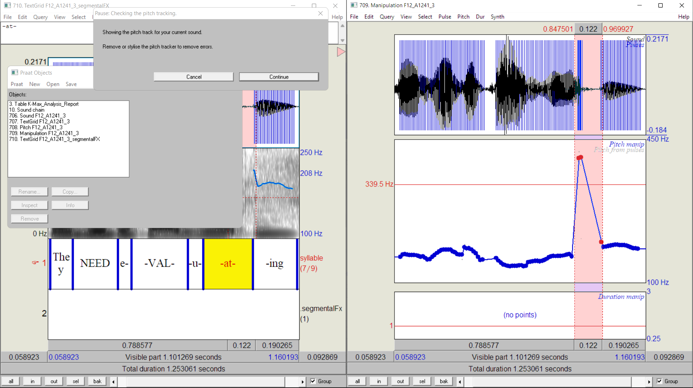

Figure . Screenshot of the fix_pitch script being used to correct errors in the f0 contour.

|  |
| --- |
|  |
| Figure . Example of corrected f0 contour (dark blue) after running fix_pitch script. The original contour is shown in light blue. |

After pitch correction, the onset (S) and offset (E) of voicing were annotated in the **tone** tier. L and H tonal targets were also marked in the tonetier according to the local minimum and maximum *f*0 in the appropriate portion of contour. In cases where there were several potential maxima or minima, a candidate in the most vowel-like portion of the syllable was chosen. For example, in Figure 5.3 above, there are two potential L targets in the RIV- syllable, one in the approximant /ɹ/ and on in the vowel /ɪ/. In this case, /ɪ/ was preferred, since the low in /ɹ/ may have been the result of a minor segmental effect.

A Praat script called process_texgrids[9] was used to tabulate the data across all the text grids for each Corpus. This data is used for the analytical experiments detailed in Parts II and III.

## Data Wrangling Methods for Visual Representation of Count Data

All the subcorpora contain missing data points, so there is a risk that tabulated raw phonological data would over- or under-represent specific speakers and target utterances. To avoid misrepresentation of the data, especially for visual analysis of trends, raw values have been adjusted to project a more balanced predicted distribution of counts per speaker and per stimulus. The adjustment accounts for the number of repetitions per speaker, the number of speakers per target, and, in some cases, the number of tokens per gender. The output from this process is a table projecting an ideal count of five utterances per speaker per target (and an equal number of male and female speakers).

The code for these procedures is embedded in the R code associated with the analysis for each chapter. It is available at [github.com/AERodgers/PhD](https://github.com/AERodgers/PhD) (see Appendix D). Do note, however, that the data adjustment process is used only to facilitate data visualisation but not for any of the inferential statistical analyses.

## Inferential Statistical: Linear Mixed-Effects Models

All inferential statistical analysis was conducted in R (R Core Team, 2022) using the packages outlined below alongside some purpose written functions. Microsoft Office Excel (Microsoft Corporation, 2020) was also used for some data visualisation and the calculation of means and standard deviations. All data, R Code, and Excel workbooks can be found in the GitHub repository in the data and analysis folders (see Appendix D and [github.com/AERodgers/PhD](https://github.com/AERodgers/PhD)). The summary which follows is largely a synthesis of Baayen (2008), Baayen *et al*. (2008), Bates et al.(2015), and Winter (2019).

Mixed-effects models have been used throughout the dissertation for inferential statistical analysis. These have several advantages over non-mixed-effects models, but there are two which are especially important here. First, they are good at coping with multiple repetitions of a target phrase, including cases where there are missing data points, as is the case here. Secondly—and closely connected to the first—they can, unlike ANOVAs for example, cope with multiple random factors. That is, mixed-effects models can compensate for variance caused by multiple random effects, and thus compensate for the amount of error or noise they add to the estimates.

A random factor represents a factor which is known to influence the result but is not of interest in the analysis. Most precisely, it represents a factor within the data set, the levels of which are taken from a sample of the whole population. For example, Chapter Six analyses the effects of anacrusis and foot size on the temporal alignment of tonal targets. Foot size and anacrusis are fixed effects with a limited number of levels, which are controlled experimentally. However, the data are taken from eleven speakers, who represent a random sampling of the population of Derry City English speakers, and each has their own idiosyncrasies. Thus, some speaker-specific variation will add noise to the model. By treating speaker as a random effect, we can reduce the effect of this noise. Sometimes, however, features which are typically random effects can be of interest and are thus included as fixed factors. Conversely, factors which are—by strict definition—fixed effects may be of little interest and can be included as random factors instead.

Mixed-effects models are not without their flaws, however. For the purposes here, two issues must be highlighted. The first is that they are prone to convergence errors, especially when the model is complex. A convergence error means that the algorithm for resolving the model has not achieved a stable solution for the model and that the estimates may not be reliable. The second problem with mixed-effects models is singularity. This refers to cases where the variance-covariance matrix is equal to zero or one (i.e., perfect correlation), suggesting that the model has been over-fitted. This means that the model is overly adapted to the current sample but is unlikely to be suited for generalising to the population, so similar results are unlikely to be found if the model is tested on another random sample from the population.

Two types of Mixed-effects model are used here, linear mixed-effects models (LMEMs) for continuous phonetic variables and Bayesian generalised linear mixed-effects models (BGLMMs) for categorical phonological data. Originally, Bayesian models were not to be used at all; however, they provided the best solution to another problem which came up during the analysis of categorical data (see 5.4.2 below) that does not occur in the continuous data.

### Analysing Continuous Parameters with Linear Mixed-effects Models

Linear Mixed-effects Models (LMEMs) were chosen to evaluate the continuous phonetic parameters, and the lme4 package (Bates et al., 2015) was used for this purpose. For each analysis, an ideal maximal model was identified which was believed to best describe the relationship between the independent variable(s), random factors, and the dependent (outcome) variable. If the effect of a specific factor was to be analysed, it was included as a fixed effect; however, if the factor was not to be analysed but was thought of influence the response parameters, it was included as a random factor. However, these ideal models were sometimes prone to convergence and singularity problems.

To mitigate against convergence and singularity issues, advice included in the lme4 package was followed, including lowering the tolerance threshold for singularity and using the allFit() function to check for alternative optimizers. Additional approaches suggested by Nugent (2022) were also implemented. A function, optimizeModel(), was written to automate this process and identify a set of model optimization parameters which avoid convergence and singularity issues[10].

If convergence errors or singularity issues remained, the model was simplified, and this was generally necessary. Each model was simplified in two stages. First, the step() function from the lmerTest package (Kuznetsova, 2017) was employed to help reduce model complexity. This works by automatically performing a series of tests using stepwise backward reduction of fixed and random effects from the original model. This helps identify simplify the model by removing non-significant effects from the original formula. However, sometimes, non-significant results are of interest (i.e., sometimes we want to check that a factor has very little effect), so they were not always removed from the model. (In fact, fixed factors were only removed as a last resort.) In cases where backward reduction of the model still led to convergence errors, models were retested via the stepwise by removal of random slopes followed by random intercepts to find the most complete model which did not generate convergence or singularity errors. Typically, this ended up being a random-intercepts-only optimal working model.

Once the final model was established, the residuals of the model were examined visually using a histogram of residuals, Q-Q plots of residuals, and a residual plot (see Figure 5.6 below). In cases where the histogram was skewed or leptokurtic (i.e., spikey), the Q-Q plot indicated extreme outliers, or the residual plot indicated heteroskedasticity (i.e., the distribution of residuals changes along the plot), the dataset was trimmed of outliers. This was done following Baayen (2008, pp. 279–282), by removing observations with residuals beyond a standard deviation threshold. The standard deviation threshold was set for each individual model to minimize the number of observations trimmed while producing a more reasonable distribution of residuals. An example of visual residual analysis is shown in Figure 5.6, with panel a. indicating the model residuals before trimming and the panel b. showing the residuals after trimming observations using a standard deviation threshold of 2.5 (though do note, in the second plot, heteroskedasticity has not been completely removed). The process of determining the most informative model for each parameter is documented in the HTML output of the markdown scripts used for analysis in each chapter. These can be found in the GitHub repository (see Appendix D), while the models themselves are discussed in the results sections of each relevant chapter.

To further check each model, an ANOVA was conducted to test the statistical significance of each fixed effect in each model.

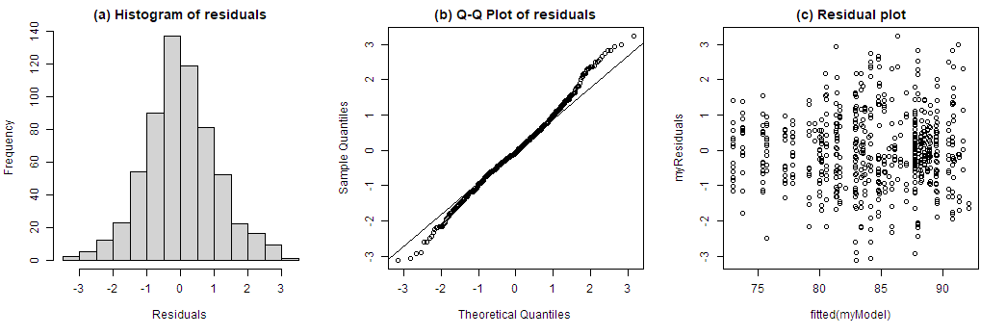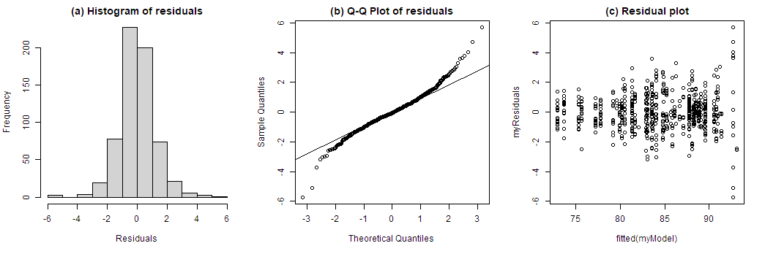

**B**

**A**

Figure . Residuals of the model l_f0 ~ mode + fin_phon + gender + (1 + mode | speaker). Panel A shows the models without trimming, where outliers can clearly be seen to create a leptokurtic histogram (i.e., one with a very narrow spike at peak distribution density), and the Q-Q plot shows large deviation from the expected correlation between sample and theoretical quartiles (i.e., the individual dots stray from the diagonal line at the edges). Panel B. shows the model residual plots after removing observations with residuals greater than 3 standard deviations in the original model, with a loss of 9 out of 632 observations.

### BGLMMs and the Analysis of Discrete Categories

As with all generalised linear models, generalised linear mixed-effects models (GLMs) use logistic regression analysis. That is, they estimate the odds ratio of a binary outcome as a function of the predictor variable or variables. As mixed-effects models, however, they incorporate both fixed effects (predictor variables) and random effects (known variables which contribute to the error in the model).

For simplicity and consistency, the original plan was to use generalised linear mixed-effects (GLMM) models from the lme4 package to evaluate categorical phonological data; however, this was not possible because of a problem called complete separation. This occurs when one or more levels of a predictor variable perfectly predicts the outcome. For example, in one analysis of sentence modes (see Chapter 7), declarative statements are never associated with an H% boundary, so in a binomial analysis, the odds of H% in a declarative statement is 0:1 against. While the probability of H% in a declarative statement is in fact zero, the model generates log-odds Confidence Intervals (CIs) tending towards plus and minus infinity, giving the erroneous impression that the likelihood of H% cannot be predicted.

This issue was resolved by using Bayesian generalised mixed-effects models (BGLMMs), using the package bglme (Chung & Rabe-Hesketh, 2013). This package is based on lme4, which makes the switch from one to the other easy, as both use the same syntax for the modelling. The BGLMM allows the user to impose priors on the model. These are in essence expectations based on prior experience and knowledge. As we know that the confidence intervals of the model is not zero or infinity, we can impose zero-mean normal priors on the model (Bolker, 2018), i.e., inform the model the priors expect a model with a normal distribution around the mean. This prevents extreme odds and CI estimation, and thus mitigates against the problem of infinitely wide CIs which are output by GLMMs in cases of complete separation.

As with the LMEMs, a maximal model with random slopes and intercepts was tested first, but this was reduced to a random-intercepts-only model if it generated convergence or singularity issues. The final model was always the most informative model which did not generate errors or warnings. Because the anova() function does not work on (B)GLMs, significance tests for fixed factors were tested using R’s in-built drop1() function with a Chi-Squared (χ2) test, as suggested in lme4’s R documentation. This function drops each fixed effect from the model one at a time, compares the reduced model against the full model in a Likelihood Ratio Test (LRT), and so summarises the differences in fit between the two models. Thus, it evaluates the effect of each fixed factor in the full model by comparing the full model to a reduced model from which the factor has been removed.

### Procedures Used in Both LMEM and BGLMM Analysis

Once the most informative working model was established for either the LMEM or BGLMM analysis and outliers has been removed, the purpose-written functions analyseModel() and getModelFixedFX() were used to perform a set of shared processes.[11]

analyseModel() produces tidy summaries of the models and a series of visuals to help analyse the results. In the case of BGLMMs, this includes predicted probabilities of for each level of the independent factors. It also calculates marginal and conditional *R*-squared (*R*2) values for each model using the r2() function from the performance package (Lüdecke et al., 2021; Nakagawa et al., 2017; Nakagawa & Schielzeth, 2013). Marginal *R*2 () indicates the amount of variance explained by the fixed effects only, while conditional *R*2 () reflects the amount of variance explained by the whole model, i.e., it includes both random and fixed effects. Thus, for example, a marginal *R*2 of 0.05 indicates that 5% of the variance in the target variable can be explained by fixed effects, while a conditional *R*2 of 0.95 indicates that 95% of the variance is explained by the whole model.

getModelFixedFX()calculates the intercepts (*b*0) for each level of the categorical fixed factor(s) in the model along with slopes (*b*1) between each level. This facilitates the pairwise comparison of effects across all levels of a fixed factor. For example, we are able to compare the estimated difference in nuclear peak alignment between a declarative statement and a declarative question, or between a declarative question and a yes-no question, or between a yes-no question and a declarative question.

Finally, after all analyses are complete for a specific topic (e.g., lexical and metrical effects on prenuclear tonal targets), *post hoc* adjustment of the *p* values of ANOVAs for that set of analyses is conducted to account for the increased likelihood of false positives. This is because, as more and more statistical tests are conducted, the likelihood of getting a spurious false positive result—or Type I error—increases (Field et al., 2012, pp. 428–432; Roettger, 2019; Winter, 2019, pp. 175–177). Therefore, a mechanism to compensate against is required. The Benjamini and Hochberg (BH) method was used for this, since it minimize the number of Type I errors while also mitigating against Type II errors (false negatives) by controlling the false discovery rate (FDR) (Benjamini & Hochberg, 1995). This was implemented via a purpose-written function adjustP_posthoc() which pools together results from connected analyses and adjusts the *p* values using the base R function p.adjust(). For example, it generates a list of every *p* value generated in the pairwise analysis of categorical phonological features of sentence mode and adjusts them accordingly. Both original and adjusted *p* values are included in the results of the statistical tests. These can be found in HTML output for each chapter the GitHub repository (see Appendix D) and in the Appendices, beginning from Appendix G. However, only the adjusted values are reported in the body of the thesis.

# Analysis of Form: Metrical and Lexical Effects

This chapter focuses on the effects of meter and lexical boundaries on the phonology and phonetic implementation of the tonal tier in declarative statements in Derry City English (DCE). In other words, the first broad aim is to answer the descriptive question regarding form raised in RQ1 (4.1.1, p. 39). It is important to answer the question of form first because it will establish a baseline before moving on to questions of function. That is, it will help identify the extent to which metrical structure and word boundaries influence the pitch accent inventory and how each affects the phonetic parameters associated with the realisation of pitch accents. Armed with this knowledge, it will be easier to isolate phonological and phonetic components associated with function and to avoid misinterpreting formal effects as functional ones. The second broad and more theoretically oriented aim of this chapter is to answer RQ3, “Is there evidence in the realisation of PN pitch accents in DCE for the special status of H tones?”

## Hypotheses and Expectations

It is clear from previous research (see Sections 3.3.1 and 3.4.1 above) that nuclear pitch accent inventories are often more limited when compared to PN inventories. It is plausible that the larger PN inventory and narrower nuclear pitch accent inventory may be explained by differences in communicative pressure. That is, the nuclear pitch accent tends to carry most of the communicative function, so the speaker has a greater need to realise it more precisely for effective communication. This pressure, however, is absent from the prenuclear pitch accent, so it is potentially more prone to non-linguistically motivated variation. Variation in pitch accents thus may have at least two competing sources:

1. Communicative intent
2. Metrical and lexical structure

If variation is motivated by communicative intent, we should expect to see little correlation between the intonational phonology, anacrusis, and foot size; however, if variation is conditioned by the metrical or lexical structure, we expect to see pitch accents vary as a function of anacrusis, foot size, and word boundaries. There is a third source of non-linguistic variation, that of speech rate. However, speech rate may also be associated with communicative intent, as speakers may increase or decrease speech rate depending on the extent to which they want to listener to attend to different components of the speech stream.

Broadly, it is hypothesized that communicative intent will determine the inventory of nuclear pitch accents, which will be almost exclusively L*H, but that this will not be the case for prenuclear pitch accents, where there is less communicative pressure. It is proposed that in PN pitch accents, less anacrusis and shorter foot size will be associated with increased occurrences of H*, while L*H will be more common once anacrusis and foot size increase. Overall, however, L*H is expected to dominate both in prenuclear and nuclear pitch accents. Thus, in answering the phonological component of RQ1, we have the following hypotheses:

1. L*H is the dominant pitch accent in nuclear and prenuclear position
2. Variation in metrical context has no effect on the inventory of nuclear pitch accents
3. Variation in metrical context has a strong effect on the (surface) phonology of prenuclear pitch accents. Specifically, given hypothesis (1), increases in foot size and anacrusis will be associated with an increase in instances of L*H.

Note in (3) the reference to *(surface) phonology*. This is because, if prenuclear pitch accent types are found to vary as a function of metrical and lexical conditions, it follows that the labelled inventory of pitch accents reflects variation in a *surface* realisation of an underlying L*H pitch accent. This would be analogous to the way that segmental allophones are variant realisations of underlying phonemes. i.e., just as /t/ is realised as [tʰ] in <time> [tʰaɪm] but as [ɾ] in <butter> [bʌɾɚ] and [t=] in <stay> [st=eɪ], we might—for example—see that /L*H/ is realised as [H*] when there is little metrical content, but as [L*H] when there is sufficient material to permit its realisation.

Looking at previous research on tonal alignment in nIE, as discussed in 3.3.2, one can expect metrical and lexical context to condition the timing of PN tonal targets. An early analysis of temporal alignment of PN accents from six speakers—presented at BAAP 2018 (Rodgers, 2018, Appendix C)—indicated that this was the case for the DCE data too. Moreover, it suggested two strategies for H alignment. In one, the right boundary of the lexically stressed word acts as an anchor while in the other the foot boundary acts as the anchor. Thus, in the analysis of the full dataset, we expect H targets to be aligned later when the foot contains more syllables or when the right word boundary occurs in a later syllable. As a corollary of this, it is also possible that there is an effect of the right word boundary on the distribution of PN pitch accents. That is, given that it is hypothesized that a longer foot is associated with an increase in L*H pitch accents, it is possible that a later word boundary is should also be associated with an increase in L*H. Therefore, a fourth provisional prediction re the phonology might be added:

1. The later in the foot the initial word boundary occurs, the greater the likelihood of a prenuclear L*H pitch accent.

When it comes to anacrusis effects on PNs, it is much less clear what the effects will be. For example, a study by Nolan and Farrar (1999) found that the addition of anacrusis was associated with earlier peaks in Belfast English. However, a study of Donegal English by Kalaldeh, Dorn, and Ní Chasaide (Kalaldeh et al., 2009) found the opposite, i.e., that anacrusis effects correlate positively with peak alignment in PN pitch accents.

In nuclear PAs, it is expected that H targets will align later as foot size increases, while it is presumed that an increase in prenuclear unstressed syllables will have little effect on H target timing. It is expected that L targets will be relatively stable across conditions, but there is a possibility that tonal crowding may influence alignment. That is, since there is increased communicative weight associated with nuclear pitch accents, it is in the speaker’s interest to realise all tonal targets associated with the nuclear pitch accent clearly. As such, the speaker may crowd the tones into a shorter time period, regardless of foot size, realigning tonal targets where necessary. Furthermore, if there is a specified L% boundary, crowding effect should also be observed, with H targets in L*H being aligned earlier. (Remember that, taken together, the nuclear pitch accent and boundary tone are viewed as the nuclear contour.) In other words, it is assumed that communicative pressure will be associated with compression effects, and that these will manifest most clearly in shorter feet and in L*H L% contours. However, there may also be truncation effects, or a combination of the two, similar to those which Sullivan found in her analysis of Belfast English (2010). For PN pitch accents, however, it is unclear if, or how, truncation and compression will manifest.

To answer the phonetic component of RQ1, therefore, we have five interconnected hypotheses:

1. Tonal alignment in PN accents will be more vulnerable to metrical and lexical effects compared to tonal alignment in nuclear pitch accents.
2. Anacrusis will affect the alignment of PN H targets; however, the direction of this effect is not predictable in advance.
3. There are competing strategies for H target anchoring in PN pitch accents, one using the right lexical boundary, the other using the right foot boundary as an anchor point.
4. Compression effects in the guise of tonal crowding will be observed in nuclear pitch accents. This will be an effect of reduced foot size.
5. Truncation effects may be observed in nuclear pitch accents.

## Materials

The A and H subcorpora are used for analysis in this chapter. The A-Corpus was designed primarily to investigate metrical effects on the inventory of nuclear and prenuclear pitch accents and on alignment of tonal targets, while the H-Corpus was designed to compare the alignment of H targets in PN pitch accents under variation in lexical boundaries.

Each target phrase in the A-Corpus contains two lexically stressed syllables, the first of which may be associated with a prenuclear pitch accent, and the second with the nuclear pitch accent. The A-Corpus contains 11 stimuli, and they are used to assess metrical effects across four variables:

1. Anacrusis, from zero to three syllables.
2. Size of the foot associated with the prenuclear pitch accent (PN foot size), from one to four syllables.
3. Unstressed syllables in the foot preceding the stressed syllable associated with the nuclear pitch accent (labelled “preceding” in the table).
4. Size of the foot associated with the nuclear pitch accent (NUC foot size), from one to four syllables.

Target utterances for the A-Corpus are listed in Table 6.1. The underlined section of the target utterance indicates the portion of the utterance under analysis. Note that some utterances, such as A0221, are used to analyse several variables.

Table . A-corpus stimuli and parameter conditions. Note that “preceding” refers to the number of unstressed syllables preceding the stressed syllable in the second foot.

|  |  |  |  |  |  |
| --- | --- | --- | --- | --- | --- |
| Code | Target utterance | Pitch Accent | Variable | Syll. count | Meter |
| A0423 | **Val**erie's is valid. | PN | Anacrusis | 0 | *... *. |
| A1422 | The **vall**ey's by the river. | PN | Anacrusis | 1 | .*... *. |
| A2422 | There's a **vall**ey with a river. | PN | Anacrusis | 2 | ..*... *. |
| A3422 | There was a **vall**ey with a river. | PN | Anacrusis | 3 | ...*... *. |
| A0131 | **Val's** valuables. | PN | Foot size | 1 | * *.. |
| A0221 | **Val's** is valid. | PN | Foot size | 2 | *. *. |
| A0321 | **Val's** is invalid. | PN | Foot size | 3 | *.. *. |
| A0423 | **Val**erie's is valid. | PN | Foot size | 4 | *... *. |
| A1111 | They know **Val**. | NUC | Preceding | 0 | .* * |
| A0221 | Val's is **val**id. | NUC | Preceding | 1 | *. *. |
| A0321 | Val's is in**val**id. | NUC | Preceding | 2 | *.. *. |
| A0423 | Valerie's is **val**id. | NUC | Preceding | 3 | *... *. |
| A1211 | He lives with **Val**. | NUC | Foot size | 1 | .*. * |
| A0221 | Val's is **val**id. | NUC | Foot size | 2 | *. *. |
| A1231 | I live with **Val**erie. | NUC | Foot size | 3 | .*. *.. |
| A1241 | They need e**val**uating. | NUC | Foot size | 4 | .*. *... |
|  |  |  |  |  |  |

Table . H-corpus stimuli and parameter conditions. The vertical bar in ‘meter and lexical boundary’ indicates the final boundary of the stressed word in the first foot.

|  |  |  |  |  |  |  |  |
| --- | --- | --- | --- | --- | --- | --- | --- |
| Pairing | Code | Target Utterance | Anacrusis (syllables) | PN Foot Size | PN word-end syllable | | Meter and lexical boundary |
| 1 | A0321 | Val's is invalid. | 0 | 3 | 1 | *|. . * . | |
| H0322 | Lally's is valid. | 0 | 3 | 2 | * .|. * . | |
| 2 | H0422 | Lally's is invalid. | 0 | 4 | 2 | * .|. . * . | |
| A0423 | Valerie's is valid. | 0 | 4 | 3 | * .|. . * . | |
| 3 | H1321 | Elaine was a nanny. | 1 | 3 | 1 | . *|. . * . | |
| H1322 | Elaina's a nanny. | 1 | 3 | 2 | . *|. . * . | |

The H-Corpus was designed to test if changes in the location of the word boundary within the foot affected the temporal alignment of the H target in PN pitch accents. As can be seen in Table 6.2, there are three pairs of phrases in the H corpus, with a different configuration of anacrusis and foot size parameters for each pair. Within each pair, however, the variable of interest—i.e., the lexically stressed PN word boundary—changes. Such variation within and across pairs will help assess the extent to which variation in H alignment is influenced by word boundary effects.

### Annotation and Data Extraction

The utterances were annotated as outlined in 5.2 with IViE labelling conventions used for the phonological labelling (Grabe, 2001). Most of the annotation was routine, but the phonological labelling, particularly of prenuclear pitch accents proved more difficult, and adjustments to the IViE labelling were made to reflect this. These adjustments are discussed below in 6.4.

### Data Extraction, Pruning, and Preparation

Once annotation was complete and the phonology had been agreed upon, data from the A and H corpora were tabulated according to the processes outlined in 5.2. Ineligible utterances were automatically pruned using a Praat script corpus_audit, [REFS]. These included utterances where speakers added special stress to a typically unstressed syllable or where they deleted a target syllable. 45 utterances were removed in this way, so the total number of valid utterances fell from 833 to 788.

Table .. Summary of valid A and H corpora utterances by target utterance, dataset and speaker. Pink and red indicate utterances with less than five tokens each. Green indicates targets with six valid tokens.

|  |  |  |  |  |  |  |  |  |  |  |  |  |  |  |  |  |
| --- | --- | --- | --- | --- | --- | --- | --- | --- | --- | --- | --- | --- | --- | --- | --- | --- |
| Speaker / dataset | A0131 | A0221 | A0321 | A0423 | A1111 | A1211 | A1231 | A1241 | A1422 | A2422 | A3422 | H0322 | H0422 | H1321 | H1322 | TOTAL |
| pn_ana |  |  |  | ü |  |  |  |  | ü | ü | ü |  |  |  |  | 209 |
| pn_foot | ü | ü | ü | ü |  |  |  |  |  |  |  |  |  |  |  | 203 |
| nuc_pre |  | ü | ü | ü | ü |  |  |  |  |  |  |  |  |  |  | 202 |
| nuc_foot |  | ü |  |  |  | ü | ü | ü |  |  |  |  |  |  |  | 196 |
| pn_lex |  |  | ü | ü |  |  |  |  |  |  |  | ü | ü | ü | ü | 316 |
| F5 | 5 | 5 | 5 | 5 | 4 | 5 | 5 | 5 | 5 | 5 | 5 | 5 | 6 | 5 | 5 | 75 |
| F6 | 5 | 5 | 5 | 5 | 5 | 5 | 5 | 5 | 5 | 5 | 5 | 5 | 5 | 5 | 5 | 75 |
| F12 | 5 | 5 | 5 | 3 | 5 | 5 | 5 | 5 | 5 | 5 | 5 | 5 | 5 | 5 | 5 | 73 |
| F15 | 5 | 5 | 5 | 5 | 5 | 5 | 0 | 5 | 6 | 5 | 5 | 5 | 5 | 6 | 6 | 73 |
| F16 | 5 | 5 | 5 | 5 | 5 | 5 | 5 | 5 | 5 | 5 | 5 | 5 | 5 | 5 | 5 | 75 |
| F17 | 5 | 5 | 5 | 2 | 5 | 5 | 1 | 5 | 5 | 5 | 5 | 5 | 5 | 5 | 5 | 68 |
| M4 | 5 | 5 | 5 | 1 | 5 | 5 | 5 | 5 | 5 | 5 | 5 | 5 | 5 | 5 | 5 | 71 |
| M5 | 5 | 5 | 5 | 5 | 5 | 5 | 3 | 5 | 5 | 5 | 5 | 5 | 5 | 5 | 5 | 73 |
| M8 | 5 | 5 | 5 | 3 | 5 | 1 | 0 | 5 | 5 | 5 | 5 | 5 | 5 | 5 | 5 | 64 |
| M9 | 5 | 5 | 5 | 0 | 5 | 5 | 1 | 5 | 5 | 5 | 5 | 5 | 5 | 5 | 5 | 66 |
| M10 | 5 | 5 | 5 | 4 | 5 | 5 | 5 | 5 | 5 | 6 | 5 | 5 | 5 | 5 | 5 | 75 |
| tot. | 55 | 55 | 55 | 38 | 54 | 51 | 35 | 55 | 56 | 56 | 55 | 55 | 56 | 56 | 56 | 788 |
|  |  |  |  |  |  |  |  |  |  |  |  |  |  |  |  |  |

Table 6.3 summarises the final distribution of valid utterances by stimulus and speaker. As can be seen from the cells highlighted in pink and red, A0423 (*Valerie’s is valid)* and A1231 (*I live with Valerie*) have the greatest data loss, with 38 and 35 total utterances respectively as opposed to the target 55. With the exception of speakers F16 and F6, there was also some data loss for each speaker.

The A and H corpora were split into five datasets, to facilitate the analysis of metrical and lexical effects on the phonology and phonetic implementation of tonal targets. These were labelled as shown in Table 6.4. Table 6.3 also indicated to which subset or subsets each target phrase belongs.

Table . List of datasets used for the analysis of lexical and metrical effects on pitch accent phonology and phonetic implementation of tonal targets. The abbreviation on the left of the underscore refers to the target pitch accent and the abbreviation to the right refers to the treatment variable.

|  |  |  |  |
| --- | --- | --- | --- |
| Data | Target pitch event | Treatment variable(s) | Function |
| nuc_foot | Nuclear pitch contour | Foot size (syllable count) | Analysis of foot size effects on nuclear pitch accents and pitch contours |
| nuc_pre | Nuclear pitch contour | Unstressed syllables preceding the stressed syllable | Analysis of effects of unstressed syllables preceding nuclear pitch accents and pitch contours |
| pn_foot | Prenuclear pitch accent | Foot size (syllable count) | Analysis of foot size effects on prenuclear nuclear pitch accents |
| pn_ana | Prenuclear pitch accent | Anacrusis (syllable count) | Analysis of anacrusis effects on prenuclear nuclear pitch accents |
| pn_lex | Prenuclear pitch accent | Anacrusis, foot size, location of word-end syllable | Analysis of word boundaries effects on prenuclear pitch accents |
|  |  |  |  |

## Methods

Using the methods outlined in 5.3, the phonological data was tabulated to provide an overview both of inter-speaker trends of the distribution of pitch accents and pitchcontours as a function of foot size and anacrusis. To remove excessive noise in the PN data, downstep was ignored, especially since this was a reflex of an initial high boundary tone, and not a unique PN pitch accent.

To assist in the assessment of word-boundary effects—especially regarding the possibility of competing alignment strategies mentioned in hypothesis 7—peak alignment of PNs was calculated as a function of syllable-normalised time and grand syllable-mean normalised time.

Syllable-normalised time converts time measured in milliseconds to time measured in syllables. Here, each syllable counts as one unit and each time point is measured as a ratio of the syllable in which it occurs. As such, for example, a target which occurs in the middle of the first syllable has a syllable-normalised time of 0.5, while a target that occurs three-quarters of the way into the third syllable has a syllable-normalised time of 2.75. This allows tonal alignment in different target phrases to be evaluated in the same figure.

Grand syllable-mean normalised time uses the grand mean duration of each syllable in identical target utterances to convert syllable-normalised time back into milliseconds. This allows comparison of multiple repetitions of the same target to be compared in the same figure. It also provides an accurate representation of the true duration of syllables. Each process is described more fully in Appendix F.

For the inferential statistical analysis of the phonological data, Bayesian generalised linear mixed-effects models (BGLMMs) were employed while linear mixed-effects models (LMEMs) were used for the analysis of phonetic parameters (see 5.4). As with every analysis, *f*0 is measured in semitones re speaker median *f*0.

The complete A- and H-Corpora data were used for mixed-effects models analysis. There were two reasons for this. Firstly, mixed-effects models can cope with datasets where all levels of independent factors are not equally represented (see Section 5.4 on LMEMs), thus allowing the use of much more data in the analyses (see Table 6.6). However, for the current analysis, this also required that extra random effects be included to account for greater segmental variation in the data. Secondly, it allowed for the assessment of a lexical effect which had initially been overlooked, namely the effect of the left word boundary. Further details on the pruning of data and selection of parameters for modelling (including extra random effects) is presented in each results section below.

Table . Comparison of PN observations available for analysis in A- and H-Corpora and subcorpora.

|  |  |  |  |  |  |  |  |  |  |  |
| --- | --- | --- | --- | --- | --- | --- | --- | --- | --- | --- |
| corpus / subcorpus | | L target analysis | | H target analysis | right word- boundary effects | | f0 excursion and slope | total | | |
| **pn_ana** | | 180 | | 205 | N/A | | 180 | 205 | | |
| **pn_foot** | | 124 | | 174 | N/A | | 117 | 203 | | |
| **pn_lex** | | N/A | | N/A | 202 | | N/A | 260 | | |
| **A- and H-Corpora** | | 498 | | 737 | 489 | | 489 | 788 | | |
|  |  | |  | | |  |  | |  |

Table . Comparison of nuclear PA observations available for analysis in A- and H-Corpora and subcorpora.

|  |  |  |  |
| --- | --- | --- | --- |
| corpus / subcorpus | | observations for analysis | |
| **nuc_pre** | | 202 | |
| **nuc_foot** | | 196 | |
| **A- and H-Corpora** | | 788 | |
|  |  | |

## Phonological Labelling

For the nuclear contours, labelling was very straightforward; however, prenuclear pitch accents presented more of a challenge. This was mostly due to the loss of a clear L target in some pitch accents. To help illustrate this, Table 6.7 presents Stylisations of PN contours. It begins with the most easily identifiable PAs at the top and moves down to the more challenging ones towards the bottom.

Table .. Stylised representation of contours typically found in PN position.

|  |  |  |  |
| --- | --- | --- | --- |
|  | **Stylisation** | **Comment** | **Label** |
| a. |  | Phonetically low initial boundary rising to a peak in or near the end of the lexically stressed syllable. Auditorily salient peak prominence in the stressed syllable. | **%L H\*** |
| b. |  | Phonetically mid-range initial boundary rising to a peak in or near the end of the lexically stressed syllable. Auditorily salient peak prominence in the stressed syllable. | **% H\*** |
| c. |  | Phonetically high boundary, leading to a small peak or plateau-like prominence in the stressed syllable before falling slightly | **%H H\*** |
| d. |  | Phonetically low or mid-range initial boundary with a clearly identifiable L*H. | **% L*H** |
| e. |  |
| f. |  | Low or mid-range initial boundary. L target is not as clearly defined as in X and Y; however, it is easily perceived as an L*H |
| g. |  | Mid-range initial boundary rising to a peak somewhere after the stressed syllable. Sounds somewhat intermediate between H* and L*H. However, there is no visually or auditorily salient L target. | **%(H) >H\*** |
| h. |  | High initial boundary rising to a peak somewhere after the stressed syllable. Sounds somewhat intermediate in between H* and L*H. However, there is no visually or auditorily salient L target. |
|  |  |  |  |

As shown in panels a to c, H* was visually and auditorily salient in many cases. If there was a noticeable rise from an initial low boundary to the peak (Table 6.7a), the boundary of these PN H*s was labelled as %L. These were labelled as such because, during the annotation, it seemed that in some cases the L of an L*H may have become re-associated with the boundary rather than the stressed syllable. However, they did not appear to give rise to the percept of an L*H pitch accent, nor did they seem to indicate a change in intonation function. In other cases of H*, there was a plateau-like *f*0 stretch from the boundary towards a peak prominence in the stressed syllable (panel c). These were labelled as %H H* to reflect the plateau structure.

L*H PN pitch accents were often auditorily salient (panels d to f), despite some variation in excursion size and the height of the L target. For example, sometimes the L target was visually less prominent (panel f) but was nonetheless perceived as an L*H, both by the author and by MOR, the intonation specialist who was consulted on the phonological analyses. The initial boundaries for L*H tended to have a phonetically low or mid-range *f*0 and added no auditorily salient effects to the pitch contour, so these were labelled as unspecified (%).

In a few marginal cases, there was a rise from an initial mid-range *f*0 to a peak, which was audibly and visually later than the peak of the typical H* pitch accent but not necessarily as late as the peaks in the L*H pitch accents. This is illustrated in panel g. In other cases—as illustrated in panel h—there was a phonetically high initial *f*0 followed by a plateau which ended after the stressed syllable. In neither case was there an auditory percept of a low target, and, in fact, there was typically no visual clue to the presence of an L target either, unlike in the L*H PAs described. Overall, these contours sounded neither quite like L*H nor like the typical H*. They were labelled as >H* to reflect the salient high quality, their later peak alignment, and the lack of any auditory or visual cue to an accompanying L target.

## Phonological Analysis and Results

The phonology of nuclear pitch accents is largely uninteresting and will be considered first before moving on to prenuclear pitch accents, which are more varied and offer more challenging data for analysis.

### Phonology of Nuclear Pitch Contours

The distribution of nuclear pitch contours as a function of foot size (foot_syls) and preceding unstressed syllables (pre_syls) are summarised in Table 6.8 while per-speaker summaries are presented in Table 6.9 (next page). The tables present adjusted values only (see Chapter 5, Section 5.3), while raw counts can be found in Appendix E (Table E1.4–Table E1.6).

Table 6.8 shows that L*H was used exclusively as the nuclear pitch accent for all speakers across all conditions. This confirms L*H as the dominant pitch accent. It also confirms that variation in metrical context has no effect on the inventory of nuclear pitch accents. The table also shows that there were both L% and unspecified boundary tones. However, L% accounts for only 4.3% of the adjusted data (4.3% of raw data, *n* = 12/343). Previous AM studies of nIE (c.f. 3.3.1) also found L*H L% contours in declaratives, so its presence is not unexpected. L% does not appear to be an effect of foot_syls or pre_syls, as there is no pattern associated with either factor, as evidenced by the distributions shown in the final column of each panel in Table 6.8. In fact, Table 6.9 reveals that the majority of L% boundaries come from a single speaker (F12), accounting for 30% of her utterances, while the remaining few (*n* = 4/343, *n*.*adj*. = 5/385) come from only two other speakers, M8 and M9.

Table . Nuclear contours by foot size (adjusted) in the A-Corpus subsets.

|  |  |
| --- | --- |
| A. Distribution of pitch contours in nuc_foot. | B. Distribution of pitch contours in nuc_pre. |

Table . Nuclear contours by speaker (adjusted) in the nuc_foot and nuc_pre datasets.

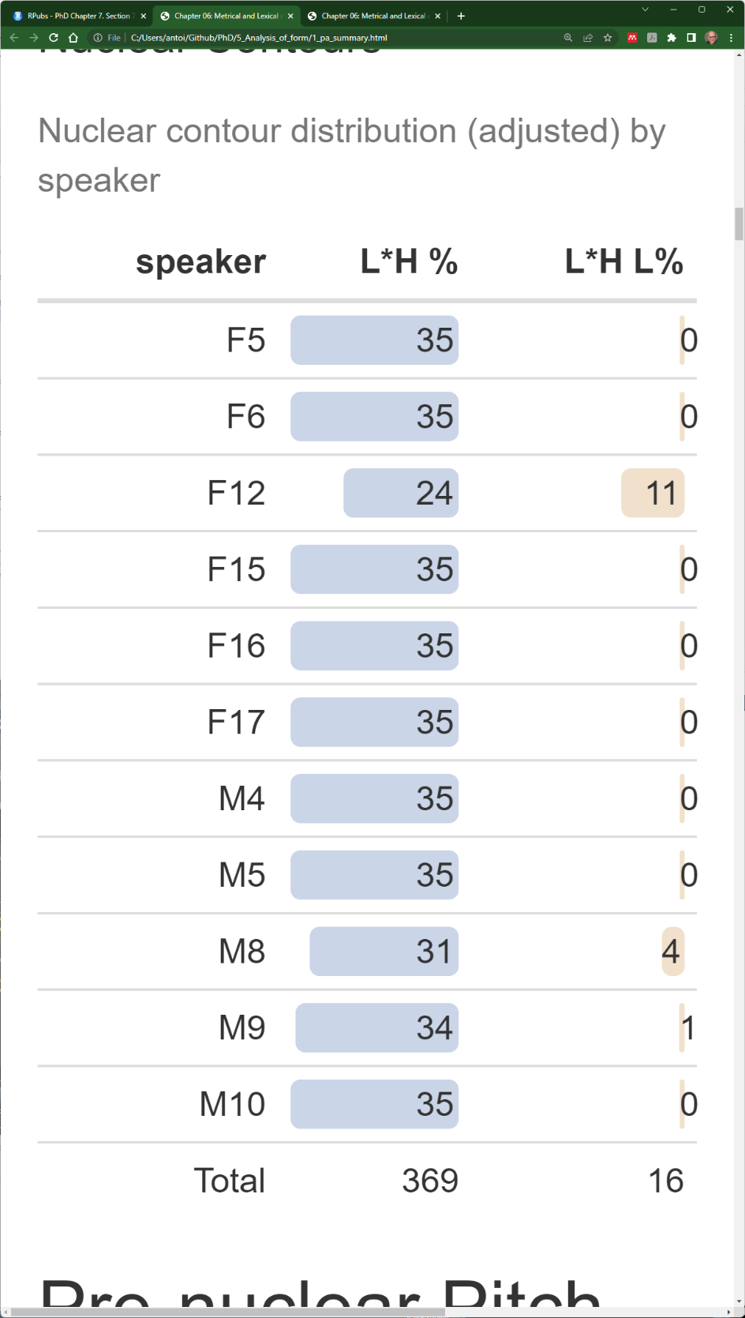

L% may convey a meaning based on the speaker’s interpretation of the stimuli or simply reflect idiosyncratic speaker preference. However, based on my own impression of the L*H L% contour—as well as on intuitions elicited from DCE speakers and people familiar with DCE—it seems to serve a different communicative function from L*H %. Namely, it gives the impression that the speaker is clarifying something they believe the listener should already know, as if they were implying the idea, “…and I thought you already knew that.” More technically, the speaker appears to be signalling to the listener that the propositional content is already given rather than new.

L*H L% sounds similar in form to the rising-falling nuclear contour (tone C) described in McElholm’s (1986) two-speaker study of DCE. However, McElholm states that the fall in tone C may only be slight, which makes it more akin to L*H % than L*H L%. Formally, it is somewhat similar to the extra-high rise-fall (tone D), which he describes as having a steep fall which returns to a low pitch. Of course, the difference here is that L*H L% is not extra-high. Functionally, L*H L% is also closer to tone D, which McElholm suggests indicates surprise or assertion. However, as the main aim of this analysis is to establish the effects of metrical and lexical effects rather than establish the function of different nuclear contours, it is sufficient to note that the occurrence of L*H L% appears to be a matter of function rather than form. (For more on this, however, see Section 6.7.3 later in this chapter and the discussion of L% in Chapter 7, Section 7.7.1)

### Foot-size and Anacrusis Effects on Prenuclear Pitch Accent Phonology

The distribution of prenuclear pitch accents as a function of foot size (foot_syls) and anacrusis (ana_syls) are shown in the left- and right-hand panels of Table 6.10 respectively. Again, only adjusted counts are shows, while the raw data is available in Appendix E (Table E1.1–Table E1.3).

The most noticeable feature of the distribution of PN pitch accent types is simply that there are more of them, namely L*, H*, >H*, and L*H. There are also with several cases of non-accentuation, represented by (*). This is in sharp contrast to the nuclear pitch accents, which were exclusively L*H. While five PA types—including unaccented cases—are found in the pn_foot data, only three occur in the pn_ana data, namely H*, >H*, and L*H. The larger inventory of prenuclear pitch accents is the first hint to the validity of hypothesis 3, that variation in metrical context has a strong effect on the (surface) phonology of prenuclear pitch accents.

Table . Prenuclear pitch accents by foot size and anacrusis in the A-Corpus subsets (adjusted count).

|  |  |
| --- | --- |
| A. Distribution of pitch accents in pn_foot. | B. Distribution of pitch accents in pn_ana. |
|  |  |

A second striking feature in the pn_foot data is that, as foot size increases, there is an overall proportional increase in occurrences of L*H while instances of non-accentuation and L* decrease. This can be seen clearly in Figure 6.1, which shows the adjusted PA distributions across PNs across foot-size conditions, where we see non-accentuation and L* occurrences drop off sharply while L*H becomes more dominant as foot size increases. This lend more support to hypothesis 3, as it does appear that increased foot size is associated with increased occurrence of L*H.

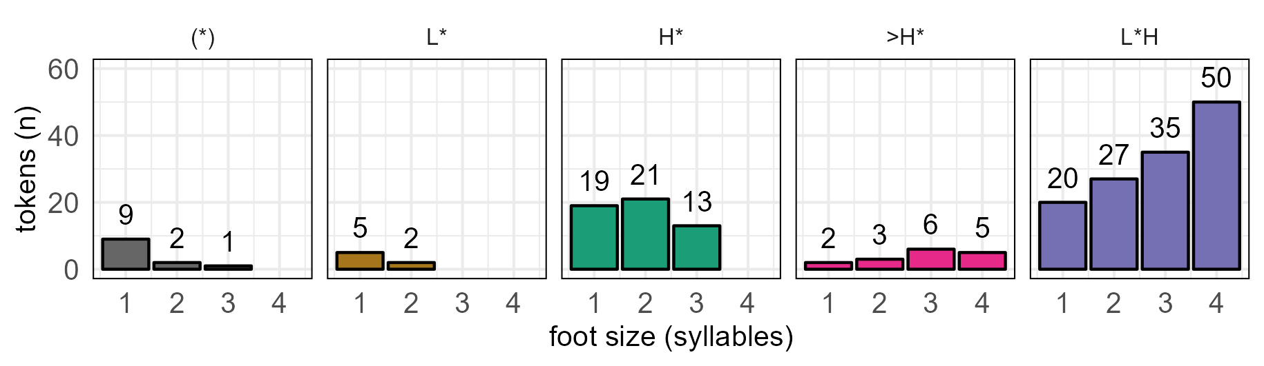

Figure . PNs across foot-size conditions (adjusted)

This trend is not mirrored in the pn_ana data, where L*H dominates throughout. This is reflected in Figure 6.2, which shows the adjusted distributions of PA tokens across anacrusis conditions. It should, however, be noted that all target phrases in the pn_ana data contain an initial four-syllable foot. This suggests that, once foot-size conditions are sufficient, anacrusis has little effect on the phonology. Unfortunately, the extent of the foot size effect had not been anticipated and was not incorporated into the corpus design.

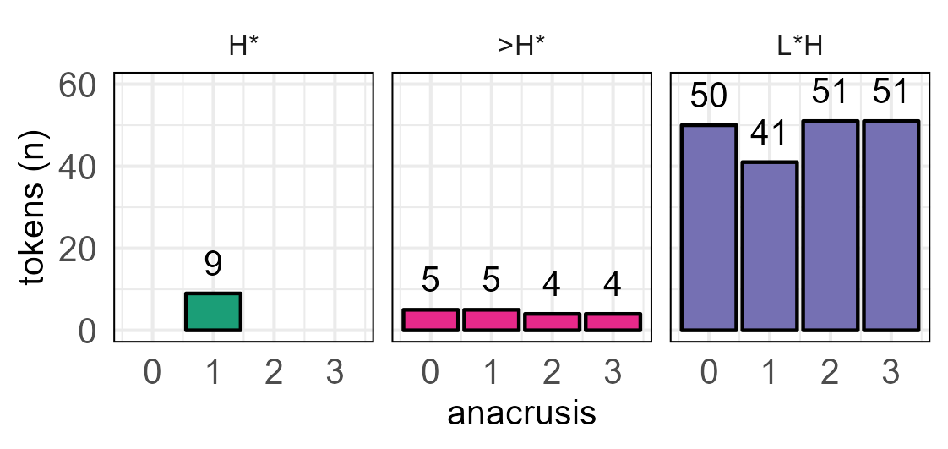

Figure . PNs across anacrusis conditions (adjusted)

When we consider the distribution of prenuclear pitch accents by speaker across the pn_ana and pn_foot data combined—as presented in Table 6.11 below—we can see that L*H dominates, accounting for 70% the adjusted count. This further confirms hypothesis (1), L*H is the dominant pitch accent in both nuclear and prenuclear position. While this hypothesis holds true for all the female participants, it is not the same for the male speakers. While M8 and M10 both show a clear preference for L*H, M5 has an almost even split between L*H and H* (51% and 49% respectively), while M4 shows a weaker preference for L*H (42%), followed closely by H* (32%). Unlike all the other speakers, M9 has a clear preference for H* (67%) and uses L*H only occasionally (7%). In fact, M9 also uses the ambiguous >H* most more frequently than the other speakers (27%**)**. Overall, this give the impression that there is an effect of gender on the distribution of pitch accent types.

Table . Prenuclear PAs by speaker in pn_ana and pn_foot subcorpora (adjusted).

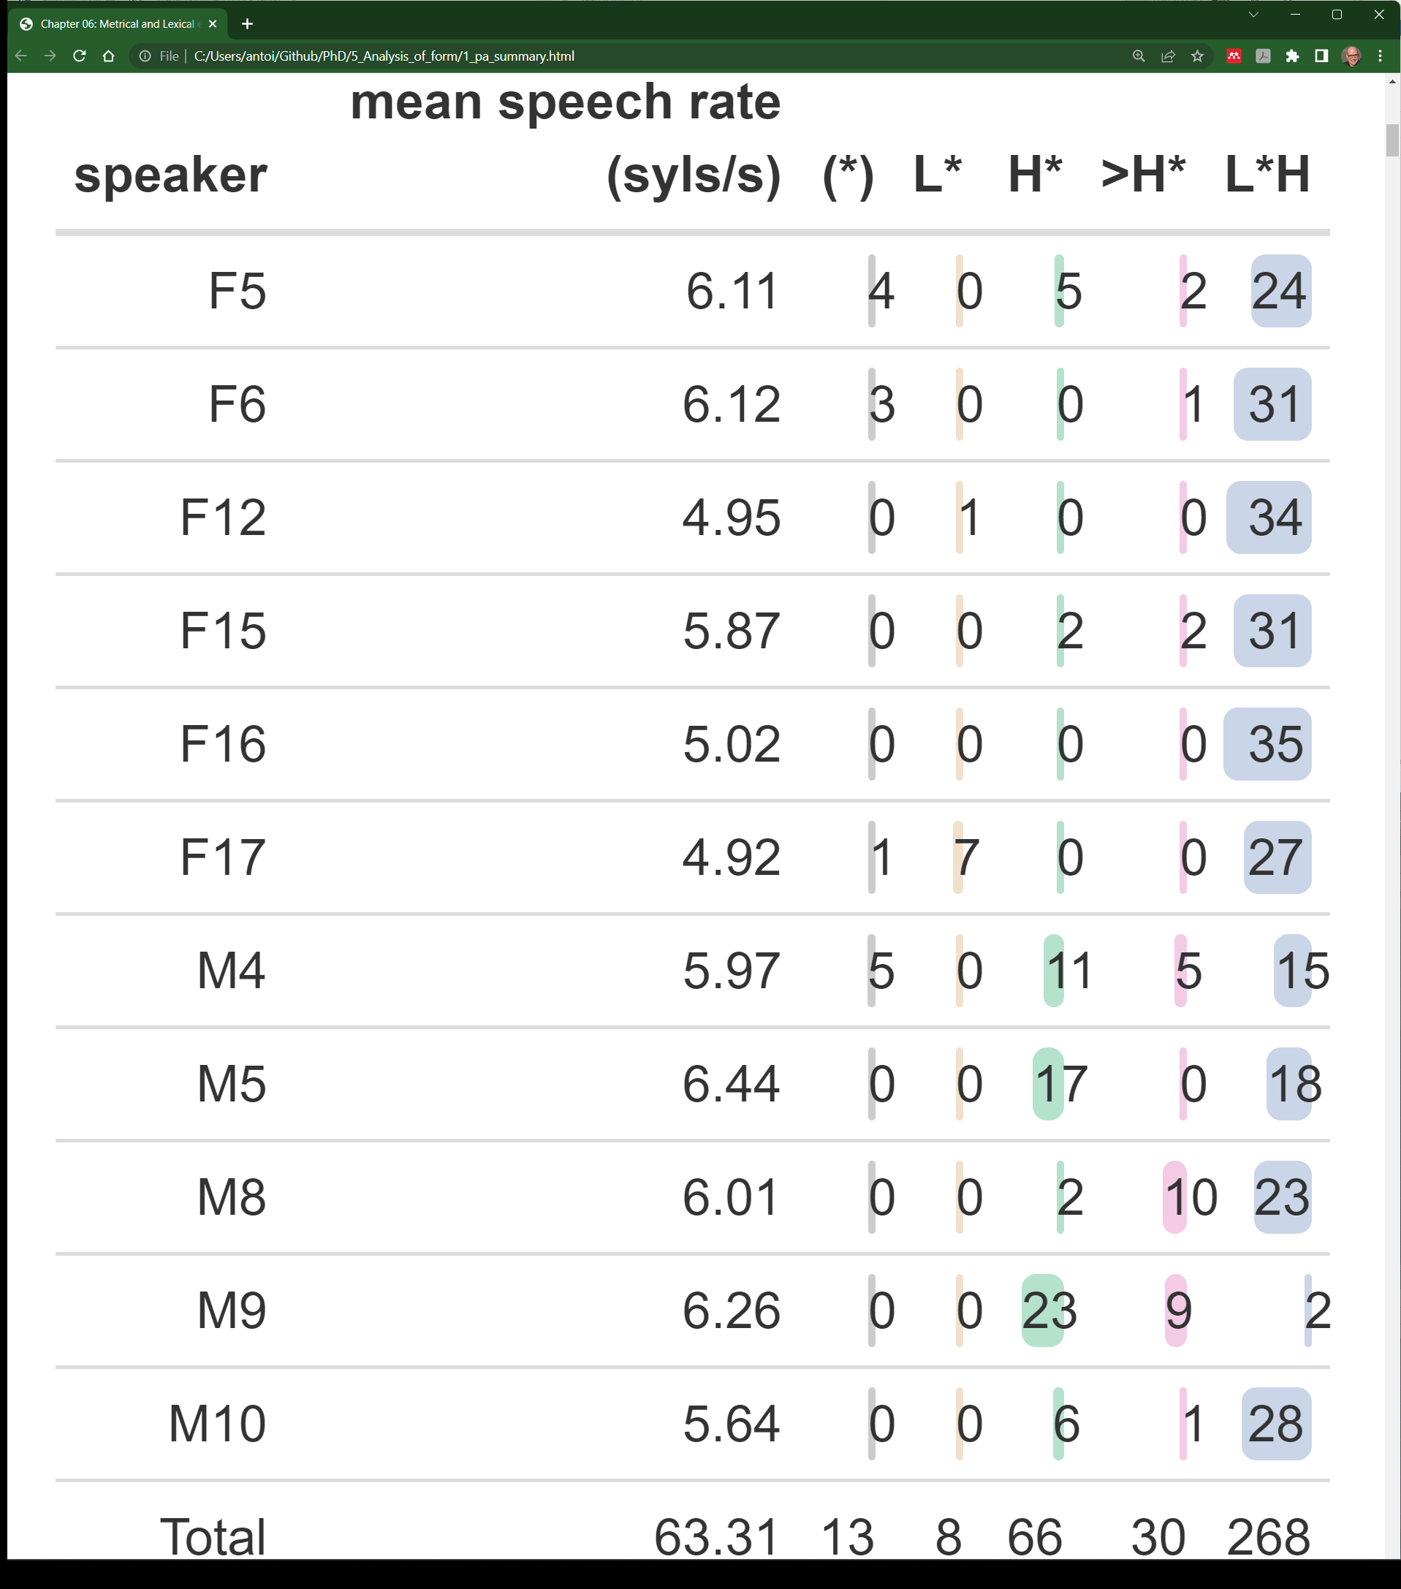

Inter-speaker variation in the realisation of pitch demonstrates that the correlation between foot size and L*H realisation suggested by the summary data (Figure 6.1) does not reflect all individual trends. The aggregated data do appear to reflect a general trend, but speakers such as M9 (and to a lesser extend M5 and M4) simply do not follow it. Perhaps these speakers continue to produce H* because, for them, it is functionally contrastive with L*H, or, perhaps functional contrast is not intended, but they are affected by metrical conditions.

|  |
| --- |
|  |
| Figure .. Linear regression of per-speaker proportional use of L*H and H* and mean speech rate in prenuclear pitch accents in the pn_ana and pn_foot subcorpora. |

Based on auditory impressions, it also seemed that realisations of L*H versus H* were partially determined by speech rate. This was confirmed by plots (Figure 6.3) correlating the proportion both of H* and of L*H per speaker against each speaker’s average speech rate (syllables per second) for pn_ana and pn_foot data combined. This suggests a negative correlation between speaker average speech rate and use of L*H, and a positive correlation between speaker average speech rate and H* use. The r-squared value for L*H ~ mean_speech_rate is .38, *p = .*041, while it is .41, *p = .*034, for H* ~ mean_speech_rate, indicating a significant effect of speech rate on the realisation of each PA. However, it also seemed that male speakers tended to speak faster than the female speakers, so there may be an interaction of gender and speech rate. Therefore, to assess the general effect of speech rate and gender, two linear models were tested, as shown in Equations 6.1 and 6.2.

L*H ~ gender * mean_speech_rate (6.1) H* ~ gender * mean_speech_rate (6.)

L*H and H* here refer to the proportion of the target pitch accent per speaker in the adjusted data. An ANOVA of the model indicates that the only significant effect is gender, *F(1,7)* = 10.72, *p =* .014 in the L*H model and F(1,7) = 14.11, *p =*.007 in the H* model. Therefore, we cannot reject the null hypothesis for mean_speech_rate or the gender:mean_speech_rate interaction.

### Word Boundary Effects in Prenuclear Pitch Accents

Figure 6.4 shows the adjusted counts of prenuclear PAs for each pair of utterances in the H-Corpus. In each pair, the target with the earlier word boundary is shown on the left and the target with the later boundary on the right. For both the first and the third pairs, there is a noticeable increase in L*H occurrences when the right word boundary is later, i.e., at the end of the second syllable and not the first, stressed syllable. In the first pair, L*H occurrences increase by 11, from 35 to 46. In the third pair, L*H occurrences increase dramatically from 34 to 50, an increase of 16. In each case, there is a corresponding decrease in H* occurrences. In the second pair, where the right word boundary occurs at the end of the second and third syllable, we see only a very minor increase, from 48 to 50.

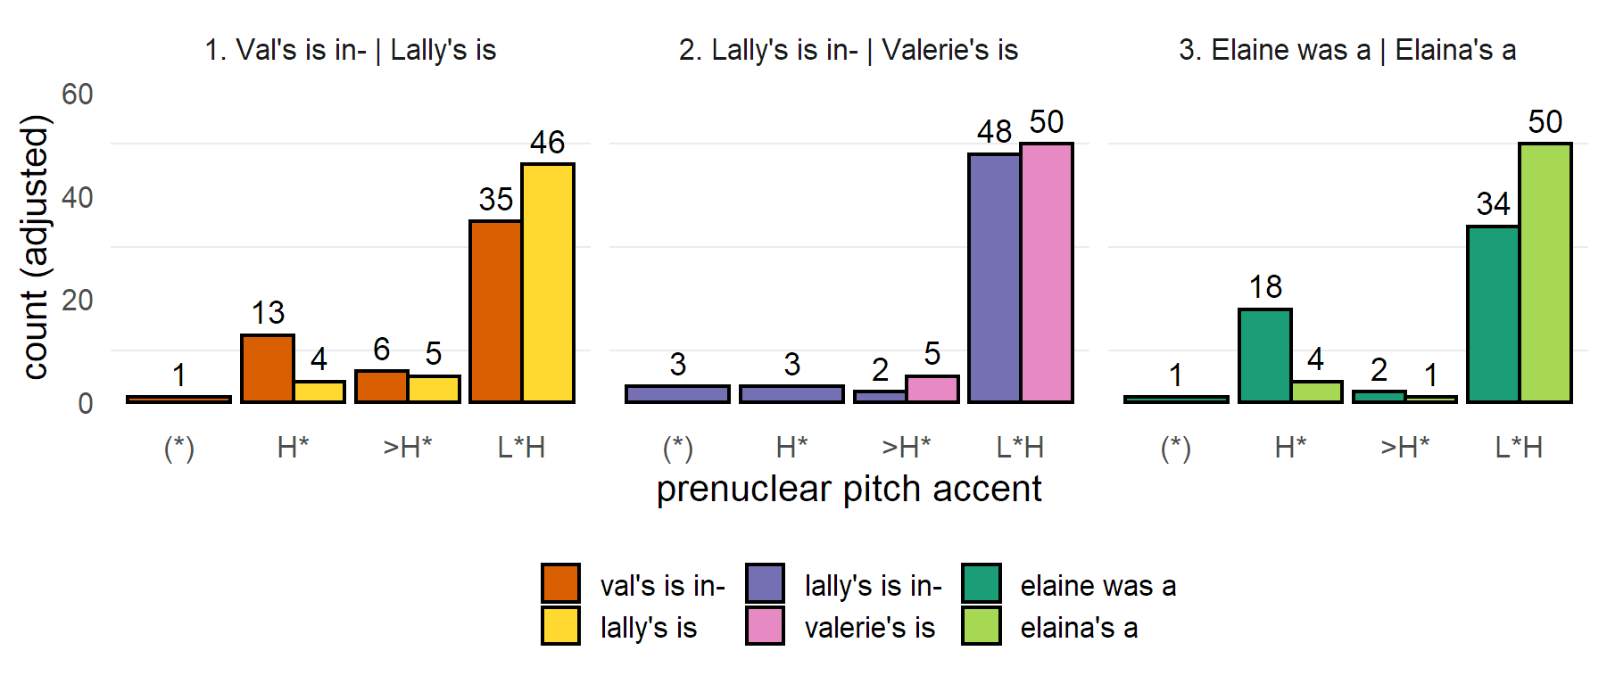

Figure .. Pitch accent counts (adjusted) per target phrase in H-Corpus.

These results suggest that prenuclear pitch accent realisation is indeed subject to the effects of the right word boundary. That is, if the right word boundary is later, then L*H is more likely. However, it also seems that the distinction might only matter in terms of whether or not the boundary occurs at the end of the stressed syllable, since there is little difference in the distribution of pitch accents in pair two, where the word boundary either one or two syllables later than the stressed syllable.

### Mixed-effects Modelling of Effects on PN Pitch Accents

Based on the initial results, it appears that anacrusis (ana_syls) has no effect on prenuclear pitch accents, but that foot size (foot_syls) and the location of the right word boundary (wrd_end_syl) do. Speech rate (speech_rate) appeared to have an effect when considered in terms of the proportional use of pitch accent per speaks, but this disappeared when gender was also included in the analysis. To test the effects of each of these parameters using mixed-effects models, all these parameters, along with gender, were treated as fixed factors. ana_syls was also included because an effect may be revealed in the larger data set. speaker was treated as a random intercept with random slopes for foot_syls and wrd_end_syl.

Since it was decided to run the mixed-effects models on the whole A and H corpora rather than on the five subsets individually, three extra random effects were included to account for variation in segmental content across utterances. These were ana_text, pn_str_syl, and nuc_pre_text. These refer respectively to the text in anacrusis, the text of the stressed syllable, and the unstressed text of the foot, with each effect acting as a proxy for segmental variation in anacrusis and the first foot of the utterance.

Two models were constructed, one to test the likelihood of L*H (isLH) and the other to test the likelihood of H* (isHStar). The final model is shown in Equation 6.3, where x refers to the response parameter. Detailed results for each test can be found in Appendix G.

|  |  |
| --- | --- |
| x ~ ana_syls + foot_syls + wrd_end_syl + speech_rate  + gender + (1|speaker) + (1|ana_text) + (1|nuc_pre_text)  + (1 | pn_str_syl) | (6.) |

A Likelihood Ratio Test (LRT) was performed on each model using R’s drop1() function. (See Chapter 5, Section 5.4.2 above.) The LRT of the isLH model indicates that the effects of foot_syls, wrd_end_syl, and speech_rate were significant, not for ana_syls or gender, as summarised in Table 6.12. The marginal *R*2 of the model is .4 with a conditional *R*2 of .8, indicating that the fixed effects account for 40% of the variance in likelihood of L*H, while the whole model accounts for 80%.

Table .. Results of LRTs comparing full isLH model with using R’s drop1() function.

|  |  |  |  |  |  |  |
| --- | --- | --- | --- | --- | --- | --- |
| **effect** | **npar** | **Chisq** | **Df** | **Pr(>Chisq)** | **p.adj (BH)** | **signif.** |
| ana_syls | 3 | 564.92 | 4.33 | .228 | .254 |  |
| foot_syls | 3 | 574.56 | 13.97 | .003 | .006 | *p* < .05 |
| wrd_end_syl | 2 | 579.22 | 16.64 | < .001 | < .001 | *p* < .05 |
| speech_rate | 1 | 579.52 | 14.93 | < .001 | < .001 | *p* < .05 |
| gender | 1 | 567.53 | 2.94 | .086 | .108 |  |
|  |  |  |  |  |  |  |

The LRT of the isHStar model indicates significant effects of ana_syls, wrd_end_syl and gender but not of foot_syls or speech_rate. The initial analysis of the pn_ana dataset showed no effect of anacrusis. However, the first foot of each target phrase in that dataset always contained four syllables, and the four-syllable foot was already strongly associated with L*H. In the larger dataset, there is more variation in foot size across anacrusis conditions, so this biasing of the results disappears.

Table .. Results of LRTs comparing full isHStar model with using R’s drop1() function.

|  |  |  |  |  |  |  |
| --- | --- | --- | --- | --- | --- | --- |
| **effect** | **npar** | **Chisq** | **Df** | **Pr(>Chisq)** | **p.adj (BH)** | **signif.** |
| ana_syls | 3 | 513.02 | 14.64 | .002 | .005 | *p* < .05 |
| foot_syls | 3 | 506.79 | 8.41 | .038 | .055 |  |
| wrd_end_syl | 2 | 518.4 | 18.02 | < .001 | < .001 | *p* < .05 |
| speech_rate | 1 | 502.15 | -0.23 | 1 | 1 |  |
| gender | 1 | 509.7 | 7.32 | .007 | .011 | *p* < .05 |
|  |  |  |  |  |  |  |

#### Effects on the Likelihood of L*H

**.** Looking at Figure 6.5a, there does appear to be an effect of anacrusis in the two- and three-syllable conditions, at .64 and .69 respectively, 95% CIs [.04, .99] and [.05, .99] respectively. Unfortunately, the confidence intervals are very large, so it is impossible assume this effect would be found in a larger sample or in the population as a whole.

The initial analysis suggested that the likelihood L*H increases with foot size, and the mixed-effects model indicates this also. However, unlike the initial analysis, the mixed-effects model suggests that the effect of foot size reaches saturation point at three syllables. This is clear from Figure 6.5b, which shows the predicted probability of L*H as a function of foot size alone in the isLH model. We see that it rises steadily from .29, 95% CI [.02, .89], in the one-syllable-foot condition up to 0.81 in both the three- and four-syllable conditions, 05% CIs [.18, .99] and [.18, 1] respectively). In the pairwise comparison of foot-size conditions, L*H is 10.5 [2.8, 49.4] times more likely in the three-syllable foot and 10.7 [1.89, 60.4] times more likely in the four-syllable foot than in the one-syllable foot, *p. <* .001 and *p* = .007 respectively. (Full details of pairwise comparisons can be found in Appendix Table G1.9.)

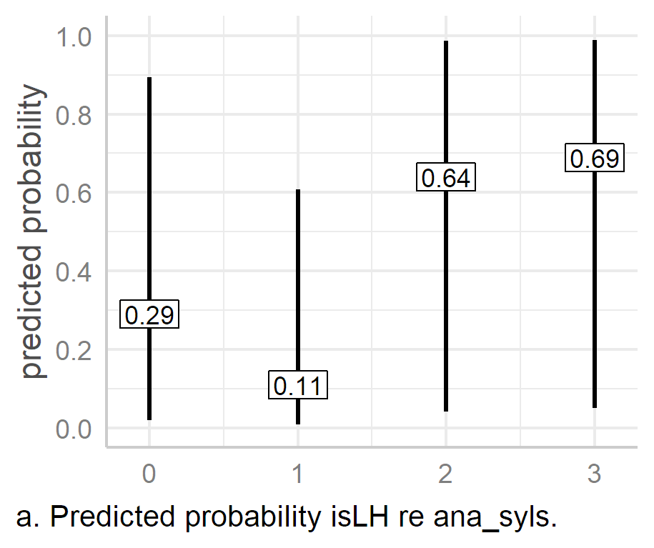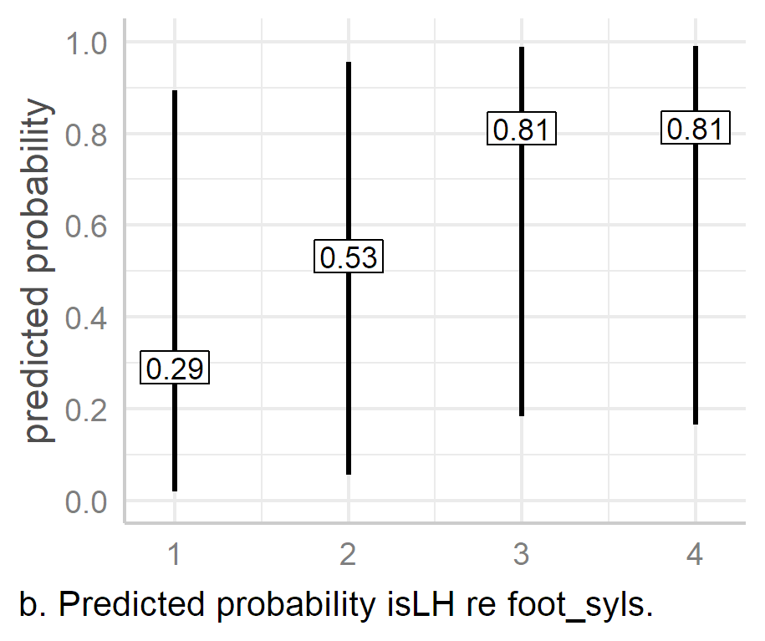 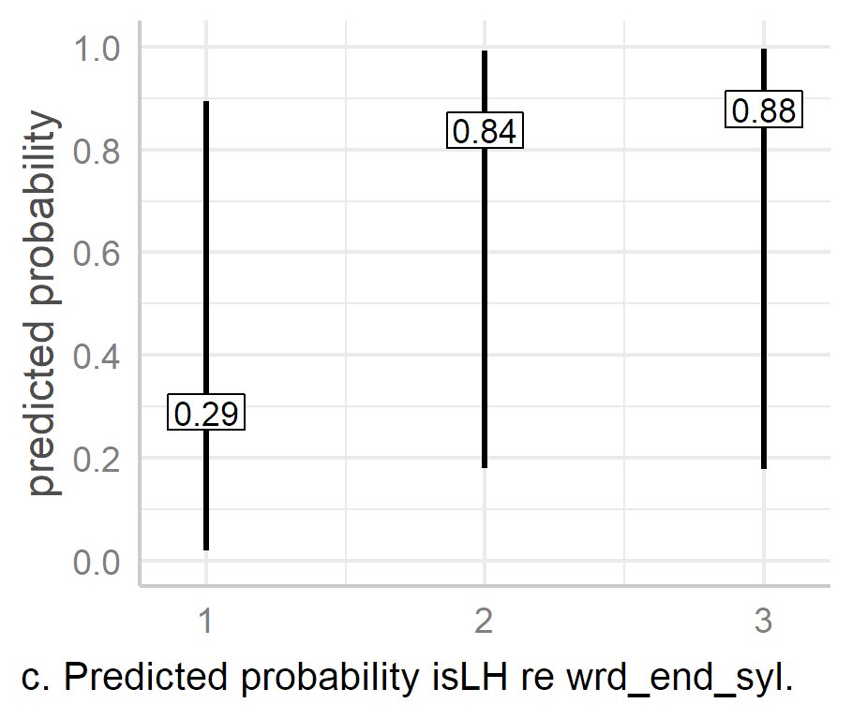

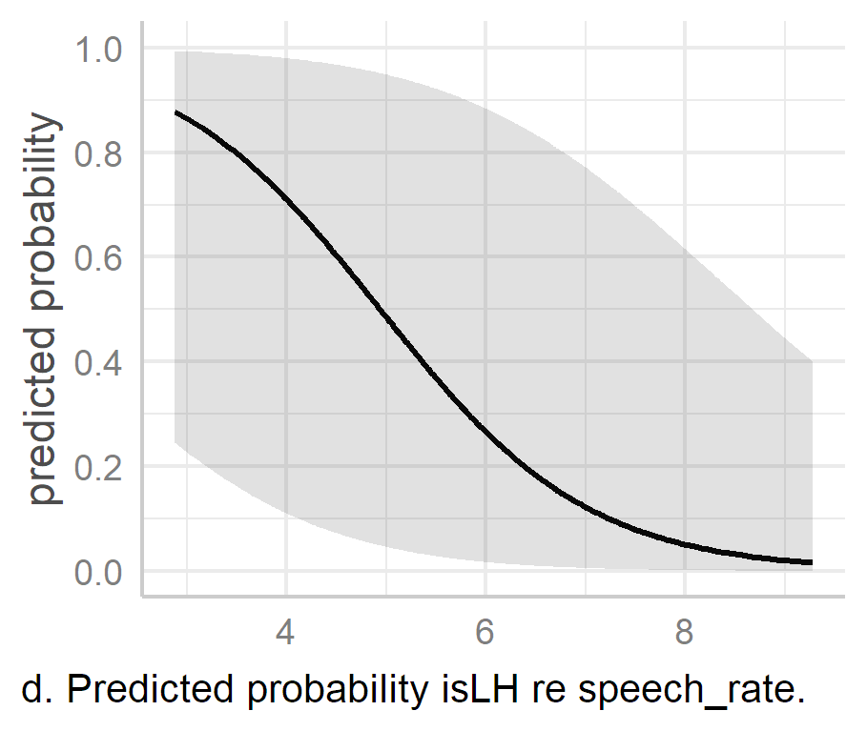

Figure . Predicted probability of L*H as a for each fixed factor (excluding gender) in the isLH model[12]. Bars indicate 95% CIs. Red line panel c. indicates where the upper 95% CI crosses 50%.

Looking at the right word boundary effect, the probability of L*H increases dramatically when the right word boundary is not coterminous with the stressed syllable. This can be seen in Figure 6.5c, which shows the Predicted probability of L*H as a function of the word-final syllable. When the lexically stressed syllable and word-final syllable are the same (the intercept), the probability of L*H is .29, but this rises sharply to .48 when it occurs in the second syllable and is only slightly higher again in the third, at .88, 95% CIs [.02, .89], [.18, .99], and [.18, 1] in turn. The likelihood of L*H is 12.7 [4, 2.44] times greater than the intercept in the two-syllable condition and 18.7 [2.44, 129.6] times greater in three-syllable condition, *p* < .001 and *p* = .005 respectively. Speech rate was statistically significant, with the expected odds of L*H falling by 63% with each additional syllable per second, odds ratio (OR) = 0.39 [0.24, 0.63], *p.adj <* .001. the red line in Figure 6.5d indicates that the mean predicted likelihood of L*H exceeds 50% when lower than 5 syls/s. For reference, the speech rate in the A- and H- ranges between 2.87 and 9.82 syls/sec.

Turning finally to gender, the odds of a male speaker using L*H are 79% lower than those of a female speaker, OR = 0.21, 95% CI [0.03, 1.56], *p =* .128. However, when we look at the 95% confidence interval, we see that it stretches from 33:1 against to 3:2 in favour, so we cannot reject the null hypothesis here.

#### Effects on the likelihood of H*.

The predicted probabilities of isHStar, as shown in Figure 6.6, are essentially the inverse of those of isLH. The probability of H* is never greater than 0.01 when there is more than one syllable of anacrusis, 0.04 when foot size is greater than two syllables, and 0.01 when the end of the word is later than the end of the stressed syllable, 95% CIs [0, .18], [0, .24], and [0, 0.15] respectively. As was noted in Section 6.5.3, H* is much less likely than L*H in prenuclear pitch accents. Therefore, it is unsurprising that the predicted probability of H* does not exceed .28 [0.06, 0.7] as an effect of ana_syls alone, .12 [0.02, 0.54] as an effect of foot_syls alone, or 0.09 [0.01, 0.48] as an effect of wrd_end_syl. While the likelihood of H* increases with increased speech rate, OR = 1.16 [0.73, 1.86], *p* = .524, it achieves a predicted probability of only .16 [0, .84] at 10 syls/s. The greatest effect on H* is gender. The male speakers are estimated to be 13.4 [13.4, 13.5] times more likely to produce H* than female speakers, *p <* .001.

The results of the two mixed-effects models reflect the much greater likelihood of L*H over H* even in PN position. Increased foot size and post-stress word-end syllables are both closely associated with greatly increased likelihood of L*H. For foot size, the increased likelihood of L*H appears to reach saturation point once there are at least three syllables in the foot, while for the word-end syllable, it appears that L*H is more likely as long as the word-final syllable occurs after the stressed syllable. Conversely, H* is less likely in longer feet or when the stressed syllable is not coterminous with the end of the word. The effect of speech rate is slightly more pronounced than expected as a predictor of L*H, while the effect of gender on the likelihood of H* is much stronger.

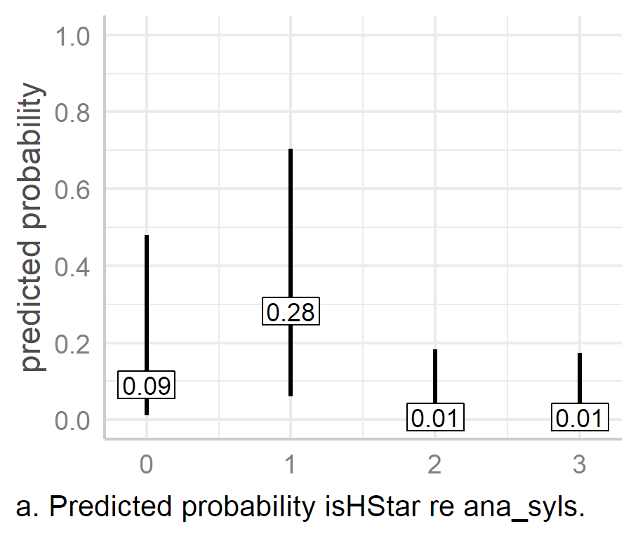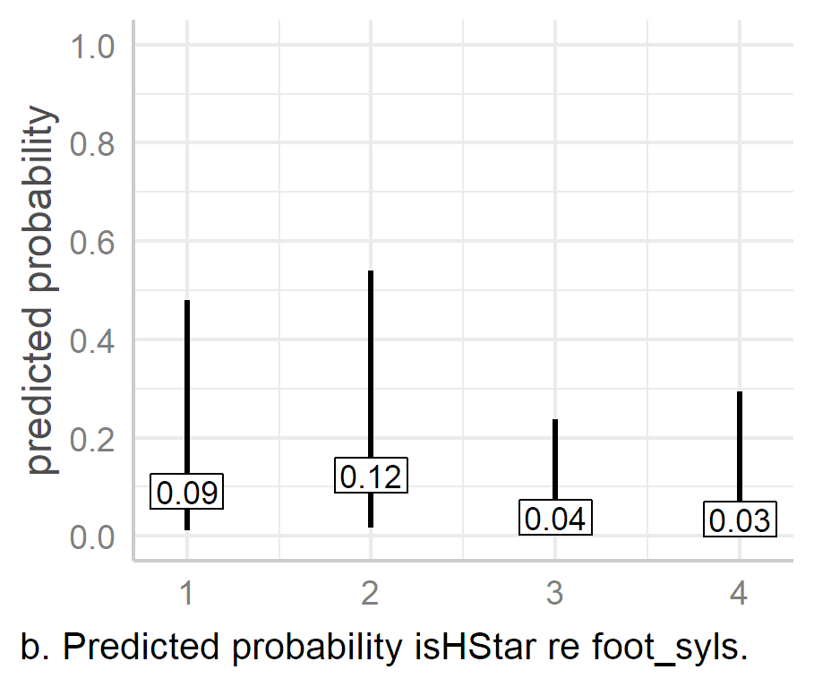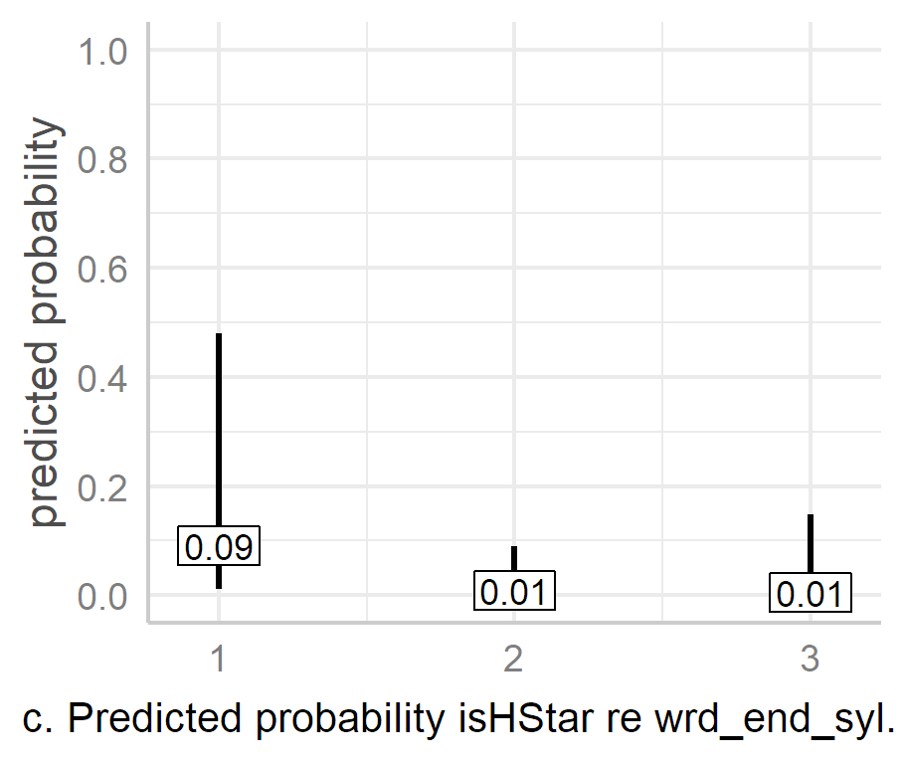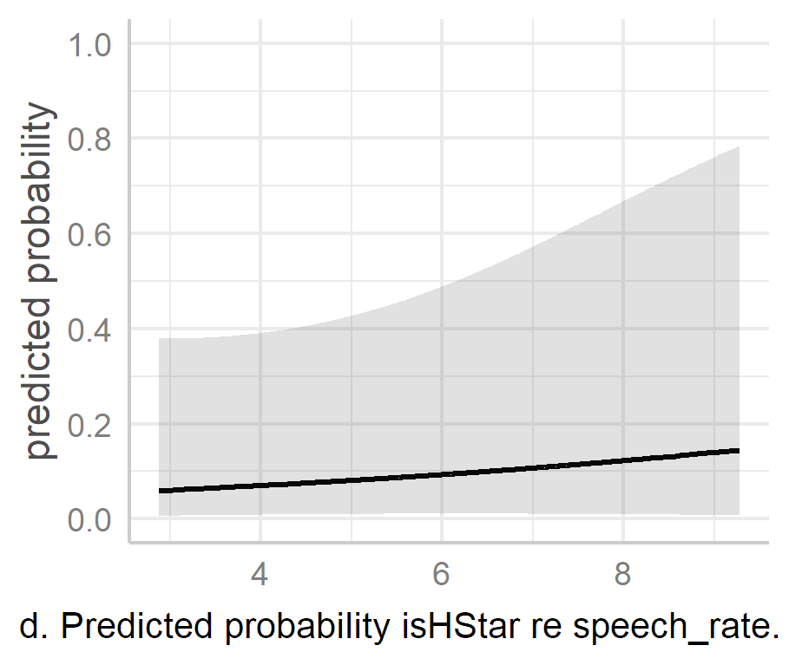

Figure . Predicted probability of L*H as a for each fixed factor in the isHStar model (excluding gender). Bars indicate 95% CIs. Red line panel c. indicates where the upper 95% CI crosses 50%

## Phonetic Analysis and Results

This section begins with an analysis prenuclear peak alignment as an effect of the lexical boundary before moving on to the LMEM analysis of tonal target parameters. The separate analysis of lexical boundary effects does not use linear mixed-effects models (LMEMs), as it is concerned with potential bimodality in PN peak alignment. It is believed that this issue is best assessed using density plots to analyse peak alignment because these show if there is a modal, bimodal, or multimodal distribution of the data. However, lexical boundary effects will also still be included in the subsequent LMEM analyses.

### Distribution and Temporal Alignment of PN Peaks in the H-Corpus

In the H-Corpus, L*H is the most common pitch accent (*n* = 250) while H* and >H* are much sparser (*n* = 42 and *n* = 19 respectively). To avoid adding pitch accent type as an additional confounding factor, L*H pitch accents alone are considered here. Alignment effects of pitch accents are still considered in mixed-effects modelling in subsequent sections.

An important caveat must be mentioned before continuing. The H-Corpus was designed so that there were three pairs of target phrases, with the key variable in each phrase being a difference in the number of syllables before the word boundary after the lexical stress in the first foot. However, sets one and two also vary in segmental content. The effect that this variation might have on the results was (quite naively) not considered until after the data had been collected. Therefore, one must be careful when trying to interpret the results from these two sets. Fortunately, the third set contains two target sentences which are segmentally and morphosyntactically very similar, namely *Elaine was a nanny* and *Elaina’s a nanny*. The only segmental difference between this is /wəz ə/ in the firsttarget and /əz ə/ in the second, while the only morphosyntactic difference is in the tense of the verb *be*. Therefore, any differences in peak alignment between these two sentences can be attributed more confidently to the word boundary effects.

#### Analysis of Peak Timing with Syllable-normalised Time

**.** Dot plots of PN peak temporal alignment of L*H accents were generated in R using ggplot2 (Wickham, 2016), with the bin width set to the default (1/30 of total range). This facilitates the assessment of distribution density of peak timing, much like a histogram, but with each dot representing an individual token. Figure 6.7 shows a dot plot of peak alignment for each pair of target phrases in the H-Corpus per speaker using syllable normalised time (section 6.3). Each panel begins with the stressed syllable in the foot. The first six rows show the distribution density for the female speakers and the final five rows for the males, with speaker IDs listed on the right.

At a glance, we can see that the male speakers (with the exception of M10) typically align the peaks earlier than the female speakers. We can also see that for each pair, the phrase with the earlier word boundary is aligned earlier than its counterpart with the later word boundary (dark and light circles respectively). The only exception to this is F5, who only produced one PN L*H token in *Lally’s is*, the peak of which is aligned in the second syllable, while each peak of *Val’s is in-* is aligned in the middle of the third syllable (first row, third column).

With the exception of M10, the male speakers are consistent with each other in their alignment of targets. In feet where the word-end syllable is also the stressed syllable (*Val’s is in-* and *Elaine was a*), peaks are aligned somewhere between the final third and the end of the first syllable. Each of these represents a case where the word boundary is at the end of the stressed syllable. In phrases where the right word boundary is in the second syllable (*Lally’s is*, *Lally’s is in-*, and *Elaina’s a*), peaks are aligned near the boundary of the first and second syllable. In the phrase where the right-word boundary is at the end of the third syllable (*Valerie’s is*), peaks occur in the first half or towards the middle of the third syllable, i.e., in the word-final syllable of *Valerie*. Thus, we see that as the number of syllables before the end of the word increase, the male speakers—with the exception of M10—tend to align the targets later in a consistent manner. However, this is a sample of only four speakers, so it is unwise to make generalisations about male DCE speakers. M10 aligns the peaks of *Lally’s is in-* and *Valerie’s is* in a similar manner to the other male speakers, in the other utterances the alignment patterns are different and also indicate internal variation in alignment strategies.

|  |
| --- |
|  |
| Figure . Dot plot of syllable-normalised peak timing in L*H PNs in the H-corpus. Each panel begins with the stressed syllable, and each dot represents an individual utterance, with bin width set to 1/30 of the total range (geom_dotplot default). Panels highlighted in grey indicate instances with noticeable variation in peak alignment across repetitions of the same utterance. |

Among the female speakers—with the exception of F12—what is most striking is the greater intra-speaker variation in peak alignment. Instances where intra-speaker variation is evident are indicated by panels shaded in grey. We see that the right edge of the first syllable is the most common location of peak alignment in phrases where the right word boundary is the end of the stressed syllable (*Val’s is in-* and *Elaine was a)*, but this is not consistent speaker-internally. For example, F6 aligns the peak in *Val’s is in-* (first column, second row) just after the boundary, but the peaks in *Elaine was a* are all aligned much later (third column), in the second or third syllables. Unlike the other female speakers, F5 consistently aligns the peak of *Val’s is in-* in the middle of the third syllable, and F16 aligns the peak with the start of the third syllable on one occasion.

There is a similar inter- and intra-speaker variation in the cases where the word ends in the second syllable. Except for F12, none of the female speakers is consistent in the peak alignment in *Lally’s is-* (first column), where it is aligned between the middle of the second syllable or the boundary between the second and third syllables. A similar pattern occurs both in *Lally’s is in-* and *Elaina’s a*, although the second anchoring point is a little later in these cases.

For the phrase with the word-end syllable in the third syllable (*Valerie’s is*), most of the female speakers align the peak in the centre of the third syllable, much like the males. However, there are two occasions where F6 aligns with the beginning of the following word (second row).

In summary, there is a general and consistent tendency to align peaks earlier when there are fewer syllables before the word boundary, with males being most consistent on this front. However, it also appears that there are alternative locations for anchoring peaks.

#### Analysis of Peak Timing with Grand Syllable-mean Normalised Time.

In order to further assess variation in peak alignment, data were analysed in terms of grand syllable-mean normalised time. A combined density and dot plot for each utterance was produced (Figure 6.8), which shows peak alignment trends over time across all repetitions of each target utterance. To avoid an imbalance in per-speaker token representation for each target, each plot only includes tokens from each speaker who produced at least four L*H tokens of the target. (The selection is shown in Table 6.14 below.) Unlike syllable-normalised time, grand syllable-mean normalised time is excellent for reflecting syllable duration in a realistic manner. However, also unlike syllable-normalised time, it is not good for comparing different phrases. Therefore, each target phrase is plotted separately.

In *Val’s is in-* (Figure 6.8a), we see that the majority of peaks are aligned roughly 350 ms just after edge of the stressed syllable, which is also the end of the word. In *Lally’s is* (panel b), there appears to be a three-way split. One cluster is at the edge of the stressed syllable (c. 215 ms). There is a second one at around 300 ms in the middle of the second (word-final) syllable, and a final one just after the end of the word (c. 300 ms), at boundary of the second and third syllables. Thus, the first and third clusters reflect the syllable and lexical alignment of *Val’s is* because one clusters at the right edge of the stressed syllable and the other at the word boundary; however, unlike *Val’s is in*, the right-word boundary and stressed-syllable boundaries are in different locations.

*Lally’s is in*- (panel c) is very similar to *Lally’s is* (panel b), in that there are three clusters, one near the right edge of the stressed syllable, one in the middle of the second syllable and one just after the right edge of the word boundary. The absolute timing of these is also almost identical to *Lally’s is*, which is unsurprising as they are also segmentally the same.

In *Valerie’s is* (panel d), there is one large cluster, peaking at around 380 ms, which is similar to the absolute timing of the peak density in *Val’s is in*. However, in this case, the cluster is in the middle of the third (word-final) syllable. This makes the main region of peak alignment similar to the second clusters in both *Lally’s is* and *Lally’s is in-* in that the all occur in the middle of the word-final syllable of the word with lexical stress.

|  |  |
| --- | --- |
|  | |
| Figure . Density and dot plots for the prenuclear portion of each phrase in the H-Corpus plotted by grand mean syllable-normalised time. The lightly shaded rectangle indicates the stressed syllable while vertical black lines indicate syllable boundaries. Each panel states the number of tokens after filtering out underrepresented speakers. | |
| Table . Raw counts for L*H per speaker and target utterance in the H-Corpus. Cells highlighted in grey represent data used for the generation of density / dot plots using grand mean syllable timing. |
|  |

In the third pair (panels e and f), we see an apparent bimodal distribution. In *Elaine was a* (panel e), there is a cluster which peaks at the end of the stressed syllable (also the end of the word) at around 310 ms, and a second small cluster at the start of the third syllable in the foot (c. 460 ms), a full syllable after the end of the word. In *Elaina’s a* (panel f), there is a large cluster which peaks near the centre of the last syllable in *Elaina’s*, at a similar time point to the one in *Elaine was a*.This is followedby a second smaller cluster at the start of the third syllable, just after the right edge of the word, with a density peak around 450 ms. Thus, we see that the bimodal peaks are timed similarly. However, the first density peak in *Elaine was a* is at the end of the word/stressed syllable, just as in *Val’s is in-*. This is also similar to the first cluster in each of the *Lally* phrases in that it is also at the right edge of the stressed syllable. The second density peak in *Elaine was a* is not associated with the boundary of the stressed syllable or the final syllable of the word with lexical stress but occurs one syllable after the end of the word. In *Elaina’s a*, the first large cluster peaks towards the middle of the word-final syllable, much like the second clusters in both of the *Lally’s* phrases(panels b and c) as well as in *Valerie’s is* (panel d). In short, with the final two utterances, we see a pattern which could be interpreted in terms of absolute timing or in terms of anchoring to the word-final syllable of the word with lexical stress (with the exception of the second peak in *Elaine was a)*.

When we consider the six target utterances together, there are clusters of peak alignment in three utterances centred around a similar 350 ms, i.e., in *Val’s is in-*, and the second peak in both *Lally* phrases, panels a, b, and c. Of course, this is 350 ms in time-normalised data, so the actual timing would vary from speaker to speaker. More generally, however, peak alignment seems to be associated with three lexical and syllable locations. These are:

1. The right edge of (or just after) the stressed syllable.
2. The middle of the last syllable of the word with lexical stress.
3. The right edge of (or just after) the word with lexical stress.

These three options appear to create bimodal or multimodal distributions of peak alignment in four of the six target phrases.

One way to test for unimodal/multimodal distributions is via the Hartigan dip test of unimodality (Hartigan & Hartigan, 1985). In this test, the null hypothesis is that the distribution is unimodal, so the alternative hypothesis (*p* < .05) means that the distribution is at least bimodal. Unfortunately, the data here may not be ideally for such a test since the observations are not independent, i.e., they are grouped by speaker, and (to the best of my understanding) the Hartigan dip test is not designed for nested observations. However, it can still be used to get a general impression of the presence or absence of multimodality. Bearing these issues in mind, the test was conducted on the four sets in which there appear to be bi- or multimodal distributions (Figure 6.8, panels b, c, e, f) using the diptest module in R (Maechler, 2021), with the results summarised in Table 6.15. After adjustment for multiple testing using the Benjamini and Hochberg method (see Chapter 5, Section 5.4.3), three out of the four results were found to be significant. *Elaine was a* is non-significant (*p.adj =*.366), but is unsurprising, as there are only five tokens in the second smaller peak-alignment cluster.

Table . Hartigan dip test for unimodality / multimodality in peak alignment of L*H in the H-Corpus for potentially bi-/multimodal phrases. N.B. These results should be considered with caution since the observations are not independent (i.e., they are grouped by speaker).

|  |  |  |  |  |  |
| --- | --- | --- | --- | --- | --- |
| **set** | **observations** | **D.value** | **p.value** | **p.adj (BH)** | **signif.** |
| Lally’s is | 40 | .09 | .006 | .011 | *p < .*05 |
| Lally’s is in- | 44 | .08 | .036 | .048 | *p < .*05 |
| Elaine was a | 30 | .07 | .366 | .366 |  |
| Elaina’s a | 51 | .09 | .004 | .011 | *p < .*05 |
|  |  |  |  |  |  |

These results suggest that temporal alignment of peaks is not simply an effect of the number of syllables in the foot (although it does seem to play some role in skewing the peaks slightly later), but that there is a range of peak alignment options for the speaker, which are largely a matter of preference. Thus, in the sections which follow, we need to be aware of the fact that the distribution of peak alignment may not simply be accounted for by the lexical and metrical structure of the phrase, nor by the segmental string, but that an amount of error in the results may be inevitable as we cannot account for variation in speaker preference across tokens.

### Mixed-effects Modelling of Prenuclear Pitch Accents

Data was trimmed to exclude utterances without prenuclear pitch accents. Only L* and L*H PNs were included in the analysis of L targets, and only L*H, >H*, and H* were used for the analysis of H targets. Slope and excursion size were measured for L*H targets only.

Six phonetic response parameters were tested. These were the temporal alignment and *f*0 of each L and H target alongside the excursion size and slope of contours in L*H pitch accents. As elsewhere, *f*0 minima and maxima are used to represent tonal targets, while temporal alignment is measured in milliseconds from the onset of the vowel in the stressed syllable. *f0* is measured in semitones centred around speaker median. *f*0 excursion size is calculated as the difference between L and the H target *f*0. *f*0 slope is calculated as the slope of the linear regression of *f*0(t) between the L and H time points. However, in the modelling, slope was logged since it resulted in a better model fit. The response parameters are summarised in Table 6.16.

For each response parameter associated with tonal targets, six fixed effects were included into the model. These were pitch accent, anacrusis, foot size, right-word boundary, presence/absence of word break at the foot onset, and gender (see Table 6.17). For the analysis of compression and truncation effects, only foot_syls was of interest, so it was the only fixed factor included in the models, while other factors were included as random intercepts. As there were a large number of random effects, resulting in convergence and singularity issues, the step() function (see Chapter 5, Section 5.4.1) was used to help reduce the number of factors by eliminating non-significant random effects in the models.

Table . Response parameters for PN and nuclear pitch accent analysis.

|  |  |  |
| --- | --- | --- |
| **Parameter type** | **Parameter code** | **Description** |
| L target alignment | l_t | Time in milliseconds from vowel onset to *f*0 minimum |
| L target *f*0 | l_f0 | *f*0 minimum measured in ST, centred on speaker median *f*0. |
| H target alignment | h_t | Time in milliseconds from vowel onset to *f*0 maximum |
| H target *f*0 | h_f0 | *f*0 maximum measured in ST, centred on speaker median *f*0. |
| *f*0 excursion | f0_exc | *f*0 maximum ST - *f*0 minimum (ST) |
| slope | log_lh_slope | Log slope of linear regression of *f*0(t) between L and H |

Table . Fixed Effects for PN pitch accent analysis.

|  |  |  |
| --- | --- | --- |
| **Parameter type** | **Parameter code** | **Comments / levels** |
| pitch accent | acc_phon | Not included in slope and excursion size analysis. |
| Anacrusis | ana_syls | Zero to Three syllables |
| foot size | foot_syls | One to four syllables |
| right-word boundary | wrd_end_syl | One to three syllables |
| word break at foot onset | pn_new_word | True/False |
| Gender | gender | Female/Male |

After an optimal model was established, each model typically had random intercepts of speaker (speaker) and stressed syllable (pn_str_syl). Stressed syllable had been added to the models to mitigate against random effects introduced once the dataset was enlarged. (Other random effects were tested, but they either caused convergence issues or had no meaningful effect on the output.) A range of random slopes were tested, most of which led to convergence or singularity issues. In the final models, foot_syls was the only random per-speaker slope used. For the sake of clarity, the random effects for each model are listed in Table 6.18.

Table . Random effects for PN LMEMs in analysis of A- and H-Corpora.

|  |  |
| --- | --- |
| **Response** | **Random effects in model** |
| l_t | (1 | speaker) + (1 | pn_str_syl) |
| l_f0 | (1 + foot_syls | speaker) |
| h_t | (1 + foot_syls | speaker) + (1 | pn_str_syl) |
| h_f0 | (1 + foot_syls | speaker) + (1 | pn_str_syl) |
| f0_exc | (1 | speaker) + (1 | gender) + (1 | ana_syls) + (1 | pn_str_syl) |
| log_lh_slope | (1 | speaker) + (1 | gender) + (1 | ana_syls) + (1 | pn_str_syl) + (1 | wrd_end_syl) |
|  |  |

The following subsections present the analysis of the L target models, followed by those of the H targets, and finally by the analysis of the *f*0 excursion and slope. In some cases, the results warranted further investigation, so additional models were tests. These are presented separately.

#### L Targets.

An ANOVA of the l_t model indicates three statistically significant effects, namely acc_phon, *F*(1, 471.2) = 6.37, *p.adj* = .024 , wrd_end_syl , *F* (2, 350.7) = 8.84, *p.adj* < .001, and gender, *F*(1, 9.8) = 100.26, *p.adj* < .001. The model has a marginal *R*2 of 0.42 and a conditional *R*2 of 0.83, indicating that the fixed effects count for 42% of the variance in l_t while the whole model accounts for 83% of the variance. An ANOVA of the l_f0 model also indicates three significant effects. In this case, they are ana_syls, *F*(3, 451) = 12.97, *p.adj* < .001, pn_new_word, *F*(1, 460) = 8.72, *p.adj* = .007, and gender, *F*(1, 6.2) = 12.88, *p.adj* = .022. gender is the only effect which is significant for both l_t and l_f0. The l_f0 model has a marginal *R*2 of 0.19 and a conditional *R*2 of 0.41, indicating that the fixed effects count for 19% of the variance in l_f0, while the complete model accounts for 41%. The output of the model and all associated tables from which figures and statistics below are derived can be found in Appendices H2 and H3 for l_t and l_f0 respectively.

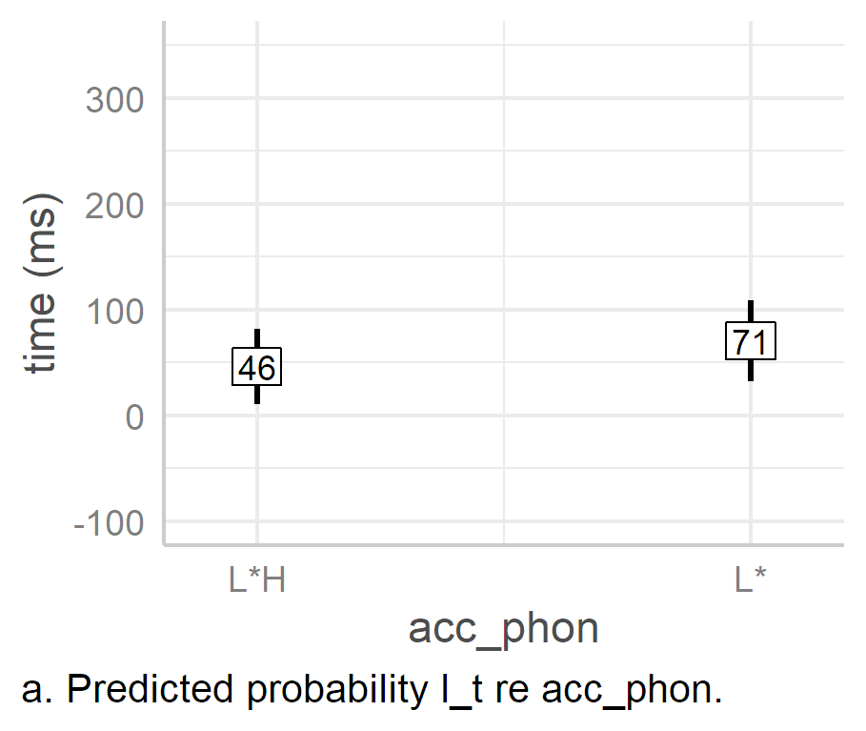 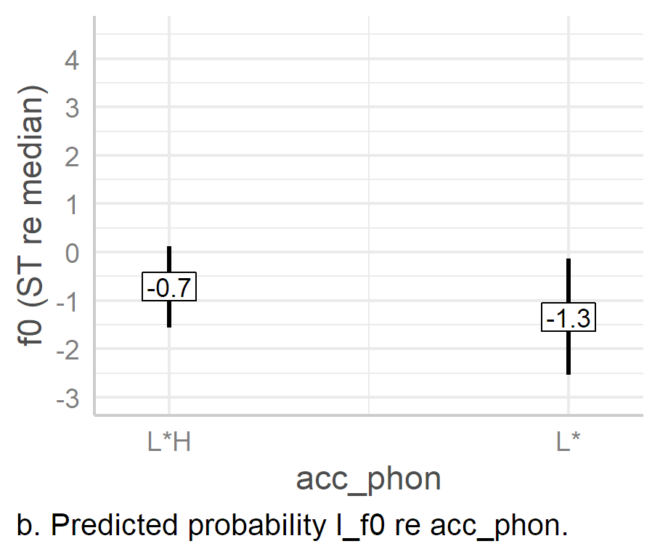

Figure .. Predicted values of L targets based on pitch accent effects alone in LMEMs.

Beginning with the effects of pitch accent (acc_phon), shown in Figure 6.9, we see that the mean estimated timing of L*H is 46 ms, 95% CI [11, 82]. L* is an estimated 24 [5, 43] ms later , *p =* .012. The estimated *f*0 of the L target is -0.7 [-1.6, 0.1] ST re the speaker median, with the estimated mean *f*0 in L* 0.6 [-1.6, -0.36] ST lower, *p =*.211, and sits at -1.3 [-2.5, -0.1] ST re the speaker median. The 95% CI for the L* low *f*0 is large, but this is unsurprising since L* accounts for only nine out of 498 prenuclear PA tokens. As such, it is unwise to read too much into the estimated differences between L* and L*H, beyond the fact that it appears to be aligned slightly later, which may be due to the fact that there is no backwards pressure on it go accommodate an upcoming H target.

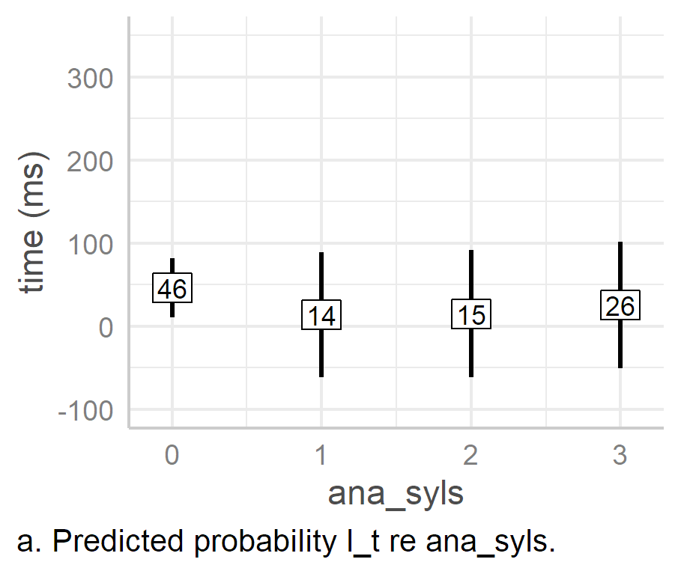 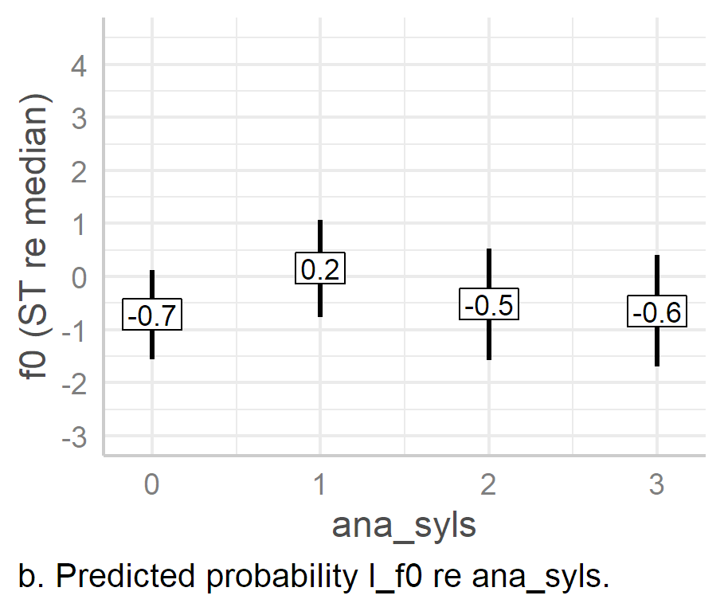

Figure .. Predicted values of L targets based on anacrusis effects alone in LMEMs.

Turning to anacrusis effects (Figure 6.10), it appears, superficially at least, that the addition of a single syllable of anacrusis causes the L target to align much earlier (panel a). For example, when there is no anacrusis, the estimated mean alignment of the target is 46 ms, 95% CI [11, 82], while for the one syllable condition it drops to 14 [-62, 89] ms, after which it rises slightly until it reaches 26 [-51, 102] ms. This implies that it is simply the presence or absence of anacrusis which affects the alignment of the L target. However, the CI for ana_syls conditions one to three are exceedingly large, as can be seen in panel a, and there is no significant difference between the zero-syllable condition and other levels of ana_syls. A summary of this is shown in Table 6.19. Note again, the exceedingly large 95% confidence intervals make the estimated means differences unreliable. This suggests that the apparent effect of the presence or absence anacrusis on the timing of L targets is too diffuse to justify being described as a trend.

|  |
| --- |
| Table .. Summary of effect of levels 1-3 of ana_syl as slope and ana_syls0 as intercept in the model l_t ~ acc_phon + ana_syls + foot_syls + wrd_end_syl + pn_new_word + gender + (1 | speaker) + (1 | pn_str_syl) for PN pitch accents. |
| |  |  |  |  |  |  |  |  |  | | --- | --- | --- | --- | --- | --- | --- | --- | --- | | intercept | slope | est. (ms) | 2.5% CI | 97.5% CI | SE | |*t*| | df | *p* | | ana_syls0 | ana_syls1 | -32 | -136 | 701 | 41.2 | 0.79 | 5.46 | .463 | | ana_syls0 | ana_syls2 | -31 | -134 | 72 | 41.26 | 0.75 | 5.52 | .482 | | ana_syls0 | ana_syls3 | -21 | -124 | 82 | 41.3 | 0.5 | 5.54 | .637 | |

When we consider anacrusis and l_f0 (Figure 6.10b), there is an odd effect. The estimated means show very little difference in the effect of ana_syls0, ana_syls2, and ana_syls3. However, there is a large effect of ana_syls1, in which the l_f0 estimate is much higher than the other levels of ana_syls, at ‑0.7 ST, 95% CI [-1.6, 0.1]. That is, the estimated difference between ana_syls1 and the other levels of ana_syls ranges from 0.68 [-1.1, -0.2] ST in ana_syls2 and 0.87 [0.52, 1.2] ST in ana_syls0, *p =*.002 and *p* < .001 respectively. It is difficult to explain this phenomenon, beyond the possibility that there are two conflicting underlying causes, one which causes *f*0 lowering at the onset of the IP, and one associated with *f*0 lowering when the extra anacrusis provides more planning time to realise a lower *f*0 target. However, this still does not adequately explain the anomalously higher mean *f*0 in the single syllable of anacrusis.

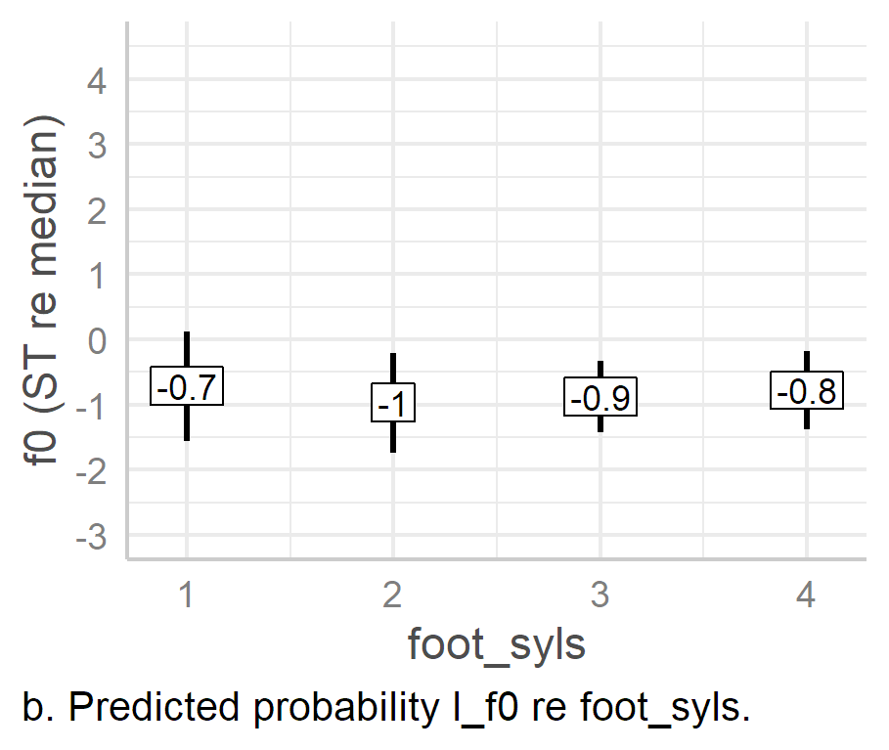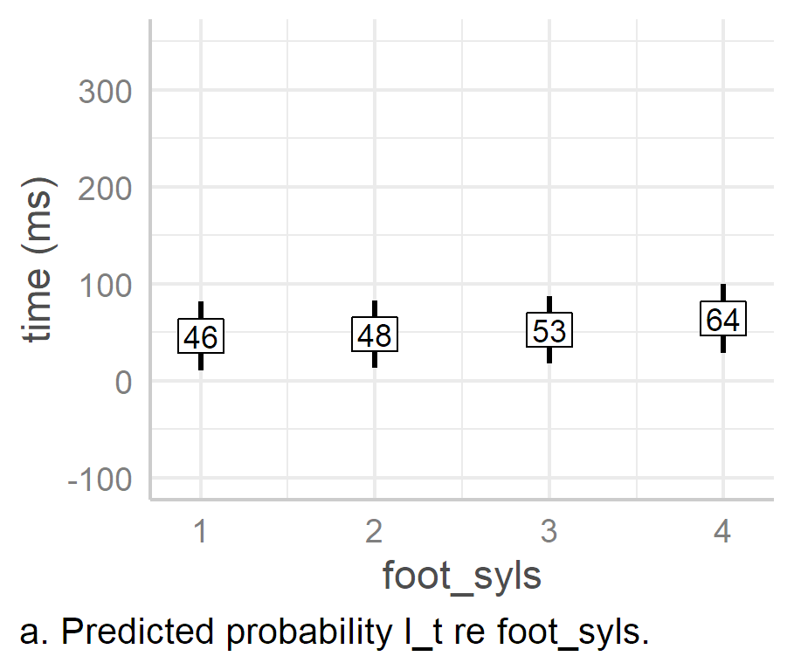

Figure .. Predicted values of L targets based on foot size effects alone in LMEMs.

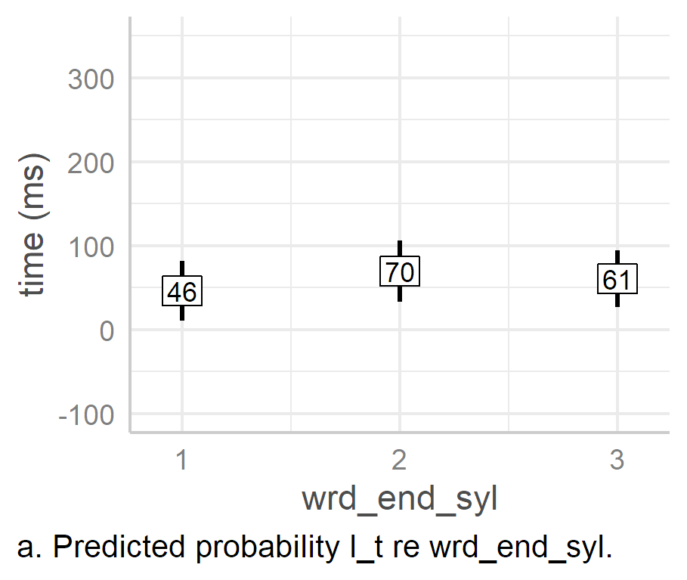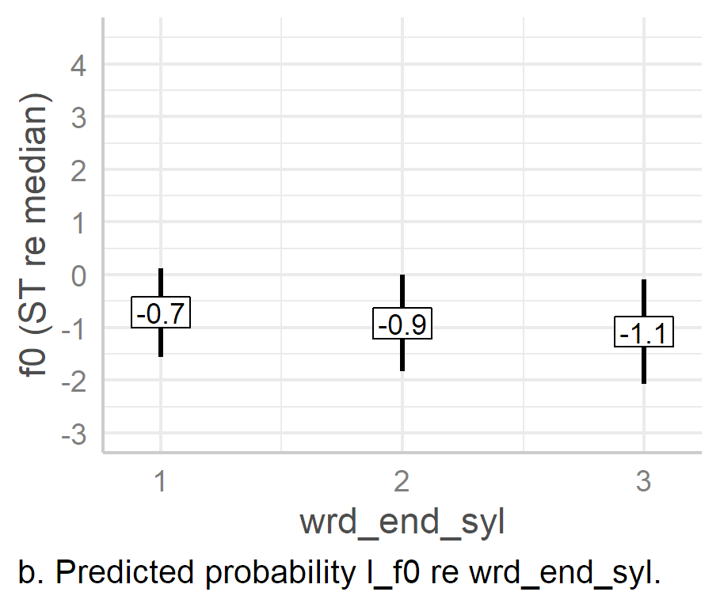

Figure .. Predicted values of L targets based on word-end syllable effects alone in LMEMs.

The number of syllables in the foot (foot_syls) has almost no effect on either the timing or *f*0 of the L target (Figure 6.11), which is unsurprising as we expect foot size to have a stronger effect on H targets that on L targets, especially in L*H. However, it is surprising—at least superficially—that there is a word boundary effect (wrd_end_syl) on the timing of the L target (Figure 6.12a). When the word boundary is at the end of the stressed syllable (wrd_end_syl1), the predicted timing of the L boundary is quite early at 46 ms, 95% CI [11, 82], but it is later when the word boundary is at the end of the second or third syllable, at 70 [34, 106] ms and 60 [27, 95] ms respectively. The estimated difference between the first- and second-syllable boundary is 24 [12, 35] ms and while it is 15 [-10, 39] ms between the first and third syllable , *p <* .001 and *p* = .249 respectively. The estimated difference between the second- and third-syllable boundaries is even smaller again, at 9 [-31, 13]ms, *p* = .42. While the difference between the first- and third-syllable boundary is not statistically significant, we do still see a general trend towards later alignment once the word boundary is no longer coterminous with the stressed syllable. This suggests that the true difference may be between words which end in the stressed syllable and those which end later.

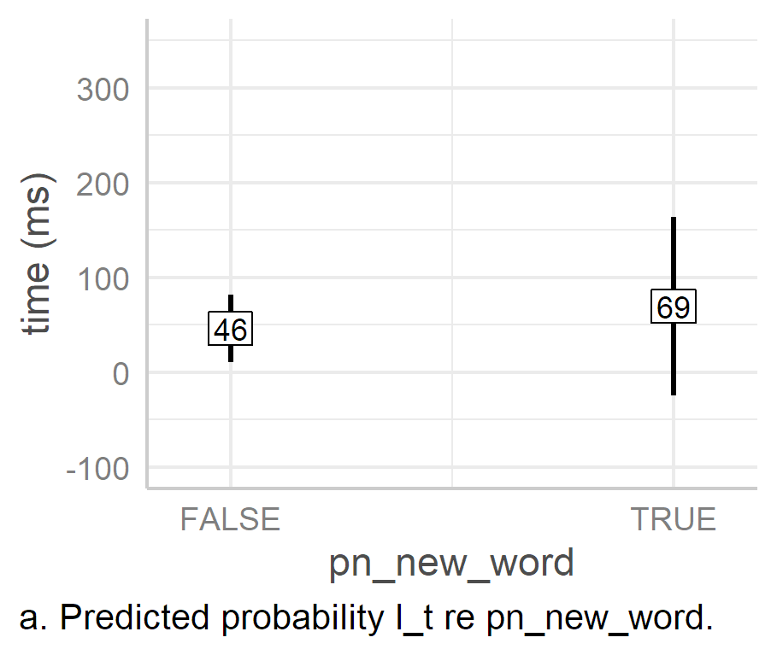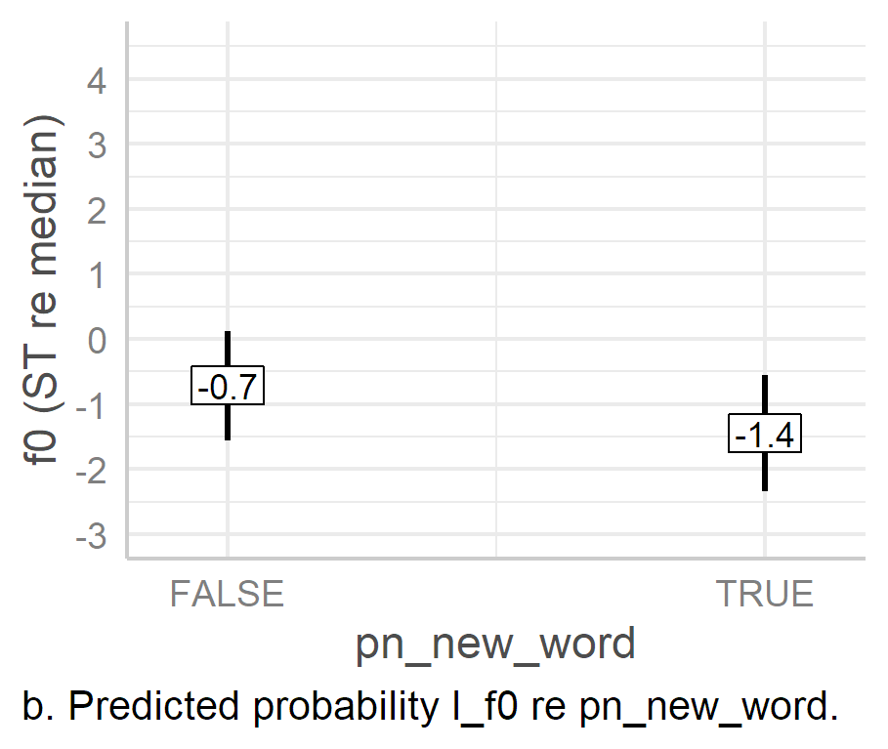

Figure .. Predicted values of L targets based on word boundary effects at foot onset alone in LMEMs.

In contrast to the word-end syllable, there is no significant alignment effect on l_t when the foot begins with a new word (pn_new_word) (Figure 6.13a). Even though the effect of the True condition appears be associated with later alignment of the L target—that is 69 ms as opposed to 46 ms in the False condition, 95% CIs [-25, 164], [11, 82]—the extremely large confidence interval for the true condition renders any claim about this effect spurious.

There is a significant effect of pn_new_word on l_f0, as can be seen in Figure 6.13b. A foot beginning with a new word is associated with an estimated 0.7 ST lowering *f*0 in the L target, 95% CI [-1.2, 0.2], *p =* .003. While such an effect was not originally considered, and the reason for it is not completely clear, the lower *f*0 may help to indicate juncture between the previous word and the current word.

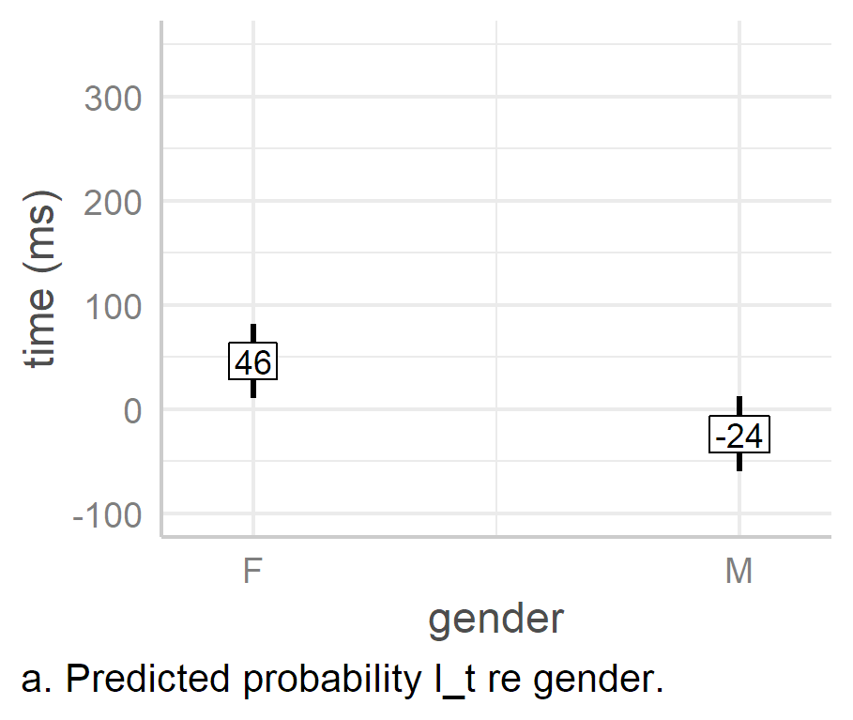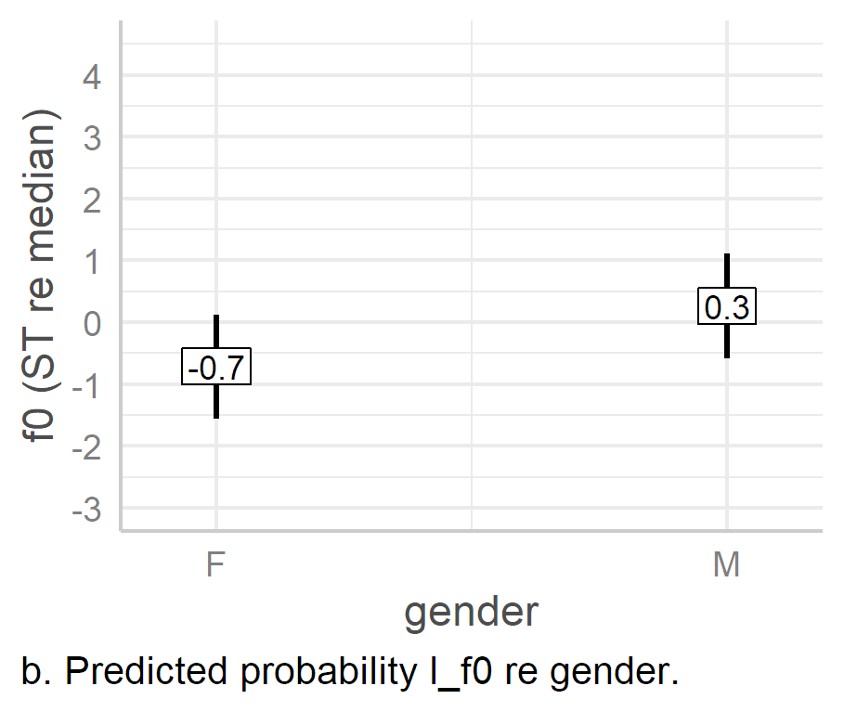

Figure .. Predicted values of L targets based on gender alone in LMEMs.

Finally, the effect of gender on alignment is striking (Figure 6.14), with the male speakers aligning the L target an estimated 70 ms earlier than females, 95% CI [-86, -55], p. < .001. This effect is consistent across PN and nuclear PAs, both in the timing of L targets and H targets (see below). There is also a significant effect of gender on the height of the L target, with an estimated mean group increase of 1 [0.3, 1.6] ST, *p =* 0.011 for the genderM (male speakers) condition compared with the intercept (female speakers). This effect will be seen again in PN h_f0, but not in the nuclear pitch accents.

#### L Targets and the Absence versus Presence of Anacrusis.

Having analysed effects on PN l_t and l_f0, it seems that the effect of anacrusis on the timing of the L target may be more accurately be viewed in term of to the presence or absence of anacrusis. Similarly, the effect of the word-end syllable on the L target may essentially be a matter of whether or not the word and the stressed syllable are coterminous. To test this, an additional model was constructed. Non-significant factors from the first l_t model were removed. ana_syls was replaced with has_anacrusis, a logical parameter which is true when the phrase includes anacrusis. wrd_end_syl was replaced with a logical parameter called wrd_end_syl_late, which is true when the word-end syllable is not the stressed syllable, i.e., when it is the second or third syllable of the foot, as suggested by the analysis above. The model, including random effects, is shown in Equation 6.4.

|  |  |
| --- | --- |
| l_t ~ acc_phon + has_ana_syls + wrd_end_syl_late + gender  + (1 + foot_syls | speaker) + (1 | pn_str_syl) | (6.) |

An ANOVA of the model indicates that acc_phon (as before) is significant and so too is gender, with *F*(1, 171.95) = 15.66, *p.adj* < .001 and *F*(1, 9.38) = 139.6, *p.adj* < .001 respectively. While the effect of has_ana_syls, is not significant, word_end_syl_late is, with *F*(1, 454.9) = 24.75, *p.adj* = .547 and *F*(1, 454.9) = 139.6, *p.adj* < .001 respectively. The model has a marginal *R*2 of .29 and a conditional *R*2 of .86. Thus, while the amount of variance explained by fixed effects of the model is lower than the original l_t model (29% as opposed to 42%), the overall variance is roughly the same (86% as opposed to 83%). The full output and tables for this model can be found in Appendix H4.

When we look at the estimated slopes of the fixed effects (see Figure 6.15), we see that the presence of anacrusis (has_ana_syls) has almost no effect anyway, with an estimated mean effect of 4 ms, 95% CI [-5, 12]. As such, the earlier impression it is simply the addition of anacrusis which causes the earlier alignment of the L target is not supported. The late word-end syllable (word_end_syl_late) is associated with an estimated later alignment of 27 [16, 37] ms. This appears to confirm the interpretation of the original l_t model, namely that the more appropriate interpretation word boundary effects on the alignment of the L target relates to whether or not the stressed syllable and the word-end syllable are coterminous with the word-end syllable. When they are coterminous, the L target is aligned earlier.

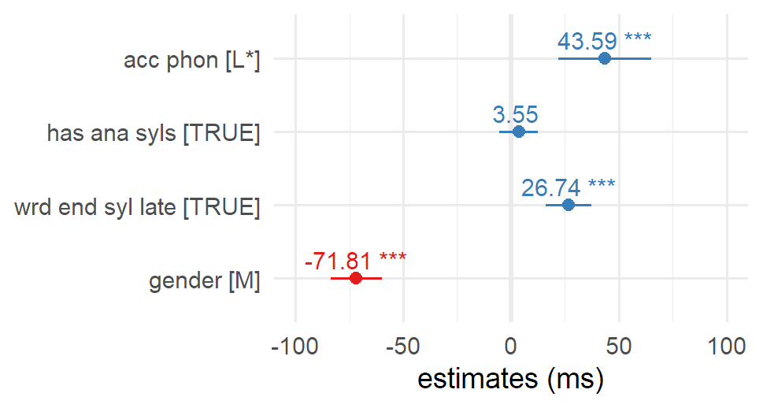

Figure . Estimated effects from the model l_t ~ acc_phon + has_ana_syls + wrd_end_syl_late + gender + (1 + foot_syls | speaker) + (1 | pn_str_syl).

#### H targets.

An ANOVA of the h_t model indicates statistically significant effects for acc_phon, ana_syls, and foot_syls, at *F*(2, 381.5) = 147.4, *p.adj* < .001, *F* (3, 14.2) = 19.84, *p.adj* < .001, and *F*(3, 28.44) = 12.5, *p.adj* < .001 respectively. The model has a marginal *R*2 of .59 and a conditional *R*2 of .83. This indicates that the fixed effects explain the majority of the variance in h_t (59%), a larger amount than was explained by the l_t model (42%). An ANOVA of the h_f0 model also indicates two significant effects, foot_syls, and gender, *F*(3, 26.42), *p.adj* = .024 and *F*(1, 9.42), *p.adj* <.001 respectively. The model has a marginal *R*2 of 0.23 and a conditional *R*2 of 0.46. This means that the fixed effects in the h_f0 model explain 42% of the variance in the response parameter, noticeably higher than the 19% explained by the l_f0 model. The fact that the fixed factors in the H target models explain a greater deal of the variance than they did in the L target models suggests that the H target is generally more susceptible to metrical, lexical, and gender effects. (Complete model analysis and tables can be found in Appendices H5 and H6.)

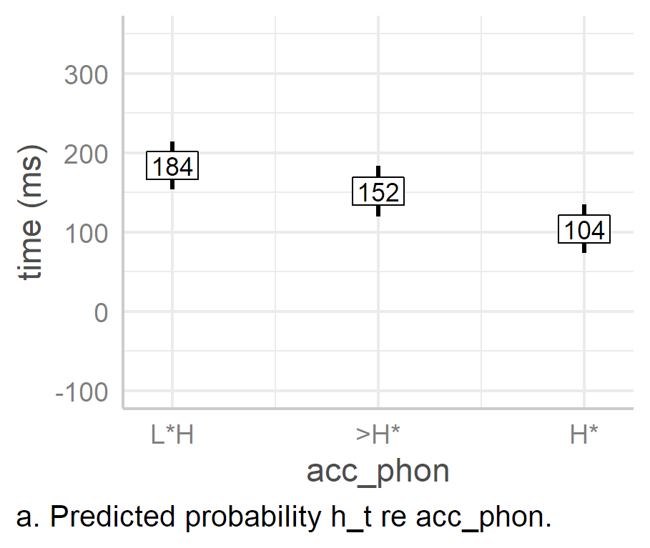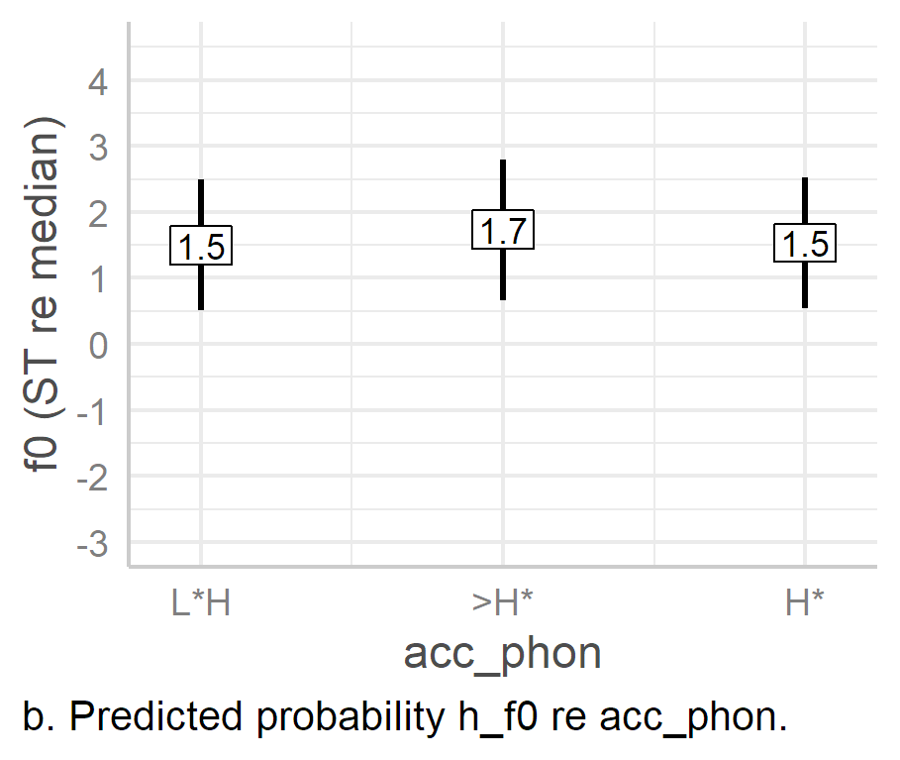

Figure .. Predicted values of H targets based on pitch accent effects alone in LMEMs.

Figure 6.16 shows the predicted values of h_t as an effect of pitch accent alone (L*H, >H*, and H*). We see a noticeable staged decrease in the mean estimated timing of the H targets, from 184 ms in L*H, down to 152 ms in >H*, with H* the earliest, at 104 ms, 95% CIs [154, 214], [120, 184], and [73, 135] respectively. These results simply reflect the intuited distinctions in timing across the three pitch accent types. In contrast, there is almost no difference between the estimated mean *f*0 of each pitch accent types, at 1.5 ST for both L*H [0.5, 2.5] and H* [0.7, 2.8], and a mere 0.2 ST higher at 1.7 [0.54, 2.53] ST for >H*

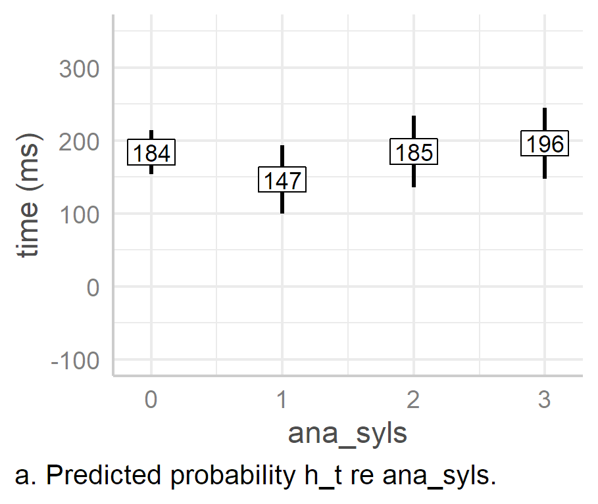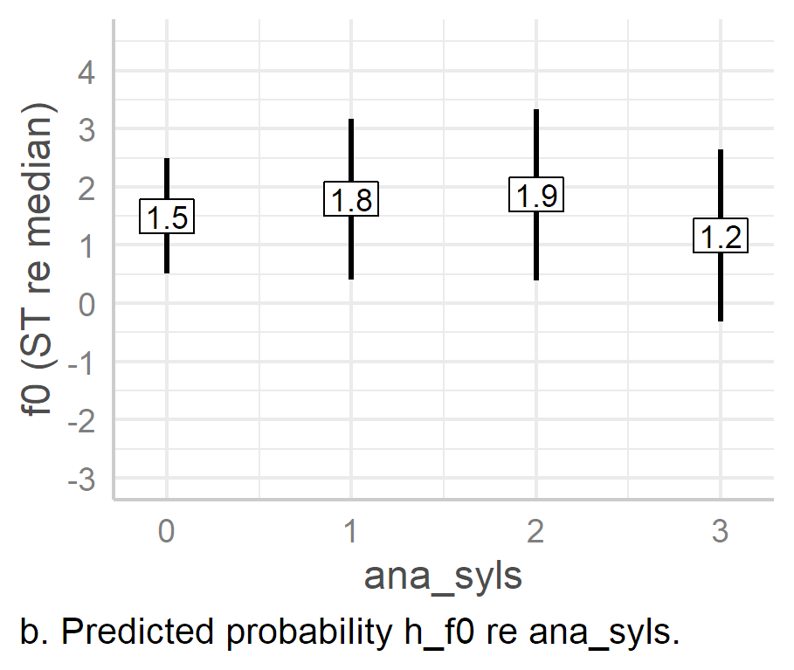

Figure . Predicted values of H targets based anacrusis effects alone in LMEMs.

The predicted effects of anacrusis on the alignment of H targets look odd (Figure 6.17a). It appears that, with the addition of a single syllable of anacrusis, mean estimated time of h_t falls from 184 ms to 147 ms, 95% CIs [154, 214] and [100, 194], giving the impression that the addition of anacrusis leads earlier alignment of h_t. However, once a second is added, estimated mean alignment returns to roughly the same the zero-anacrusis condition and then 10 ms later in the three-syllable condition, at 185 [136, 234] and 196 [147, 245] ms respectively. Thus, the current study suggests that the addition of anacrusis does lead to earlier H alignment, but that these effects are lost with further syllables of anacrusis.

When it comes to the effects of anacrusis on h_f0, it seems that the addition of anacrusis is associated with an increase in *f*0, but that the effect dissipates beyond the two-syllable conditions (Figure 6.17b). The only significant differences, however, are between the one- and two-syllable conditions and the three-syllable condition, at -0.6 and -0.7 ST respectively, 95% CIs [-1, 1] and [-1.2, -0. 2], *p* = 0.017 and 0.009 respectively.

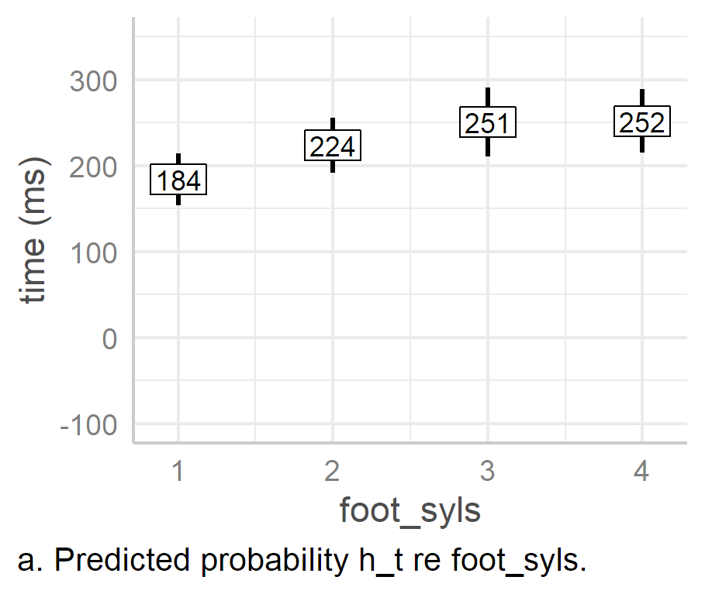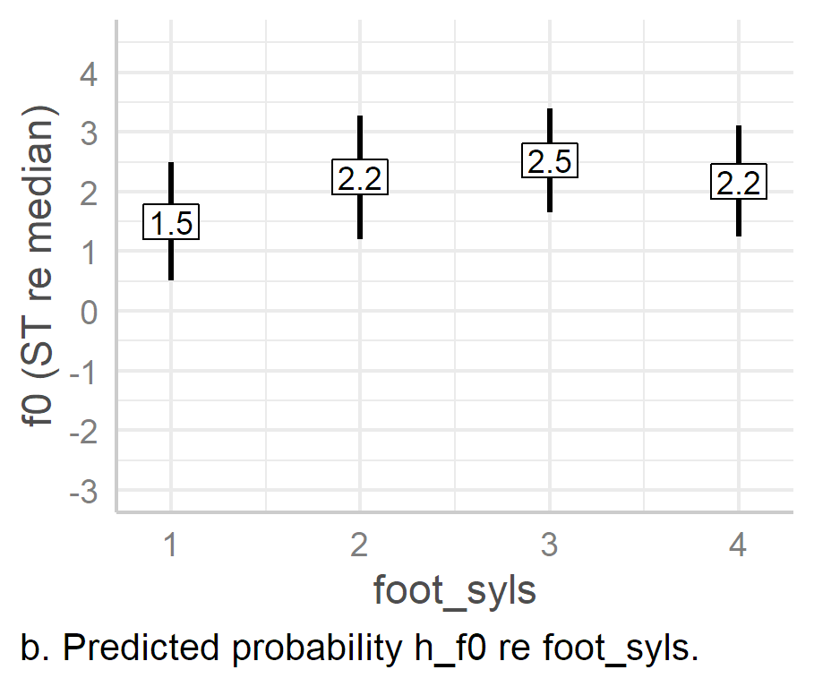

Figure .. Predicted values of H targets based foot size effects alone in LMEMs.

The effect of foot size on peak alignment is clear, as seen in Figure 6.18a. That is, as foot size increases, the alignment of the peak is later, but the effect only extend up to three syllables, after which the timing does not change. This is interesting, as it matches the effect of foot_syls on the likelihood of L*H (see section 6.5.4 above), wherein the estimated likelihood of L*H increases until it reaches saturation point in the four-syllable condition. Together, these results suggest that increasing foot size effects plateau at three syllables. This is very clear when we compare the estimated differences between neighbouring foot-size conditions. The estimated difference between each condition dissipates from 40 ms between the one- and two-syllable conditions, to 27 between the two- and three-syllable condition, until a negligible 1 ms between the three- and four-syllable conditions, 95% CIs [22, 58], [1, 53], [-18, 20] and *p* < .001, *p* = .043, p = .899 respectively.

The estimated effects of foot size on h_f0 (Figure 6.18b) are quite similar to those on h_t. That is, as foot size increases, *f*0 also increases. However, in this case, it seems that rather than stabilizing at the three-syllable condition, the effect seems to wear off, so to speak, in the four-syllable condition. That is, after rising to an estimated 2.5 ST, 95% CI [1.7, 2.4] in the three-syllable condition, it falls back down to 2.2 [1.2, 3.1] ST, roughly where it was in the two-syllable condition, i.e., 2.2 [1.2, 3.3] ST. However, these estimates are still all very similar, differing by at most 0.3 ST. The greatest estimated differences are between the one-syllable condition and the others. The two-syllable condition an estimated 0.7 [0, 1.4] ST higher, the three-syllable conditions an estimated 1 [0.4, 1.6] ST higher, and the four-syllable condition an estimated 0.8 [-0.7, 1.6] ST higher, *p* = 0.039, 0.002, and 0.155 respectively. Despite the fact that the difference between the one- and four- syllable conditions is not statistically significant, there is still a general effect on *f*0, whereby a greater number of syllables is associated with higher *f*0 scaling.

Figure . Predicted means and 95% CIs of L and H PN targets from LMEMs based on foot-size effects.

The one-syllable condition is an instance of stress clash, and it appears that anticipation of the upcoming low of the next pitch accent (which is always L*H) leads to a damping of the *f*0 peak. Given that both h_t and h_f0 increase and then become stable at a point beyond the one-syllable condition, it seems that the PN pitch accent rise is truncated in the stress-clash condition. When the predicted means of the L target and H target parameters are plotted together for each level of foot_syls, we see that truncation does indeed appear to occur as a function of stress-clash in the one-syllable foot conditions, as shown in Figure 6.19 above. Truncation and compression are considered further in Section 6.6.3.4

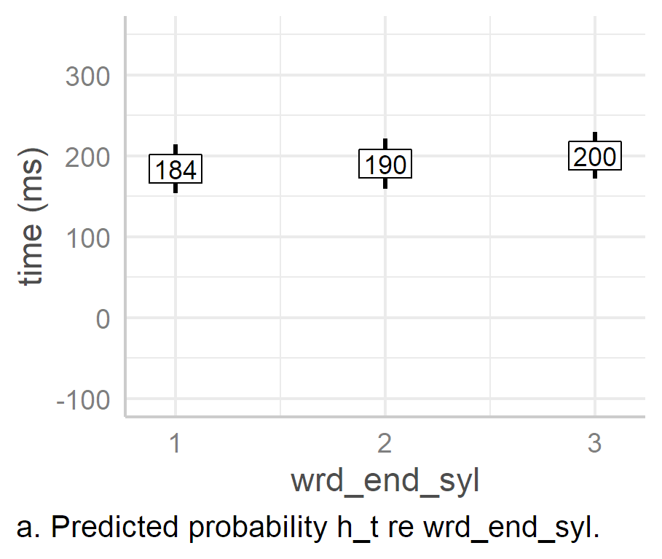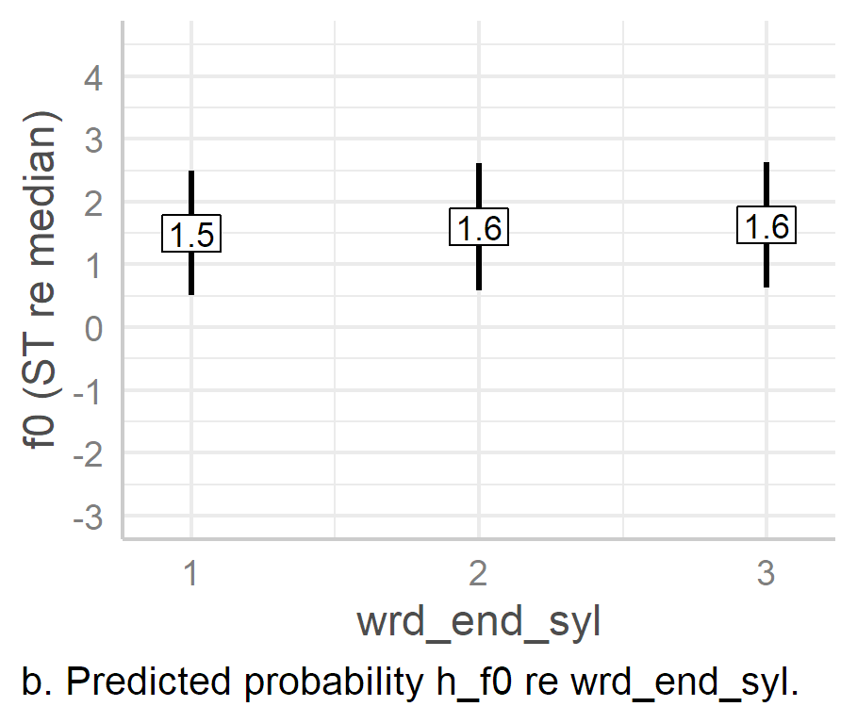

Figure .. Predicted values of H targets based on word-end syllable effects alone in LMEMs.

As can be seen in Figure 6.20, there is essentially no effect of the word-end syllable on either the alignment or *f*0 of the PN peak. There is an estimated mean difference of 6 ms and 16 ms in the alignment of the second- and third-syllable word-end conditions respectively, 95% CIs [-6, 19] and [-13, 46], *p* = .34 and .273 in turn, when compared to the first-syllable word-end condition. The difference in *f*0 is even less pronounced, at 0.1 [-0.4, 0.6], [-0.9, 1.2] ST in each case, *p* = .665, .787 for the second- and third-syllable word-end conditions respectively.

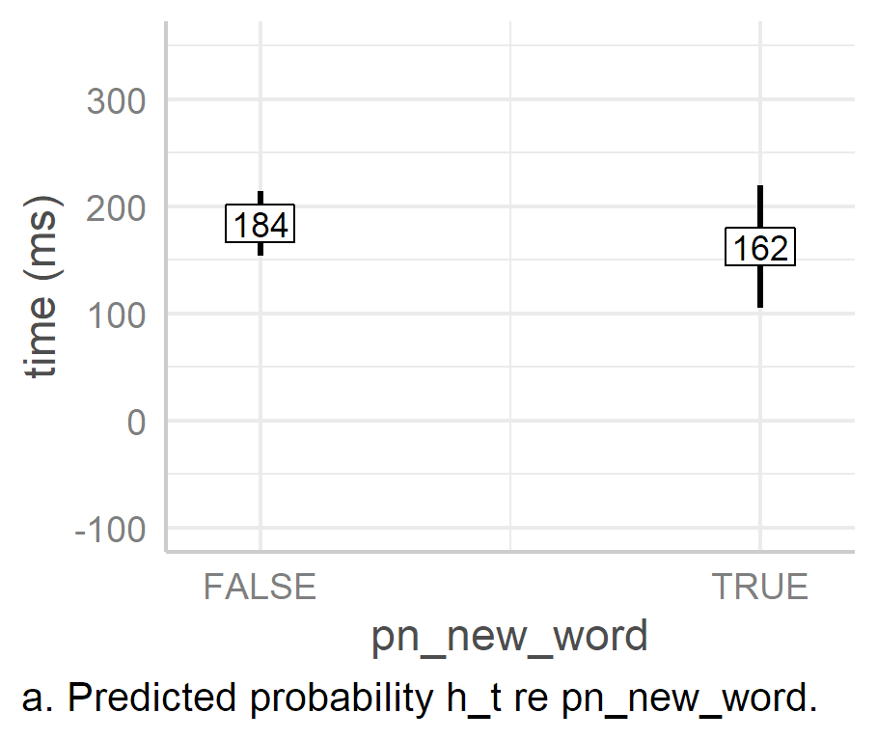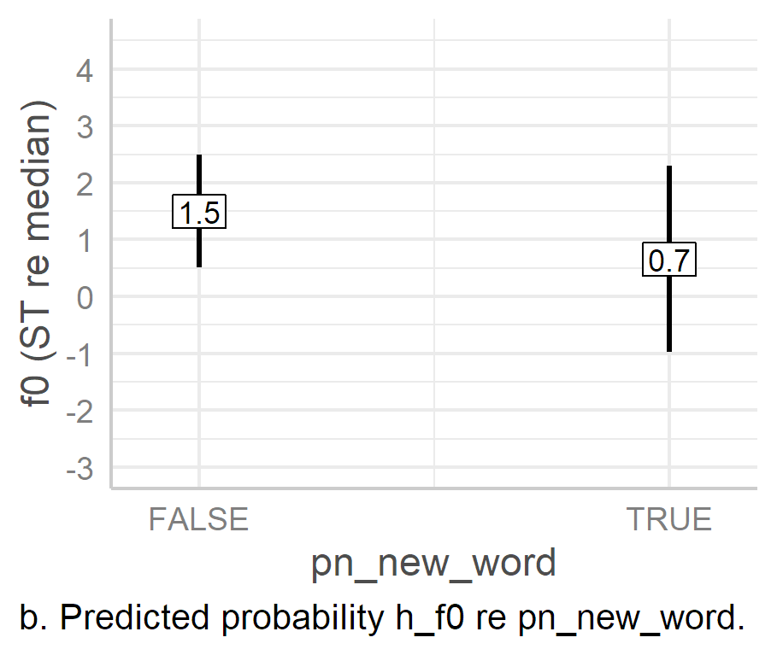

Figure . Predicted values of H targets based on word boundary effects at foot onset alone in LMEMs.

Superficially, it appears that when the foot begins with a new word (Figure 6.21), the H target is aligned slightly earlier, and the peak is slightly lower, with estimated difference in the true condition of -22 ms and -0.8 ST in each case, 95% CIs [-80, 38], [-2.8, 1.1] and *p* = .403, 0.288 respectively. However, the CIs for each true condition are large, with each CI stretching well into a positive effect, indicating that the mean estimates are far from reliable (and so the high *p* values).

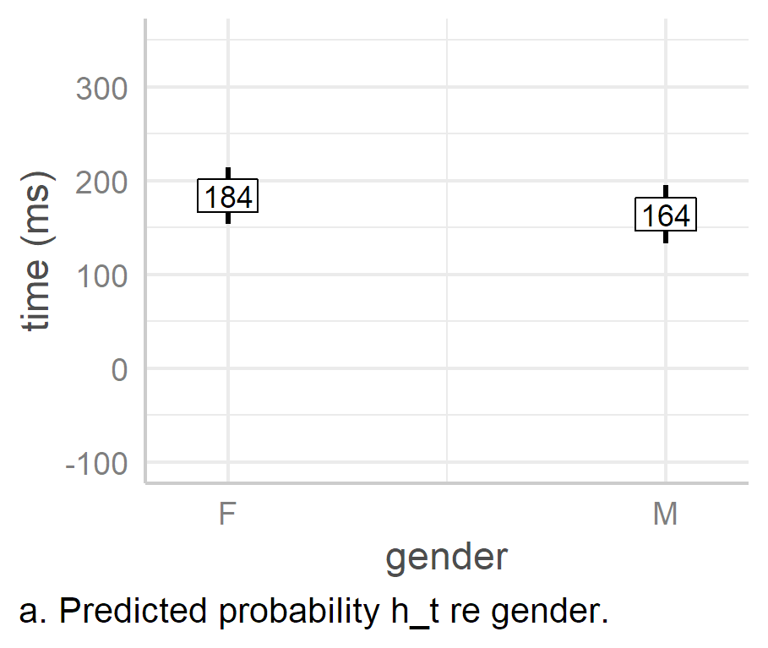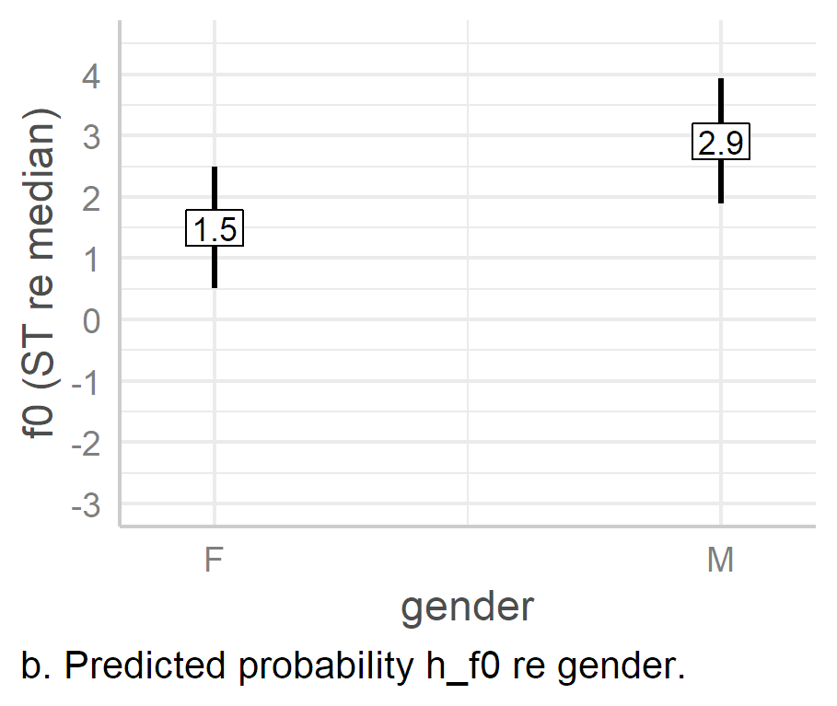

Figure .. Predicted values of H targets based on gender effects alone in LMEMs.

As with the L targets, the effect of gender is quite striking, with the male speakers once again aligning the peak 20 ms earlier than the female speakers, 95% CI [-43, 3.4], p = .086, but in this case the CI is larger, with the upper CI extending above zero, rendering the difference statistically non-significant. However, this does still reflect the pattern seen with the L target. On average, male speakers realise the *f*0 peak 2.9 [1.9, 3.9] ST above their median *f*0, which is an estimated 1.4 [0.9, 1.9] ST higher than the estimated female peak, p < .001. This reflects the trend seen in the L *f*0 target.

#### PN Peak Alignment and Anacrusis Effects in L*H and H*.

Given the strange results of the effects of anacrusis on h_t, it seemed worth further investigation. Based on the results above, we know that the peak alignment in >H* and H* is progressively earlier compared to L*H. However, when we look at the distribution of PN pitch accents by ana_syls in the PN h_t data, we see that there are only four examples each for ana_syls2 and ana_syls3, with no examples of H* in either condition (see Table 6.20).

Table . Number of pitch accents per ana_syls condition in the data set for the h_t model (n = 737).

|  |  |  |  |
| --- | --- | --- | --- |
| ana_syls | >H* | H* | L*H |
| **0** | 21 | 60 | 211 |
| **1** | 20 | 139 | 175 |
| **2** | 4 | 0 | 52 |
| **3** | 4 | 0 | 51 |
|  |  |  |  |

h_t was retested using two subsets of the data, one containing only L*H and another only H* pitch accents.[13] Each new dataset was tested using the model in Equation 6.5:

|  |  |
| --- | --- |
| h_t ~ ana_syls + (1 | speaker) + (1 | gender)  + (1 | foot_syls) + (1 | pn_str_syl) | (6.) |

An ANOVA of the L*H-only model showed a significant effect of ana_syls, *F*(3, 364) = 23.4, *p.adj* < .001, but an ANOVA of the H*-only model did not, *F*(1, 5.76) = 2.3, *p.adj* < .257. The marginal *R*2 of the L*H-only was .1, with a conditional *R*2 of .82. In the H*-only model they were .13 and .61 respectively, so ana_syls accounts for a similar amount of variance in each model.

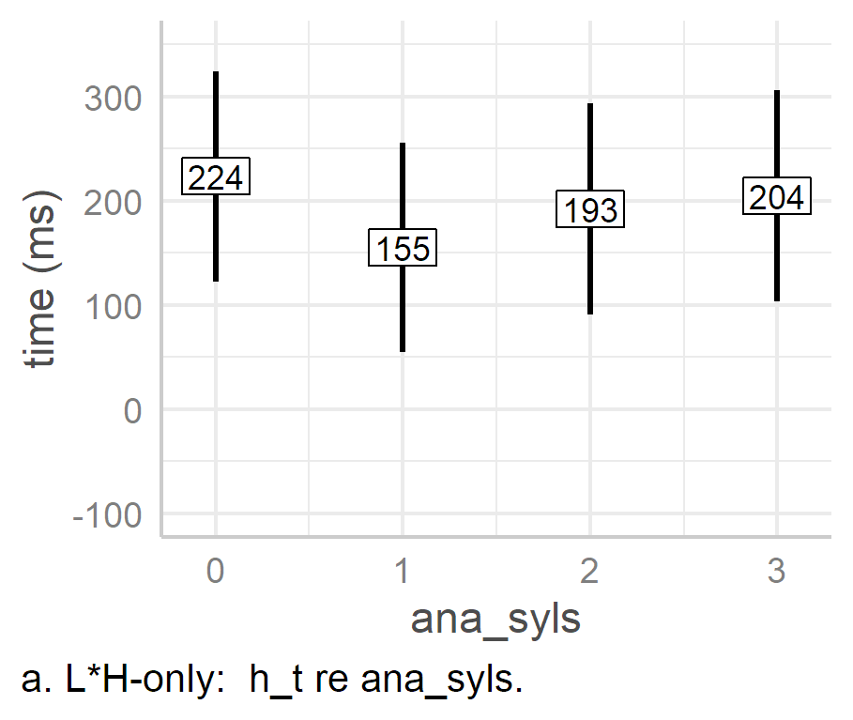 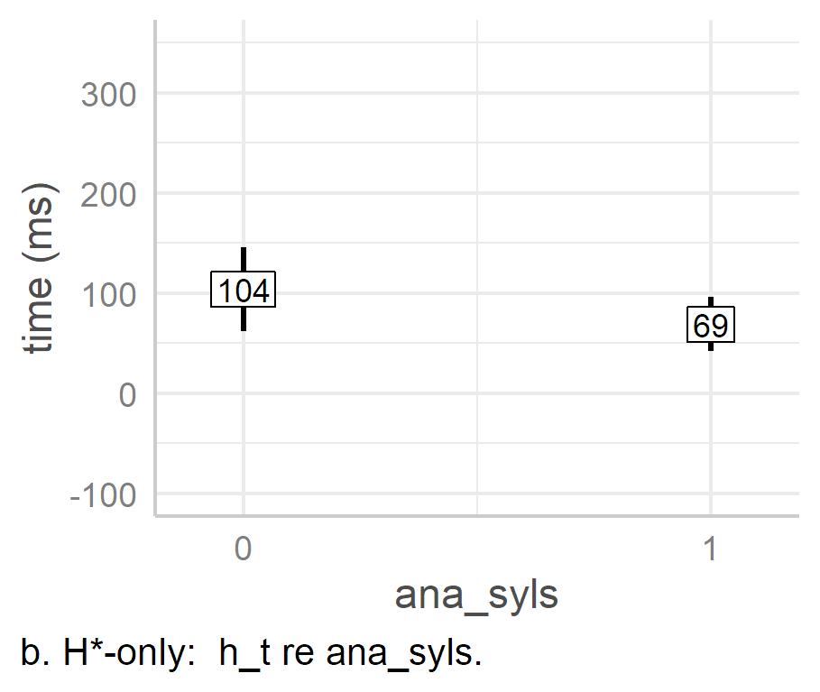

Figure . h_t modelled re the effects of ana_syls from L*H-only and H*-only data sets.

Figure 6.23 shows the predicted peak alignment as an effect of ana_syls in the L*H-only and H*-only models, in panels a and b respectively. We see that, as expected, predicted peak alignment in the H* model is much lower than in the L*H model.

The L*H model looks quite similar to the original model, with peak alignment falling in the one-syllable condition and the rising progressively in the two- and three-syllable conditions. However, because the leftward alignment effect of H* has been removed, we see that in the zero-anacrusis condition, the peak is aligned noticeably later. That is, in the L*H-model, the predicted alignment of h_t is 224 ms, 95% CI [123, 325] compared to 184 [154, 214] ms in the original model. Thus, when there is no anacrusis at all, peak alignment is noticeably late, but as more anacrusis is added, the peak slowly drifts rightward again. Moreover, unlike the original model, estimated h_t in the L*H model is always earlier than the zero-anacrusis condition once anacrusis is added to the beginning of the phrase. In fact, all three conditions with anacrusis are significantly earlier then the zero-anacrusis condition, by 68 [‑85, ‑51], 31 [‑48, ‑14], and 19 [‑36, ‑2] ms in the one-, two-, and three-syllable conditions, *p* < .001, *p* < .001, *p* = .028 respectively. The estimated peak in the one-syllable condition of the H*-model only model is also earlier than the zero-anacrusis condition, by 35 [-92, 22] ms, *p* = .183, but this is not a statistically significant difference.

Overall, this reanalysis helps shed light on the effect of anacrusis on PN peaks. Essentially, we see that a lack of anacrusis causes a significant delay in peak alignment, while the addition of anacrusis allows it to be aligned earlier. However, with the addition of further syllables of anacrusis, the peak begins to drift rightwards again.

#### Stress-clash Effects on PN H Targets.

Because of the apparent effect of stress clash on h_t and h_f0, two additions tests were conducted, one on each response parameter. Non-significant fixed effects were removed from the model, while significant effects which were not of interest were treated as random intercepts. A new logical factor, stress_clash, was added, which is true if there is only one syllable in the foot. The model was further reduced by running the step() function (see section 5.4.1) and removing non-significant random effects. The h_t model, however, would not converge unless acc_phon was retained as a fixed effect. The final two models are shown in Equations 6.6 and 6.7.

|  |  |
| --- | --- |
| h_t ~ stress_clash + acc_phon + (1 + stress_clash | speaker)  + (1 | gender) + (1 | pn_str_syl) | (6.) |
| h_f0 ~ stress_clash + (1 + stress_clash | speaker)  + (1 | gender) + (1 | pn_str_syl) | (6.) |

ANOVAs of the models suggest that stress_clash is significant, *F*(1, 20.57) = 28.86, *p.adj* < .001 in the h_t model, and *F* (1, 17.29) = 8.74, *p.adj* = 0.21 in the h_f0 model. (acc_phon is also significant in the h_t model, *F*(2, 527) = 145.26, *p* < .001, but this is not of interest here.) The marginal *R*2 of the stress-clash h_t model is .26, with a conditional *R*2 of .74, indicating that the overall variance explained by the fixed factors in the alternative model is much less than that of the original—which was .59—but the variance explained by the whole model is only slightly less than the original, which was .83. The marginal *R*2 of stress-clash h_f0 model is 0.02, very low compared to the original (.23), while there is little difference in the conditional *R*2 of the original and alternative models, at .44 and .46 respectively. The similarity of the conditional *R*2 in each original and alternative model reflects the fact that the full alternative models have shifted most of the fixed effects to random effects. Full reporting of the stress-clash h_t and h_f0 models can be found in Appendices H7 and H8.

The presence of stress_clash in h_t was associated with an earlier estimated mean alignment of 54 ms, 95% CI [-75, -33], *p.adj* < 0.001. The effect of stress_clash on h_f0 was also significant, as the presence of stress clash was associated with a lowering of peak *f*0 by an estimated mean of 0.88 [-1.5, -0.3] ST, *p* = .006. This suggests, therefore, that the main effect of foot size on the H target may be better interpreted by the absence or presence of stress clash rather than the total number of syllables in the foot.

#### Truncation and Compression.

An ANOVA of the f0_exc model indicates a significant effect of foot_syls on *f*0 excursion, *F*(3, 306.15) = 4.95, *p.adj­* = .006. However, an ANOVA of the log_lh_slope model indicates that there is no significant effect of foot_syls on the slope of the L*H rise, *F*(3, 184.88) = 1.19, *p.adj.* = .418. The marginal *R*2 of the f0_exc is .03, while the conditional *R*2 is 0.56, indicating that foot size only accounts for 3% of the variance *f*0 excursion. For the log_lh_slope model, the marginal *R*2 is .01 with a conditional *R*2 of .46, indicating that foot size accounts for merely 1% of the variance in *f*0 slope.

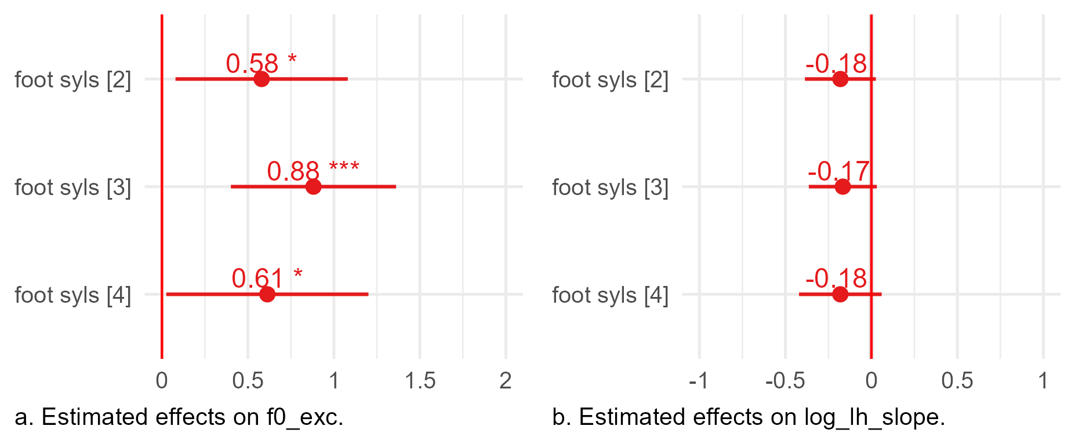

Figure .. Estimated effects of foot size on f0 excursion and log slope of PN L*H from LMEMs. The vertical red line indicates the zero-effect of the intercept, foot_syls[1].

Beginning with the effect of foot_syls on f0_exc, we see—as shown in Figure 6.24a—that the two-, three-, and four-syllable conditions are all associated with 0.6 to 0.9 ST increases in *f*0 when compared to the one-syllable condition (the intercept), and all are significantly different from it, 95% CIs [0.1, 1.1], [0.4, 1.4], and [0, 1.2,], *p* = 0.24, < .001, and .041 respectively. Conversely, there is little estimated difference in *f*0 excursion among the effects of the two-, three-, and four-syllable conditions themselves, with mean estimates ranging between zero and 0.3 semitones and all CIs crossing zero. These are summarised in Table 6.21. These results suggest that in the presence of stress clash, the *f*0 excursion is typically just over a half a semitone lower.

Table . Results of LMEM comparison of effects of two-, three-, and four-syllable feet on f0 excursion in PN L*H pitch accents.

|  |  |  |  |  |  |  |  |  |
| --- | --- | --- | --- | --- | --- | --- | --- | --- |
| intercept | Slope | est. (ST) | 2.5% CI | 97.5% CI | SE | |t| | df | p |
| foot_syls2 | foot_syls3 | 0.3 | -0.1 | 0.7 | 0.22 | 1.39 | 274.89 | .166 |
| foot_syls2 | foot_syls4 | 0.0 | -0.5 | 0.6 | 0.28 | 0.12 | 216.89 | .904 |
| foot_syls3 | foot_syls4 | -0.3 | -0.6 | 0.1 | 0.18 | 1.48 | 403.29 | .139 |

Turning to slope, it is clear—as shown in Figure 6.24b—that there is little effect on log_lh_slope across foot_syls conditions. The estimated differences between one-syllable condition (the intercept) and the two-, three-, and four- syllable conditions are ‑0.18, ‑0.17, and ‑0.18 log(ST/s) respectively, 95% CIs [-0.39, 0.27], [-0.36, 0.32], and [-0.42, 0.06], *p* = .088, .1, and .142 in turn. The mean estimates of the effects of the non-stress clash conditions are almost identical, with each slightly lower than the stress-clash condition. However, even this difference is quite small, and it is not statistically significant (rows one to three of Table 6.22).

Table . Results of LMEM comparison of effects of two-, three-, and four-syllable feet on log L*H slope in PN pitch accents.

|  |  |  |  |  |  |  |  |  |
| --- | --- | --- | --- | --- | --- | --- | --- | --- |
| intercept | slope | est. (ST) | 2.5% CI | 97.5% CI | SE | |t| | df | p |
| foot_syls1 | foot_syls2 | -0.18 | -0.387 | 0.027 | 0.11 | -1.72 | 191.38 | 0.088 |
| foot_syls1 | foot_syls3 | -0.17 | -0.365 | 0.032 | 0.10 | -1.65 | 177.07 | 0.1 |
| foot_syls1 | foot_syls4 | -0.18 | -0.423 | 0.061 | 0.12 | -1.48 | 130.36 | 0.142 |
| foot_syls2 | foot_syls3 | 0.07 | -0.25 | 0.37 | 0.14 | 0.52 | 12.75 | .609 |
| foot_syls2 | foot_syls4 | 0.05 | -0.24 | 0.34 | 0.14 | 0.37 | 16.38 | .719 |
| foot_syls3 | foot_syls4 | -0.02 | -0.25 | 0.21 | 0.11 | -0.19 | 21.04 | .848 |
|  |  |  |  |  |  |  |  |  |

From the point of view of perception, these differences in slope are also most likely indistinguishable. For example, ’t Hart, et al.’s seminal study of pitch perception found that the differential threshold of pitch change was best measured as measured as *g*1/*g*2, where*g* refers to the glide or slope measured in ST/s. For listeners to distinguish between two glides, there needed to be a difference of at least a factor of two between glides (’t Hart et al., 1990, pp. 33–35). In the current analysis, when the mean estimated slopes are converted back into their non-logged counterparts (Figure 6.25) and compared in this way (Table 6.23), we see that there is likely almost no perceptual difference between each glide. As indicated by Table 6.23, the differential is only 1.2 even between the one-syllable condition and the others, greatly below the threshold for differentiation between slopes. (It should be noted that in the original experiments outlined by ’t Hart et al., this threshold was established based on perception experiments of non-speech pitch glides. It should also be noted that the slopes mentioned here are not actual slopes, but rather estimates abstracted from a model. Therefore, the analysis using the differential threshold should be seen as suggesting rather than confirming the extent of similarity and difference between slopes.)

Figure . Visual representation of slope in ST/s as an effect of foot-size in PN pitch accents.

Table . Differentials of pitch change in foot_syl conditions, i.e., ratio between slopes measured in ST/s.

|  |  |  |  |
| --- | --- | --- | --- |
|  | foot_syls1 | foot_syls2 | foot_syls3 |
| foot_syls2 | 1.2 |  |  |
| foot_syls3 | 1.2 | 1.0 |  |
| foot_syls4 | 1.2 | 1.0 | 1.0 |
|  |  |  |  |

In summary, there appear to be effects of stress clash on both *f*0 excursion and slope, but the effects on slope are relatively small. However, for the current purposes, we note that slope barely changes overall as a function of foot size even though the size of the excursion does change as a function of foot size. We also noted that there is a strong effect of foot size on the alignment of the H target, with longer feet being associated with later alignment up to the three-syllable condition. The earlier inference that truncation effects are in operation in the PN condition is reinforced by the fact that, while both the timing and *f*0 of the peak do change, the slope of the L*H rise barely changes at all. The overall effect is that stress-clash between the PN stressed syllable and the nuclear PA’s stressed syllable causes the rise of the L*H to be truncated. This strongly implies that speakers effectively sacrifice the full rise of the PN contour to ensure that they can realise the L of the nuclear L*H pitch accent more fully.

Together, this all suggests a hierarchy of importance. That is, the nuclear PA is more important than the prenuclear PA. In the prenuclear PA, the L target is less important than the H target and is more likely to be deleted than the H target. However, since the nuclear pitch accent is still more important than the prenuclear one, the prenuclear L*H rise (where it is not replaced by H* or >H*) is likely to be truncated in service to the nuclear pitch accent in cases of stress clash.

### Mixed-effects Modelling of Nuclear Pitch Accents and Contours

The six phonetic response parameters assessed for the prenuclear pitch accent were also tested for the nuclear pitch accent, namely, L target alignment, L target *f*0, H target alignment, H target *f*0, *f*0 excursion, and slope (see Table 6.16). In addition, temporal alignment and height of the final boundary were evaluated, with the parameter codes e_t and e_f0. The timing of the final boundary is not of interest, but it was included so that Stylised *f*0 contours could be correctly plotted (see Figure 6.38, p. 108 below).

There are several changes in the fixed effects of the nuclear models. acc_phon is not included since L*H is the only nuclear pitch accent. For similar reasons, wrd_end_syl is not used since there is only one word in the final foot. In place of ana_syls, the number of unstressed syllables in the preceding foot (pre_syls) is included as a fixed effect. The effect of the final boundary tone—either % or L%—is also included (fin_phon) in each model. The fixed parameters for nuclear PA and boundary tone analysis are summarised in Table 6.24.

Table . Fixed effects for nuclear pitch accent analysis.

|  |  |  |
| --- | --- | --- |
| **Parameter type** | **Parameter code** | **Comments / levels** |
| Foot size | foot_syls | One to four syllables |
| Preceding syllables | pre_syls | Zero to three syllables |
| Final boundary | fin_phon | Phonological tone of the final boundary, % or L% |
| Word break at foot onset | pn_new_word | True/False |
| Gender | gender | Female/Male |
|  |  |  |

Table . Random effects for nuclear PA and boundary tone LMEMs in analysis of A- and H-Corpora.

|  |  |
| --- | --- |
| Response | Random effects in model |
| l_t | (1 | speaker) + (1 | nuc_str_syl) |
| h_t |
| e_t |
| l_f0 |
| h_f0 |
| e_f0 |
| f0_exc | (1 + foot_syls | speaker) + (1 | nuc_str_syl) + (1 | pre_syls) |
| log_lh_slope |
|  |  |

As with PN analysis, all fixed effects were included in the models for the tonal target response parameters. For the *f*0 excursion and slope models, foot_syls and fin_phon were the only fixed-effect parameters, and the other parameters were treated as random intercepts. Random effects also were reduced until a maximal model without convergence or singularity issues was found. The random effects of the final models are summarised in Table 6.25.

As with the analysis of PN pitch accents, the analysis of tonal targets is presented first (L, then H, and then the boundary tone), followed by the analysis of the *f*0 excursion and slope. Again, in some cases, additional models were tested to refine the analyses. These are presented as separate subsections after the initial analysis of the associated target.

#### L Targets.

An ANOVA of the nuclear l_t model indicates two significant effects, namely pre_syls, *F*(3, 758) = 4.03, *p.adj* = .014 , and gender, *F*(1, 8.96) = 58.7, *p.adj* < .001. The model has a marginal *R*2 of 0.37 and conditional *R*2 of 0.71, suggesting that the fixed effects account for a more than a third of the variance in the response parameter. An ANOVA of nuclear l_f0, however, indicated that only the effect of foot_syls is significant, *F*(3, 543) = 8.07, *p.adj* = < .001. The l_f0 model has a marginal *R*2 of .05 with a conditional *R*2 of .36. This suggests that neither the fixed effects of the l_f0 model nor the whole model itself capture a large amount of the variance in *f*0 scaling. This may be due to the fact that, with the exception of foot_syls effects, there is little variance in the L target *f*0 at all. LMEM output and tables from which figures and statistics below are derived can be found in appendices I2 and I3 for nuclear l_t and l_f0 models respectively.

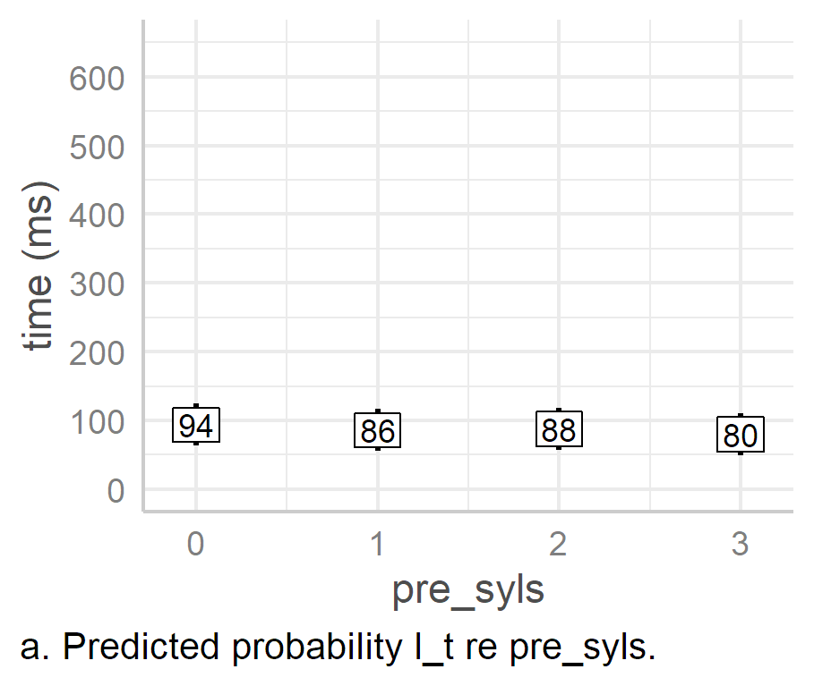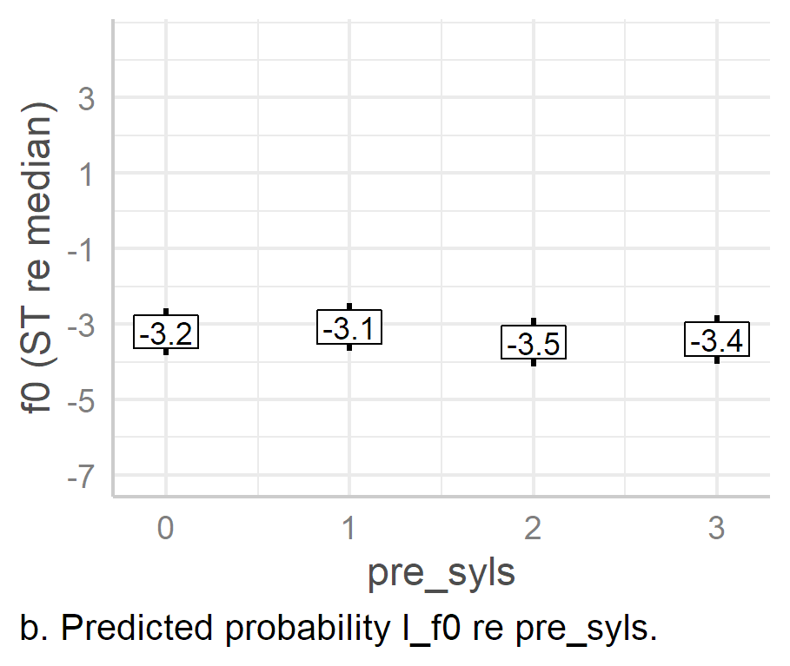

Figure . Predicted values of nuclear L targets based on pre_syls effects alone in LMEMs.

Beginning with pre_syls effects, we see that there is a gradual decrease in the predicted temporal alignment of l_t as the number of preceding syllables increases (Figure 6.26a), from 94 ms in the zero-syllable condition down to 80 ms in the three-syllable condition, 95% CIs [63, 125] and [50, 111] respectively. When we consider these differences in terms of pairwise comparison of effects between pre_syls conditions, we see that both the one-syllable and three-syllable conditions are statistically significantly different from the zero-syllable condition, each 8 [-15, -1] and 14 [-25, -2] ms earlier in turn, *p* = .026 and .019 respectively. While these are not particularly large shifts in alignment, they do suggest that there is a residual effect of stress-clash, in that the l_t is aligned slightly later in the zero-condition. The effect, however, is not as large as the effect of stress clash on h_t in the PN pitch accent, where h_t is aligned an estimated 30 ms earlier in the one-syllable condition than in the two-syllable foot condition (see Section 6.6.2, p. 82). Thus, the stress-class effect on nuclear l_t mirrors the findings in the previous section, i.e., while anticipation of a nuclear L target is associated with the earlier alignment of the PN H target in stress clash conditions, the nuclear L target is aligned slightly later. It also reinforces the view that nuclear pitch accent targets are less subject to metrical effect than prenuclear PA targets, given that the effect is noticeably smaller in the nuclear pitch accent.

The ANOVA indicates that we cannot reject the null hypothesis that pre_syls has no effect on l_f0. There does appear to be very slight division in l_f0 between the zero- and one-syllable conditions on the one hand, to the two- and three-syllable conditions on the other (Figure 6.26b), but this is essentially an effect of the order levels in the plot. If we put the mean estimates in order of height, we see that there is only a 0.2 ST difference between the two groups. That is, the zero-syllable condition is only slightly lower than the two-syllable condition, (CI [-0.6, 0.2], *p* = .334). The largest differences as an effect of pre_syls conditions are between pre_syls1 and pre_syls2 at 0.4 [‑0.7, ‑0.1] ST and between pre_syls1 and pre_syls3 at 0.3 [-0.6, 0] ST, *p* = 0.009 and 0.045 respectively. While these are statistically significant, and even though such differences may be salient when played consecutively as tones, they are still relatively small and such differences may not be salient in continuous speech.

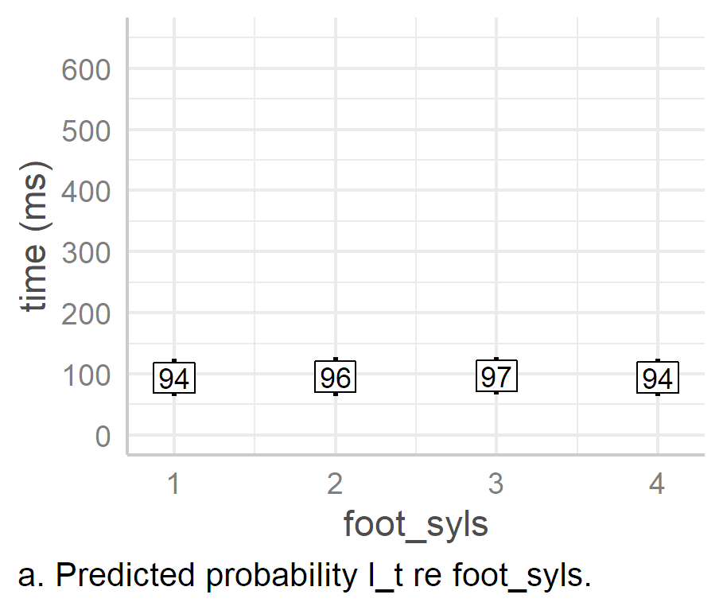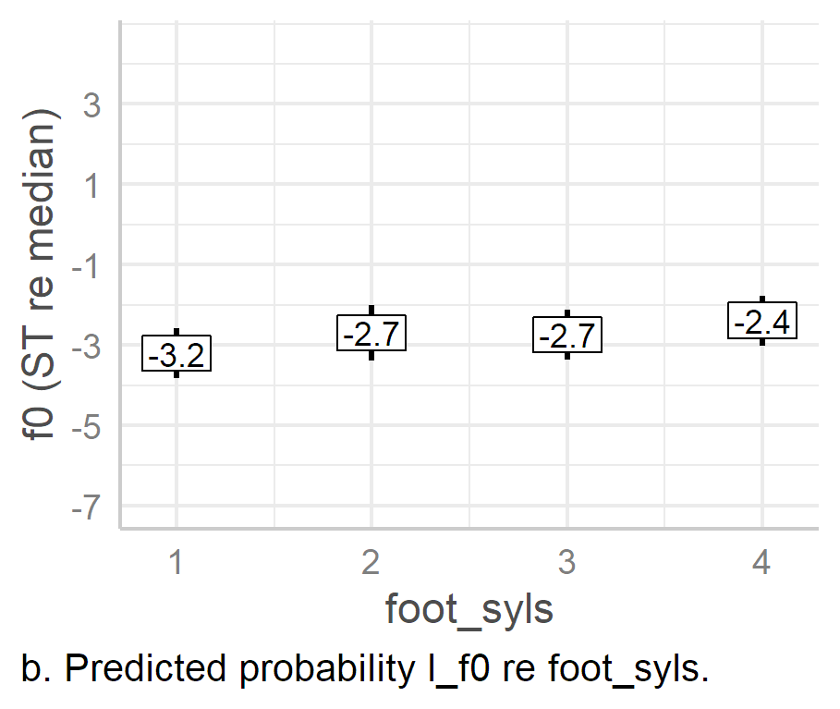

Figure . Predicted values of nuclear L targets based on foot_syls effects alone in LMEMs.

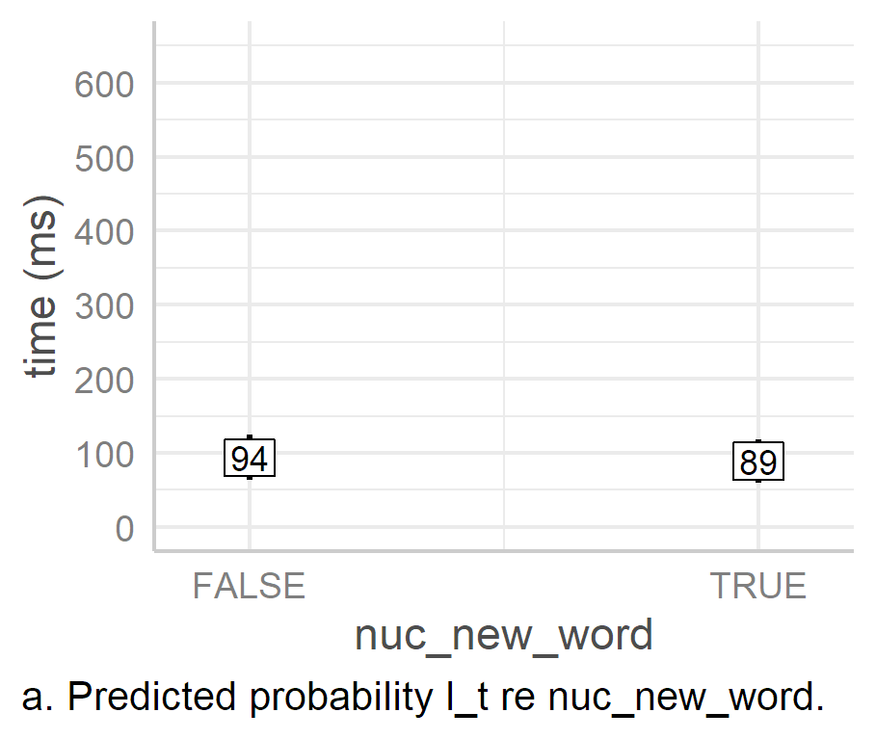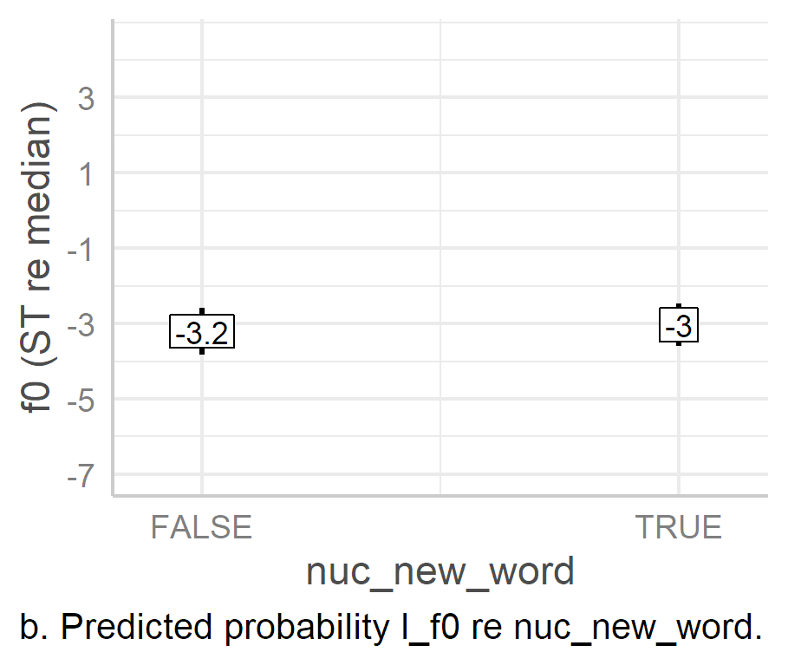

Figure . Predicted values of nuclear L targets based on nuc_new_word effects alone in LMEMs.

There is almost no effect of either foot_syls or nuc_new_word on l_t, as shown in panel a of Figure 6.27 and Figure 6.28 respectively. There is barely any deviation from the intercept of 94 ms, 95% CI [61, 124], across different levels of either factor. This is also true of the effect of nuc_new_word alone on l_f0 (Figure 6.28b). In this case, a new word at the onset of the nuclear foot is only associated with a 0.2 [0, 0.4] ST rise in the L target, *p* = 0.52.

There is, however, a clear effect of foot size on h_f0, which increases steadily with the addition of more syllables to the foot. In fact, the main effect appears to be related to the absence or presence of trailing syllables in the foot. That is, the two-, three-, and four- syllable feet conditions are at least 0.5 ST higher than the one-syllable condition, at 0.5 ST, 0.5 ST, and 0.8 ST, CIs [0.2, 0.8], [0.2, 0.7], and [0.4, 1.2], *p* = .002, *p* < .001, *p* < .001 respectively (see also Table 6.26 rows one to three). However, the two-, three-, and four-syllable feet conditions do not differ from each other by more than 0.3 ST, and there is no significant difference in estimated l_f0 between any of the three, as indicated by the last three rows in Table 6.26

Table . Table H2.8. Pairwise comparison (b1) of effects of levels of foot_syls on nuclear l_f0.

|  |  |  |  |  |  |  |  |  |
| --- | --- | --- | --- | --- | --- | --- | --- | --- |
| Intercept | slope | estimate (ST) | 2.5% CI | 95.5 % CI | SE | |t| | df | p |
| foot_syls1 | foot_syls2 | 0.5 | 0.2 | 0.8 | 0.16 | 3.08 | 749.68 | .002 |
| foot_syls1 | foot_syls3 | 0.5 | 0.2 | 0.7 | 0.13 | 3.58 | 749.7 | < .001 |
| foot_syls1 | foot_syls4 | 0.8 | 0.4 | 1.2 | 0.2 | 4.04 | 279.87 | < .001 |
| foot_syls2 | foot_syls3 | 0.0 | -0.4 | 0.3 | 0.17 | -0.26 | 749.95 | .797 |
| foot_syls2 | foot_syls4 | 0.3 | -0.1 | 0.7 | 0.21 | 1.46 | 303.32 | .144 |
| foot_syls3 | foot_syls4 | 0.3 | -0.1 | 0.8 | 0.21 | 1.67 | 305.73 | .095 |

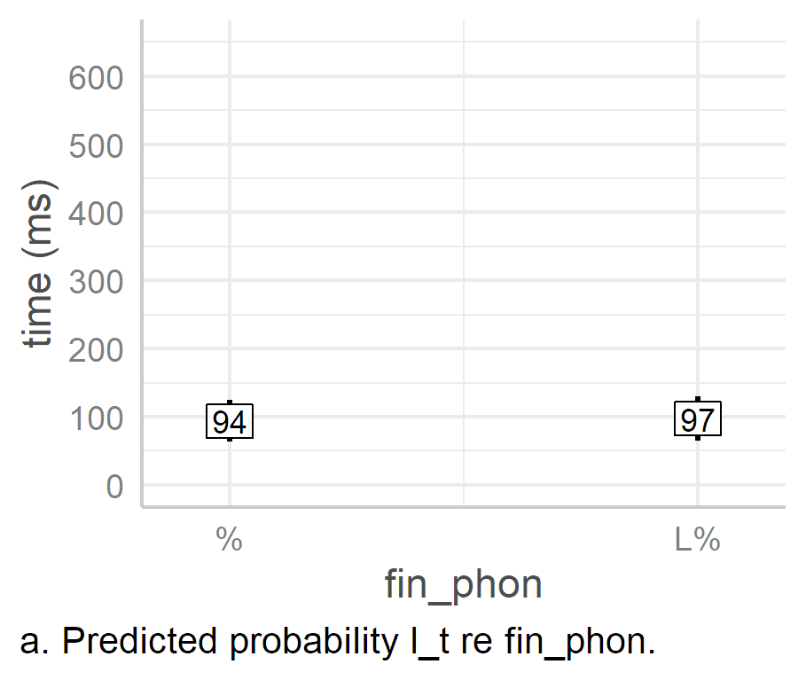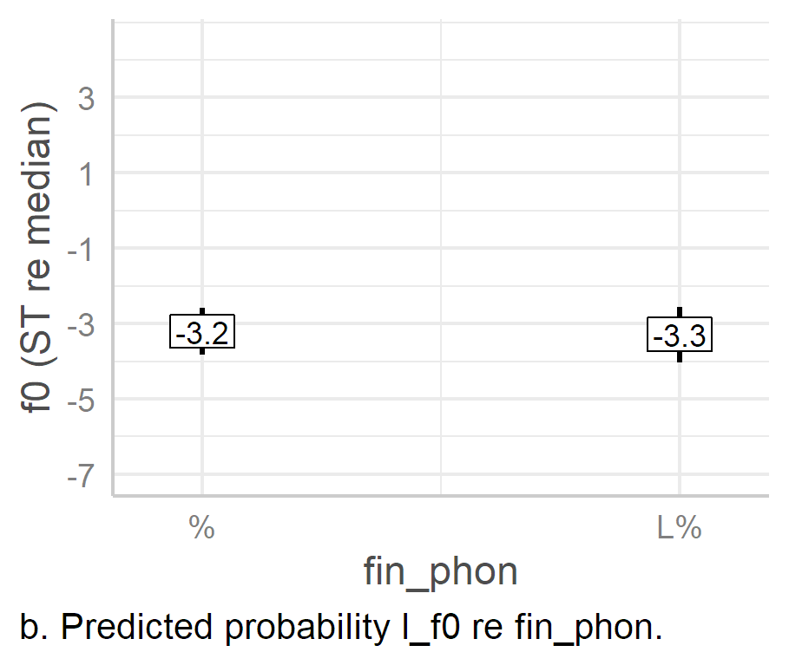

Figure . Predicted values of nuclear L targets based on fin_phon effects alone in LMEMs.

Again, as indicated by the ANOVAs for the l_t and l_f0 models, there is barely any effect of fin_phon on either l_t or l_f0 (Figure 6.29), with only a 4 ms and -0.1 ST difference between L% and %, 95% CIs [-7, 17], [-0.5, 0.31], and *p* = .682, .492 respectively. It is unsurprising that the boundary tone has little effect on L target parameters, given that the two are separated by the H target.

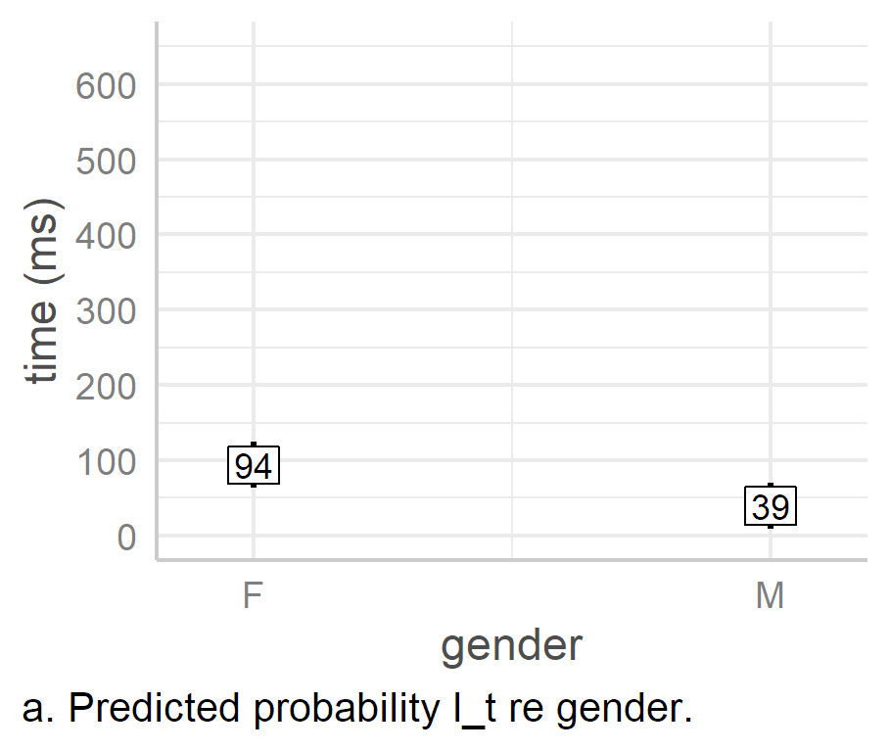 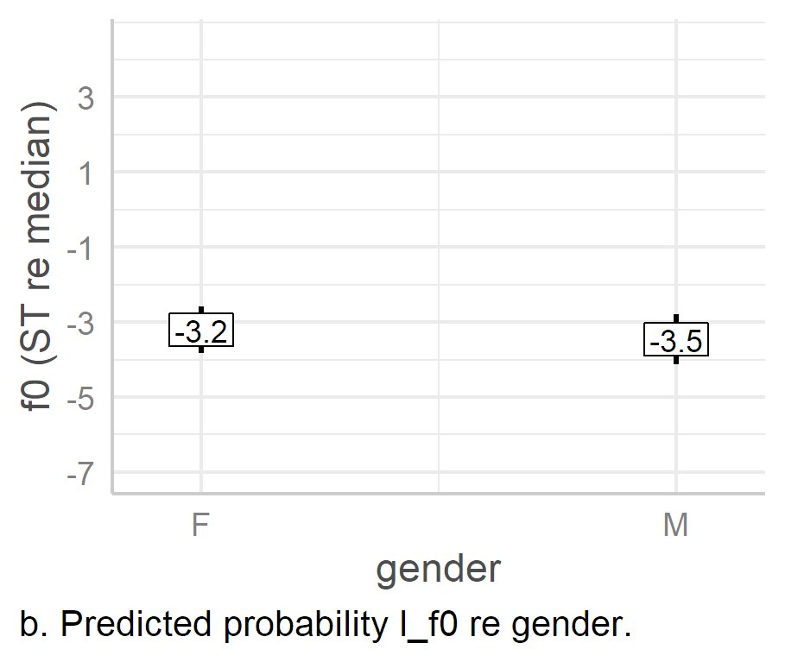

Figure . Predicted values of nuclear L targets based on gender effects alone in LMEMs.

Finally, as indicated by the ANOVAs, there is a significant effect of gender on the alignment of l_t, with male speakers realising the target an estimated 54 ms earlier than the female speakers, 95% CI [-74, -12], *p* < .001. The effect of gender on nuclear l_t reflects a similar trend in prenuclear alignment, and this pattern will be seen again in h_t and e_t below. While the l_f0 model indicates that the male speakers realise the L target an estimated 0.3 [-1.1, 0.7] ST lower than female speakers, this is a small difference and is not statistically significant, *p­* = 0.52.

#### H Targets.

An ANOVA of the nuclear h_t model indicates that all fixed effects are significant, as shown in Table 6.27. The model has a marginal *R*2 of .9 and conditional *R*2 of .71, indicating that the fixed effects account for a large proportion of the variance in the response parameter while the whole model accounts for 90% of the variance. An ANOVA of nuclear h_f0, however, indicated that only the effect of foot_syls and pre_syls are significant, *F*(3, 767) = 41.23, *p.adj* = < .001, and *F*(3, 607) = 5.98, *p.adj* = 0.001 respectively. The h_f0 model has a marginal *R*2 of .11 with a conditional *R*2 of .44. This indicates that the fixed effects of the h_f0 model accounts for a noticeably larger amount of variance in the response parameter than its l_f0 counterpart (*R*2m =.05) while the complete model accounts for a slightly large amount of variance than the l_f0 model (*R*2c = .36). Overall, the differences in *R*2 between the L target and H target parameters indicate that the H target is more susceptible to changes in metrical and lexical structure of the IP. (Complete tables and charts for the models can be found in Appendices I4 and I5.)

|  |
| --- |
| Table . ANOVA of nuclear h_t model. |
| |  |  |  |  |  |  |  |  |  | | --- | --- | --- | --- | --- | --- | --- | --- | --- | | **term** | **sumsq** | **meansq** | **NumDF** | **DenDF** | ***F* value** | ***p*** | | ***p.adj* (BH)** | | foot_syls | 1.2×106 | 4.0×105 | 3 | 765.88 | 586.86 | <.001 | | *p < .*05 | | pre_syls | 56659 | 18886 | 3 | 763.69 | 27.43 | <.001 | | *p < .*05 | | fin_phon | 41246 | 41246 | 1 | 768.38 | 59.9 | <.001 | | *p < .*05 | | nuc_new_word | 8036 | 8036 | 1 | 766.46 | 11.67 | .002 | | *p < .*05 | | gender | 12918 | 12918 | 1 | 9.01 | 18.76 | .004 | | *p < .*05 | |  |  |  |  |  |  |  |  | | | |

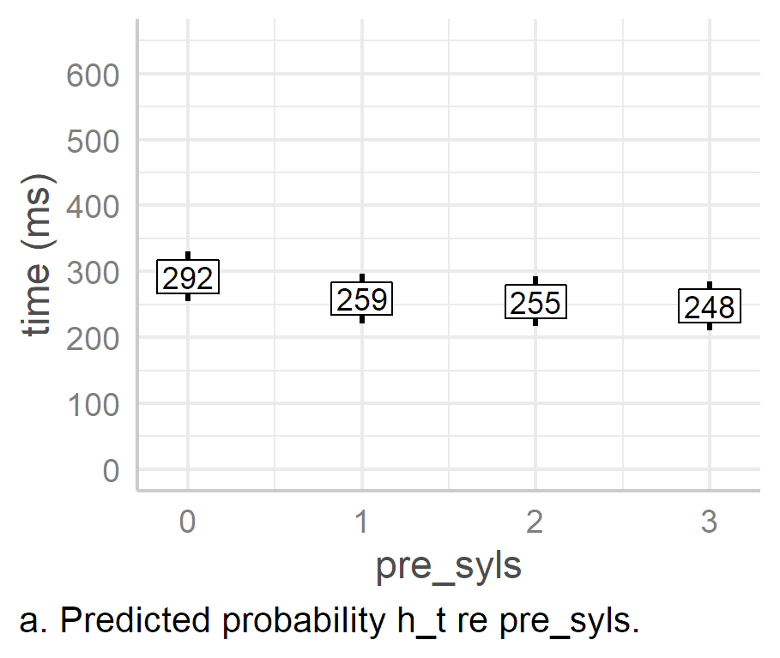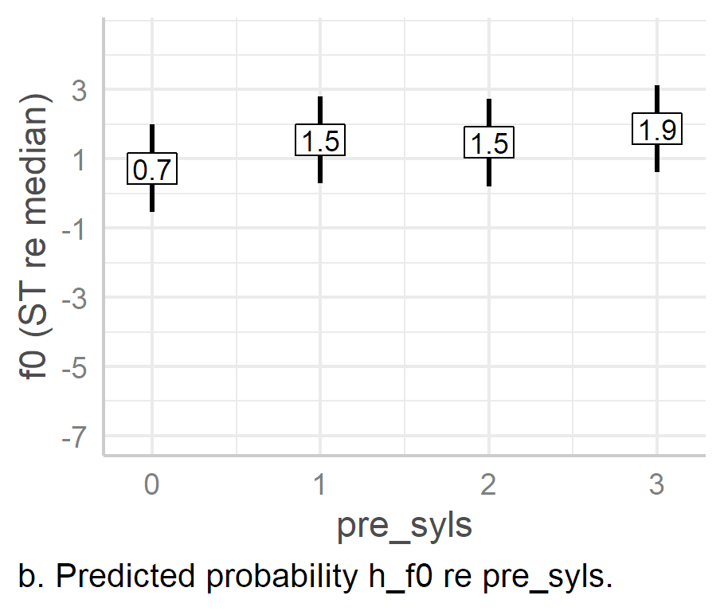

Figure . Predicted values of nuclear H targets based on pre_syls effects alone in LMEMs.

There is a gradual—if slight—decrease in peak alignment as the number of preceding syllables increases (Figure 6.31a). However, the estimated alignment of the stress-clash condition (zero preceding unstressed syllables) is noticeably higher from the non-stress-clash conditions (levels one to three), at 292 ms, 95% CI [255, 230]. There is at least a 34 [-41, -26] ms estimated mean difference between the stress-clash condition and the other conditions, the smallest difference being between pre_syls0 and pre_syls1, *p* < 0.001. However, there is only a slight difference between each of the non-stress-clash conditions (pre_syls2-4). The largest estimated difference here is 11 [-21, -1] ms between pre_syls1 and pre_syls2, *p* = .024. (This is a statistically significant difference, but it is still very small, and neither of the remaining comparisons is statistically significant. See Appendix I4, Table H3.9.)

A similar effect of stress clash is seen in the predicted values of h_f0 as an effect of pre_syls, where the predicted scaling of the H target ranges between 1.5 ST above the speaker median in both the one- and two- syllable conditions and 1.9 ST in the three-syllable conditions, 95% CIs [0.28, 2.83], [0.21, 2.74], [0.62, 3.13]. Each of the non-stress clash conditions is associated with noticeably higher *f*0 scaling than the stress-clash condition, an estimated 0.8 ST higher in both pre_syls1 [0.4, 1.2] and pre_syls2 [0.1, 1.4], and 1.1 [0.4, 1.8] ST higher in pre_syls3, p < .001, *p* = 0.31, and *p* = 0.001 respectively. The difference in *f*0 peak scaling is much smaller between non-stress-clash conditions, ranging from 0.1 [0, 0.8] ST between pre_syls1 and pre_syls2 and 0.4 [-0.6, 0.4] ST between pre_syls2 and pre_syls3, *p* = .53 and .781 respectively.

It is interesting that both the timing and height of the H target are more susceptible to the effects of pre_syls than the L Target, even though the L target is more proximate to the preceding foot. As already indicated by the ANOVAs, this reinforces the fact that the H target is more strongly conditioned by metrical and lexical effects.

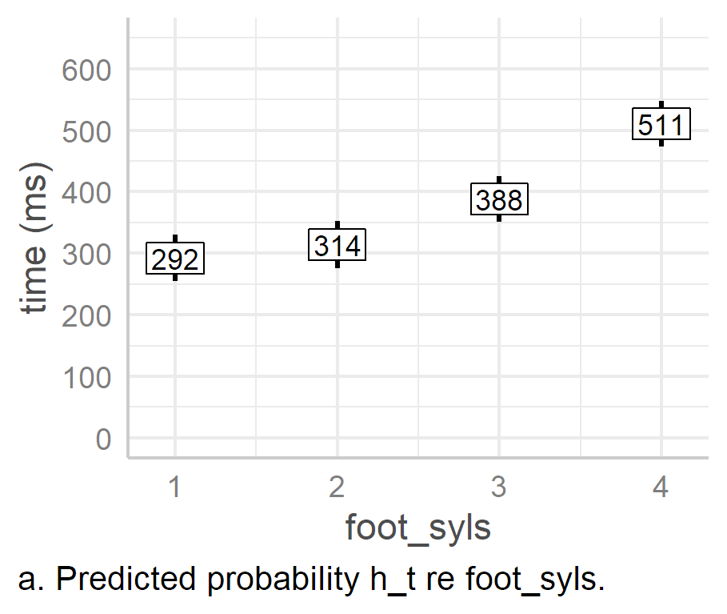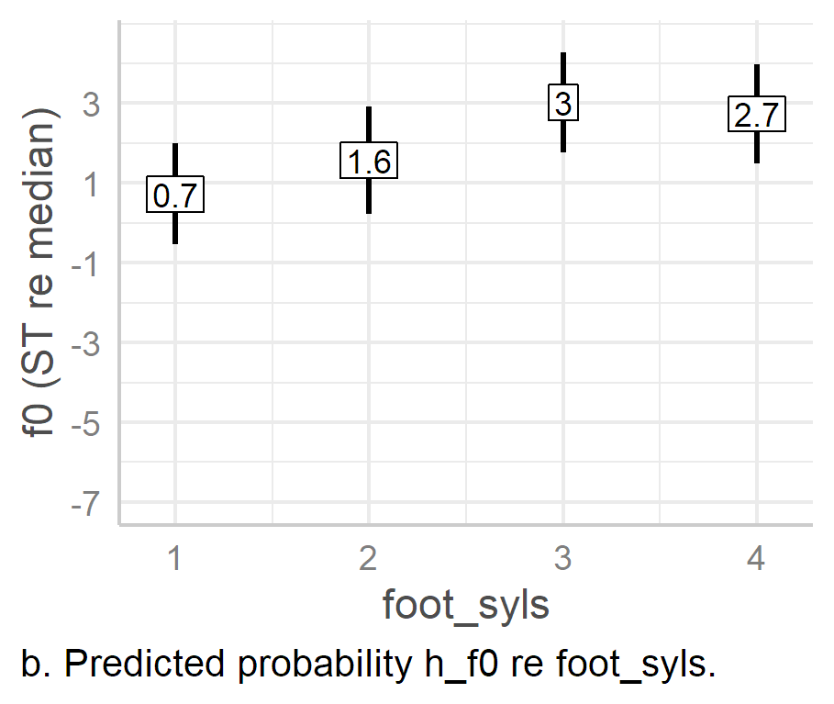

Figure . Predicted values of nuclear H targets based on foot_syls effects alone in LMEMs.

The effect of foot_syls on the H target is very strong, especially in comparison to the more muted effect on the L target. As the number of syllables in the foot increases, there is a corresponding increase in the alignment and timing of the peak (Figure 6.32). The largest change in h_t occurs between the one-syllable and four-syllable conditions, with peak alignment an estimated 219 ms later, 95% CIs [207, 230], *p <* 0.001. For h_f0, it is between the one-syllable and three-syllable conditions, with the latter being an estimated 2.3 [1.9, 2.7] ST higher than the former, *p* < 0.001. However, the pattern of changes between foot size conditions is not the same for alignment and *f*0 height.

In h_t, there is only a small increase in peak alignment between the one- and two- syllable conditions of 21 ms, but a much large increase of 75 ms from the two- to the three-syllable condition, and an even larger increase again of 123 ms from the three- to the four-syllable condition, 95% CIs [12, 2], [65, 85], and [110, 135] respectively, *p* < .001 in each case. This suggests that as foot size increases, the peak is aligned increasingly later. For example, the change between the one- and two-syllable foot conditions very small, at 21 [12, 31] ms, but in the difference between the three- and four-syllable foot conditions, the difference has increased dramatically to 123 [185, 210] ms, *p* < .001 in each case. This is similar to the findings for nuclear peak alignment in Donegal English (Kalaldeh et al., 2009), but the exponential increase is more extreme in the current case.

In contrast, it appears that there is a more linear correspondence between foot_syls and the scaling of the *f*0 peak, i.e., h_f0. However, the effect of foot_syls on *f*0 peak scaling appears to reach saturation point by the three-syllable condition, after which *f*0 drops slightly. However, there is only an estimated fall of 0.3 ST between the three- and four-syllable conditions, 95% CIs [-1, 0.4], *p* = .422, which is both small and statistically non-significant.

The fact that the alignment of the peak continues shifting rightward as foot size increases but *f*0 peak stops rising after three syllables suggests that there is an element of contour truncation in the one- and two- syllable conditions, but an element of expansion between the three- and four- syllable conditions. This issue is considered in more detail in Section 6.6.3.4 below.

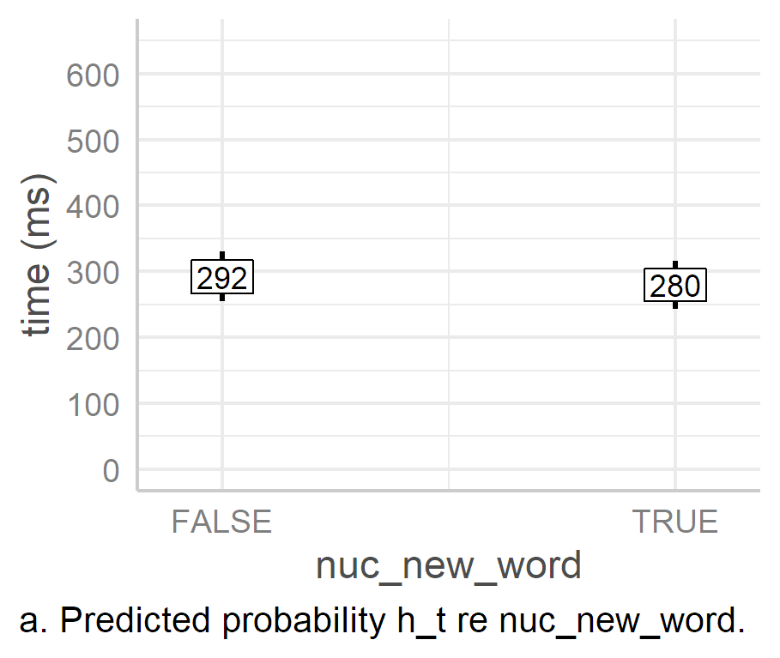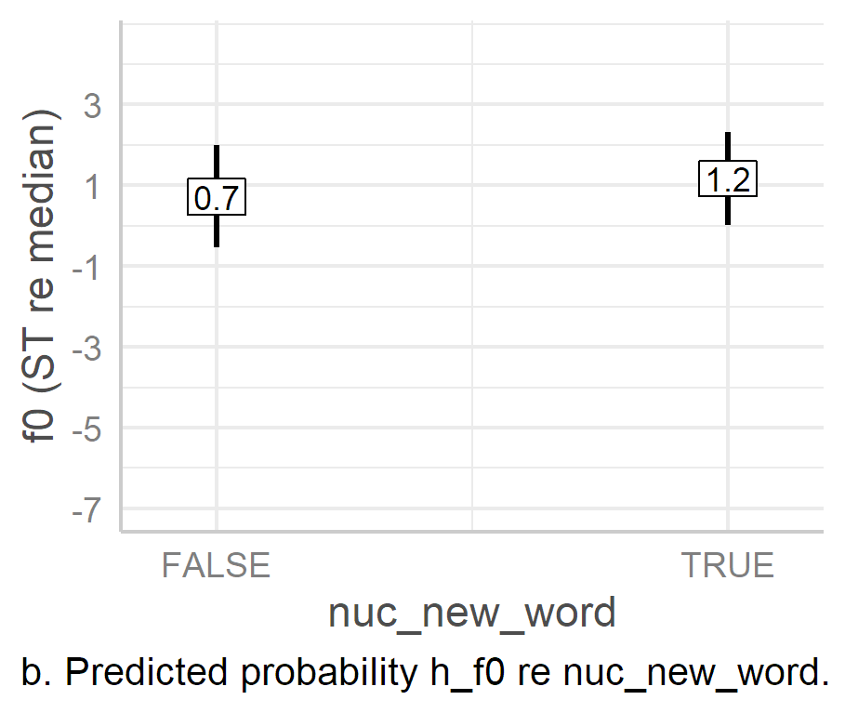

Figure . Predicted values of nuclear H targets based on nuc_new_word effects alone in LMEMs.

The presence of a word boundary at the syllable onset appears to have a very small effect on the timing and height of the H target (Figure 6.33). When there is a word boundary—i.e., in the True condition—the peak is aligned an estimated 13 ms earlier, 95% CI [-20, -5], *p* < .001. Similarly, the presence of a foot-initial word boundary is associated with an estimated increase in *f*0 peak of 0.4 [0, 0.9] ST, *p* = 0.036. Each of these effects is statistically significant but the difference is small, especially when compared to the effect of foot_syls or even pre_syls.

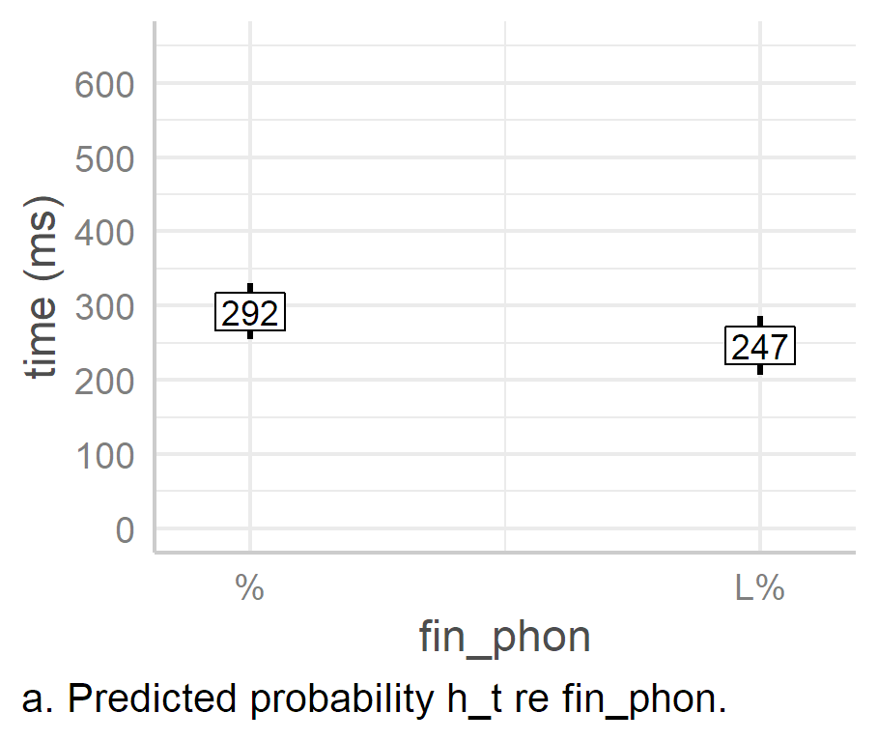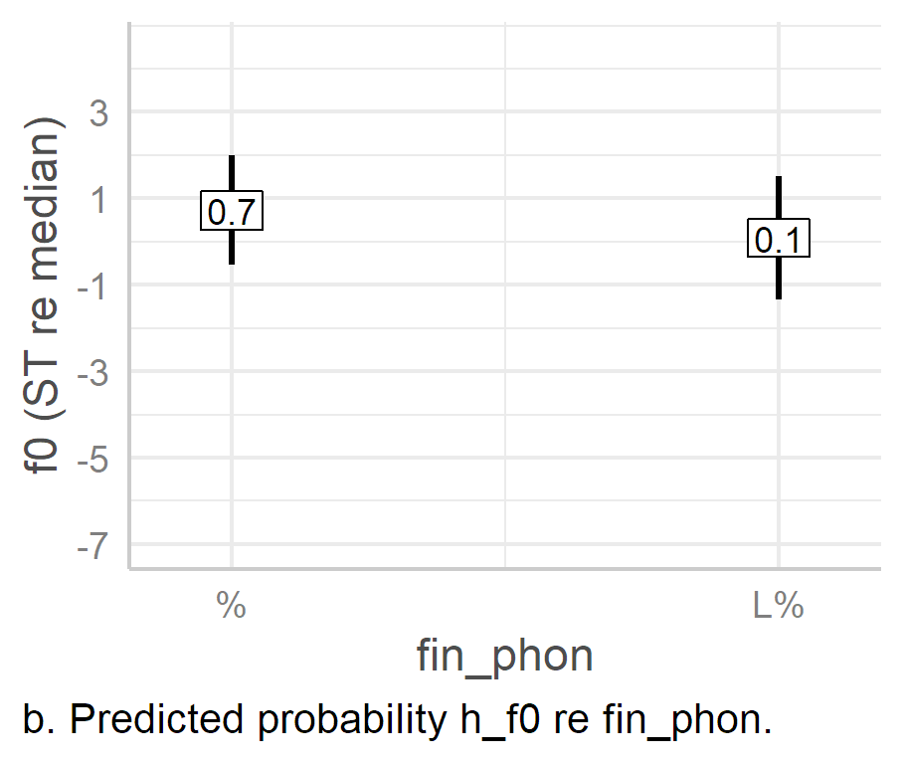

Figure . Predicted values of nuclear H targets based on fin_phon effects alone in LMEMs.

As can be seen in Figure 6.34, the presence of an L% is associated with the earlier alignment and lower *f*0 scaling of the peak, i.e., the H target is aligned an estimated 46 ms earlier as an effect of L% and is realised an estimated 0.6 ST lower, CIs [-57, -34], [-1.3, 0], *p* < .001, *p* = 0.058. However, because of the relatively large CIs in h_f0, the effect of L% is not statistically significant.

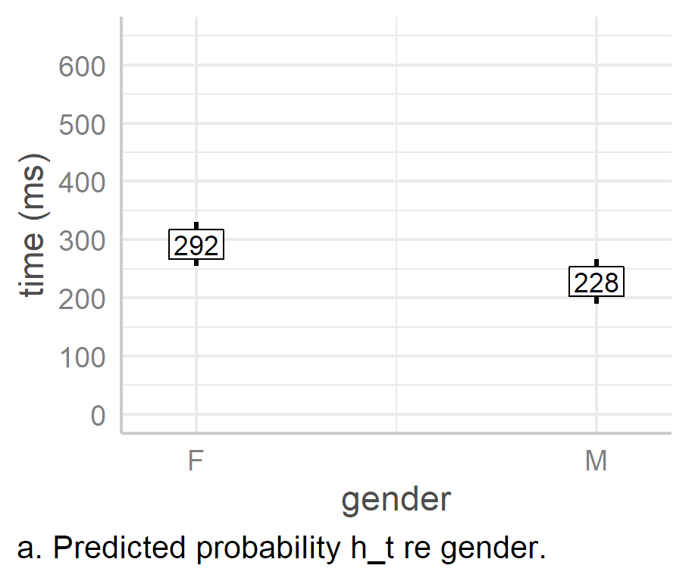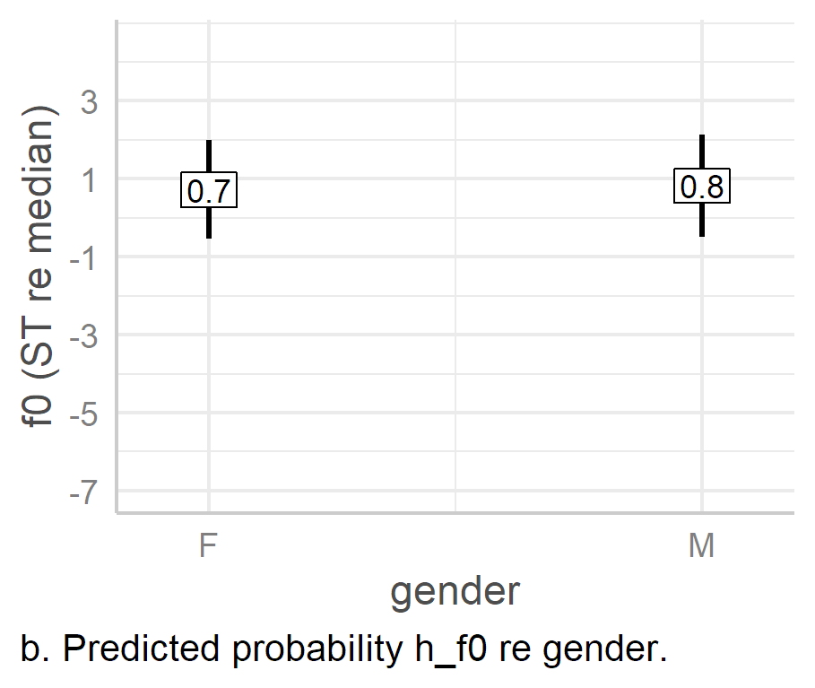

Figure . Predicted values of nuclear H targets based on gender effects alone in LMEMs.

Finally, we see once again that there is a noticeable effect of gender on the alignment of the tonal target, with male speakers realising the H target an estimated 64 ms earlier than female speakers, 95% CI [-98, -31], *p* = .002. However, there is essentially no effect of gender on the *f*0 height of the peak, with males realising it only an estimated average of 0.1 [-1.2, 1.4] ST higher in their register than female speakers, p = .872.

#### Final Boundary.

The timing of the boundary always refers to last frame of voiced speech in the IP. Therefore, it is really a measurement of the duration of voicing in the foot re the onset of the vowel in the stressed syllable. This is not of interest here, so it is not discussed further, but the results are still available in Appendix I6.

An ANOVA of nuclear e_f0, indicates significant effects of foot_syls and fin_phon, *F*(3, 754) = 19.6, *p.adj* < .001, and *F*(1, 768) = 228, *p.adj* < 0.001 respectively. The model has a marginal *R*2 of .22 and a conditional *R*2 of .53. (Complete tables and charts for the final boundary tone models can be found in Appendix I7.)

Looking at the parameters most closely associated with the beginning of the foot, i.e., pre_syls and nuc_new_word (Figure 6.36, panels b and d, next page), we see that there is barely any effect of either, with the predicted *f*0 values barely veering from the intercept of 0.2 ST re speaker median, 95% CI [-1.2, 1.6]. The only the exception is pre_syls1, which is an estimated 0.5 [0, 1] ST higher than the intercept, *p* = .038. While this may be a residual effect of stress clash, it is still clear that the overall effect of pre_syls is quite small.

There seems to be a slight effect of gender (panel e), with male speakers realising the final boundary an average estimated 0.7 ST lower than female speakers, 95% CI [-2.6, 1.2], *p* = .408. However, given the large CIs, it is not possible to make any claims about the significance of this difference, as reflected in the *p* value.

Looking at the height of the boundary as an effect of foot size (panel a), it is clear that the essential difference is between a foot with no unstressed syllables and one which contains additional syllables. That is, in the one-syllable condition (i.e., where there are no trailing syllables), the mean estimated *f*0 is between 1.4 and 1.7 ST lower than in subsequent conditions, each of which has at least one trailing syllable (see pairwise comparisons in Table 6.28, rows one to three). In contrast, there is only a small effect of foot_syls on the estimated differences between the conditions with trailing syllables, i.e., the two-, three-, and four syllable conditions, ranging from 0 to 0.3 ST, none which is statistically significant. However, each of these conditions is significantly different from the one-syllable foot, as shown in rows four to six of Table 6.28.

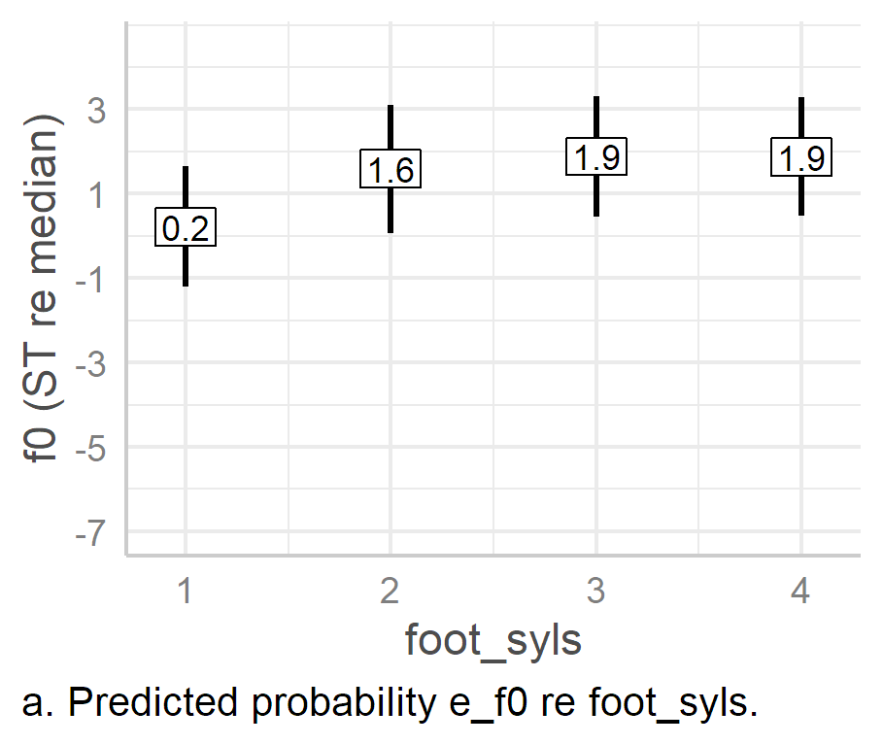 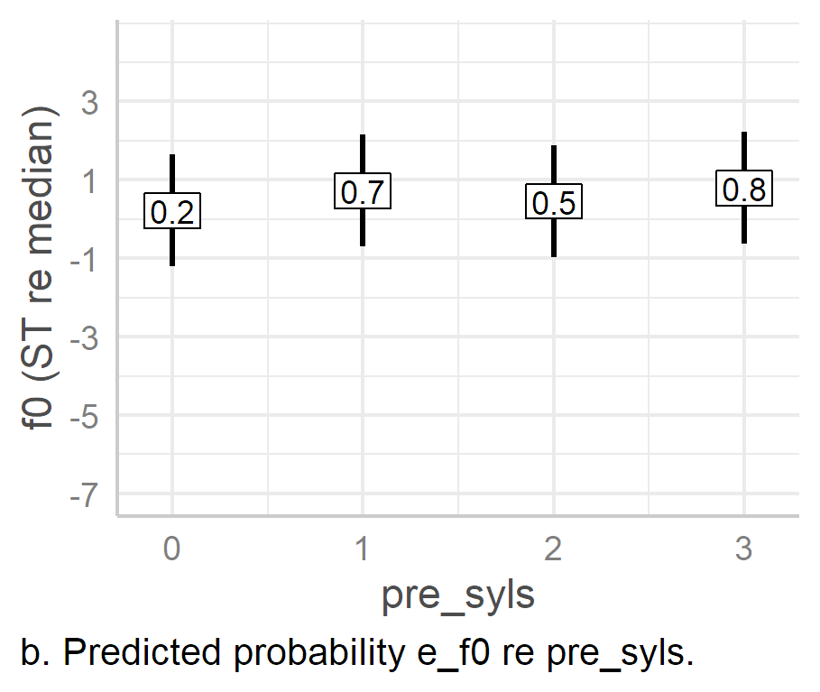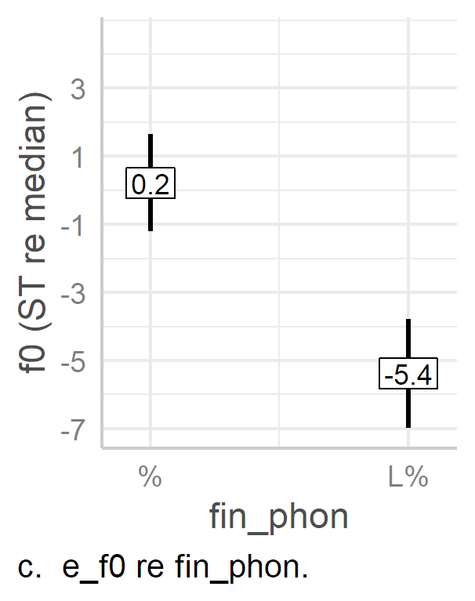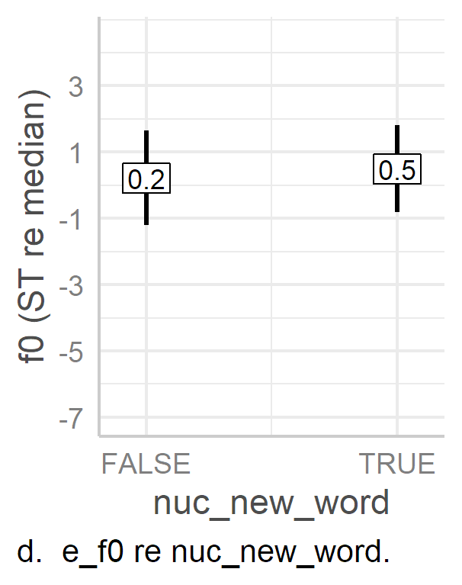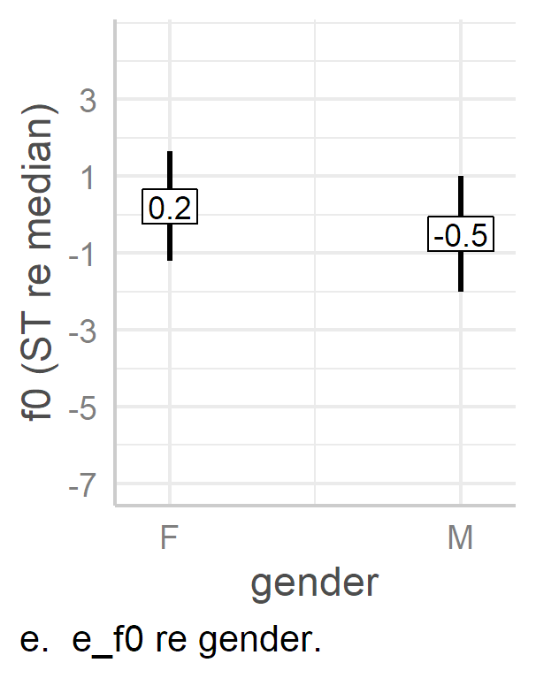

Figure . Predicted f0 values of final boundary in LMEM e_f0 model.

Table . Pairwise comparison of levels of foot_syls in the e_f0 model.

|  |  |  |  |  |  |  |  |  |
| --- | --- | --- | --- | --- | --- | --- | --- | --- |
| intercept | slope | est. (ST) | 2.5% CI | 95.5% CI | SE | |*t*| | df | *p* |
| foot_syls1 | foot_syls2 | 1.4 | 0.8 | 2 | 0.3 | 4.53 | 764 | <.001 |
| foot_syls1 | foot_syls3 | 1.7 | 1.2 | 2.1 | 0.24 | 6.97 | 764 | <.001 |
| foot_syls1 | foot_syls4 | 1.6 | 0.9 | 2.4 | 0.38 | 4.37 | 705 | <.001 |
| foot_syls2 | foot_syls3 | 0.3 | -0.3 | 0.9 | 0.32 | 0.93 | 764 | .355 |
| foot_syls2 | foot_syls4 | 0.3 | -0.5 | 1.1 | 0.39 | 0.74 | 713 | .459 |
| foot_syls3 | foot_syls4 | 0 | -0.8 | 0.8 | 0.39 | 0.02 | 715 | .985 |
|  |  |  |  |  |  |  |  |  |

Finally, we see that the presence of an L% boundary has a very strong effect on *f*0 scaling of the final boundary (Figure 6.36e). The L% is associated with an estimated lowering of *f*0 by 5.6 ST, 95% CI [‑6.3, ‑4.9], *p* < .001. This effect is unsurprising, given that the L% should be associated with a low *f*0.

#### Truncation and Compression.

An ANOVA of the *f*0 excursion model (f0_exc) indicates significant effects of foot_syls and fin_phon, *F*(3, 13.72) = 26.13, *p.adj* < .001, and *F*(1, 623) = 9.75, *p* = .002 respectively. This model has a marginal *R*2 of only 0.08 and a conditional *R*2 of 0.62. The low $R_{m}^{2}$ is to be expected given that there are only two fixed effects. An ANOVA of *f*0 slope (log_lh_slope) also indicates a significant effect of foot_syls, *F(*3, 16.45) = 55.6, *p.adj* < .001, but not for fin_phon, *F*(1, 722) = 4.65, *p.adj* = 0.052. The model has a margin *R*2 of .21 and a conditional *R*2 of 0.69. The marginal *R*2 is quite high compared with the *f*0 excursion model. (Full reports of the f0_exc and foot_syls models can be found in Appendices I8 and I9.)

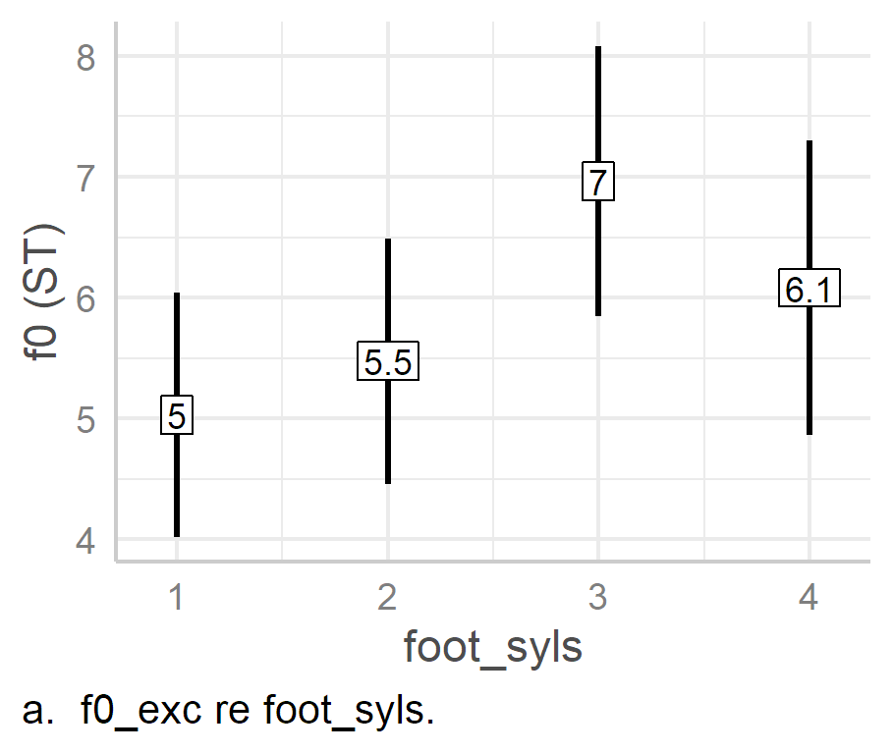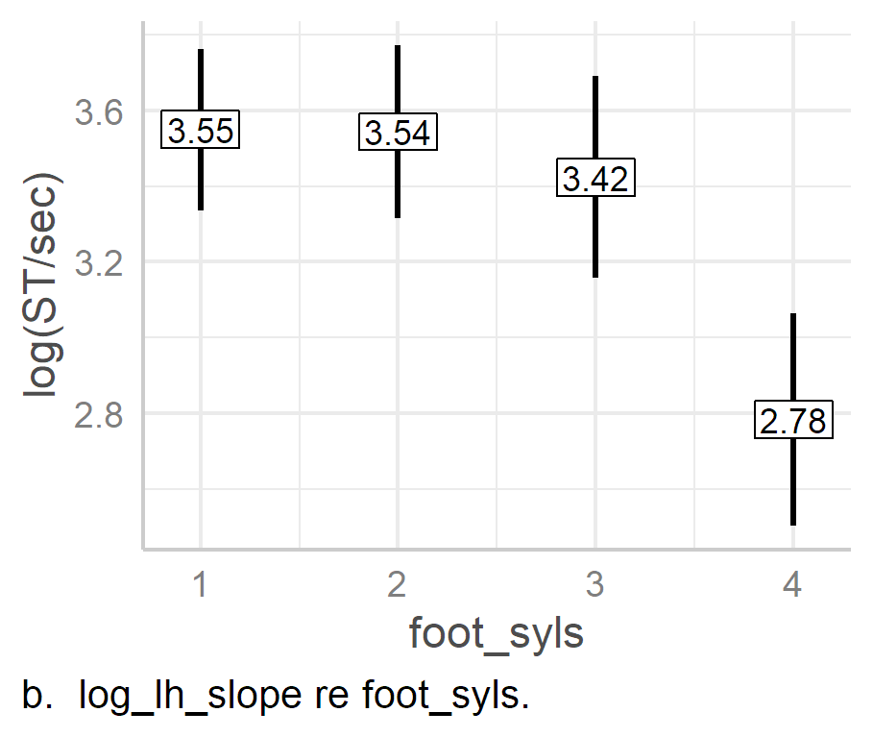

Figure . Predicted f0 excursion and log slope in nuclear L*H as an effect of foot size.

Looking at the effects of foot size on the nuclear L*H *f*0 excursion (Figure 6.37a), we see that there is a small increase from the one-syllable condition (5 ST) to the two-syllable condition (5.5 ST), 95% CIs [4, 6] and [4.5, 6.5] respectively, and the estimated difference between them of 0.4 [-0.2, 1.1] ST is not statistically significant, *p* = .164. This is followed by a large jump to 7 [5.8, 8.1] ST in the three-syllable foot condition, and a distinct fall-off in the final condition to 6.1 [4.9, 7.3] ST. This lowering of the excursion is essentially a reflex of the tapering off of foot-size effects on h_f0 in the four-syllable foot condition (see p. 87 above).

When it comes to the effect of foot_syls on *f*0 slope, there is very little change in slope until the four-syllable foot condition, where upon the slope becomes noticeably less steep, falling from 3.42 to 2.78 log(ST/s), 95% CIs [3.16, 3.69], [2.5, 3.06]. A pairwise comparison of levels of the foot_syls condition suggests that there is only the slightest of differences between the one-, two‑, and three-syllable foot conditions, none of which are statistically significant, with estimated mean differences ranging between 0.01 and 0.13 log(ST/s) (see Table 6.29 for full statistics). In contrast, there is a difference of at least 0.64 log(ST/s) between the four-syllable foot condition and the other three conditions, all of which are statistically significant.

Table . Pairwise comparison of levels of foot_syls on nuclear log_lh_slope.

|  |  |  |  |  |  |  |  |  |
| --- | --- | --- | --- | --- | --- | --- | --- | --- |
| intercept | slope | estimate | 2.5% CI | 95.5% CI | SE | |*t*| | df | *p* |
| foot_syls1 | foot_syls2 | -0.01 | -0.12 | 0.10 | 0.05 | -0.1 | 30.22 | .922 |
| foot_syls1 | foot_syls3 | -0.13 | -0.27 | 0.02 | 0.06 | -1.96 | 10.23 | .078 |
| foot_syls1 | foot_syls4 | -0.77 | -0.92 | -0.61 | 0.07 | -10.75 | 12.48 | < .001 |
| foot_syls2 | foot_syls3 | -0.12 | -0.26 | 0.02 | 0.07 | -1.82 | 21 | .082 |
| foot_syls2 | foot_syls4 | -0.76 | -0.92 | -0.60 | 0.07 | -10.3 | 14.45 | < .001 |
| foot_syls3 | foot_syls4 | -0.64 | -0.76 | -0.52 | 0.06 | -11.43 | 15.74 | < .001 |
| intercept | fin_phonL% | 0.12 | 0.01 | 0.23 | 0.06 | 2.16 | 721.69 | .031 |
|  |  |  |  |  |  |  |  |  |

Figure . predicted mean f0(t) slopes of nuclear L*H PA as an effect of foot_syls shown in ST/s.

When the effect of foot size on *f*0 slope is considered in terms of ST/s (Figure 6.38), there is very little difference among the one-, two-, and three-syllable foot conditions, but we see a fall from 32.1 ST/s in three-syllable foot condition to 16.9 ST/s in the four-syllable condition. Viewed in terms of the differential threshold of pitch change (’t Hartet al., 1990), the difference between the three- and four-syllable foot conditions is just shy of the factor-of-two perceptual threshold, while the one- and two-syllable conditions both exceed it, being at least twice as steep as the four-foot condition, at a factor 2.2 and 2.1 respectively (Table 6.30). In sharp contrast, there is either no difference or a negligible one between the slopes of the one-, two-, and three-syllable conditions.

Table . Differentials of pitch change in foot_syls conditions (ratio between slopes measured in ST/s).

|  |  |  |  |
| --- | --- | --- | --- |
|  | foot_syls1 | foot_syls2 | foot_syls3 |
| foot_syls2 | 1.0 |  |  |
| foot_syls3 | 1.1 | 1.1 |  |
| foot_syls4 | 2.2 | 2.1 | 1.9 |
|  |  |  |  |

It is easiest to analyse the meaning of these effects in terms of compression and truncation by working backwards from the four-syllable foot conditions. There is very large increase in slope from the four-foot to the three-syllable foot, followed by only very slight increases in slope from the three-to two-syllable foot, and from the two- to one-syllable foot conditions. This is highly indicative of a compression effect between the four- and three-syllable foot conditions, with little to no compression as the foot size decreases further. In contrast, there is a noticeable decrease in *f*0 excursion from the three-syllable to the two-syllable foot-size condition. This is followed by a less dramatic decrease in the one-syllable foot. Given that there is little change in slope across these three conditions, this indicates truncation effects as the foot decreases in size from three syllables to one syllable. This is also what was inferred from the analysis of the H target in Section 6.6.3.2 above.

Figure .. Nuclear L*H % pitch contour plotted as a function of foot_syls alone.

The tonal targets of the nuclear contour are plotted together as a function of foot size effects in Figure 6.39. This shows the combination of truncation and compression more clearly. Again, working backwards from the four-syllable foot condition, it is very clear that the contour is compressed in the three-syllable condition, but is then truncated in both the two- and one-syllable conditions. This suggests that there is a limit to the amount of compression which can occur—at least for these speakers of DCE—leading to the replacement of compression by truncation as the foot becomes shorter.

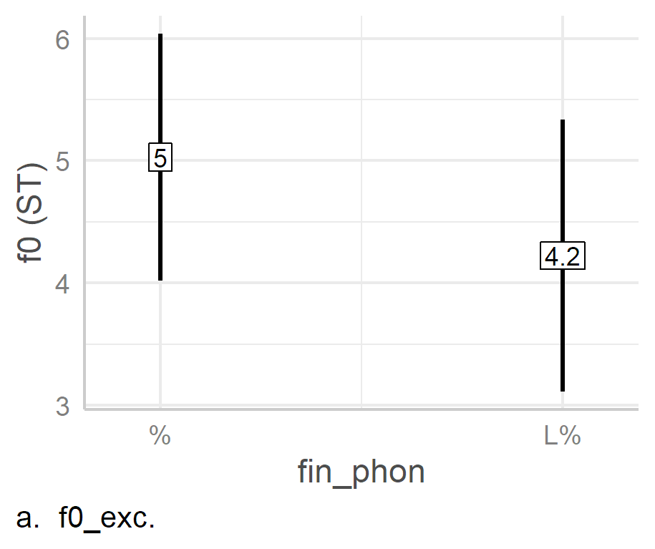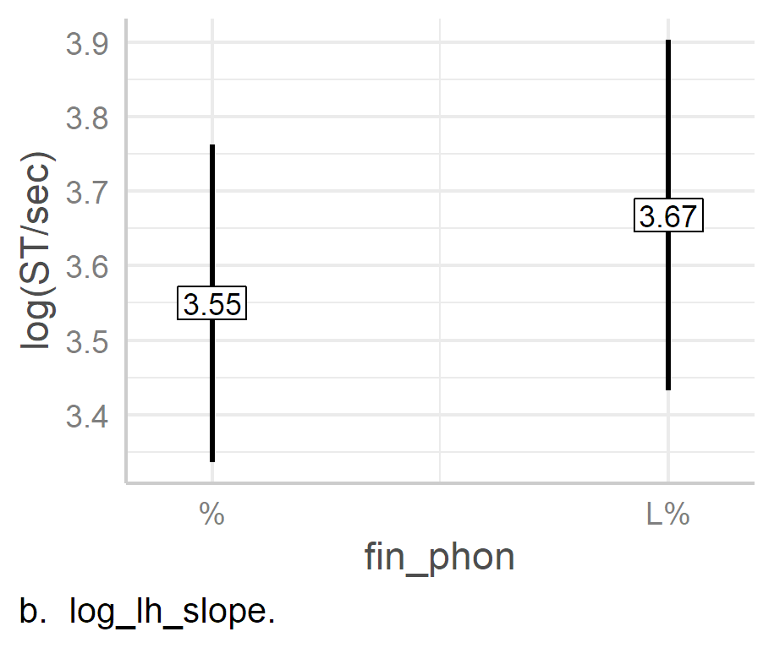

Figure . Predicted f0 excursion and log slope in nuclear L*H as an effect of boundary tone.

Boundary tone effects on *f*0 excursion and slope are shown in Figure 6.40. A low boundary is associated with a lowering in the *f*0 excursion of L*H by 0.8 ST and a slight rise in slope of 0.12 log(ST/s), 95% CIs [-1.3, -0.3] and [0.01, 0.23], *p* = 0.031 and .002 respectively. This combination of a lower excursion and little change in slope is indicative of truncation. This is reflected in Figure 6.41, which plots the estimated coordinates of the L*H % and L*H L% tonal targets. Thus, it seems that the addition of an L boundary is not just associated with earlier peak alignment but also with truncation of the rise.

Figure . Coordinates and 95% CIs of L*H % and L*H L% tonal targets in the 4-syllable foot condition.

### Comparing of Metrical and Lexical Effects in Prenuclear and Nuclear PAs.

The prediction that metrical and lexical effects are stronger in the prenuclear than the nuclear position is not transparently supported by the preceding analyses. To assess the prediction more clearly, the effect size of lexical and metrical effects in each model has been calculated using the partial omega-squared statistic ($ω_{p}^{2}$) (Ben-Shachar et al., 2020). Unlike marginal *R*2, which indicates the amount of variance explained by all of the fixed effects in the model, $ω_{p}^{2}$ indicates the amount of variance explained by each individual fixed effect in a model. It is a less biased estimate than alternatives such as eta-squared (Albers & Lakens, 2018; Richardson, 2011).

Table 6.31 summarises the size of lexical and metrical fixed effects on each PN tonal target parameter, while Table 6.32 shows them in relation to nuclear PA target parameters. Each table summarises effect size in the original models, not in the additional models used to further refine the analyses. In both tables, the first column lists the fixed effect parameter while the tonal target response parameters are listed in the header row. wrd_end_syl is a lexical effect parameter; however, it is only used in the prenuclear PA models, so it is not included here. However, ana_syls in the PN models is comparable with pre_syls in the nuclear PA models, while pn_new_word and nuc_new_word are also equivalent parameters. Therefore, along with foot_syls, ana_syls / pre_syls and pn_new_word / nuc_new_word parameters are compared.

Table . Effect size ($ω_{p}^{2}$) of fixed lexical and metrical effects on prenuclear pitch accent tonal targets. Arrows indicate comparison with equivalent nuclear parameter. [14]

|  |  |  |  |  |  |  |  |  |  |  |  |  |  |  |
| --- | --- | --- | --- | --- | --- | --- | --- | --- | --- | --- | --- | --- | --- | --- |
|  | l_t | | | l_f0 | | | h_t | | | h_f0 | | | Ave. | |
| **parameter** |  | $$ω_{p}^{2}$$ | **95% CI** |  | $$ω_{p}^{2}$$ | **95% CI** |  | $$ω_{p}^{2}$$ | **95% CI** |  | $$ω_{p}^{2}$$ | **95% CI** |
| ana_syls | **▲** | .2 | [0, .49] | **▼** | .07 | [.03, .12] | **▲** | .76 | [.42, .87] | ▲ | .35 | [0, .68] | **▲** | **.35** |
| foot_syls | **▲** | .01 | [0, .02] | **▼** | 0 | [0, 0] | **▼** | .52 | [.21, .68] | ▲ | .25 | [0, .46] | **▼** | **.20** |
| pn_new_word |  | 0 | [0, 0] | **▼** | .02 | [0, .05] | **▼** | 0 | [0, 0] | ▲ | .1 | [0, .66] | **▲** | **.03** |
| **average** | **▲** | **.07** |  | **▼** | **.03** |  | **▲** | **.43** |  | **▲** | **.10** |  | **▲** | **.19** |

Table . Effect size ($ω_{p}^{2}$) of fixed lexical and metrical effects on nuclear pitch accent tonal targets. Arrows indicate comparison with equivalent prenuclear parameter.

|  |  |  |  |  |  |  |  |  |  |  |  |  |  |  |
| --- | --- | --- | --- | --- | --- | --- | --- | --- | --- | --- | --- | --- | --- | --- |
|  | l_t | | | l_f0 | | | h_t | | | h_f0 | | | Ave. | |
| **parameter** |  | $$ω_{p}^{2}$$ | **95% CI** |  | $$ω_{p}^{2}$$ | **95% CI** |  | $$ω_{p}^{2}$$ | **95% CI** |  | $$ω_{p}^{2}$$ | **95% CI** |
| pre_syls | **▼** | .01 | [0, .03] | **▲** | .1 | [0, .26] | **▼** | .09 | [.06, .13] | **▼** | .02 | [0, .05] | **▼** | **.06** |
| foot_syls | **▼** | 0 | [0, 0] | **▲** | .04 | [.01, .07] | **▲** | .7 | [.6, .73] | **▼** | .14 | [.09, .18] | **▲** | **.22** |
| nuc_new_word |  | 0 | [0, .01] | **▲** | .03 | [0, .18] | **▲** | .01 | [0, .03] | **▼** | .01 | [0, .02] | **▼** | **.01** |
| **average** | **▼** | **.00** |  | **▲** | **.06** |  | **▼** | **.27** |  | **▼** | **.06** |  | **▼** | **.10** |
|  |  |  |  |  |  |  |  |  |  |  |  |  |  |  |

While ana_syls has an average effect size ($ω_{p}^{2}$) of .35, i.e., 35%, its nuclear counterpart, pre_syls, only has an average of .06. Similarly, while pn_new_word has an average of .03 in the prenuclear models, its nuclear equivalent, nuc_new_word, is even lower, 0.01. In contrast, while foot_syls has an average effect size of .2 in prenuclear tonal target parameters, it has a slightly higher effect size of .22 on nuclear tonal target parameters. The overall average of comparable effect sizes on prenuclear tonal targets is 0.19, while it is noticeably lower for nuclear tonal targets, at 0.1 (nine percentage points lower). This gives the overall impression that nuclear pitch accents are indeed less susceptible to metrical and lexical effects than prenuclear pitch accents.

When it comes to lexical and metrical effects on alignment parameters alone, l_t is only minimally affected, whether in prenuclear or nuclear pitch accent models, with average effect sizes ( $ω_{p}^{2}$) of .07 and 0.003 respectively. Lexical and metrical effects on h_t, however, are much greater, with an average of 0.43 in the prenuclear model and of 0.27 in the nuclear model. The difference here is largely because ana_syls has an effect size of 0.76 in the prenuclear model while pre_syls has an effect size of only 0.09 in the nuclear model. Still, we can see that once combined, lexical and metrical effects have a greater effect on the alignment of prenuclear targets than on nuclear targets.

In terms of *f*0 scaling, lexical and metrical parameters have a marginally larger average effect size in prenuclear models than nuclear tonal target models, averaging 0.065 in prenuclear *f*0 models, and 0.06 in nuclear *f*0 models. The effect sizes of ana_syls and foot_syls on PN h_f0 are noticeably higher than their nuclear equivalents (pre_syls and foot_syls) are on nuclear h_f0. That is, ana_syls has an effect size of .35 and foot_syls one of .25 in prenuclear model, while in the nuclear model, pre_syls has an effect size of 0.02 and foot_syls one of 0.14.

The large effect of ana_syls may be due to planning, in that the speaker may have more opportunity to make physiological adjustments to achieve the high tonal target based on the amount of time gained through additional anacrusis. However, this is purely speculative. The effect size of foot size on h_f0 is more readily explained by the fact that in the one-syllable foot-size (and stress-class) condition, there is noticeable truncation of the PN rise in anticipation of the nuclear L target, an issue which was discussed in 6.6.2.5 above.

In summary, nuclear and prenuclear pitch accents are both affected by lexical and metrical effects, but with a greater average effect on PN pitch accents (.19 vs .10.) Added to this, we must remember that PN L targets are also prone to deletion as an effect of foot size, meaning that L*H is sometimes replaced by or realised as >H* or H*. Given the strong phonetic and phonological effects of foot size and word boundary, we can conclude that prenuclear tonal targets are more prone to lexical and metrical effects than their nuclear counterparts.

### Analysis of H Alignment as a Proportion of Foot Size

The analysis nuclear PA indicates h_t is highly susceptible to changes in foot size, more so than the PN peak (.7 as opposed to .52). In nuclear PA, the effect becomes increasingly larger as foot size increase, which in the PN position it weakens after the three-syllable foot conditions. These effects give the impression that the H target is a floating target which drifts rightwards as the foot gets longer, especially in the nuclear position. However, it is possible that the H target is aligned in such a way as to remain proportional to the foot, or possibly even to the amount of voiced material, and so it more stable than the absolute measurements in milliseconds suggest.

For this reason, two additional types of model were generated to assess the stability of peak alignment as a proportion of the foot or of the voiced material in the foot. The first type calculates H alignment proportionally to the foot, with alignment measured from the onset of the foot. The second type measure H alignment proportionally to the amount of voiced material, measured from the vowel onset to the last voiced frame. However, this second type could not be tested on prenuclear peak alignment since, with very few exceptions, voicing continues to the very right edge of the foot.

To ensure each type of model was comparable, and to ensure comparability between the nuclear and prenuclear versions, each model was kept as similar as possible, using foot_syls alone as the fixed factor, with all other factors treated as random intercepts. The model for proportional prenuclear peak alignment is shown in Equation 6.8 while the model for proportional nuclear peak alignment is shown in Equation 6.9.

|  |  |
| --- | --- |
| PN response ~ foot_syls + (1 | speaker) + (1 | gender)  + (1 | ana_syls) + (1 | pn_str_syl) + (1 | wrd_end_syl) | (6.) |
| nuclear response ~ foot_syls + (1 | speaker)  + (1 | gender) + (1 | pre_syls) + (1 | nuc_new_word)  + (1 | nuc_str_syl) + (1 | fin_phon) | (6.) |

#### Prenuclear Peak Alignment as a Proportion of Foot Size.

An ANOVA of the model testing h_t as a proportion of the foot in the prenuclear PA indicates that the effect of foot_syls is significant, *F*(3, 435) = 43.92, *p* < .001. The marginal *R*2 for this model is .23, while the conditional *R*2 is .88. This suggests that, when considered as a proportion of the foot, foot_syls accounts for 23% of the variance in nuclear peak alignment, only two percentage points higher than the results of the equivalent nuclear model. (See APPENDICES)

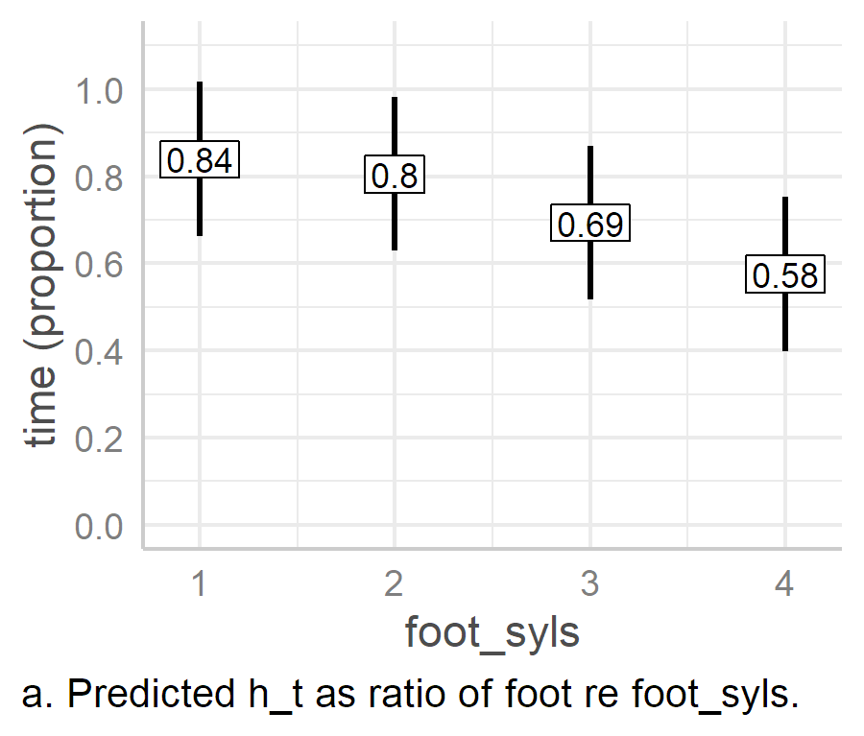 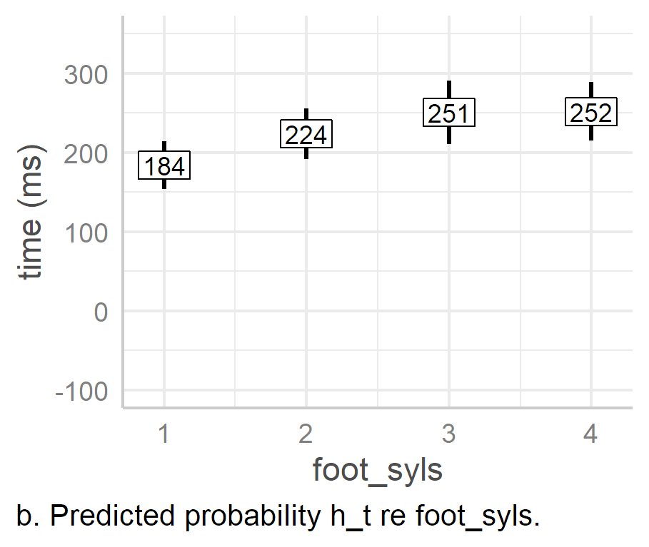

Figure . Prenuclear peak alignment as an effect of foot_syls when calculated proportionally to the duration of the foot (a) and when calculated in milliseconds (b).

Table . Pairwise comparison of foot_syls effects when h_t is measured proportionally to foot size.

|  |  |  |  |  |  |  |  |  |
| --- | --- | --- | --- | --- | --- | --- | --- | --- |
| intercept | slope | estimate | 2.5% CI | 97.5% CI | SE | |*t*| | df | *p* |
| foot_syls1 | foot_syls2 | -0.03 | -0.07 | 0.01 | 0.02 | -1.62 | 441.02 | .106 |
| foot_syls1 | foot_syls3 | -0.15 | -0.18 | -0.11 | 0.02 | -7.25 | 444.16 | < .001 |
| foot_syls1 | foot_syls4 | -0.26 | -0.31 | -0.22 | 0.02 | -10.69 | 430.27 | < .001 |
| foot_syls2 | foot_syls3 | -0.11 | -0.15 | -0.07 | 0.02 | -6.06 | 421.86 | < .001 |
| foot_syls2 | foot_syls4 | -0.23 | -0.28 | -0.18 | 0.02 | -9.86 | 405.55 | < .001 |
| foot_syls3 | foot_syls4 | -0.12 | -0.15 | -0.09 | 0.01 | -8.1 | 452.18 | < .001 |
|  |  |  |  |  |  |  |  |  |

When we look at the predicted timing of peak alignment as an effect of foot_syls, we see that as the number of syllables in the foot increases, the alignment of the peak as a proportion of the foot becomes lower (Figure 6.42a), and the difference between each foot size condition is statistically significant, except in the case of foot_syls1 and foot_syls2 (see Table 6.33). At first glance, this striking since, when compared to the earlier analysis conducted in milliseconds (Figure 6.42b), PN peak alignment actually increases with foot size, and the affect drops off as foot size increases. However, if we assume that foot duration increases relatively linearly with foot size, then the contrast disappears. This is because, if the duration of the foot increases linearly while the peak alignment does not keep pace with this change, then the peak will be aligned increasingly earlier proportionally to foot. This is illustrated in the Figure 6.43, which shows a theoretical plot of alignment and foot duration.

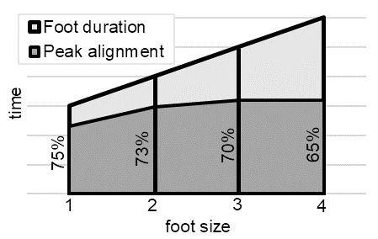

Figure . Theoretical plot of foot size and peak alignment. Foot duration increases linearly. Peak *alignment also increases but less rapidly with each additional foot. Conversely, peak alignment as a proportion* of the foot decreases more rapidly.

#### Nuclear Peak Alignment Measured Proportionally to Foot Size and Voicing Duration.

An ANOVA of the model testing h_t as a proportion of the foot indicates a significant effect of foot_syls, *F*(3, 19.06) = 117.37, *p* < .001. However, the marginal *R*2 for this model is .21, while the conditional *R*2 is 0.76. Thus, foot_syls, as the only fixed effect, accounts for 21% of the variance in peak alignment. An ANOVA of the model testing h_t as a proportion of voiced material in the nuclear PA also indicates that the effect of foot_syls is significant, *F*(3, 15.38) = 4.45, *p* = .035. The marginal *R*2 for this model is 0.01, while the conditional *R*2 is 0.78. This suggests that, when, considered as a proportion of voicing, that foot_syls only accounts for 1% of the variance in nuclear peak alignment, which is substantially lower than the 21% of the model measuring peak alignment as a proportion of the foot. (See APPENDICES)

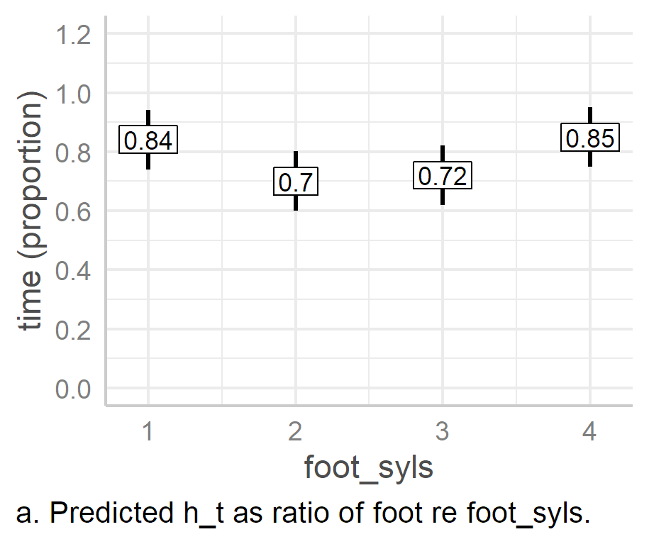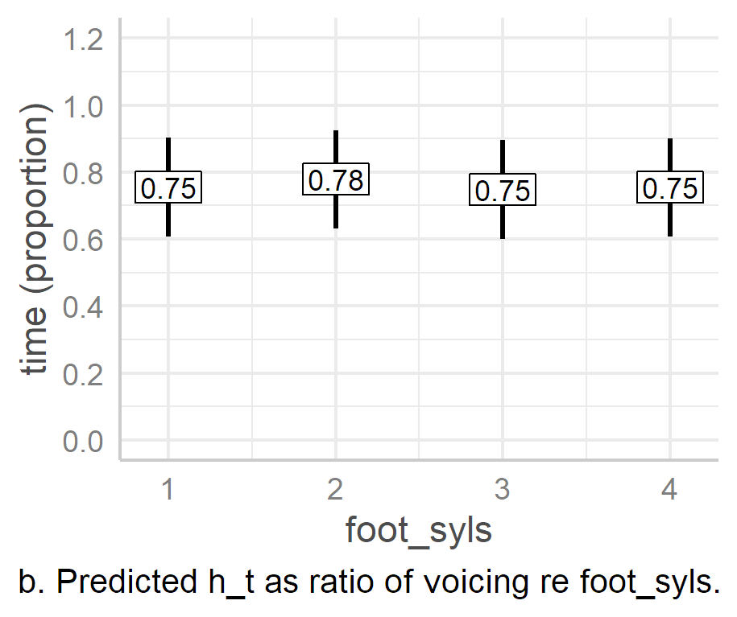

Figure . Nuclear peak alignment as an effect of foot_syls when calculated proportionally to foot size (a) and the duration of voicing (b).

When we look at peak alignment as a proportion of the foot, we see that it ranges between an estimated 70% and 85% of the foot (Figure 6.44a), but varies very little when measured proportionally to the duration of voicing, hovering around 75% (Figure 6.44b). The largest difference in peak alignment measured proportionally to the foot is 15 percentage points, between foot_syls4 and foot_syls2, 95% CI [0.12, 0.18], *p* < .001. In contrast, we see that the largest estimated difference in terms of the duration of voicing is only 3 [‑0.05, ‑0.01] percentage points, between foot_syls2 and foot_syls3, *p* < .005.

The implication of these two types of analysis, especially in the light of the initial findings that peak alignment increases with foot size, is that peak alignment in the nuclear PA is quite stably aligned as a proportion of the voiced material in the final foot. This further implies that compression and truncation actually work in tandem to maintain this proportionality. Furthermore, at least based on this data, it seems that it is not the duration of the foot which matters so much as the duration of voicing.

#### Summary of Proportional Peak Alignment Analysis.

The results of the PN model measuring peak alignment proportionally to foot duration simply mirror the results of the original model, which measured it in milliseconds. This tells us that—unlike nuclear peak alignment—peak alignment in the PN pitch accent is not less susceptible to the effects of foot size when measured proportionally. In the nuclear analysis, however, while peak alignment increases dramatically in absolute terms (ms) with foot size, this is not mirrored when it is measured relative to the foot. In fact, nuclear peak alignment, when measured relative to the foot, vacillates between 70% and 85% of the duration of the foot. When measured proportionally to the duration of voicing, it remains stable at roughly 75%. Therefore, peak alignment of the nuclear pitch accent—unlike that of its prenuclear counterpart—is only susceptible to metrical effects in so much as it is adjusted to maintain a stable position proportional to the voiced material in the foot.

## Summary and Discussion

This chapter has focused on the phonological form and phonetic implementation of pitch accents in prenuclear and nuclear position in neutral declaratives. The main motivation for this was to establish the extent to which lexical boundaries and meter affect both the distribution of pitch accents and their phonetic implementation, thus dealing with the descriptive concern raised by research question one:

1. What are the phonological and phonetic characteristics of pitch accents in DCE in unmarked speech under variation in metrical and lexical structure?

In working towards an answer to this question, it was also possible to evaluate the importance of underlying phonological tones by assessing the extent to which they are realised in the surface phonology. The helped worked in service to the theoretical concern of research question three:

1. Is there evidence in the realisation of PN pitch accents in DCE for the special status of H tones?

To further guide the analysis, a series of hypotheses were generated based on the literature, provisional analysis of the data, and, to a lesser extent, intuition.

To answer the research questions and test the hypotheses, prenuclear and nuclear pitch accents in the A- and H-Corpora were analysed. Firstly, the distribution of pitch accents was evaluated in subcorpora designed to test the effects of anacrusis, foot size, and word boundaries on prenuclear pitch accents, and of preceding unstressed syllables and foot size on the nuclear PA. After this, Bayesian generalised linear mixed-effects models (BGLMMs) were used to evaluate these effects across all utterances in the A- and H-Corpora. This was followed by a phonetic analysis of peak alignment in PN pitch accents in the H-Corpus. Linear mixed-effects models (LMEMs) were used to evaluate phonetic parameters associated with tonal targets, and compression and truncation effects on pitch accents. Moreover, wherever the results hinted at previously unexplored issues, these too was assessed using updated models. For the mixed-effects model analyses, the complete A- and H-Corpora rather than the subcorpora were used, which allowed for the inclusion of much larger data in the analyses (Section 6.3, Table 6.5 and Table 6.6).

The summary of the analysis which follows is organized in terms of the hypotheses and expectations laid out in Section 6.1 above.

### Pitch Accent Labelling

One problem became apparent early in the analysis and labelling of PN pitch accents (Section 6.4). The was an ambiguous quality of some PN PAs, wherein there was sometimes a distinct pitch event with a noticeable peak or a high plateau which ended after the stressed syllable. A visual analysis showed that these were aligned noticeably later than the typical H* but—especially in cases where there was a rise to the peak—also lacked a salient L-like quality in or near the stressed syllable. As such, they neither looked like nor sounded like L*H or H*. In the early analysis, these has been categorised either L*H and H* categories (Rodgers, 2019). However, on reflection it was decided that it was wiser to introduce an intermediate category for these, namely >H*, which is used in this chapter. Admittedly, this adds a degree of gradience to the range of PAs available and introduces what might be viewed as an over specified phonetic marking in the phonological description. However, it felt more honest to use the intermediate category for pitch accents which were neither clearly H* nor L*H rather maintaining a strict two-way categorical distinction, forcing them into categories to which they did not clearly belong.

### Metrical and Lexical Effects on Prenuclear and Nuclear pitch accent Phonology

The first hypothesis proposed that L*H would be the dominant pitch accent in nuclear and prenuclear position. The second, third, and fourth hypotheses proposed that there would be no metrical effect on nuclear pitch accent phonology but that both metrical and lexical effects would be apparent in the distribution of prenuclear pitch accents. All four hypothesis were confirmed in the phonological analysis, as summarised below.

L*H was the only nuclear pitch accent observed in A- and H-Corpora (Section 6.5.1), while L*H accounted for 71% of the PN pitch accents in the prenuclear subcorpora (pn_foot and pn_ana), or 69% once adjusted for per-speaker and per-target representativeness (Section 0). In the nuclear contour (Section 6.5.1), L*H L% boundaries were also observed, but these were less common than L*H %, i.e., nuclear pitch accents with unmarked boundaries, with L*H L% accounting for only 4% of the nuclear subcorpora (nuc_foot and nuc_pre). However, L% was not associated with any lexical or metrical effect and was largely a matter of speaker preference. Intuitively, the low final boundary seems to infer a separate discourse function, one which indicates speaker’s surprise that their interlocutor was previously unaware of the propositional content of the utterance. Essentially, L% conveys the message, “…and I thought you already knew that!”.

The third expectation was that an increase in foot size and anacrusis would be associated with increased occurrences of L*H in the prenuclear position. Initial analysis of the pn_ana and pn_foot data (Section 0) indicated that there was no effect of anacrusis, but that increased foot size was strong associated with increased occurrences of L*H. Further, initial analyses of the subcorpora suggested that there was an effect of speech rate and gender. A subsequent linear model analysis of per-speaker proportional use of L*H and H* as an effect of gender and average speech rate suggested that only gender had a significant effect. However, these were crude average-based tests, and were further examined via BGLMMs.

The BGLMMs indicated a significant effect of foot size on PN L*H pitch accents, but the effect reached saturation by the three-syllable foot conditions (Section 6.5.4.1). That is, as foot size increases from one to three syllables so too does the likelihood of L*H, after which there is no further change in likelihood. Speech rate was significant, with an increase in speech rate associated with a decrease in the likelihood of L*H. While male speakers were less likely to produce L*H than female speakers, these results were not significant, so we cannot be sure if there is truly any effect of gender.

For H*, the results were slightly different, mostly due to the overall lower likelihood of H* (Section 6.5.4.2). The likelihood of H* generally decreases with foot size and remains below 10% for the three- and four-syllable conditions while the likelihood increases slightly with speech rate. Neither of these effects were found to be significant, however. There was a strong effect of gender on the likelihood of H*, however, which indicated that male speakers are much more likely to produce H* than females (roughly 75% for males versus 20% for females).

The fourth prediction was that there would be a greater likelihood of L*H when the right boundary of the word with the lexical stress occurred later in the foot. This was indeed suggested by the initial analysis of the H corpus (Section 6.5.3), where in each case, the foot with the later word boundary had a greater number of L*H pitch accents. However, this was only a marginal difference in the “Lally’s is in- | Valerie’s is” pairing, suggesting that the effect of the word boundary depended on whether the word boundary was coterminous with the stressed syllable. The BGLMM models of L*H and H* likelihood confirmed this (Section 6.5.4). That is, L*H is much more likely when the word boundary occurs later than the right edge of the stressed syllable while conversely H* is much less likely. This effect was very strong in both cases.

### A comment on L%

While the aim of this chapter is not an analysis of function, it is still worth revisiting the L% boundary and considering it in the light of McElholm’s (1986) study of Derry City English (see also 3.2 above). The nuclear L*H L% may seem structurally similar to the rising-falling nuclear contour (contour C) described in in McElholm. However, McElholm’s described the fall in contour C as “slight”, which is in sharp contrast to the size of the fall in the L*H L% phrases. This is in sharp contrast the L*H L% contour found in this data, which has quite a sharp fall. The mean predicted peak in L*H L% was 0.1 ST (as an effect of L% along) and ‑5.4 ST for the boundary, a mean fall of 5.5 ST. In contrast, the mean estimated peak in L*H % (the intercept) was found to be 0.7 ST while the estimate for the unspecified boundary was 0.2 ST, a slight fall of only 0.5 ST. Thus, contour C, as described in McElholm is in fact more similar to L*H % than L*H L%. Functionally, however, McElholm describes contour C as suggesting reservation or signalling an upcoming contrast, which is quite different to the neutral declarative effect of the L*H %. Functionally more similar to the L*H L% contour in McElholm is contour D (extra-high-rising-falling), which is described as signalling surprise or assertiveness. However, the L*H L% contour—while containing a steep fall—is not extra high, and has, as noted above, a slightly lower peak than the L*H %.

### Metrical and Lexical effects on Phonetic PA Parameters

The final five predictions dealt with metrical and lexical effects on phonetic parameters. Hypothesis number five was that tonal alignment of PN accents would be more susceptible to metrical and lexical effects than nuclear pitch, while six predicted that that anacrusis would affect the alignment of H targets. However, given conflicting findings in previous studies (Kalaldeh et al., 2009; Nolan & Farrar, 1999), it was unclear what direction this effect might go in. The seventh prediction was that there would also be competing strategies for the anchoring of PN H targets, one associated with the right word boundary and one with the right edge of the foot. Finally, in relation to compression and truncation effects, it was predicted that compression effects were likely to be seen in the nuclear pitch accent, though truncation effects might also be seen. As to truncation and compression effects on prenuclear accents, no prediction was made.

A comparison of effect sizes in prenuclear and nuclear tonal target parameters indicated that prenuclear tonal targets were indeed more susceptible lexical and metrical effects (Section 6.6.4). It was also noted that there is already a clear foot-size and word-boundary effects on the phonology of prenuclear pitch accents, leading to the deleting of the prenuclear L target altogether.

As for the specific prediction that word boundary and meter would have a greater effect on the alignment of prenuclear pitch accent targets, this does indeed appear to be the case. The effect sizes of comparable lexical and metrical effects in the prenuclear and nuclear positions were compared using the partial omega-squared, or $ω_{p}^{2}$, statistic (Section 6.6.4). In PN pitch accents, L target alignment was only mildly affected by metrical and lexical effects, with an average $ω_{p}^{2}$, of 0.07 while in nuclear pitch accents, the average effect size of the metrical and lexical effects was almost zero (mean $ω_{p}^{2}=$ 0.003). Effects on peak alignment were much larger, both in prenuclear and nuclear contexts but still with a noticeably lower mean effect size in the nuclear position, $ω_{p}^{2}$ = 0.43 and 0.27 respectively. The extremely low average effect size of metrical and lexical effects on L target alignment reflects its especially strong stability in the nuclear pitch accent.

The issue of peak tonal alignment was investigated further by assessing peak timing proportionally to foot duration in prenuclear and nuclear pitch accents, and also a proportion of voicing in the nuclear pitch accent (Section 6.6.5). The analysis of prenuclear peak alignment as a proportion of the foot (Section 6.6.5.1) provided results which simply reflected the results of the original analysis in milliseconds, with foot size accounting for 22% of the variance in peak alignment (*R*2 = .22). Nuclear peak alignment proved slightly more stable when measured as a proportion of the foot (Section 6.6.5.2), with the peak occurring at between 70% to 87% of the foot, CIs [.61,.79], [.73, .92], and with foot size accounting for 21% of the variance in peak alignment ( $R_{m}^{2}$ = .21). When measured a proportion of voicing, however, nuclear peak timing proved remarkably stable, occurring mostly at around 75% under each foot size condition, and with foot size accounting for only 1% of the variance in peak alignment ( $R_{m}^{2}$ = .01). The extremely low marginal *R*2 of the model (in which foot size was the only fixed effect), indicates the very small influence foot size has on peak nuclear alignment when measured proportionally to the duration of voicing.

In short, while peak alignment appears to be generally much more vulnerable to the effects of foot size than the alignment of the L target, the effect size lessens in the nuclear position when the H target is viewed as a proportion of the foot, and almost disappears when analysed in terms of the proportion of voice material.

In the prenuclear pitch accent, the effect size of anacrusis was the largest of all fixed effects in the model, $ω_{p}^{2}$ = 0.76, 95% CI [0.42, 0.87] (Section 6.6.5.1). However, the effect of anacrusis appeared largely as the difference between one syllable of anacrusis and all other conditions, including the zero-anacrusis condition. The special status of one syllable of anacrusis was hard to interpret, so the effects of anacrusis on peak alignment in H* and L*H pitch accents were tested separately after which the pattern became clearer. In conditions with no anacrusis, PN peak alignment is noticeably delayed, whether in H* or L*H. However, with the addition of anacrusis, it shifts noticeably leftward, leading to earlier alignment. However, with the addition of further anacrusis, the peak begins to drift rightwards again, although never becoming as late as in the zero-anacrusis condition. The effect of *additional* anacrusis could only be observed in L*H since there were no instances of H* beyond one syllable of anacrusis.

These results go some way to reconciling conflicting findings in previous studies of nIE. Nolan and Farrar’s (1999) study of Belfast English found that the addition of anacrusis led to earlier PN peak alignment, while Kalaldeh et al.’s (2009) study of Donegal English found that increasing amounts of anacrusis were associated with later alignment of the PN peaks. In the current study, Nolan and Farrar’s findings are borne out by the results of the analysis of anacrusis on PN H* accents and on the zero- and one-syllable anacrusis condition effects on L*H. The rightward drift effects found in the study by Kalaldeh et al., however, are borne out by the one-, two-, and three-syllable anacrusis conditions.

Two analytical approaches were adopted to assess if there were competing anchor points for H targets in prenuclear pitch accents (Section 6.6.1). First, PN peak alignment of L*H in the H-Corpus was analysed in terms of syllable-normalised time, with each syllable counting as one time unit and peaks measured proportionally to syllable (Section 6.6.1.1). This allowed the comparison of peak alignment across different pairs of target utterances. The syllable-normalised time analysis indicated that the peak was typically aligned early when the syllable boundary was in an earlier syllable. Furthermore, six of the nine speakers appeared to alternate between different metrical and lexical landmarks when aligning the peaks of L*H pitch accents. However, the landmarks were not as predicted. The alignment targets were the right edge of the stressed syllable (or start of the second syllable), the right edge of the word boundary (one of the predictions), the middle of the final syllable of the word, or the middle of the third syllable. In no case was the boundary the right edge of the foot, which was the other prediction.

The H-Corpus PN L*H data were then analysed in terms of grand-mean syllable time to evaluate peak alignment of each individual target phrase in terms both of lexical and metrical anchors and of absolute timing (Section 6.6.1.2). This led to a refinement of the analysis of peak alignment anchor points, with each potential *location* of the peak as follows:

1. The right edge of (or just after) the stressed syllable.
2. The middle of the last syllable of the word with lexical stress.
3. The right edge of (or just after) the word with lexical stress.
4. A fixed time-based anchor point (350 ms in grand-mean average scaling)

Furthermore, this analysis indicated that there did indeed seem to be a bimodal or multimodal distribution of peak alignment in three of the six target phrases in the H corpus, further supported indicated by a Hartigan dip test. However, it was also noted that the results of the Hartigan dip test should be viewed with caution, as each observation in the data was not independent (i.e., there were multiple observations per target per speaker).

### Truncation and Compression Effects

Hypothesis eight predicted that compression would be observed in the nuclear PA but with the H peak being shifted leftward in order to accommodate cases of L%, and also in cases where the foot had fewer syllables. That is, it was assumed that the rise of the nuclear L*H pitch accent would be preserved via compression in the light of phrase final tonal crowding and reduced syllabic content. Given that truncation had also been observed in Belfast English, it was also predicted, in hypothesis nice, that truncation *might* observed. There were, however, no expectations on how truncation or compression might manifest in prenuclear pitch accents.

In the prenuclear pitch accent, truncation appears to be the main strategy employed to maintain the L*H rise, where there was little change in slope across foot-size conditions, but a lowering of *f*0 excursion as the foot size grew shorter (Section 6.6.2.6). The estimated mean slope in PN pitch accents ranged from 20.7 ST/s in the one-syllable foot condition to 17.3 ST/s in the four-syllable foot condition.

In the nuclear L*H pitch accents, both compression and truncation were observed (6.6.3.4). In the shift from a four-syllable to a three-syllable foot, peak alignment was shifted earlier, without any significant effect on peak height or *f*0 excursion but with an increase in *f*0 slope. This indicates compression. However, once the foot was only one or two syllables long, there was little to no change in *f*0 slope, but both *f*0 scaling and excursion decreases systematically. In the nuclear pitch accent, after the average maximum slope—i.e., in the one-syllable foot condition—was 34.8 ST/s, while truncation appears to begin somewhere above 30.6 ST/s, the mean estimated slope of the three-syllable foot condition.

The addition of an L% boundary was associated with earlier peak alignment, a lower excursion size, but only a very slight rise in slope (Section 6.6.3.4). Earlier alignment, lower excursion size, but little change in slope indicate that the addition of an L% tone to the boundary does not lead to compression, as predicted, but to truncation of the rise. The mean predicted slope of the intercept with the addition of L% was 39.25 ST/s, a slight but statistically non-significant change from 34.8 ST/s.

Differences in slope were also evaluated using ’t Hart *et al*’s differential threshold of pitch change (’t Hart et al., 1990, pp. 33–35). This evaluation indicated that there was unlikely to be any salient perceptual difference between slopes as an effect of foot size in prenuclear pitch accents. However, in the case of nuclear pitch accents, the *f*0 slope in the one-syllable foot condition was likely to be perceptually distinct from slopes in the three- and four-syllable foot conditions, and possibly also the two-syllable foot condition. A comparison of slopes as an effect of the final boundary tone indicated that they were unlikely to be perceptually distinct.

To put these results in context, they can be compared with similar studies. Xu and Sun (2000, 2002) examined the rate of change of pitch movements among a cohort of General American English speakers and Mandarin speakers studying in the US. They found, on average, that a rise of 4.8 ST was associated with a mean slope of 36.5 ST/s rise from L to H and a duration of 132 ms (Xu & Sun, 2002, p. 1403). They also found that the English speakers tended to have a longer duration of the rise and greater slope than the Mandarin speakers. In the current study, we see that the intercept for *f*0 excursion and slope (the one-syllable condition) is associated with an average rise of 5 ST, with a slope of 34.8 ST/s, and a duration of 162 ms[15], with CIs [4, 6], [146, 179], and [3.43, 3.9][16] respectively, although this rises to 39.25 [3.11, 5.34] ST/s in the one-syllable foot L*H L% condition. Thus, when compared with Xu and Sun’s study, there is little difference in the slope or rise (in the intercept at least, which is the most readily comparable), but the duration is longer by 30 ms. This may seem inconsistent, because longer duration should be associated either with a similar slope but greater excursion or a shallower slope but similar excursion. However, it should be noted that slopes in the Xu and Sun study were calculated differently. They divided the height of the excursion by its duration, while here slope was calculated directly from the contour as the slope of the linear regression of *f*0(t) between the valley and the peak. We also need to bear in mind that Xu and Sun’s data were collected in a different context. That is, they were not recorded in a communicative context but via a contour repetition task using non-meaningful contours and phoneme sequences (e.g., /malamalama/). When it comes to the prenuclear pitch accents, a study of prenuclear rises in Dutch by Ladd et al.Schepman (2000) found rises less steep than Xu and Sun[17], averaging 23 ST/s and 31 ST/sec across two experiments. In the data analysed here, the average slopes of PN L*H rises ranged between 17.3 and 20.7 ST/s, which is less steep than the prenuclear rises found Ladd *et al*. However, the slopes of the nuclear rises in this current study were also on average greater than the PN rises the Ladd et al. study. We can infer from this, that nuclear rises may typically be steeper than prenuclear rises.

Unfortunately, there is not enough comparable data for a thorough cross-study comparison. However, it does seem that the speakers in this analysis of Derry City English tend to use rises less steep than those in the two previous studies mentioned here. There is also a tendency for PN slopes to be less steep than nuclear slopes.

## Conclusion

To return to the key research questions which this chapter aimed to answer, there was a descriptive and a theoretical question. The descriptive question dealt the phonological and phonetic characteristics declarative pitch accents under variation in metrical and lexical structure, while the theoretical question dealt with the possible special status of H tones more generally.

### Descriptive Concerns

To begin with the phonological description, the most common pitch accent is L*H, both in nuclear and prenuclear positions, while H* occurs less commonly, but only in PN position. An additional pitch accent category was used, >H*, for PN pitch accents which were intermediary between L*H and H*. This was a practical decision to avoid a forced categorisation of ambiguous pitch accents. L* was also observed in PN position but was exceedingly rare (*n* = 9/788), with seven of the tokens coming from a single speaker (F17). Moreover, L* only occurs in one-syllable and two-syllable feet, suggesting that it is an instantiation of H-deletion of L*H targets in shorter feet. There is also evidence that the increased occurrence of prenuclear >H* and H* is an effect of metrical and lexical effects, and that typically L*H is the underlying pitch accent. That is, when the stressed syllable associated with the L* is also the final syllable of the word to which the H tone may be anchored, the L is more likely to be deleted. In such cases, only the H tone remains, which is reinterpreted as the starred tone, H*. A similar effect occurs when foot size decreases, leading to a greater likelihood of H* in shorter feet, while conversely L*H becomes increasingly likely as foot size increases.

Although not central to current research goals, two other effects were observed on the likelihood of L*H and H* in prenuclear pitch accents. Firstly, an increase in speech rate was strongly associated with a decrease in the likelihood of L*H. Conversely, increased speech rate was associated with a slight increase in the likelihood of H*. This latter effect was statistically non-significant, most likely due to the sparsity of H* in general. Secondly, there was also a gender effect on H*, with the male speakers being an estimated eleven times more likely to use H* than the female speakers.

When it comes to phonetic effects, PN pitch accents were found generally to be more susceptible to lexical and metrical effects than nuclear pitch accents. However, in both PN and nuclear position, the alignment and scaling of L targets is very stable. Alignment of L*H peaks in both prenuclear and nuclear position appear to be strongly affected by foot size. However, further analysis indicated that, while this is indeed true for the PN peak, the nuclear peak is also stable when viewed as a proportion of the duration of voicing in the final foot, at around 75%. Thus, there is evidence of pressure to maintain peak stability in the nuclear pitch accent which is not found in the prenuclear pitch accent.

Prenuclear PA rises were subject to truncation, which was especially pronounced in stress clash conditions, indicating that the rise of the L*H is sacrificed to ensure the stable realisation of the nuclear L target in L*H. In the nuclear pitch accent, it was found the addition of an L% boundary led to the truncation of the rise and not, as expected, simply compression. Compression was observed in between the four-syllable and three-syllable foot conditions, but once the foot was only two- or one-syllable in length, the rise was truncated. This suggests that there is a limit to the amount of compression which can be accommodated by these speakers and that the nuclear rise is not deleted, just truncated, after the limit to compression is reached.

### Theoretical Concerns

The theoretically oriented research question for this chapter was, “Is there evidence in the realisation of PN pitch accents in DCE for the special status of H tones?” The answer to this question is *yes*, for both for phonological and phonetic reasons. Firstly, in the phonology, by far the most common strategy for dealing with earlier peak alignment target (as an effect of earlier word boundaries or shorter feet) is to delete the L target while retaining the H target. Secondly, where the L target is not deleted and the L*H pitch accent remains, the H is truncated as an effect of stress clash and in anticipation of the upcoming L of the nuclear L*H. This may seem, on the surface, to indicate that the L target takes precedence of the H target. A better interpretation is that the nuclear target takes precedence over the prenuclear targets. However, rather than a prenuclear H target deletion strategy to “make way” for the upcoming nuclear PA, a phonetic truncation strategy is available for retaining the prenuclear H tone. Such a strategy is not available for the L tone, which *is* more likely to be deleted. Thus, in the prenuclear position, we see a mechanism in place to help preserve the H target but not the L tone. Taken together, these two phenomena—one phonological and one phonetic—indicate a special status for the H tone, even in this variety of English known for its starred L targets.

### Relevance

The overall importance of the findings outlined above is threefold.

It is common in AM studies to evaluate differences in phonetic realisation of different pitch accents and how they are affected by changes in metrical, lexical, and segmental structure. However, here, we see that there are constraints on the realisation of pitch accents themselves, with decreased foot size and earlier word-boundary anchor points being associated with L deletion and the realisation of PN L*H as H* or the ambiguous >H*. Thus, we see lexical and metrical effects on the phonology, not just effects on the scaling and alignment of tonal targets. They influence the presence or absence of tonal targets and, consequently, the (apparent) distribution of pitch accents.

Secondly, there is evidence of a pitch accent hierarchy, in which the nuclear pitch accent is prioritised over the prenuclear pitch accent. For example, we see deletion effects operate on the prenuclear pitch accent but not on the nuclear pitch accent. We also see that the rise of PN L*H is likely to be truncated in order to accommodate the L target of the L*H. While evidence of a pitch accent hierarchy is not new, the results presented here indicate how the hierarchy is likely to affect the stability of tones in the nuclear and prenuclear positions.

Finally, we see that the peak alignment of the nuclear L*H is realised in a stably as a proportion of the voiced material in the foot (and slightly less stably as a proportion of the foot itself). Such stability is not found in the prenuclear L*H. At the same time, the general ‘universal’ tendency toward H* nuclei and nuclear falls in declaratives is not in any way reflected in the overwhelming dominance of L*H % in the nuclear pitch contour. However, we do see that the H target is prioritised over the L target in prenuclear pitch accent, indicating that, even in this variety of English dominated by unmarked nuclear L*H %, the H target itself appears to have a special status.

# Analysis of Function: Sentence Modes

Chapter 3 observed that AM analyses of nIE attest to the dominance of L*H nuclear pitch accents across declarative and question forms. This includes declarative questions, which are lexically and grammatically identical to declarative statements. However, in other (standard) varieties of English, speakers tend to employ a falling nuclear contour for statements (H* L% or H*L %) and a rising contour for binary questions (L*H % or L*H H%). Even in varieties which use declarative rises (e.g., varieties in the North of England), the declarative rise does not dominate to the extent as in nIE.

It was also observed that, if one follows the AM approach championed by Gussenhoven (2004) and illustrated in Haan’s study of Dutch question intonation (2002), the distinction between declarative intonation and question intonation can be ascribed to paralinguistic effects. That is, as the number of lexical and grammatical cues to interrogativity decrease, the overall scaling of *f*0 is likely to increase in a gradient fashion. Thus, in nIE, while L*H may dominate across all sentence modes, interrogativity will be signalled paralinguistically.

Two problems were noted with the paralinguistic/linguistic split in the description of intonation. Firstly, it was argued that if there is a consistent correlation between *f*0 contours and grammatical function, it is important to investigate the possibility that the correlation reflects a phonological event, not simply a paralinguistic effect. Not to do this may lead to a corollary danger. Namely, by partitioning off uncooperative data as paralinguistic, we would exclude data which challenge the theory’s ability to adequately describe our observations. This would preserve the phonological theory as is rather than allowing it to evolve to provide a fuller description of the data.

The second problem relates to the way in which the paralinguistic/linguistic split suggests an unlikely typological division between nIE and other varieties of English. That is, if question forms are not typically expressed using intonational phonology but rather must be signalled by paralinguistic means in nIE, then this would imply that nIE does not have recourse to a chunk of the English Grammar system that other varieties of English do. Of course, we do expect that different varieties of any language will vary in the form, application, and distribution of structural components; however, it is a different proposition to imply that a feature is altogether missing. Thus, with nIE, it seems unlikely that—even as L*H dominates—it offers no consistent recourse to a phonological intonational form to signal the difference between declaratives and interrogatives.

The proposed solution is that nIE speakers (speakers from Derry City in this case) exploit a phonological register tier to distinguish between interrogative and declarative forms, called here the register-tier hypothesis. Note, it is possible that speakers of other varieties also exploit a register tier, but—as there is also recourse to a distinction in the distribution of pitch accents—this may largely go unnoticed or may appear redundant.

This chapter assesses the viability of a register-tier hypothesis in the phonology and phonetics of sentence mode in Derry City English. That is, it aims to answer the following research questions:

1. **Descriptive:** What are the phonological and phonetic characteristics of nuclear pitch contours in DCE across sentence modes?
2. **Theoretical:** Does a register tier provide a plausible phonological explanation for variation across sentence modes in DCE?

Although utterance-wide intonational features are not central to the core questions, the chapter will also consider them as nuclear contour is still situated within the domain of the IP[18].

## Expectations

There will be two sets of analyses of the phonetics and phonology of intonation in relation to sentence mode in this chapter. One will assume a null hypothesis where there is no register tier, while the other will assume that the register tier exists. The first will be called the non-register-tier analysis, and the second the register-tier analysis. In employing the two approaches, the plausibility (or lack thereof) of the register-tier hypothesis should become clearer. That is, for the register-tier hypothesis to hold water, we need to establish if the register-tier analysis can provide a more coherent, efficient, and transparent explanation of the intonational phonology and its phonetic implementation than the non-register-tier analysis can. There will be a degree of overlap in the results of the two sets of analyses. Therefore, to avoid redundancy and repetition, wherever the same expectation applies to both sets, it will not be discussed in full twice.

Throughout this chapter, abbreviations are used for each sentence mode type. These follow the conventions used for naming target utterances during data collection. That is, they begin with a corpus reference (M) followed by a code identifying the sentence type mode, as shown in Table 7.1

Table . Abbreviations for different types of sentence mode.

|  |  |
| --- | --- |
| Sentence mode | Abbreviation |
| Declarative Statement | MDC |
| Wh-Question | MWH |
| Yes-No Question | MYN |
| Declarative Question | MDQ |
|  |  |

### Phonological Analysis

Setting aside the register-tier component, L*H % is expected to dominate as the nuclear contour across sentence modes. However, as both L*H % and L*H L% were observed in the analysis of formal effects on declaratives, L*H L% is also expected. Given that there were no H* % or H*L% contours in the H- and A-Corpora, they are unlikely to occur in MDCs and even less likely in MYNs or MDQs, sentence modes with which they are not typically associated in other varieties of English.

Broadly, most final boundaries in the M-corpus should be unmarked; however, we should expect some differences in the distribution of boundary tones compared to the A- and H-corpora of the previous chapter. Based on studies of Belfast English, we can expect L*H H% in the nuclear contour—even if relatively rare—increasing in frequency from MYN to MDQ. That is, we should expect H% to be used to reinforce interrogativity. We should also expect to see L% in boundary tones, as previously; however, we should also expect a different distribution across sentence modes.

In chapter 6 (Section 6.5.1), it was suggested that L% is used for discourse functional purposes, namely that the speaker use L% to signal that a previous expectation of givenness conflicts with a newer understanding of the shared knowledge in the discourse space. For example, the statement “I live with Valerie”, if it ends with an L%, seems to imply the additional meaning of “I live with Valerie [L% = and I thought you already knew that].” We can also expect L% to occur in MDQs, where the speaker is questioning the propositional content of the whole utterance. For example, in the question, “You live in the valley?”—which can be interpreted as a checking question—the speaker might want to indicate that the new information (embedded in the propositional content of the sentence) conflicts with what they expected to be true, and they might use L% to indicate this, i.e., “You live in the valley? [L% = I’m surprised. I’d never have guessed.]” However, this does not mean that L% signals interrogativity, rather that the discourse function it represents is more compatible with the interrogativity of declarative questions. Finally, the function of a low boundary will be the same regardless of whether it is in service to a register-tier or non-register-tier analysis.

This intuition regarding L% is in essence a re-articulation of the surprise and redundancy contour described by Sag and Liberman in GenAm, which also involves a final fall (1975). However, it is not that surprise and redundancy share the same intonational contour or, as Sag an Liberman suggest it might (p. 497), that redundancy is a secondary effect. Here, the use of L% instantiates the same discourse mechanism. The L% is interpretable as surprise in the echo question—which, as an echo, is inherently also redundant—since the speaker uses it to show surprise that the propositional content in the sentence conflicts with their understanding of already established shared knowledge in the discourse. In the declarative statement responding to the question, “Where do you live?” it is also surprise since the speaker is indicating surprise that the information was not already established fact, and also therefore—from the speaker’s perspective—the response is (or should be) redundant.

In associating L% and H% with different functions, this reflects an implicit view that boundary tones are compositional in relation to meaning. H% reinforces the question status of the utterance, while L% indicates a conflict between the speaker’s understanding of givenness and the current state of the discourse. How these two conflicting boundary-tone functions might manifest in a single question utterance, however, is unclear. One possibility is that a speaker may use a compound HL% to signal interrogativity while also indicating the conflict in their understanding of shared knowledge.

Expectations specific to the non-register-tier analysis of intonational phonology are as follows:

1. L*H % will dominate across sentence modes in the non-register-tier analysis.
2. H% can re-enforce interrogativity in the non-register-tier analysis, leading to increasing frequency of H% in MYNs and MDQs.
3. Compound HL% boundaries may also occur in the register-tier analysis.

When considering the register-tier analysis, we expect that the H% will generally not be required since the register tier will already account for the higher scaling in the nucleus. We also expect that the register-tier analysis will provide a more accurate account of phonological change across sentence modes than the non-register-tier account. The expectations from the register-tier phonological analysis are as follows:

1. Patterns will occur which are adequately explained only with reference to both a register tier and the tonal tier.
2. The register-tier analysis will indicate phonological changes across sentence mode more effectively than the non-register-tier analysis.

For both H% and high register, the expectation is that neither will occur in the nuclear pitch accent of MDC or MWH but will occur with increasing frequency in MYN and MDQ.

The low boundary is hypothesized NOT to be primarily a function of sentence mode, unlike either H% or high register. Therefore—if we include compound boundaries HL% from the non-register-tier analysis as a variant of L%—we expect no difference in the use and distribution L% in either approach. The expectation from L% is:

1. L% will occur in all sentence modes but more frequently in MDQs.

### Phonetic Analysis of Tonal Targets

If we reject the register-tier hypothesis, we should expect to observe gradient *f*0 scaling of tonal targets in pitch L*H pitch accents as a function of sentence mode. That is:

1. Non-register-tier analysis: *f0(*MDC) <= *f0(*MWH) < *f0(*MYN) < *f0(*MDQ)

If, on the other hand, the register-tier hypothesis is valid, we should expect to see those differences scaling effects disappear once the register tier has been incorporated into the model. i.e., in a register-tier analysis, *f*0 scaling will more appropriately be associated with changes in pitch accent and register tier[19] rather than sentence mode.

Further, we should expect to find significant differences in the scaling of pitch accents themselves when they are subject to register shift. Thus, the final two expectations are as follows:

1. Apparent paralinguistic differences in scaling of tonal targets across modes will disappear in a model incorporating the effects of the register tier.
2. There will be significant differences in the scaling of tonal targets across pitch accents due to register-tier effects.

### Phonetics and Phonology of Utterances

In both the phonological and phonetic analysis of the utterance, we should expect MDC and MWH forms to be similar. This is because wh-questions are most highly saturated with lexical and morphosyntactic cues to interrogativity and thus are least likely to require intonational support to distinguish them from statements. However, question words are typically prominent, so they are more likely to be associated with prenuclear H* PAs. H* is less likely to occur in declaratives, where PN accentuation may be less common. If we follow Haan’s hierarchy (2002, and 2.3.5 above), we should expect to see IP mean *f*0 increase from wh-questions to yes-no questions to declarative questions as other cues to interrogativity disappear. Given the greater likelihood of wh-questions beginning with an H*, we can also expect the slope of the IP in wh-questions to be lower than both declaratives and other question forms. We should also expect the slope to increase from statements to yes-no questions to declarative questions. Typically, this is attributed to gradient effects of paralinguistic biological codes. However, it could equally be an effect of the deployment of the proposed register tier in the nuclear contour or across the utterance.

If we accept the register-tier hypothesis, we should expect to see increased use of high register in YNQ and DCQs, which will parallel changes in the scaling of *f*0 in tonal targets. That is, an increase in the use of high register in question forms should increase in inverse proportion to the amount of syntactic and lexical markers of interrogativity, as described in expectation 7 above.

## Materials

The M-Corpus is used for the analyses in this chapter. The stimuli were designed to assess phonological and phonetic variation across sentence modes, i.e., declarative statements (MDC), wh-questions, (MWH) yes-no questions (MYN), and declarative questions (MDQ) (see Table 7.2). There are three phrases per sentence mode, ending with the word *valley*, *vases*, and *valuables* in turn. These were chosen to have both two- and three-syllable final feet. *Valley* was chosen as it ends in a fully voiced syllable, while *vases* has a is more likely to become devoiced. By varying syllable count and the potential amount of phrase-final voiced material, this data can be used in further future research on truncation and compression. As with all the read speech stimuli, each target utterance is a response to a stimulus read by a speaking partner and is embedded in a short dialogue (see 5.1.1 and 5.1.3).

Table . Target phrases for sentence mode analysis.

|  |  |  |
| --- | --- | --- |
| **Code** | **Sentence mode** | **target response (B)** |
| MDC_1 | declarative | I valued the **vases**. |
| MDC_2 | declarative | I live in the **valley**. |
| MDC_3 | declarative | I've hidden the **valuables** |
| MWH_1 | wh-question | Who valued the **vases**? |
| MWH_2 | wh-question | Why do you live in the **valley**? |
| MWH_3 | wh-question | Where have you hidden the **valuables**? |
| MYN_1 | yes-no question | Have you valued the **vases**? |
| MYN_2 | yes-no question | Do you live in the **valley**? |
| MYN_3 | yes-no question | Have you hidden the **valuables**? |
| MDQ_1 | declarative question | You valued the **vases**? |
| MDQ_2 | declarative question | You live in the **valley**? |
| MDQ_3 | declarative question | You've hidden the **valuables**? |
|  |  |  |

Ideally, there would be 660 utterances in the M-corpus. As previously, if there were speaker or recording errors, speakers were asked to record one or two extra repetitions, and only the good repetitions were retained. Unfortunately, some errors weren’t noticed until later, so there is still some data loss. After repetitions with disfluencies or speaker and recording errors were excluded, there were a total of 639 utterances, as shown in Table 7.3. (Note that there are no repetitions for M9_MDQ1, as the interlocuters accidentally skipped this prompt, an error which was missed at the time of recording.)

Table .. Summary of valid utterances in M-Corpus. Red shows missing utterances, green superfluous ones.

|  |  |  |  |  |  |  |  |  |  |  |  |  |  |
| --- | --- | --- | --- | --- | --- | --- | --- | --- | --- | --- | --- | --- | --- |
|  | MDC1 | MDC2 | MDC3 | MDQ1 | MDQ2 | MDQ3 | MWH1 | MWH2 | MWH3 | MYN1 | MYN2 | MYN3 | TOTAL |
| F5 | 5 | 5 | 5 | 5 | 5 | 5 | 5 | 5 | 5 | 5 | 5 | 4 | 59 |
| F6 | 5 | 5 | 5 | 5 | 5 | 5 | 5 | 5 | 5 | 5 | 5 | 5 | 60 |
| F12 | 5 | 5 | 5 | 5 | 5 | 5 | 5 | 5 | 5 | 5 | 5 | 5 | 60 |
| F15 | 5 | 5 | 5 | 5 | 5 | 5 | 5 | 5 | 5 | 5 | 5 | 5 | 60 |
| F16 | 5 | 5 | 5 | 5 | 5 | 5 | 5 | 5 | 5 | 5 | 5 | 5 | 60 |
| F17 | 5 | 4 | 5 | 5 | 5 | 5 | 5 | 1 | 5 | 5 | 5 | 5 | 55 |
| M4 | 5 | 5 | 5 | 5 | 2 | 5 | 5 | 5 | 5 | 5 | 5 | 5 | 57 |
| M5 | 5 | 5 | 5 | 5 | 5 | 5 | 5 | 5 | 5 | 5 | 5 | 5 | 60 |
| M8 | 5 | 6 | 5 | 5 | 5 | 5 | 5 | 5 | 5 | 5 | 5 | 5 | 61 |
| M9 | 5 | 3 | 5 | 0 | 3 | 3 | 5 | 5 | 5 | 5 | 3 | 5 | 47 |
| M10 | 5 | 5 | 5 | 5 | 5 | 5 | 5 | 5 | 5 | 5 | 5 | 5 | 60 |
| Total | 55 | 53 | 55 | 50 | 50 | 53 | 55 | 51 | 55 | 55 | 53 | 54 | 639 |

## Methods

As with each corpus in Part II, utterances were annotated in Praat and a data table was extracted using the process_texgrids script, as described in Chapter 5, Section 5.2. The data table for M-Corpus can be found in the GitHub repository (*4_data/m_corpus.csv*, see Appendix D). IViE labelling conventions were used as the basis for the phonological labelling (Grabe, 2001). However, during the process of annotation, IViE labelling proved inadequate for labelling distinctive pitch patterns—which is be expected given the register-tier hypothesis—so modifications were made which accommodated the register-tier hypothesis while preserving the underlying IViE labelling system. These adjustments and the rationale behind them are outlined in the following section.

For representative visualisation of count data, raw counts were adjusted to be proportionally representative, using the process outlined in Chapter Five (5.3). For inferential statistical analyses, phonetic parameters are analysed using Linear Mixed-effects models (LMEMs) while phonological categories are analysed using Bayesian Generalised Linear Mixed-effects models (BGLMMs), as outlined in Chapter Five (5.4). As with all chapters, all inferential statistical analyses were conduct in R (R Core Team, 2022). All code and markdown for this chapter can be found on the GitHub repository (*6_analysis_of_function,* see Appendix D).

## Phonological Labelling

As with the A and H subcorpora, L*H dominated the nuclear position. However, there were many cases where simply labelling them as L*H would have been misleading, and an alternative which incorporated the register tier into the labelling was developed. Firstly, there were often cases the L*H simply occur at a distinctly high register. In fact, the raised register sometimes covered the whole IP in such a way that the whole contour of MDQ was essentially a copy of the MDC raised a several semitones. In such cases, the nuclear contour L*H % was highly salient in each case but so too was the IP-wide raised register. In other cases, the raised register was limited to the nuclear pitch accent, or possibly even just a single tone. In fact, while the L*H quality of the nuclear pitch accent was very salient, it was difficult to label the data without also accounting for local and global changes in register. Several examples are provided below to further demonstrate the issue, including the problems raised by non-register-tier alternatives. After this, the new approach to labelling is outlined.

**Figure 7.1** presents all the pitch contours for F5 for MDC2 and MDQ2. In the MDQ utterances there is a distinct shift to register high in the speaker’s range. This indicates that the speaker is making a categorical distinction between an unmarked low register and a marked higher register.

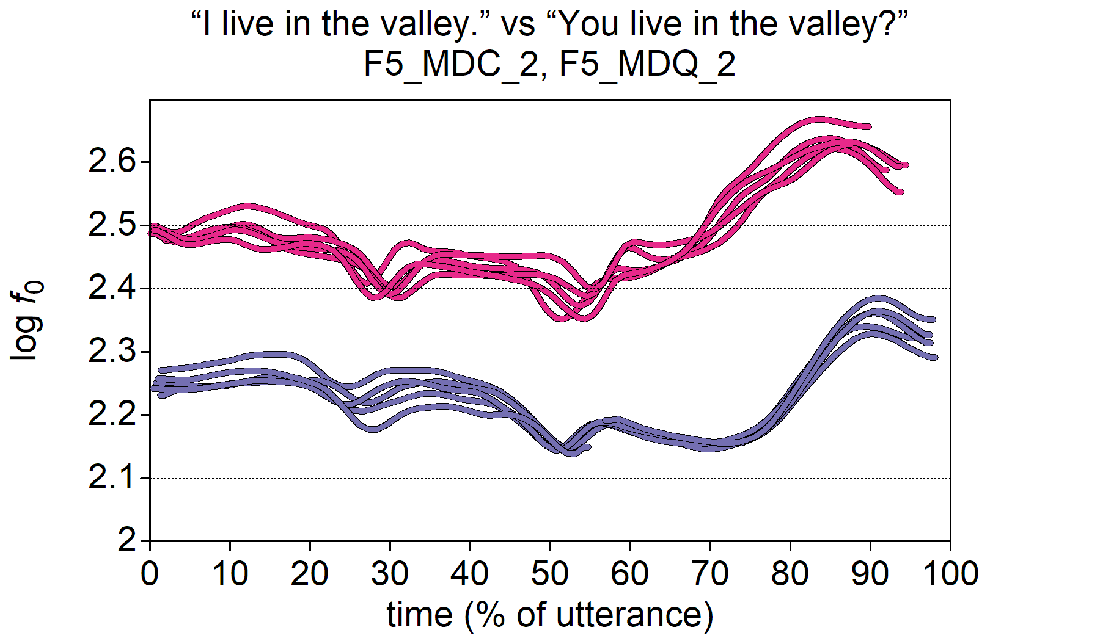

**Figure 7.1** An illustration of IP-wide raised register across all repetitions. f0 contours from F5, MDQ2 and MDC2, “You live in the valley?” and “I live in the valley.” Respectively.

Figure 7.2 illustrate cases where raised register occurs in the pitch accent (PA) but not in the prenuclear stretch or on the boundary tone. Each phrase has a L*H nuclear PA, which we see in the rise out of the stressed syllable in the final foot at roughly 65-75% in the utterance. One MDC has an unspecified boundary while the other ends with L%. This is also true of the two MDQ contours. During the prenuclear stretch (up to roughly 55%), each contour contains an H* pitch accent with a similar pitch scaling. However, in the nuclear pitch accent of the MDQs, *f*0 falls only slightly in the stressed syllable before beginning to rise. This is distinct form the MDCs, where the fall is much greater. Despite differences in the initial scaling of the nuclear PA, the rise in each MDQ is essentially a copy of the MDC pitch accent but just in at a higher register. For the MDQ and MDC with the unspecified boundaries, there is a slight *f*0 drop just before the offset of voicing. However, in each utterance with an L% boundary, *f*0 falls to the speaker’s baseline (roughly 2.11 log10 Hz, or 130 Hz). This suggests that the process causing the upward shift in *f*0 during the MDQ nuclear PA is absent at the boundary. The general impression from these example contours is that there is a motivated upshift in register affecting only the scaling of the tonal targets of the nuclear pitch accent.

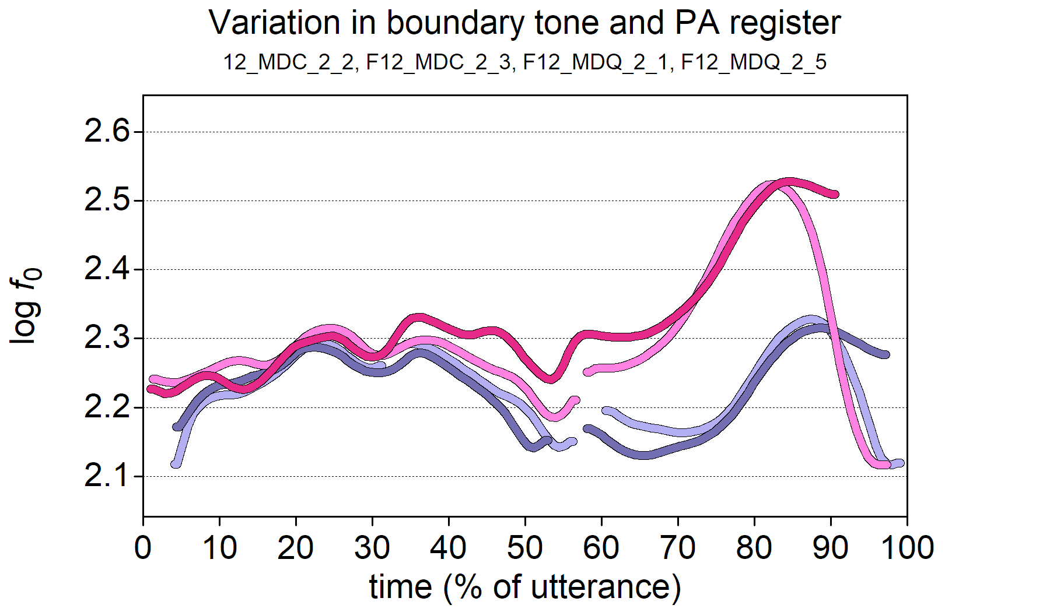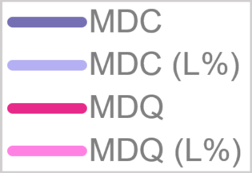

**Figure 7.2** An illustration of register shift in nuclear PA which does not affect the PN stretch or the final boundary. f0 contours from F12_MDC2_2, F12_MDC2_3, F12_MDQ2_1, and F12_MDQ2_6, “I live in the valley?” and “You live in the valley.” respectively.

One might be tempted simply to ignore the changes in register and transcribe all PAs as L*H with only variation in the boundary, but this would ignore the salient scaling difference changes in *f*0 to a register shift. Alternatively, one might choose to label them differently. As such, once might decide to interpret the MDQ H* H%, while the MDQ with the boundary fall could be viewed as H* HL%. However, there are several arguments against this.

Firstly, we can see from the illustration of the contours in **Figure 7.2** that the nuclear pitch accent of each MDQ is essentially a raised version of the corresponding MDC, even though the beginning of the rise is slightly earlier. It would be odd, therefore, that while the MDC would be L*H %, the MDQ with a similar contour shape would be interpreted as H* H%. In fact, such an analysis would require that the H target at the end of each rise be ascribed to a different structural unit of the IP, i.e., to the pitch accent in the case of MDC but to the boundary in the case of MDQ. However, there is no evidence for such an analysis. In fact, in these particular cases, the peaks of the MDQs are aligned slightly earlier their corresponding MDCs, which actually goes against expectations of a peak associated with the boundary rather than the PA.

Similarly, when the MDC is L*H L%, its non-register-tier-analysis MDQ counterpart would become H* HL%, with the H peak again reassigned to the boundary. This would, once more, also suggest a shift in the structural association which is not borne out by the alignment of the targets. It would also require a compound boundary, although this is not an unreasonable possibility, as mentioned in section 7.1.1. However, the compound boundary does not account for the distinctiveness of the boundary fall with its large negative excursion, which suggests that there is more happening at the boundary than the regular relative low of the L tone. Of course, to represent the size of the fall, one could suggest that the boundary is in fact a complex HLL%, but this looks like an overly complicated Procrustean interpretation of the contour serving only a desire to reject the possibility of a register tier while simultaneously using the boundary sequence to provide a detailed more *phonetic* representation of the large fall.

Finally, the shapes of the *f*0 contours in the MDQ pitch accents in **Figure 7.2** do not look anything like prototypical low targets. Each contour is concave and has the appearance of rising out of a low target, features which are typical in the realisation of an L tone. In contrast, the H tone is prototypically associated with a convex shape (as in a peak) in the *f*0 contour, but there is no such evidence for this around the lexically stressed syllable. In fact, if there were a H* tones in nuclear pitch accent, we might expect to see a sagging pitch contour between the prenuclear H*s and the nuclear pitch accent. Rather, what we see is quite different. After the PN H*s, the *f*0 contour falls until the nucleus of following lexically stressed syllable before beginning to rise. All in all, it is hard to interpret either MDQ as H* H% or H* HL%.

The most sensible reading of the example MDQ contours presented above is, I believe, to interpret each as L*H with a raised register. That is, each should be understood as an instantiation of a register-tier shift from an (unmarked) L register to the H. The IViE labelling conventions have been adapted to incorporate interpretation, as follows:

1. The caret symbol ^ is used indicate register shift
2. square brackets [] to indicate the scope of the register shift.

In other words, an upshift in the register tier, i.e., high register, is indicated by ^[...] in the labelling, while the normal (low) register is unlabelled. In this way, the four example contours in **Figure 7.2** are represented symbolically as follows:

1. MDC 1: % H* L*H 0%
2. MDC 2: % H* L*H L%
3. MDQ 1: % H* ^[ L*H] 0%
4. MDQ 2: % H* ^[ L*H] L%

This approach preserves the clear similarity in the contour shape across the four examples while reflecting the distinct rise in the nuclear PAs of the MDQs. Moreover, since it limits the scope of register shift to the PAs and not the boundary tones, it neatly captures the dramatic fall at the boundary of one of the MDQs. In cases where the whole IP is affected by high register, the scope of the effect can be indicated using square brackets. This is exemplified in the following labelling for the two IPs represented in **Figure 7.1**:

1. MDC: ^[% H* L*H %]
2. MDQ: ^[% H* L*H %]

One reasonable criticism of this approach is that it implicitly rejects the null hypothesis, yet, as outlined above, it was impossible to ignore the effects of register shift during labelling. Basically, the difficulties encountered even during the labelling process already began to provide evidence for expectation 4, that “patterns will occur which are adequately explained only with reference to both a register tier and the tonal tier” (section 7.1.1). That said, two strategies were adopted to avoid falling into the self-fulfilling hypothesis trap.

The first strategy was to generate a set of labels that excludes the register tier. This was done by replacing register-tier/PA combinations with alternatives which can be expressed adequately in terms of PA+boundary and then removing all register-tier labelling from the data. In only two contexts, however, did relabelling seem reasonable, namely L*^[H] % and L*^[H] L%. These are reinterpreted as L*H H% and L*H HL% respectively. The other potential scenario for relabelling was in cases where an apparent upward register shift in the nuclear PA (as illustrated in the MDQs of **Figure 7.2**) might possibly be interpreted as H* H% and H* HL%. However, as noted above, this would represent a Procrustean stretching of data which phonetically and phonologically still retain an L*H (L)% quality. Admittedly, this will weaken the case for the non-register-tier analysis, but it would have been dishonest to use the H* H(L)% labels. **Table 7.4** summarises register-tier labelling, the non-register-tier alternative, and the rejected alternatives.

**Table 7.4** Differences between register-tier and non-register-tier labelling used in phonological analysis. Rejected alternative non-register-tier labels are also included.

|  |  |  |
| --- | --- | --- |
| Register-tier labelling | Non-register-tier alternative | Rejected non-register-tier alternative |
| L*^[H] % | L*H H% |  |
| L*^[H] L% | L*H HL% |  |
| ^[L]*H L% | L*H L% |  |
| ^[L*H] % | L*H % | H* H% |
| ^[L*H] L% | L*H L% | H* HL% |
| ^[L*H L%] | L*H L% | H* HL%, H* HLL% |

The second strategy was in the decision to analyse the phonetic parameters of each PA/register-tier combination. This will help assess the reliability and validity of labelling choices such as L*H and ^[L*H], allowing us to see if there is indeed a consistent distinction between them.

### Interpreting Initial boundaries and Prenuclear Pitch Accents

While this chapter focuses primarily on the nuclear pitch accent of the IP, it also considers utterance-wide phonology. Again, as with the previous chapter, prenuclear pitch accents which gave rise to the most difficulty, specifically the second prenuclear pitch accent of wh-questions. These difficulties are outlined below, primarily for the sake of transparency, but will be considered again in Chapter 8.

In most cases, the second prenuclear pitch accent was unproblematic, especially in cases where it was clearly an L*H or a L*!H (Figure 7.3, panels a. and b. respectively). In other cases, however, there is a salient L on the stressed word in the second foot, yet, even though a slight rise may be visible in the pitch contour, it is so dampened that there is no H percept at all, either auditorily or visually (Figure 7.3, panel c.), so it feels more appropriate to label it L* rather than (*), the label used for a stressed syllable not associated with pitch accent (see Chapter 5, Section 5.2). Figure 7.4 superimposes each contour on top of the other, illustrating the differences between each PN accent.

In terms of function, there is little apparent difference between the L*H and the L*!H, and in each case, the speaker appears to be packaging the semantic content of the utterance in to three units: who, valued, and vases. However, in the utterance with L*, there is an impression that the speaker is dividing the information between the question word who and its complement, valued the vases.

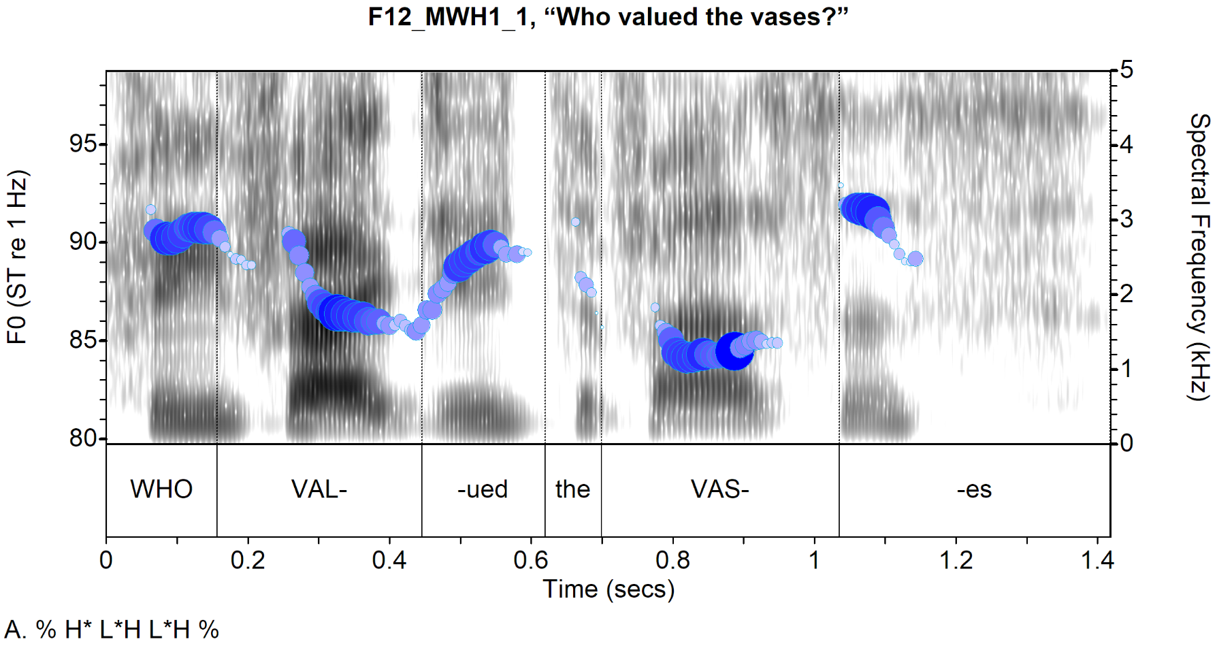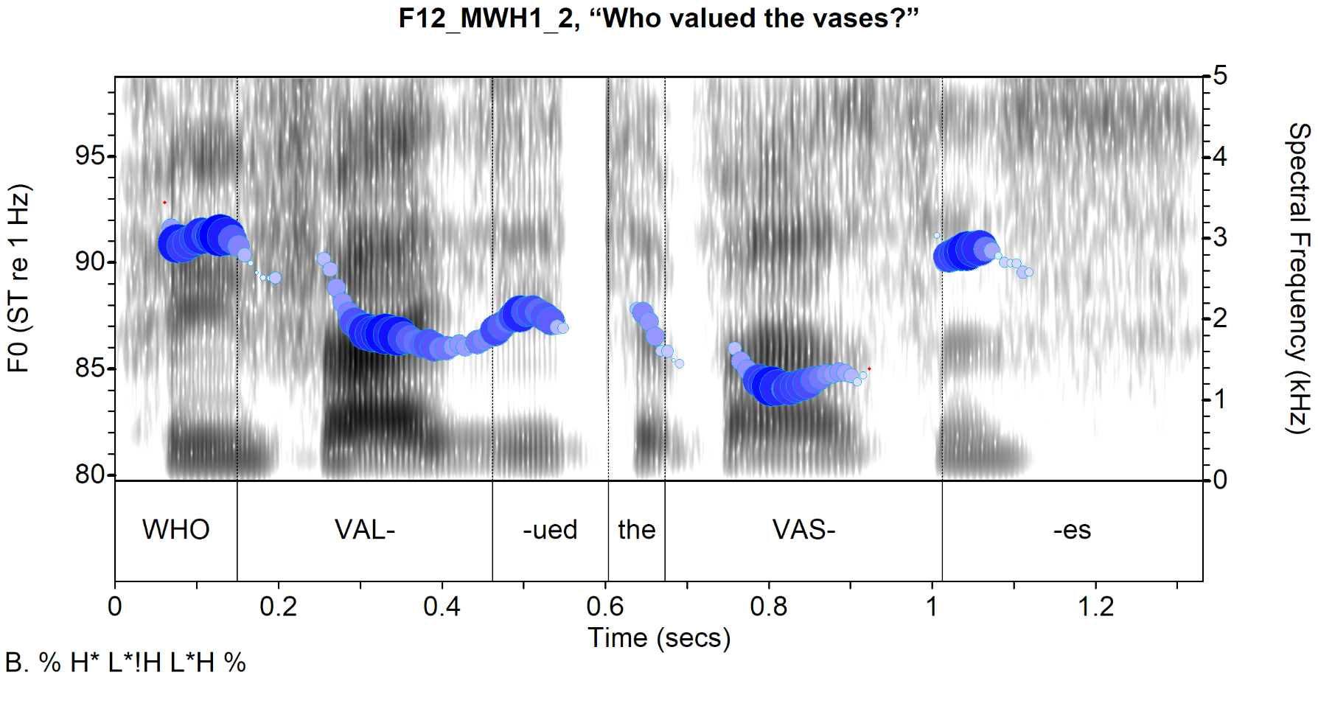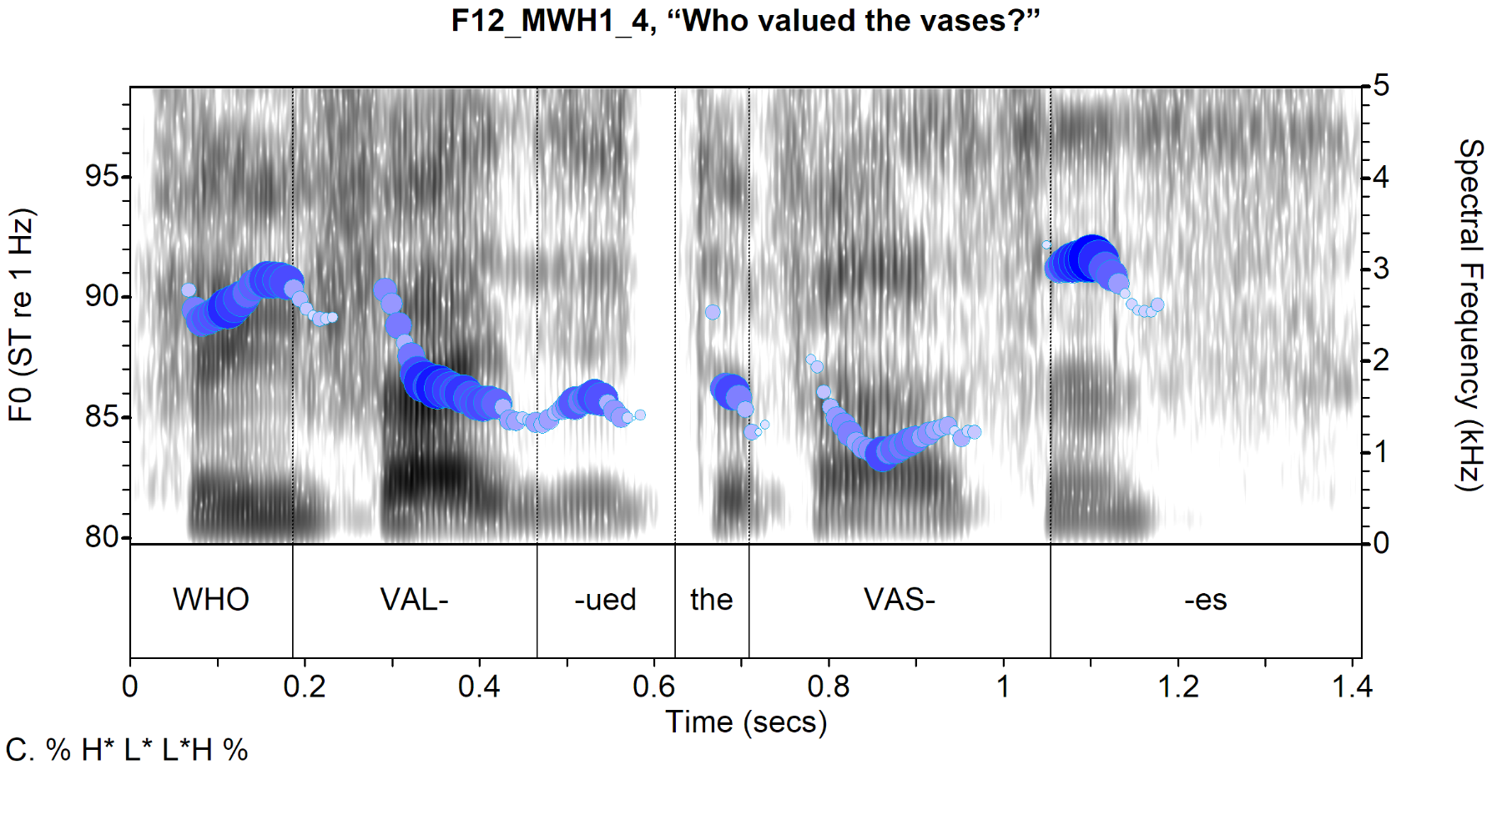

**Figure 7.3** Spectrograms and f0 contours of three repetitions of the same target with different prenuclear pitch accents in the second foot. f0 contours show Cepstral Peak Prominence (CPP) shown by the size and intensity of the circles. The combination of f0 and CPP is used throughout to help visually de-emphasise parts of the contour with low periodicity, often due to microprosodic segmental effects. Adapted from Albert et al. (2019).

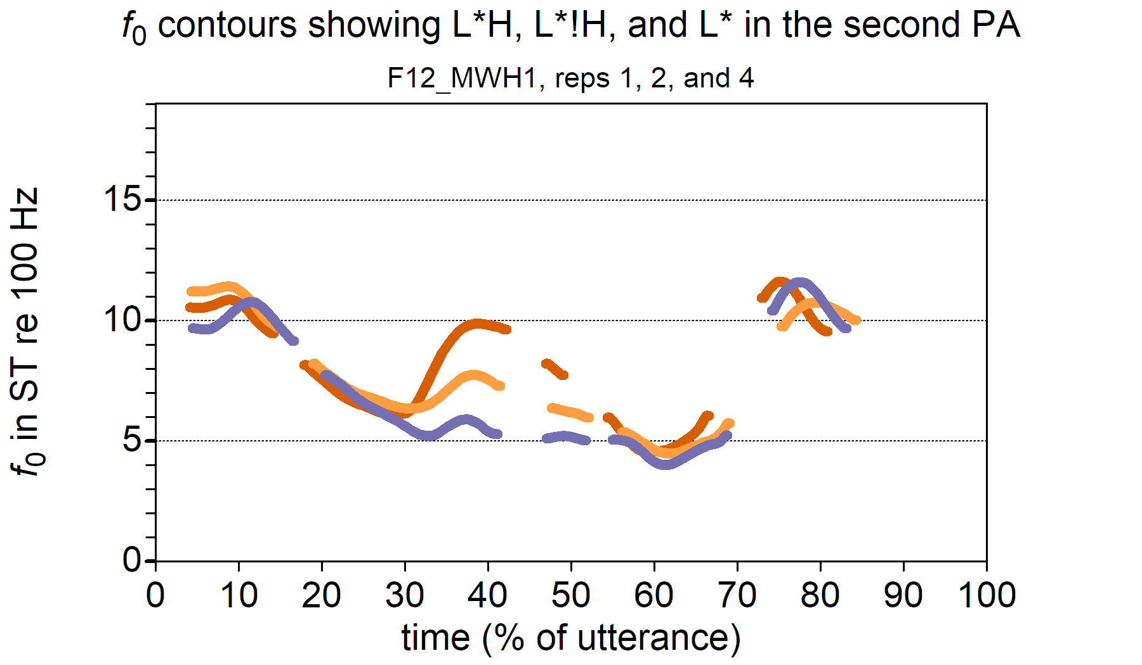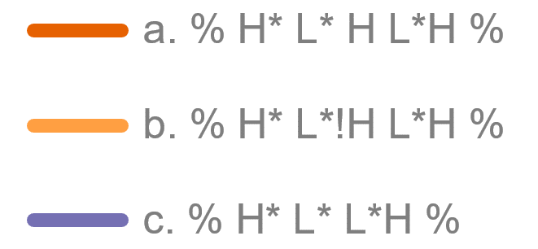

**Figure 7.4** The contours in Figure 7.3 superimposed on each other (time normalised).

Another issue with the prenuclear PA pertains to the difficulty distinguishing between accentuation and lack thereof, especially in the second foot. Sometimes, there is a slight perturbation in *f*0, but it does not trigger the percept of a phonological pitch event. This issue is illustrated in **Figure 7.5**, where each line is an *f*0 contour from F15’s repetitions of MYN2, “Do you live in the valley?”

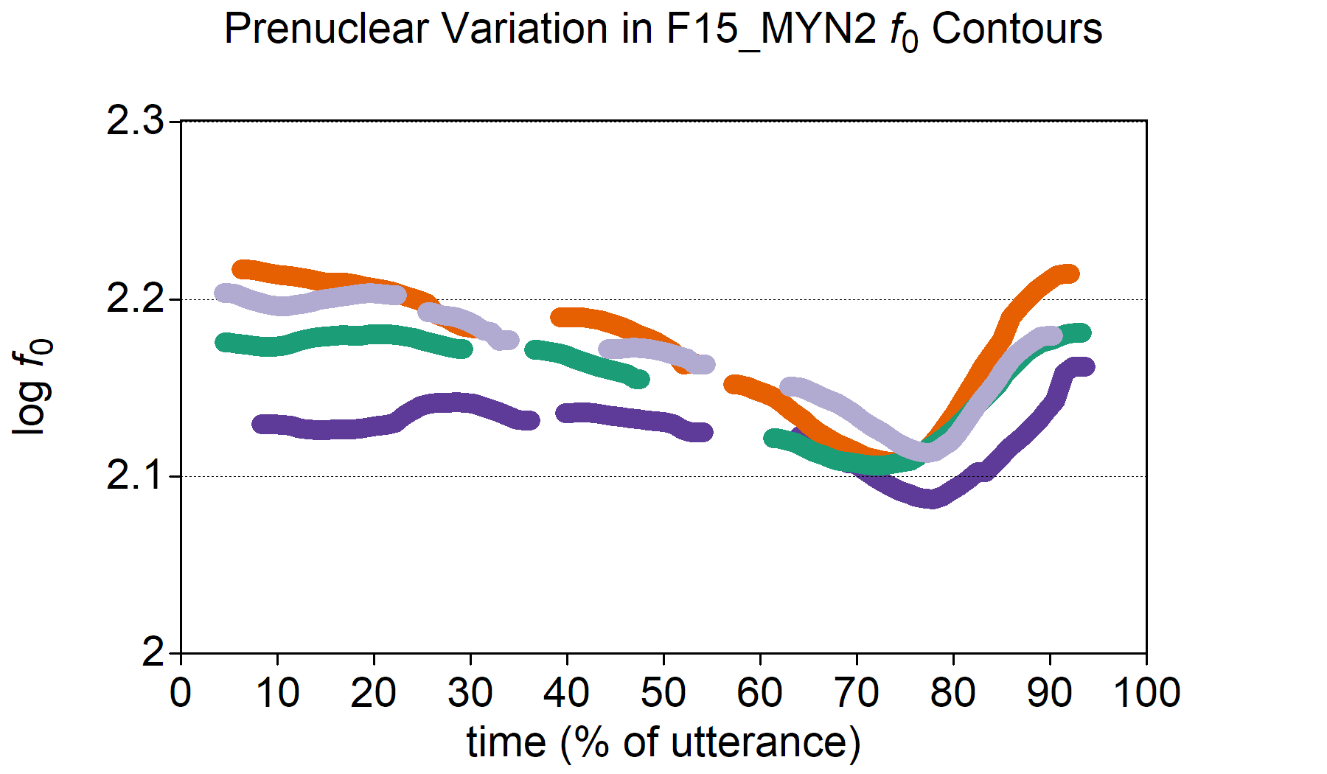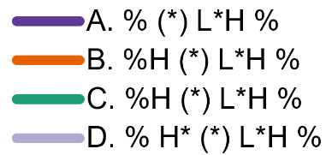

**Figure 7.5** Contours for M-corpus repetitions of MYN2 by F15, “Do you live in the valley?”

In **Figure 7.5**, contour A begins relatively low in the speaker’s range and there is no pitch event until the nuclear pitch accent despite a slight *f*0 rise around the word “live”. Contour B is similar to C, with an initial high boundary but no pitch accent until the nuclear pitch accent. Even though there are some perturbations in *f*0 around “live”, they do not trigger a percept of prominence. Only in D is there a salient pitch event, on “you”, transcribed as H*. While c. also has a bump in *f*0 around “you”, it is auditorily less salient and was not identified as a pitch accent.

The final issue for annotation relates to whether a pitch accent in the second foot should be interpreted as L* or !H*. L* is perceptually different from !H* and visually different too, as each is typically accompanied by a different contour shape. When the L* occurs after a preceding H, the L* often has a concave elbow, with the most curved portion of the elbow occurring in the stressed syllable. This is exemplified in **Figure 7.6**, panel A. There is a concave elbow of the *f*0 contour in the /a/ vowel of *val-*. In contrast, with !H*, a convex elbow is more likely in the stressed syllable as illustrated in panel B. Figure 7.7 highlights the difference between the concavity of the L* and the convexity of the !H* by superimposing the *f*0 from **Figure 7.6** on top of each other.

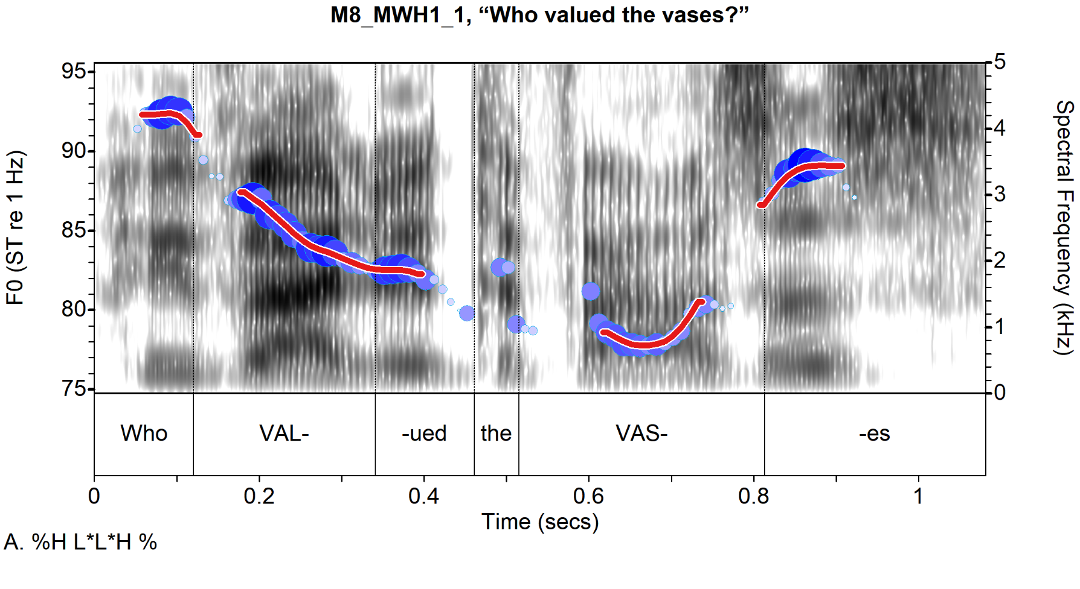

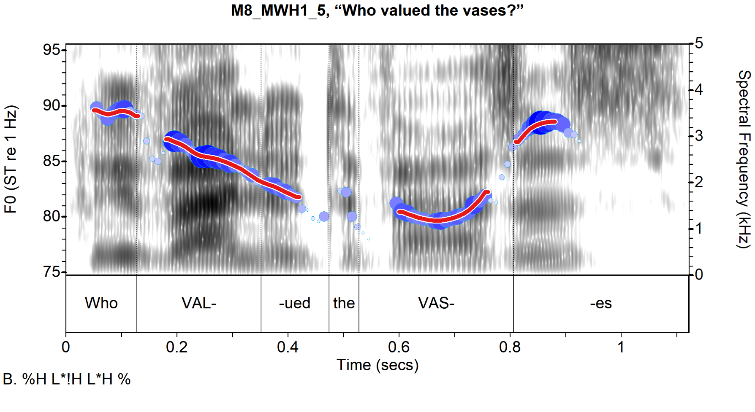

**Figure 7.6.** Spectrogram and f0 contour of two repetitions of MWH1 (“Who valued the vases?”) from M5. Red lines indicate a slightly smoothed contour (bandwidth = 19) drawn with Praat settings set to ignore f0 at time points with low amplitude and low periodicity (silence threshold = 0.15, voicing threshold = 0.6).

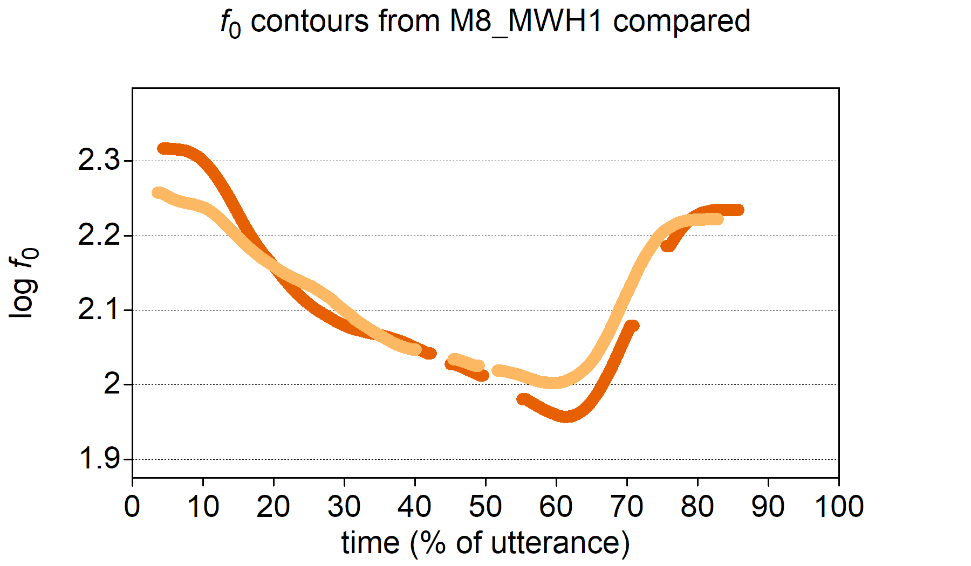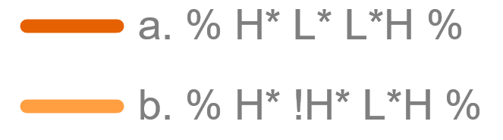

/a/

Figure . f0 Stylised contours from **Figure 7.6** compared, with time normalised to utterance duration. The grey bar indicates the vowel in “val-”. (Speaker M8, two repetitions of MWH1, “Who valued the vases?”)

As with all labelling, things are sometimes even less clear cut. Figure 7.8, for example, shows two contours where there is a distinct PA in the second foot. However, in each case, the concave elbow occurs before the stressed word and the convex elbow after the stressed syllable, making it more difficult to interpret. In each case, there is obviously some kind of downstep, but the question is: is this downstep from H* to !H* or is it an L* after the previous H*. In each case, one could even opt for !H* as a compromise, but the L* interpretation has been preferred.

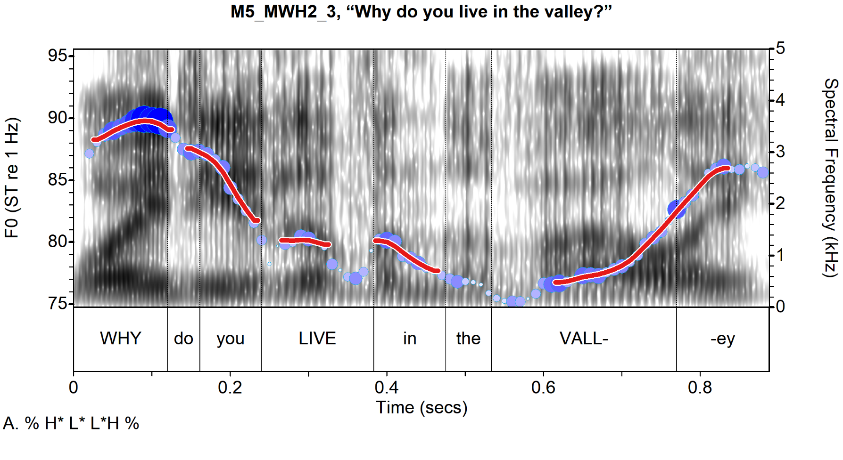

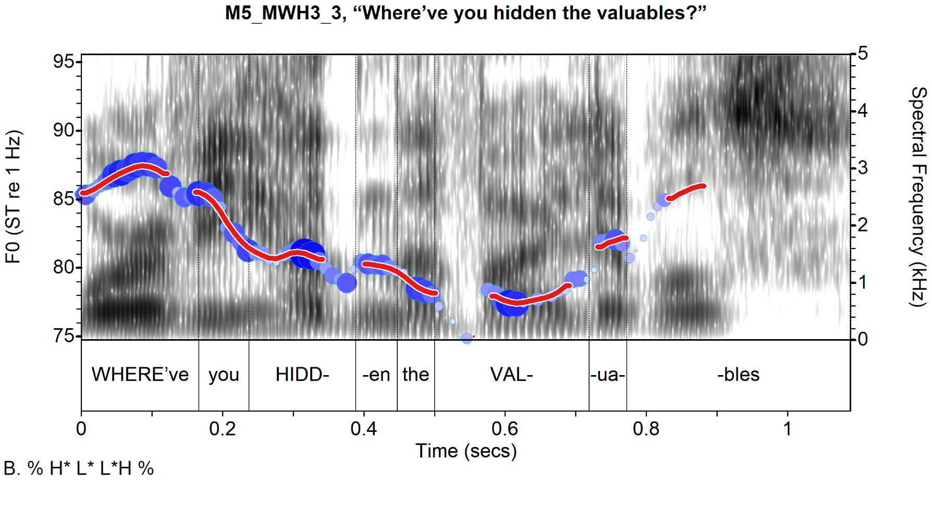

Figure . Spectrogram and f0 contour of two utterances labelled as % H* L* L*H % from M5. Red lines indicate a slightly smoothed contour (bandwidth = 19) drawn with Praat settings set to ignore f0 at time points with low amplitude and low periodicity (silence threshold = 0.26, voicing threshold = 0.28).

The reasoning for the L* choice is as follows. Overall, the contours curve concavely toward the stressed syllable, and the low continues throughout the lexical word. (Note, however, that the dip in *f*0 before the syllable nucleus of *hidd-* is an effect of the voiced glottal fricative [ɦ] in the onset.) *f*0 then drops slightly again at the onset of the verbal complement (“in the valley” and “the valuables” respectively), as if in anticipation of the L in the L*H of the nuclear PA rather, not as if at the end of a delayed peak. This anticipatory lowering is quite common and will be revisited in Chapter 8.

All the examples discussed above reflect edge cases in categorical judgments, and many other utterances do not pose such problems. Other labellers might have made slightly different judgments.

## Phonological Analysis and Results

Statistical analysis of the relationship between sentence mode and intonational phonology was carried out using the non-register-tier analysis and the register-tier analysis. Non-register-tier analysis results are presented first, followed by the register-tier analysis. They are then compared, before turning to IP-wide phonology. (Note, sentence mode is shortened to *mode* here on in.)

### Non-register-tier Analysis

Without the register tier, nearly all nuclear PAs are L*H, accounting for 98.9% (*n* = 632/639) of the raw data. When adjusted, it accounts for the same proportion. (See Appendix J.) The only cases without L*H as the nuclear pitch accent are H* (*n =* 2) and >H*(*n =* 5) are both produced by the same speaker, M8. In short, in the non-register-tier analysis, the nuclear pitch accent alone does not contribute to sentence mode, much as expected.

When we look at the distribution of nuclear contours (pitch accent plus boundary), we see a more interesting distribution, as illustrated in Figure 7.9, which shows the adjusted distribution of nuclear contours by mode. Percentages indicate the percentage of all tokens in the adjusted data. We can see that occurrences of L*H L% begin to increase in MYN and are most common in DCQ. As expected, L*H H% is not found at all in MDC or MWH, and it is more common in MDQ than MYN (2.6% as opposed to 0.8%). There are a few rare occurrences of L*H HL% in MDQ. We can therefore assume that it is really only the boundary condition that is associated with mode, again, as expected from a non-register-tier analysis of intonational phonology.

|  |
| --- |
|  |
| Figure .. Proportional distribution of pitch contours by mode, non-register-tier analysis. |

Figure 7.10 shows the boundary tone distribution by mode alone. It is almost identical to Figure 7.9, but the added *noise* from the >H* and H* contours is lost. When we further break this down to show the distribution of boundary conditions by mode and gender, it appears that there is also an effect of gender (Figure 7.11) That is, the male speakers tend to use L% more frequently in MDQ than female speakers, at 6.2% of all tokens in the adjusted data as opposed to 2.6% among females. Conversely, they are slightly less likely than female speakers to use the unspecified % boundary, at 5.6% as opposed to 6.9% of all tokens. Female speakers, on the other hand, appear slightly more likely to use the high boundary in YNQ and DCQ than men, accounting for 3.5% of all tokens in the adjusted data as opposed to 0.8% for the male speakers. Therefore, we can speculate that gender may have some effect on the choice of boundary tone.

|  |  |
| --- | --- |
|  | |
| Figure .. Proportional distribution of boundary tones by mode, non- tier analysis. |

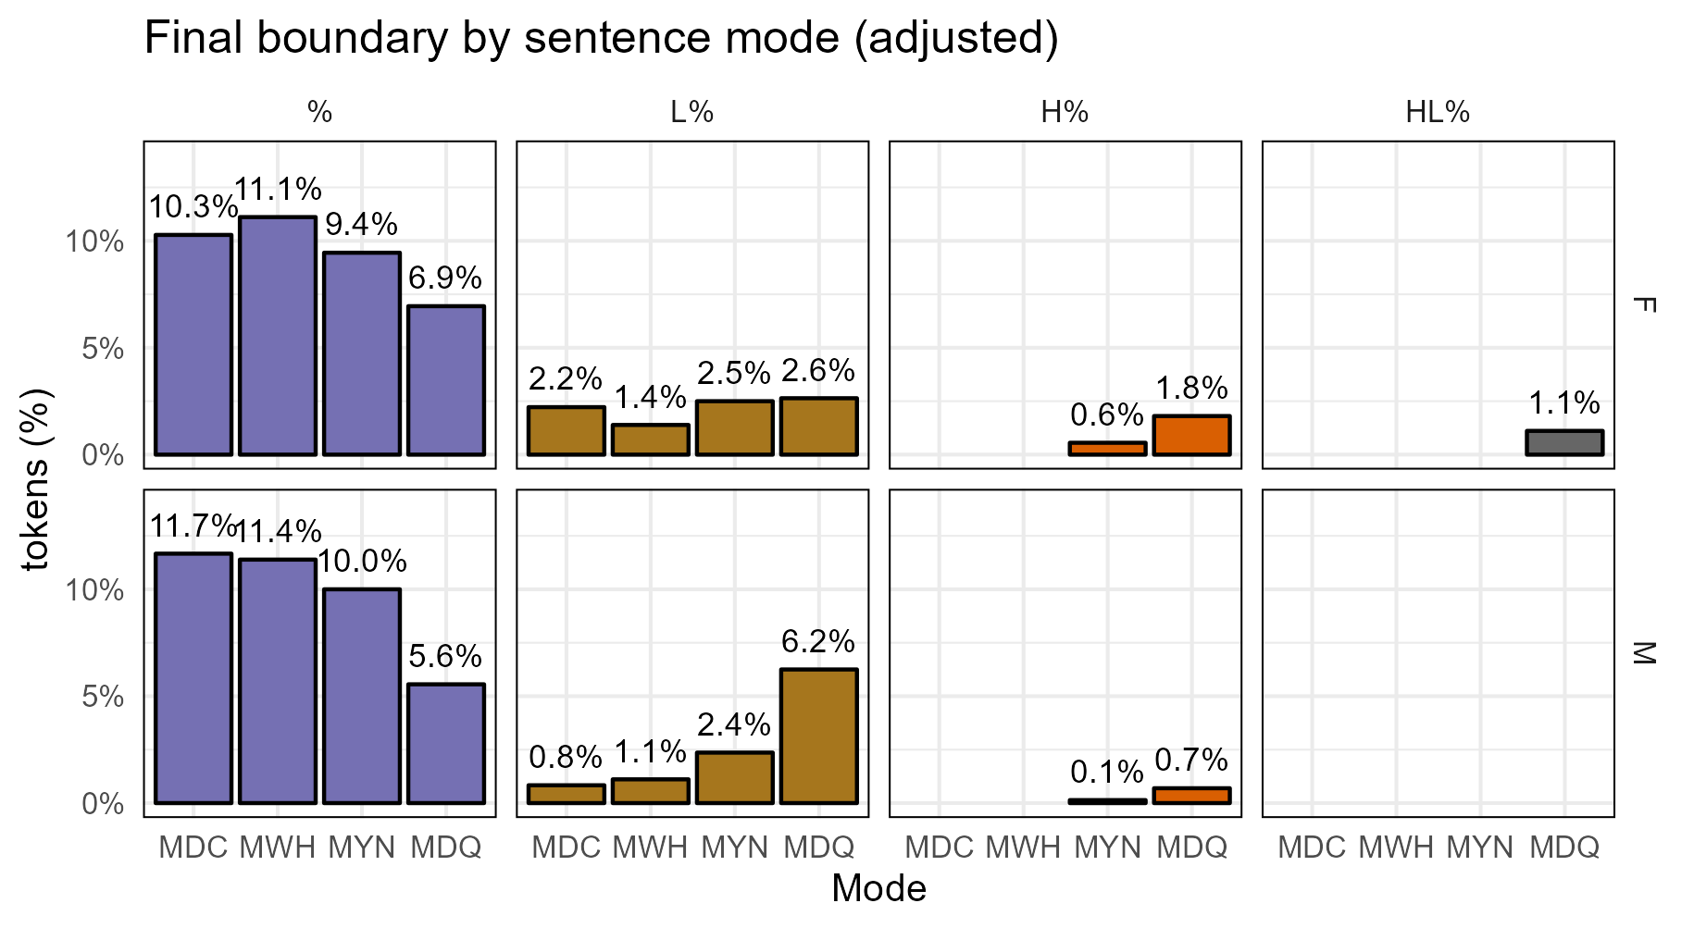

Figure .. Boundary tones by mode and gender (adjusted), M-Corpus non-register-tier analysis.

#### BGLMM Analysis of H% and Mode

. A model was constructed to test the likelihood of H% as an effect of mode and gender, with speaker and prompt as random intercepts, as shown in Equation 7.1.

|  |  |
| --- | --- |
| `H%` ~ mode + gender + (1|speaker) + (1|prompt) | (7.1) |

A Likelihood Ratio Test (LRT) was performed on the model using the drop1() function in R. (See Chapter 5, Section 5.4.2 above.) It indicates that the effect of mode is significant but that the effect of gender is not, χ2(3) = 65.02, *p.adj* < .001 and χ2(1) = 3.45, *p.adj* = .076 respectively. The model has a marginal *R*2 of .41 and condition *R*2 of .75. The high marginal *R*2 suggests that mode and gender account for 41% of the variance between % and H%, while the addition of the random speaker and prompt effects explains a further 34% of the variance.

Figure 7.12 presents two sets of statistics from the BGLMM analysis. This mode of graphical representation of the results will be used throughout the rest of the chapter, so it is worth explaining what each panel represents. Panel A shows the predicted probabilities of H% as an effect of each level mode while the other fixed effect (gender) does not change from the reference level (intercept), female speakers in this case. Thus, for example, there is an almost zero probability[20] of H% in MDC among female speakers. Panel B shows the estimated odds ratio (OR) difference between levels of mode and of gender. Going left to right in panel B, the first pair of comparisons is between MDC and MWH, followed by MDC and MYN, and so on, until the final comparison between female and male speakers. In each pair, the first item listed is the reference level (or intercept) while the second item is the level being compared to it. Thus, each value indicates the estimated OR difference of the second level in the pair from the first. An OR of one (the red line) indicates no predicted difference between the two. A value greater than one indicates that the outcome (H% in this case) is more likely in the second item of the pair while a value lower than one indicates that the outcome is less likely in the second item. The vertical bars in each panel indicate the 95% confidence interval. In panel B, if the 95% CI crosses the red line at one (1:1 odds), the probability of the null hypothesis (i.e., no difference between levels or 1:1 OR) is greater than .05.

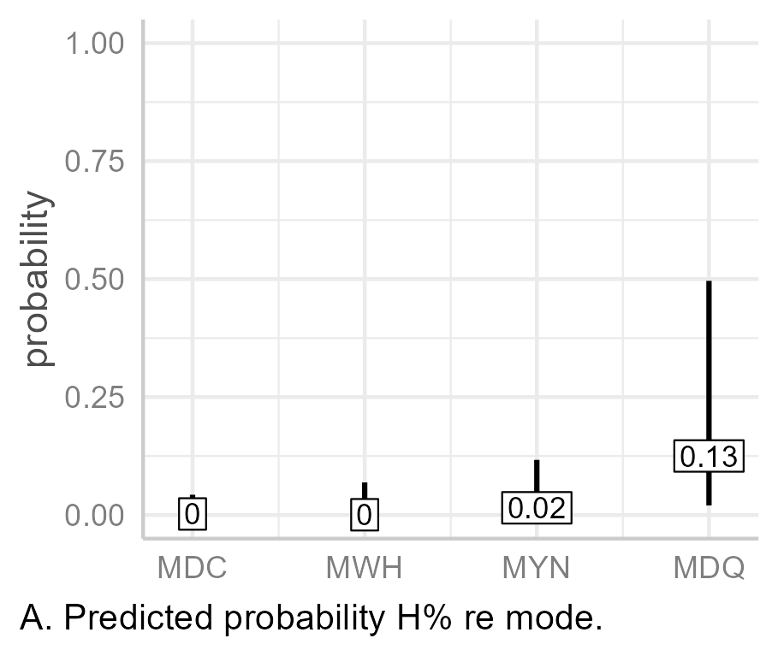

**Figure 7.12.** Graphical summary of predicted probabilities of H% by mode and pairwise comparison of likelihood of H% across levels of mode and gender in the non-register-tier analysis.

As can be seen in Panel A (Figure 7.12), the predicted probability of H% as an effect of mode is almost zero for MDC and MWH, 95% CIs [0, .04] and [0, .07] respectively. While MYN has slightly higher probability of being associated with H% at .02 [0, .12], it is still very low. MDQ is the most probable to be associated with H%, but still only at .13 [.02, .5].

Turning to the pairwise comparison of slopes in panel B, we see that only MDQ is significantly more likely to have a H% when compared to the other levels of mode. That is, it is 63 time more likely to be associated with H% than both MDC and MWH, and 9.75 times more likely than MYN, CIs [5.88, 682], [5.86, 682] and [3.06, 31.1] respectively, *p* < .001 in each case. The male speakers are approximately 85% [0, 2.46] less likely than the females to use H%, *p* = .177, but with the 95% CI crossing through 1:1 odds, we cannot be confident that the true mean is not one or greater (i.e., no difference or that male speakers are more likely to use H%).

### Register-tier Analysis

Looking at the nuclear contour in the register-tier analysis labelling—shown in Table 7.5—we see a large range of possibilities. L*H % still dominates, even after the inclusion of the register tier, with 419/639 tokens. This is followed its raised register counterpart, ^[L*H] % with 81 tokens, and then by L*H L% (59 tokens).

Table .. Nuclear contour / register-tier tokens in the M-Corpus

|  |  |
| --- | --- |
| Nuclear contour | Count |
| L*H % | 419 |
| ^[L*H] % | 81 |
| L*H L% | 59 |
| L*^[H] % | 22 |
| ^[L*H] L% | 19 |
| ^[L*H L%] | 18 |
| ^[L*]H L% | 6 |
| L*^[H L%] | 6 |
| >H* L% | 5 |
| H* L% | 2 |
| L*^[H] L% | 2 |
| **Total** | **639** |
|  |  |

#### Nuclear Pitch Accents.

There are seven tokens without an L*H-like nuclear PA. As noted in the non-register-tier analysis, these are >H* L% (5 tokens), and H* L% (2 tokens). These are the only tokens similar to the falling nuclear contour of standard Southern British English and General American English; however, only two of them occur in declaratives, while the other three occur in either MYN (*n =* 2) or MDQ (*n =* 1). This is quite surprising and reinforces the idea that fall to the low boundary does not serve the same function in DCE as in standard varieties, or at least doesn’t serve to suggest finality in the same way. It does reinforce the view that L% serves a discourse function which is compatible with question forms but does not in itself signal a question. For this reason, the rest of this section will treat accent phonology separately from the boundary tone.

The M-corpus contains six different nuclear pitch accent/register-tier combinations: L*H, L*^[H], ^[L*]H, ^[L*H], H*, and >H*. Table 7.6 presents the distribution of these pitch accents by mode (adjusted data). The vast majority of nuclear pitch accents are L*H (*n*.adj.=506), with the next most common, ^[L*H] having considerably fewer tokens (*n*.adj.=112). This is followed by L*^[H] (raised H target only) (*n*.adj.=30). Three tokens are rarely attested, namely H* (*n*=2), >H* (*n*=5), and ^[L*]H (*n =* 6). Aside the very rare tokens, MDC and MWH are otherwise exclusively L*H (*n*.adj.=162 and 165 respectively). This falls to 117 for MYN and 62 for MDQ. Conversely, instances of L*^[H] and ^[L*H] appear in MYN (*n*.adj.=5 and 38 respectively), and then rise again for MDQ, with 25 tokens (adj.) for L*^[H] and 74 for MDQ.

Table .. Distribution of pitch accent by mode (adjusted).

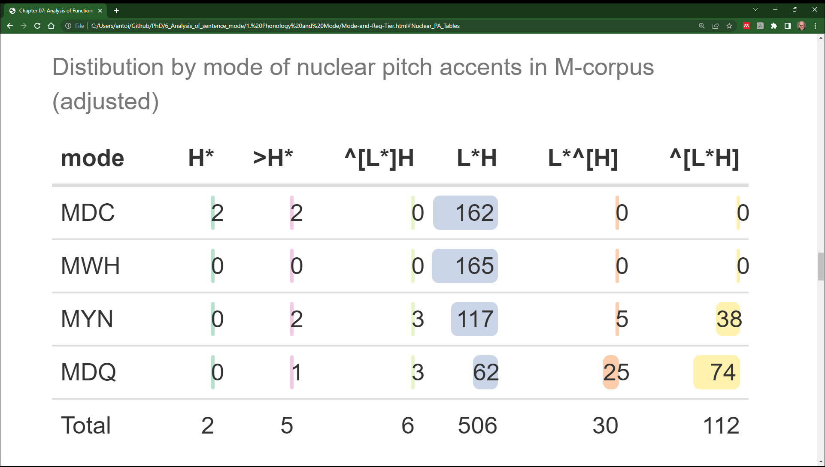

There is also considerable interspeaker variation in the use of pitch accents, which Figure 7.13 demonstrates (next page). The three rare pitch accents, H*, >H*, and ^[L*]H, it can be seen, were all produced by a single speaker, M8. Some speakers used only two different pitch accents. That is, M5, M9, and M10 used only L*H and ^[L*H]. More extremely, F16 used L*H almost exclusively, with only one instance of L*^[H]. The remaining speakers employed the three more common pitch accents to varying degrees. Superficially, there appears to be a gendered difference in PA production, as M4 is also the only male speaker who used L*^[H]. However, given that three of the six female speakers (F12, F15, and F16) also used this token, it is difficult to interpret its use as a female trend.

Three speakers used raised register exclusively for MDQ. F12 used L*^[H] once and ^[L*H] the remaining 14 times, while M4 used L*^[H] four times and ^[L*H] the remaining eight times. M5 produced ^[L*H] exclusively. In contrast to this, F16 only used raised register once across all IPs. The general impression, however, is that high register is associated with YNQs and DCQs, but that it is optional rather than obligatory.

The relationship between mode and high register was tested using the model in Equation 7.2, with mode and gender fixed factors, and speaker and prompt intercepts as a random factor.

|  |  |
| --- | --- |
| nuc_H_reg ~ mode + gender + (1 | speaker) + (1 | prompt) | (7.) |

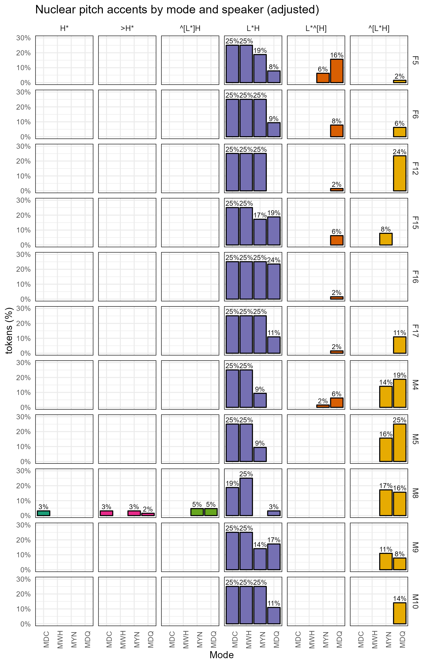

Figure .. Proportional distribution of pitch accents by speaker and mode (adjusted data). Percentages refer to the individual speakers (listed on the right y-axis).

A Likelihood Ratio Test (LRT) was performed on the model using the drop1() function in R. It indicates significant effects of both mode and gender, χ2(3) = 320, *p.adj* < .001 and χ2(1) = 5.38, *p.adj* = .027. The model has a marginal *R*2 of .69 and conditional *R*2 of .79. This indicates that mode and gender alone account for an estimated 69% of the variance in the likelihood of high register.

The probability of high register in MDC and MWH as an effect of mode alone is zero, 95% CIs [0, .01], [0, .01] (Figure 7.14A). There is a slight rise in probability to 0.2 [0.03, 0.28] in MYN followed by a large rise to .5 [.237, .762] in MDQ. When taking the estimated difference sin likelihood each level of mode into account (Figure 7.14D), we see that MYN and MDQ are both more likely be associated with high register in the nuclear pitch accent than either MDC or MWH. That is, high register is an estimated 70 [15.7, 309] times more likely in MYN than MDC, and 69 [15.5, 306] times more likely in MYN than MWH, *p* < .001 in case. Even more extremely, high register is 594 [127, 2777] times more likely in MDQ than in MDC and 587 [126, 2754] times more likely in MDQ than in MWH.

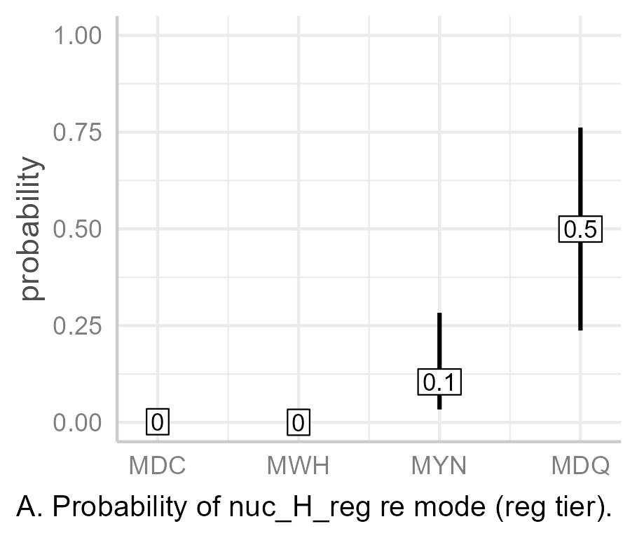

Figure . Graphical summary of predicted probabilities of high register by mode and pairwise comparison of likelihood of high register across levels of mode and gender in the register-tier analysis.

When it comes to gender, a high boundary is 5.4 times more likely among the male than the female speakers, CI [1.24, 23.8], *p* = .025. This has a noticeable effect on the predicted probability of high register among the male speakers. The predicted probabilities shown in Figure 7.14A represent female speakers, as genderF is the intercept. When the predicted probabilities by mode for male speakers plotted (i.e., with genderM), we see how much greater the predicted probability of high register is in both the MYN and MDQ conditions, as shown in Figure 7.15. The probability of high register rises to .39 [.15, .69] in MYN and to .85 [.6, .95] in MDQ, with the lower limit of the 95% CI being well above .5 in MDQ. Therefore, we can conclude that male speakers are more likely than not to use high register in declarative questions.

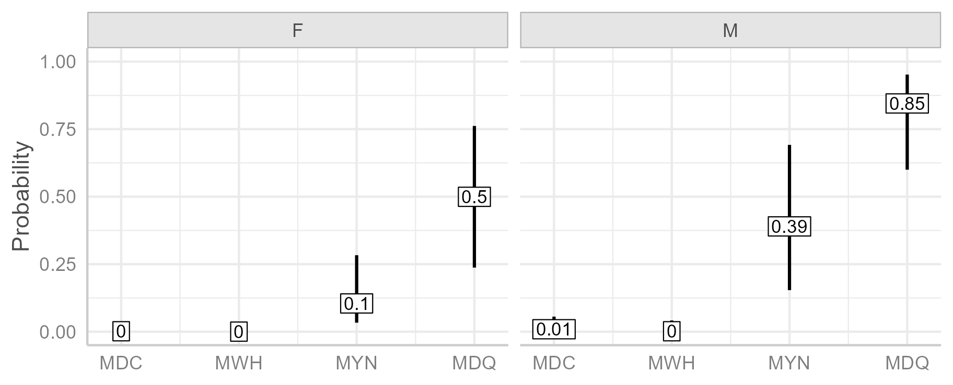

Figure .. Predicted probability of high register in nuclear PA by mode for male speakers (genderM).

#### Boundary Tones.

There are only two boundary conditions in the register-tier analysis, L% and the unspecified boundary (%). The low boundary tone may also be affected by high register, e.g., there are instances of ^[L*H L%] as opposed to ^[L*H] L%. There are 24 tokens where L% is affected by high register and 21 where it is not. However, raised register does not (and cannot) occur at the boundary alone. That is, a nuclear contour such as L*H ^[L%] would nonsensical, since would be indistinguishable from L*H %. L*H ^[%] would be equally nonsensical since the boundary is unspecified, and therefore, there would be no tone to be raised by high register. Therefore, the occurrence of raised register at the boundary is essentially an extension of raised tone across the whole IP, in the nuclear pitch accent, or in the final tone in the pitch accent.

Since it has been established that high register in the nuclear contour is already exclusively associated with MYN and MDQ sentence modes, and since raised register at the boundary is an extension of raised register preceding the boundary, the inclusion of raised register in the analysis boundary tones as an effect of mode would be uninformative. Therefore, high register is not included in the analysis boundary tone effects on mode.

Figure 7.16 shows the (adjusted) distribution of boundaries by gender and mode for the register-tier analysis. The distribution here is almost identical to the non-register-tier analysis, given that the only difference is the absence H%. Among the female speakers there is a slight drop in L% between MDC and MWH (from 2.2% to 1.4%) before a small but steady rise in MYN and MDQ (2.5% and 3.8%). Among the male speakers, however, while the use of L% in MDC, MWH, and MYN lower than for me female speakers, at 0.8%, 1.1%, and 2.4% respectively, there is a noticeably large increase of L% use in MDQ, at 6.2%. However, L% accounts for only 20.4% of all final boundaries, with almost half of those—i.e., 10% of all tokens—occurring in MDQ.

|  |
| --- |
|  |
| Figure .. Final boundary by mode and gender (adjusted data, register-tier analysis). High and low register have been collapsed into a single category. |

To test the effects of mode and gender on the boundary in the register-tier analysis, a BGLMM analysis of the model was also conducted, as shown in Equation 7.3.

|  |  |
| --- | --- |
| `L%` ~ mode + gender + (1 | speaker) + (1 | prompt) | (7.) |

A Likelihood Ratio Test (LRT) was performed on the model using the drop1() function in R. It indicates a significant of mode but not of gender, χ2(3) = 62.8, *p.adj* < .001 and χ2(1) = 0.04, *p.adj* = .914. The model has a marginal *R*2 of .07 and conditional *R*2 of .79. The conditional *R*2 of the model is the same as that of the high register model outlined in the previous section (7.5.2.1), indicating that, overall, both models explain the same amount of variance in the outcome parameter. However, the fixed effects only explain 7% of the variance in L% likelihood, which much lower than the high register model (69%).

The results of the statistical analysis reflect the finding of the initial analysis of the adjusted data. As shown in Figure 7.17A, the predicted probability of L% in either MDC of MWH is very low, at .03 and .02 respectively 95% CIs [0, .39] and [0, .3] respectively, while MYN is only slightly more likely to be associated with L%, with a predicted probability of 0.05 [0, .54]. As with high register, L% is most probable in MDQ, at .23 [.01, .86]; however, this is still much lower than the probability of high register in MDQ, which was .5 [.24, .76].

Looking at the pairwise comparisons (Figure 7.17B), we see that there is little difference in the likelihood of L% between declaratives and either MWH or MYN, with odds ratios of 0.66 and 1.83 between each pair, CIs [0.3, 1.46] and [0.88, 3.8], *p* = .304 and .104 respectively. The likely of MYN compared with MWH is slightly higher, with statistically different OR of 2.77 [1.28, 5.98], *p* = .009. The difference in the estimated likelihood of L% between MDQ and the other modes are all noticeably larger (and statistically significant), at with OR differences of 10.1 [4.7, 21.6], 15.3 [6.7, 34.3, and 5.5 [2.7, 11.3] respectively, *p* < .001 in each case. However, even though the likelihood of L% in MDQ is greater compared to the other sentence modes, differences between are, when it comes to MDC and MWH at least, still several orders of magnitude lower than those in the high register model. In that model, high register was roughly 590 times more likely in MDQ than in either MDC or MWH.

Finally, when we compare the effect of gender on the likelihood of L%, there is little difference between the male and female speakers, with male speakers an estimated 36% less likely than the female speakers to use L%, OR = 0.64, 95% CI [0.01, 29]. The exceedingly wide CIs suggest that there is in fact no meaningful effect of gender at all. In fact, differences which appeared to be gender-specific in the initial analysis—which the male speakers appeared slightly more likely to use L%—are much more likely simply to be speaker-specific.

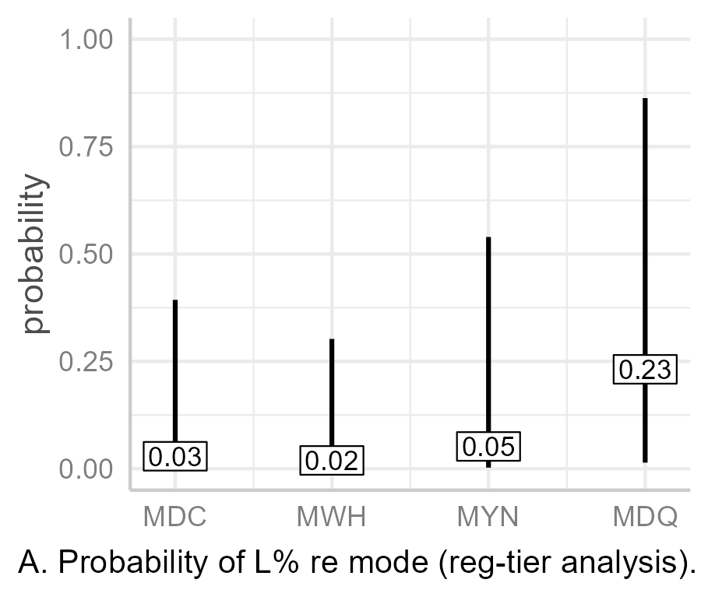

Figure .. Graphical summary of predicted probabilities of L% by mode and pairwise comparison of likelihood of L% across levels of mode and gender in the register-tier analysis. (Register tier effects at the boundary are excluded.)

#### Summary of register-tier analysis.

High register is extremely unlikely to occur in the nuclear pitch accent of either MDC or MWH. However, it is somewhat more likely to occur in MYN, and even more so in MDQ. There is a strong effect of gender on the use of high register in MYN and MDQ, with male speakers much more likely to use high register, especially in MDQ. There is a small effect of mode on the likelihood of L%, but it does not appear to be the main contributing factor. Given the overall low marginal *R*2 of the L% model (.07) compared the high register model (.69) and given also that L% is slightly more probable in MDC and MWH than high register (which is approximately zero), the view that L% is not a marker of interrogativity is upheld. That is, in MDQ, L% is more like an indicator of surprise in response to the interlocutor’s previous statement.

### Comparing the Non-register-tier Analysis and the Register-tier analysis

The fixed factors—speaker and gender—explain 42% of the variance in the non-register-tier model analysis of H% as a marker of interrogativity, while they explain 69% of the variance in the register-tier analysis. To assess the effect of speaker alone, each model was retested using gender as a random effect, but this created convergence issues, so gender was simply removed as a factor, as shown in Equation 7.4.

|  |  |
| --- | --- |
| response ~ mode + (1 | speaker) + (1 | prompt) | (7.) |

ANOVAs[21] of the non-register-tier H% and the high-register-tier models indicated that both were significant, χ2(3) = 65.3, *p* < .001 and χ2(3) = 318.6, *p* < .001 respectively. The marginal *R*2 of the non-register-tier H% model is .33 with a conditional *R*2 of 0.74, while the marginal *R*2 of the nuclear high-register model is . 63 with a conditional *R*2 of 0.8 (Table 7.7). These results indicate that mode accounts for 33% of the variance in the non-register-tier H% model but that it accounts for a much larger 63% in the register-tier analysis model. The amount of variance explained by each model in total, on the other hand, is quite similar, at 74% for the non-register-tier model and 80% for the register-tier model.

Table .. Marginal and conditional R2 ( and ) of mode-only models for H% and high register analysis.

|  |  |  |  |
| --- | --- | --- | --- |
| register tier | model | $$r_{m}^{2}$$ | $$R_{c}^{2}$$ |
| No | `H%` ~ mode + (1 | speaker) + (1 | prompt) | 0.33 | 0.74 |
| Yes | nuc_H_reg ~ mode + (1 | speaker) + (1 | prompt) | 0.63 | 0.8 |
|  |  |  |  |

Of course, the non-register-tier analysis is bound to be less informative since only L*^[H] (L)% was relabelled with a H boundary, i.e., it was interpreted as L*H H(L)%. Other instances of L*H with high register were not relabelled with H(L)% because that would have required the pitch accent also be relabelled as H* despite the fact that, in terms of both of contour shape and auditory percept, they were still clearly L*H. As observed previously (Section 7.4), such relabelling would have required an improbable re-association of tones with difference structural elements of the IP and represented a description of the data in service to the theory more than a true representation of the data. However, had ^[L*H] (L)% contours been relabelled as H* H(L)%, the results for the non-register-tier analysis would have been almost identical.

The comparison of the non-register with the register-tier analysis, therefore, does not prove the register-tier hypothesis. Rather, it demonstrates that a register-tier analysis provides a greater degree of explanation of the data (63% as opposed to 33%) without compromising the descriptive integrity of the data. For the subsequent analysis of IP-wide phonology, therefore, the register-tier analysis is maintained.

### Utterance-wide Phonology and Mode

Nearly all IPs in the M-corpus end with a nuclear L*H pitch accent (with or without register shifts). However, there is a wide variety of IP-wide patterns. Table 7.8 shows the total number of tokens for IP-wide phonology accounting for at least 1.25% of the corpus (see Appendix J2 for the full list). Overall, the most common IP-level intonation pattern is % L*H % (*n*=78), which indicates no prenuclear accentuation. In fact, 23.3% (*n*=147) of all IPs contain no prenuclear accents, a phenomenon which was not expected, and which warranted further investigation.

Table . IP-level intonation by mode for tokens accounting for at least 1.25% of the M-corpus (raw counts).

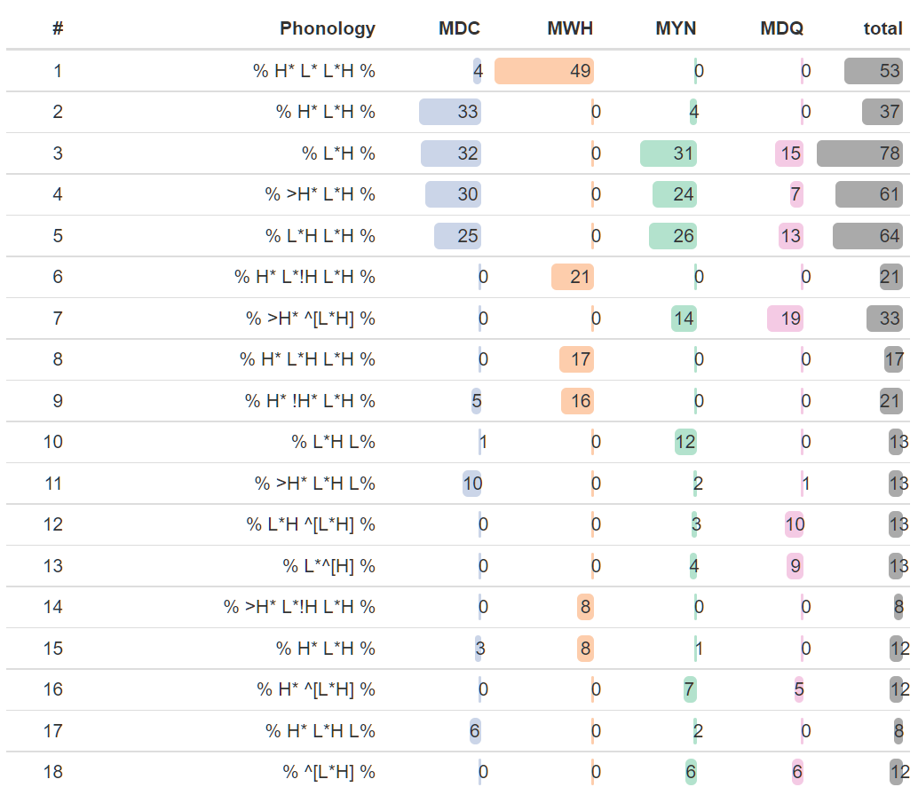

Table 7.9 summarises the raw counts for nuclear-PA-only utterances. MYN and MDQ show the highest amount of nuclear-PA-only use, at 34.6% and 35.3% respectively, while MDC is around the average, at 22.7%. There is only one utterance where MWH lacks prenuclear accentuation. It is unsurprising that all but one MWH utterances have prenuclear accentuation since the wh-word at the front of the sentence represents the focus of the question, and thus one expects it to have a pitch accent. The tendency towards a greater lack of accentuation in MYN and MDQ tokens most likely reflects the fact that by de-accentuating the prenuclear content of the IP, greater salience is lent to the rise in the nucleus.

Table . IP level intonational phonology by mode for tokens with nuclear pitch accent only

|  |  |  |  |  |  |
| --- | --- | --- | --- | --- | --- |
|  | **MDC** | **MWH** | **MYN** | **MDQ** | **Total** |
| Count | 36 / 163 | 1 / 161 | 56 / 162 | 54 / 153 | 147 / 639 |
| percentage | 22.1% | 0.6% | 34.6% | 35.3% | 23.0% |
|  |  |  |  |  |  |

It appears, therefore, that speakers may sometimes use a strategy whereby they lend more salience to the nuclear rise in YNQ and DCQ forms by avoiding prenuclear accentuation. To test this, the model shown in Equation 7.5 was used to assess the likelihood of nuclear-PA-only IPs as a function of mode and gender, given that gender was sometimes a meaningful factor in previous analyses.

|  |  |
| --- | --- |
| nuc_PA_only ~ mode + gender + (1 | speaker) + (1 | prompt) | (7.) |

An ANOVA of the model indicates that both mode and gender are significant, χ2(3) = 114.1, *p* < .001 and χ2(1)=5.47, *p* = .027. It also has a marginal *R*2 of 0.39 and conditional *R*2 of 0.75 (See Appendix K for complete output from model).

There is a significant effect of gender in this model. The log odds ratio of the gender-Male slope is -2.53 (CIs = ‑4.642—‑0.41, *p.adj =* .028), indicating that male speakers are significantly less likely than female speakers to use a nuclear-PA-only IP. The results of the pairwise comparison of slopes indicate that there is a significant difference between all levels of mode except for MYN and MDQ, between which there is almost difference (see Figure 7.18). This makes sense since there is little communicative pressure to use different intonational strategies to distinguish between them. However, when we consider the predicted probabilities of a nuclear-PA-only IP in terms of both mode and gender, we see a different picture.

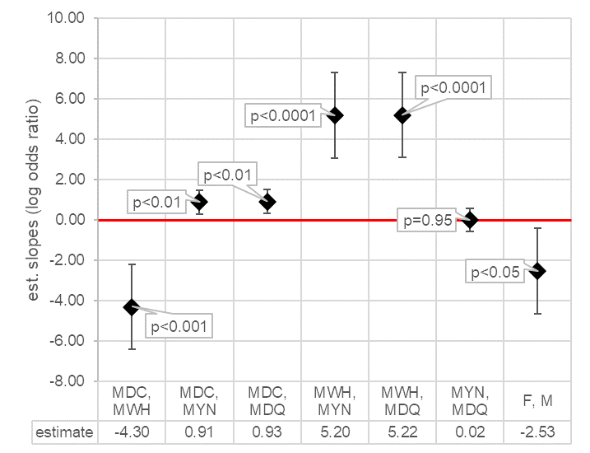

Figure .. Graphical summary of slopes of pairwise comparisons across levels of mode and gender for likelihood of nuclear-PA-only in IP in the M-corpus.

Figure 7.19 shows the predicted probabilities of a nuclear-PA-only IP as a function both of mode and gender. Here, we see the effect of gender more precisely. Both male and female speakers are very unlikely to have only one PA in MWH (less than 1%). Each is more likely to have a single PA in MDC and most likely to have only a single PA in MYN and MDQ. However, the increased probability of a nuclear-PA-only IP among females is much more dramatic, especially in MYN and MDQ (roughly 48.5% in each case, 95% CIs = 10%—90%). At the same time, however, the CIs are also very large, reflecting a wide degree of variability.

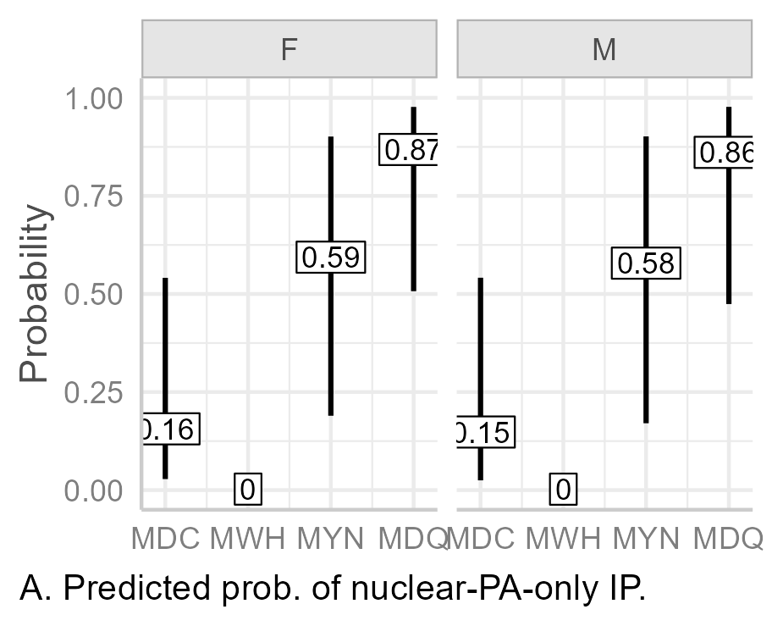

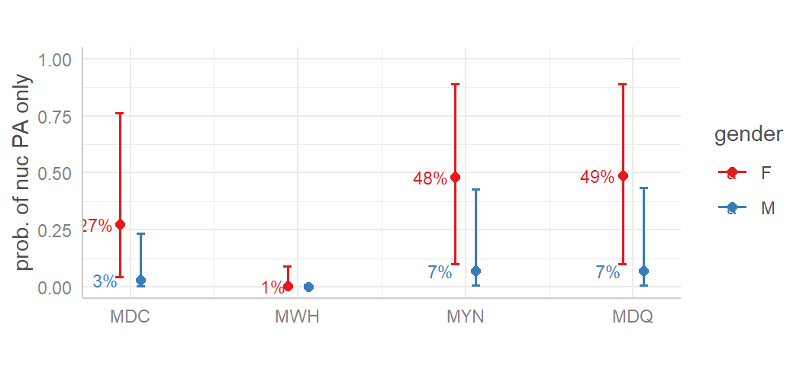

Figure .. Predicted probabilities of nuclear-PA-only IP by mode and gender in the M-corpus.

### Combining IP-wide and Nuclear PA Strategies

Females appear more likely to use the nuclear-PA-only strategy while males are more likely to use the high-register strategy to distinguish MYN and MDQ from other modes (see 27.5.2). While the choice of strategy is most likely gendered, it still appears that two phonological strategies are available to help identify question types and to distinguish MDC from MDQ. A raw count of instances of either strategy per mode (Table 7.10) indicates more than 50% use of at least one of these strategies in MYN (56.2%) and MDQ (79.7%), but both are practically absent in MWH (0.6%) and not even very common in MDC (22.1%)

|  |
| --- |
| Table . IP level intonational phonology by mode for tokens with either nuclear PA only or high register in the nuclear PA. |
| |  |  |  |  |  |  | | --- | --- | --- | --- | --- | --- | |  | **MDC** | **MWH** | **MYN** | **MDQ** | **Total** | | Count | 36 / 163 | 1 / 161 | 91 / 162 | 122 / 153 | 250 / 639 | | percentage | 22.1% | 0.6% | 56.2% | 79.7% | 39.10% | |

The effect of gender and mode on the likelihood of the using of one of these strategies was tested using a BGLMM analysis of the model shown in Equation 7.6.

|  |  |
| --- | --- |
| `at_least_1_strat` ~ mode + gender + (1 | speaker)  + (1 | prompt) | (7.) |

An ANOVA of the model comparing it with the null model indicates that it is significant (χ2 (4)=339.67, *p* < 0.0001). It has a marginal r2 of 0.57 and condition r2 of 0.78.

In this model, gender now basically has no effect, as can be seen in the Gender-Male log odds ratio of almost zero (‑0.06) and narrow CIs (‑1.66—1.15), shown clear in Figure 7.20. This strongly suggests that the gendered effects of the two different strategies are neutralised when considered together. Moreover, in this mode, there is a significant difference in slope between every level of mode (p < 0.001).

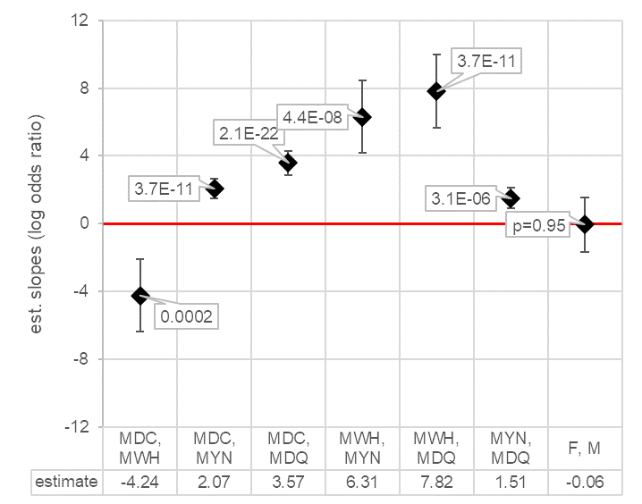

Figure .. Graphical summary of slopes of pairwise comparisons across levels of mode and gender for likelihood of nuclear-PA-only in the IP or raised register in the nuclear PA in the M-corpus.

Looking at the predicted probabilities of either strategy across modes (Figure 7.21), we see that there is only 0.3% probability of at least one of the two strategies occurring in MWH (CIs = 0.02%—4.1%). This increases somewhat for MDC to 15.6% (CIs = 2.8%—54.4%), and then against for MYN, at 59.4% (CIs = 19%—90.1%). The predicted probability for MDQ is highest at 86.8% (CIs = 50.7%—97.7%). While the CIs are still quite large (after all, we have collapsed two categories into one), we can see that there is a large different between MDC and MDQ especially. As these are the two categories for which there is the most communicative pressure to distinguish from each other, it is quite gratifying to see that speakers are likely to use phonological strategies to distinguish between the two.

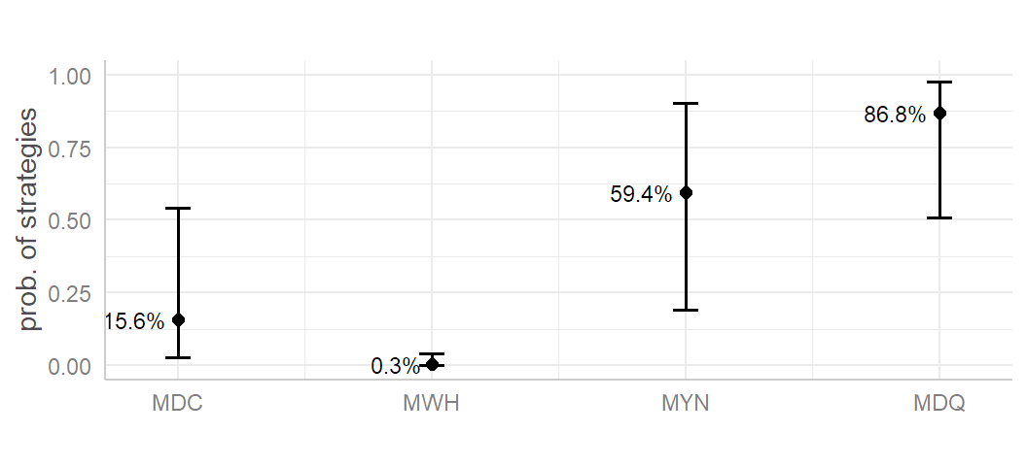

Figure .. Predicted probabilities of nuclear-PA-only IP or raised register in the IP in the M-corpus

### Summary

Nuclear contours and pitch accents were evaluated using both a non-register-tier and a register-tier analysis. In the non-register-tier analysis, H% was highly unlikely in MDC and MWH, while increasingly more likely in MYN and MDQ. In the register-tier analysis, high register was more likely to indicate a distinction between MDC and MDQ, with a very high likelihood of high register in MDQ for male speakers (85%). The register-tier analysis also demonstrated better explanatory value for phonological variation across modes than the non-register-tier analysis (r2m of 0.63 versus 0.33).

In the utterance-wide analysis, there were a large number of nuclear-PA-only IPs, which was unexpected. This may be a strategy which helps make the rise of the nuclear pitch accent more salient, thus reinforcing its function as a question.

It appears, therefore, that speakers have two phonological strategies available to help reinforce interrogativity in YNQs and DCQs, namely, register raising in the pitch accent or non-accentuation before the pitch accent. In assessing the likelihood that speakers use at least one of the of these two strategies to distinguish between modes, the predicted possibility for MDCs was 15.6%, while for MDQs it was 86.8%. Thus, in a register-tier analysis of the intonational phonology, we can see that speakers are likely to employ one of phonological strategies to distinguish between the two modes which are otherwise syntactically and semantically identical.

## Phonetic Analysis and Results

Four phonetic parameters were analysed. These were the *f*0 and temporal alignment at the *f*0 minimum in the nuclear PA and the *f*0 and temporal alignment of the *f*0 maximum, as summarised in Table 7.11. The combined alignment and *f*0 parameters were treated as the phonetic implementation of tonal targets.

Table . Phonetic parameters used in analysis of nuclear accent phonology.

|  |  |  |
| --- | --- | --- |
| **Parameter type** | **Parameter code** | **Parameter description** |
| *f*0 parameters (ST re speaker median *f*0) | l_f0 | *f*0 minimum (at L target) |
| h_f0 | *f*0 maximum (at H target) |
| Time parameters (ms) | l_t | Temporal alignment of L target re onset of vowel in stressed syllable |
| h_t | Temporal alignment of H target re onset of vowel in stressed syllable |
|  |  |  |

For the analysis of utterance-wide effects, two global parameters were considered. The first is the utterance-mean *f*0 (utt_mean_f0) measured in ST re speaker median *f*0[22]. The second is the slope of the *f*0 contour(utt_slope), which represents the slope of linear regression of *f*0(t) from the onset to the offset of voicing in the IP. Slope is measured in ST/s.

Because the focus here is on paralinguistic and phonological changes to the rise, only utterances with L*H-like PAs are. That is, the rare instances of H* (*n* = 2) and >H* (*n* = 5) are excluded, leaving L*H with four different register-tier patterns:

1. L*H a nuclear rise with unmarked low register in the pitch accent.
2. ^[L*]H a nuclear rise, where high register appears only to affect the low tone.
3. L*^[H] a nuclear rise where high register only affects the H target, creating a large rise from a low *f*0.
4. ^[L*H] a nuclear rise where the whole pitch accent is affected by high register.

Of these four, ^[L*]H is the most contentious. It is only attested six times, all from the same speaker, and it is unclear might be there might be any meaningful—as opposed to purely formal—phonological distinction between the unmarked L*H and ^[L]*H, where high register tier does not affect the H target. However, as it was analysed as an L*H-like pitch accent, it was retained.

### Mode and Phonetic Parameters of Nuclear Pitch Accents

Two kinds of model were generated to assess the effects of mode on the contour in the nuclear pitch accent. The first type is a mode-only model, which treats mode (mode) as the sole fixed factor affecting the scaling and timing of tonal targets. This represents the effect of mode as an independent factor unmediated by phonological processes. In other words, it assumes that differences in the timing and scaling of tonal targets must be purely paralinguistic. The send type is a mode plus phonology model, which treats both accent phonology (acc_phon) and mode as fixed factors affecting, i.e., it assumes that phonological processes also affect the alignment and scaling of *f*0. Since the choice of accent phonology may be associated with sentence mode, a mode*acc_phon interaction is expected in this type of model. If the register-tier hypothesis is true, we should expect to see the apparent paralinguistic effects of mode in the mode-only models which largely disappear in the mode-plus-phonology models.

For each type of models, per-speaker random slopes and intercepts of mode (and acc_phon) were included in the ideal maximal model. Even though fin_phon has a finite set of levels, it was included as a random intercept since it is not a factor of interest but may still affect the target parameter. The target phrase (prompt) was also treated as a random intercept, given that each is essentially one of an infinite range of potential phrases. Gender was not of interest here and was excluded as a random factor since gender is already nested in speaker and will thus already be included in random speaker effects. The ideal maximal models are shown in Table 7.12.

Table .. Maximal models for LMEM analysis of mode of nuclear PAs, where x is the target parameter.

|  |  |  |  |
| --- | --- | --- | --- |
|  | **factor(s) of  interest** | **random by-speaker factors** | **common random factors** |
| x~ | mode+ | (1 + mode|speaker)+ | (1|prompt) + (1|fin_phon) |
| mode*acc_phon+ | (1 + mode + acc_phon|speaker)+ |

It was not possible to get these models to work on all four tonal target parameters, and, in the end, random intercepts-intercepts only models were the only ones which did not cause convergence or singularity issues. Prompt also caused singularity issues for some *f*0 parameters, so it was removed from all *f*0 models. The final working models are those shown in Table 7.13:

Table .. optimal working models for LMEM analysis of nuclear PA tonal targets.

|  |  |  |  |
| --- | --- | --- | --- |
|  | **factor(s) of interest** | **random factors** | **shared random factor** |
| l_f0 ~ | mode | + (1|speaker) | + (1 |fin_phon) |
| mode*acc_phon |
| h_f0 ~ | mode |
| mode*acc_phon |
| l_t ~ | mode | + (1|speaker) + (1|prompt) |
| mode*acc_phon |
| h_t ~ | mode |
| mode*acc_phon |
|  |  |  |  |

Note that for each target parameter, the only difference between each type of parameter in the factor(s) of interest. This ensures that the results of each model can be fairly compared across similar parameters in the two different types of models. Since it caused singularity issues in some—but not all—models, prompt is excluded from the *f*0 models. Moreover, in the models where prompt did not cause a singularity issue (e.g., in the mode-plus-phonology model for h_f0), step()estimated had it had a non-significant effect on the model when compared with a simpler model which excluded it, (LRT(1) = 0.47, *p =*.49). The negligible effect of prompt as a random intercept is illustrated in Figure 7.22 below, which shows the estimate means and CIs of each level of prompt (identified by the final word in the utterance).

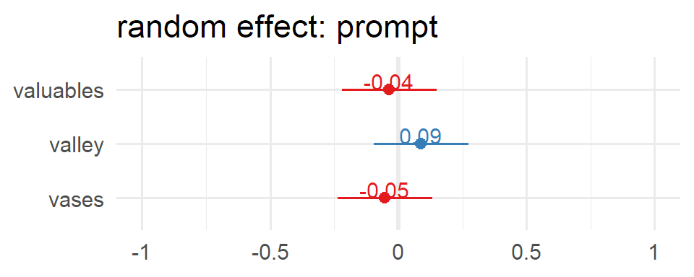

Figure .. Random effect of prompt in the model h_f0 ~ mode * acc_phon + (1 | speaker) + (1 | fin_phon) + (1 | prompt). The estimated effects almost zero.

#### Mode-only Models.

ANOVAs for each model indicate that mode is a significant factor at a level of *p* < 0.0001 (see appendix XXX). The marginal r2 of the *f*0 mode-only models were 0.04 and 0.10 for l_f0 and h_f0 respectively, indicating that mode accounts for 4% of the variation in l_f0 and 10% in h_f0. However, we expect much of variance in *f*0 is an effect of by inter-speaker differences, within which gender differences are nested. Therefore, it is unsurprising that the conditional r-squared both for l_f0 and h_f0 is much higher than the marginal r-squared, at 0.93 and 0.88 respectively. The higher r2m for h_f0 than l_f0 may reflect the fact that the height of the H target is more important in the expression of mode than the height of the L targets. Conversely, r2m of l_t is higher than that of h_t, (0.05 vs 0.01) although each of these is very low, especially given that we do not expect inter-speaker variation to be as large for alignment as for *f0* height. The r2c for the time parameters is lower than for the *f*0 parameters, with l_t at 0.77 and h_t at 0.75. This suggests that the variance in h_t is better explained by the whole model than variance in l_t.

|  |
| --- |
| Table .. Marginal and Conditional r-squared of mode-only models for each target parameter. |
| |  |  |  | | --- | --- | --- | | parameter | R2m | R2c | | l_f0 | 0.04 | 0.93 | | h_f0 | 0.10 | 0.88 | | l_t | 0.05 | 0.77 | | h_t | 0.01 | 0.85 | |  |  |  | |

Mean estimates were calculated from the models using each level of mode as intercept. These are summarised in Figure 7.23. All estimated means were significant at a level of *p* < 0.01. In terms of timing (panel a.), there is very little difference between MDC, MWH, and MYN, with estimated low mean timing ranging between 64 and 66 ms and estimated high timing between 265 and 267 ms. MDQ is noticeably earlier, with the low mean aligned at 45 ms and the high at 250. This can be seen clearly in Figure 7.24, panels a. and b., which shows the pairwise comparisons for each level of mode. MDQ slopes and CIs for both l_t and h_t are all noticeably lower than zero, as indicated by the third, fifth and sixth markers. The other slopes are at or close to zero, with CIs crossing the zero boundary. Thus, only MDQ slopes l_t and h_t achieve significance (p < 0.0001, see appendix XXX).

|  |  |
| --- | --- |
| a. Estimated means for temporal alignment | b.Estimated means for f0 targets |

Figure .. Estimated mean tonal target parameters and CIs for mode-only models.

The results for the *f*0 parameters are slightly different (Figure 7.23b.). There is little difference between estimated means of the low and high *f*0 targets for MDC and MWH, with an estimated low for MWH of 84.4 ST, only 0.1 STs above the MDC estimate. The estimated mean for the high target *f*0 of MWH is 90.5, only 0.4 STs above the MDC estimate. Both the low and high *f*0 estimates for MYN are noticeably higher, at 85.9 and 91.9 ST respectively, ranging from 1.3 to 1.7 ST higher than MWH and MDC. MDQ is even higher again, with a low *f*0 estimate of 86.7 and a high of 94.6 ST. The high estimate is more than 2.5 ST above even the MYN high estimate. These results are reinforced by the pairwise comparison levels of mode, shown in Figure 7.24, panels c. and d. Here, we see that the slope of MWH against MDC (first marker) is almost zero, with the lower CI crossing the zero threshold, and neither parameter achieving significance at *p* < 0.05. (The proximity of the mean estimated slope to zero and the short CIs indicate that might accent the null hypothesis rather than simply fail to reject it.) The slopes of MYN against MDC and MWH are noticeably higher (second and fourth markers) again, with confidence intervals well above zero. The slopes of MDQ re MDC and MWH are even higher again, again with lower CIs well above the zero line. In fact, although the difference is slighter, MDQ is even significantly higher than MYN for both *f*0 parameters, at 0.9 for l_f0 and 2.8 ST h_f0. Unsurprisingly, all MYN and MDQ slopes are significance at a level of *p* < 0.0001.

|  |  |
| --- | --- |
| Chart  Description automatically generated  a. Estimated slopes for l_t. | Chart  Description automatically generated  b. Estimated slopes for h_t. |
| Chart, scatter chart  Description automatically generated  c. Estimated slopes for l_f0. | Chart, scatter chart  Description automatically generated  d. Estimated slopes for h_f0. |

Figure .. Summary of mode-only model output phonetic parameters for pairwise comparison of each level of mode. First term in each case is the intercept, and error bars indicate 95% CIs.

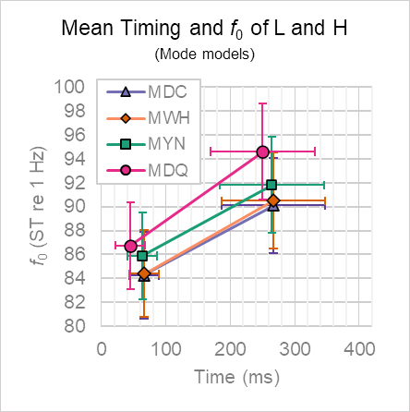

Figure .. Estimated means of phonetic parameters for each level of mode as intercept in mode-only analysis. Error bars indicate 95% CIs.

All told, the analysis of mode-only models gives the impression that there is indeed a difference in scaling from MWH/MDC to MYN to MDQ, much in the vein of Haan’s work on Dutch (2002). As such, these models support the view that there is a gradient increase in *f*0 across sentence modes as the amount of syntactic and lexical signals of interrogativity decrease. This is displayed very clearly in the visualisation of the tonal targets in Figure 7.25, where we can see that there is little difference between MDC and MWH, but that MYN and MDQ have increasingly higher *f*0 scaling.

#### Mode-and-phonology Models.

ANOVAs for each model indicate that acc_phon is a significant factor at a level of *p* < 0. 01 for each parameter. mode is significant for the l_f0, l_t, and h_f0 models at a level of *p* < 0.0001, and at a level of *p* < 0.05 for h_t (*p.adj =* .049). The acc_phon:mode interaction is significant for all models (p < 0.05) except the h_t model (*p.adj =* .212). (See appendix for full results.).

Table 7.15 shows the marginal and conditional r-squared values for the mode-and-phonology models and, in parentheses, the change from the mode-only models. For each parameter, we can see that mode*acc_phon explains only a little more of the variance than the mode-only models. (Treated proportionally, these changes could be construed as large, since and increase from 0.04 to 0.06 in the marginal r2 of l_f0 is a 50% improvement on the mode-only model; however, such interpretations are quite misleading as the actual change is from 4% of the variance to 6% of the variance.)

Table .. Marginal and conditional r-squared of mode-and-phonology models for each target parameter. Values in parentheses indicate change from mode-only models

|  |  |  |
| --- | --- | --- |
| parameter | R2m | R2c |
| l_f0 | 0.06 (+0.02) | 0.95 (+0.02) |
| h_f0 | 0.12 (+0.02) | 0.91 (+0.03) |
| l_t | 0.07 (+0.02) | 0.77 (+0.00) |
| h_t | 0.02 (+0.01) | 0.85 (+0.00) |
|  |  |  |

Figure 7.26 summarises the estimated means of the time and *f*0 parameters (β0) for the mode-and-phonology models, while Figure 7.27 shows the slopes (β1) between each level of mode. To facilitate comparison between the two models, estimated means from the mode-only models are shown in grey.

Looking at the time parameters (Figure 7.27a), we see no meaningful difference in the results when compared to the mode-only model. The estimated mean alignment of the low targets in the mode-and-phonology model for MDC, MWH, and MYN are almost identical, at 67, 68, and 69 ms respectively, with very similar CIs (from 46—48 to 89—91 ms). The estimated mean for MDQ is 20—22 ms earlier than these, at 47 ms (CIs = 25—69 ms). The estimated mean alignment of the high target is 168 ms for MDC, MWH and MYN (CIs ≈ 187.5—348.5 ms in each case) and is 16 ms earlier in MDQ at 252 ms (CIs = 192—333). The results of the pairwise comparison of slopes are unsurprising (Figure 7.27a. and b.), indicating no significant difference between in target alignment in MDC, MWH, and MYN (p.adj = 0.931—0.984 across interactions). The earlier alignment of MDQ re other levels of mode is distinct (third, fifth, and sixth markers) and statistically significant (p < 0.01 in each case).

|  |  |
| --- | --- |
| a. Estimated means for temporal alignment | b.Estimated means for f0 targets |

Figure .. Estimated mean tonal target parameters and 95% CIs for each level of mode mode-and-phonology models. Estimated means from the mode-only models are shown in grey.

|  |  |
| --- | --- |
| a. Estimated slopes for l_t. | b. Estimated slopes for h_t. |
| c. Estimated slopes for l_f0. | d. Estimated slopes for h_f0. |

Figure .. Summary of estimated mean difference between each level of mode (β1) for mode-and-phonology model and 95% CIs. Estimates for the mode-only models are shown in grey First term in each case is the intercept.

Changes in estimated mean *f*0 targets across levels of mode in the mode-and-phonology models are noticeably less pronounced than in mode-only model. This is clear from Figure 7.26b, where we see that the rise in estimated means of *f*0 targets do not rise as sharply from MWH to MYN to MDQ as they do in the mode-only models.

The estimated mean low targets for MDC (84.0 ST, 95% CIs = 80.5—87.5 ST) and MWH (84.3 ST, 95% CIs = 80.5—87.6 ST) are almost identical, with an estimated mean difference of 0.1 ST (Figure 7.27c), which is statistically non-significant at a level of *p* < 0.05 (CIs = ‑0.2—0.3, *p.adj =* .617). There is still an *f*0 does still increase from MWH to MYN (85.2 ST, 95% CIs = 81.6—88.7 ST), but the change is less pronounced than the same change in the mode-only model. That is, it is an increase of 1.1 ST rather than 1.7 ST, as shown in the MWH, MYN slope in panel c. (fourth column). Finally, the mean estimated low target *f*0 falls very slightly in MDQ to 85.5 ST (CIs = 81.5—88.6 ST) so that the mean estimated difference between MYN and MDQ is almost zero with short confidence intervals crossing the zero boundary, indicating that the difference between them is almost also non-significant (*p.adj =* .589).

As can is clear from Figure 7.27c, there is still a significant difference between all levels of mode (p < 0.0001) except for MWH re MDC and MDQ re MYN. However, each slope is noticeably less steep in the mode-and-phonology models when compared with the mode-only models, with each of the significant slopes hovering around one semitone. The change between the modes-only and mode-and-phonology models is particularly distinctive for the slope of MDQ re both MWH and MDC. Whereas the slopes in the mode-only model were 2.5 and 2.6 ST respectively, they both fall to 1 ST in the mode-and-phonology model.

For the high *f*0 targets, the damping of the changes across mode is also very noticeable in the mode-and-phonology model. In Figure 7.26b, we see that the mean estimated *f*0 for high targets (orange squares) slowly increases from 80.2 in MDC to 92.5 in MDQ. However, this contrasts with the more sharply rising curve across levels of mode in the mode-only analysis (grey diamonds), ranging from 90.1 ST in MDC to 94.6 ST in MDQ. The mean estimated *f*0 for MDC and MWH are again very similar in the mode-and-phonology model, at 90.2 (CIs = 86.1—94.2 ST) and 90.6 ST (CIs = 86.5—94.6 ST) respectively. These results are also almost the identical to those in the mode-only analysis (0.1 STs lower in each case). The from MWH to MYN is only 0.7 ST to 91.3 ST (CIs = 87.3—95.3). This contrasts with a rise of 1.2 ST in the mode-only model. The rise from MYN to MDQ is 1.2 STs in the mode-and-phonology mode, with an estimated mean high target for MDQ of 92.5 ST (CIs = 88.4—96.5 ST). This contrasts with a rise of 2.8 ST in the mode-only model.

Looking at the pairwise comparison of levels of mode for high *f*0 targets (Figure 7.27d, orange squared), we see that they all—except for MWH re MDC, which still hovers around zero and is non-significant (*p.adj =* .102)—much less pronounced in the mode-and-phonology model than in the mode-only model. Again, the most dramatic change is in the models in the slopes of MDQ re both MDC and MWH. Whereas in the mode-only models, these slopes were 4.5 and 4.1 ST respectively, in the mode-and-phonology model, they each fall dramatically to 2.3 and 1.9 ST.

#### Summary.

The overall effect of modelling the low and high targets using a mode-and-phonology model is that we see the estimates for mode coming considerably closer together compared to the mode-only model. This The overall lessening of the contrasts is indicated very clearly in Figure 7.28. Panel a shows the *f*0—time plot of targets by mode in the mode-only models, while panel b shows the plots for the mode-and-phonology models. We can see in panel b how the low and high targets of MYN and MDQ have dropped considerably and are now much closer to the targets of MDC and MWH. While MDQ is still also timed a little earlier, the main concern is that the *f*0 values are closer together. This indicates that the apparent paralinguistic effects of mode on *f*0 scaling are indeed noticeably diminished once accent phonology—i.e., pitch accent and register-tier effects—is incorporated into the model analysis.

|  |  |
| --- | --- |
| a. mode-only model. | b. mode+acc_phon model. |

Figure .. Comparing the estimated means of phonetic parameters for each level of mode as intercept in the mode-only and mode+acc_phon models Error bars indicate 95% CIs.

A simple but effective way of quantifying the extent to which mode-and-phonology models reduce the apparent effects of mode on *f*0 scaling is to compare the mean and standard deviation across the estimated slopes (β1) between each level of mode across each model. The closer each value is tozero, the less the difference in *f*0 across levels of mode. Table 7.16 shows the results of this analysis. We see the mean β1 of l_f0 fall from 1.49 ST in mode-only model to 0.7 ST in the mode-and-phonology model, a drop of 0.79 ST. There is a slight decrease in standard deviation of 0.3 ST, from 0.9 ST to 0.6 ST. The mean β1 of h_f0 falls from 2.48 ST in the mode-only model to 1.27 ST in the mode-and-phonology mode, indicating a mean decrease of 1.21 ST. There is a substantial drop in standard deviation 0.9 ST, from 1.6 ST in the mode-only model to 0.7 ST in the mode-and-phonology model.

Table .. β1 mean and standard deviation of all pairwise comparisons of mode for f0 parameters by model.

|  |  |  |  |  |  |  |  |  |
| --- | --- | --- | --- | --- | --- | --- | --- | --- |
| β1 | mode-only | |  | mode-and-phonology | |  | change | |
|  | mean | std dev. |  | mean | std dev. |  | mean | std dev. |
| l_f0 | 1.5 | 0.9 |  | 0.7 | 0.6 |  | -0.8 | -0.3 |
| h_f0 | 2.5 | 1.6 |  | 1.3 | 0.7 |  | -1.2 | -0.9 |

These results suggest that the parasitic paralinguistic effect on *f*0 scaling existed in both the mode-only model and in the model which incorporates the phonological effects of register tier as well. However, the apparent effect is quantifiably weaker once the pitch accents and register tier have been incorporated into the model. Most striking is the overall decrease in variance in β0 estimates for h_f0 from 2.62 to 0.5 ST.

Again, as with the phonological analysis, this comparison does not on its own demonstrate the existence of the register tier. However, it does demonstrate how a register-tier analysis helps separate apparent paralinguistic effects from phonological effects, and that apparently distinct paralinguistic effects are greatly dampened when accent phonology is introduced to the model. However, paralinguistic effects do not disappear completely, as suggested in section XX.XX. They are still in operation but are greatly subdued, as can be seen in the comparison of the two types of model in Figure 7.28 and the comparison of β1 *f*0 means and variance in Table 7.16, .

Many varieties of English tend to exploit a distinction in nuclear PAs contours to contrast MDC and MWH on the one hand and MYN and MDQ on the other, i.e., falling H*L or H* L% as opposed to rising L*H H% or H* H%. It does look as if the DCE speakers here—except for F16—employ low and high register to make the same distinction.

### Phonetic Parameters of Nuclear Pitch Accents

While the mode-and-phonology models are useful in teasing out the extent of paralinguistic effects of *f*0 scaling (and temporal alignment) on mode, it is also important to evaluate the phonetic parameters of tonal targets in terms of acc_phon itself. That is, we need to see if there is empirical evidence validating the differences proposed for the PA/register-tier combinations. For this purpose, the estimated means of each tonal target parameter were extracted from the mode-and-phonology model, this time with each level of acc_phon as intercept. As before, slopes (β1) of each pairwise comparison across levels of acc_phon were also estimated to help identify where and if there were statistical differences between tonal targets.

As mentioned on p. 161, ANOVAs for each model indicate that acc_phon is a significant factor at a level of *p* < 0. 01 for each parameter. Intercepts for each level of acc_phon are also significant (p < 0.001) for each target parameter (see Appendix XX).

The estimated mean temporal alignment of the low and high target—with the exception of ^[L]*H—are very similar for each level of acc_phon, as seen in Figure 7.26a. Mean alignment of the low target is 68 ms for L*H (CIs = 49—89), 63 ms for L*[H] (for CIs = 40—86), and 65 ms for ^[L*H] (43—88). For the high target, mean estimates for L*H and ^[L*H] are both 268 ms, while L*^[H] is a millisecond earlier at 267 ms, with a 95% CI range of 160-161 ms. The low target of ^[L]*H is aligned slightly later (81 ms, 95% CIs = 52—111 ms) while the high target is aligned noticeably earlier (218 ms, 95% CIs = 138—299 ms).

|  |  |
| --- | --- |
| a. Estimated means for temporal alignment | b.Estimated means for f0 targets |

Figure .. **acc_phon** mean tonal target parameter estimates (mode+acc_phon model). Error bars show 95% CIs.

The mean *f*0 estimate of the low target of L*H is 84 ST (CIs = 80.5—87.5) while it is slightly higher for L*^[H], at 84.7 ST (CIs = 81.1—88.3), as shown in Figure 7.26b. The mean estimates for the raised L* targets (^[L*]) are much closer together, at 86.9 ST for ^[L*]H (CIs = 83.1—90.6) and only 0.2 ST lower for ^[L*H], at 86.7 ST (CIs = 83.2—90.3). Mean *f*0 estimates for the non-raised and raised high tonal targets are in each case almost identical. That is the non-raised H in L*H has an estimated mean of 90.2 ST, while in ^[L*]H it is 89.9 (CIs = 86.1—94.2 and 85.5—94.3 respectively), only 0.3 ST lower in the case of ^[L*]H. The estimated mean *f*0 for raised H is 93.7 ST in each case (CIs = 89.6—97.8 in L*^[H] and 89.7—97.8 in ^[L*H]).

When we plot the target parameters together on a two-dimensional time-*f*0 plane (Figure 7.30), we see quite clearly that ^[L*H] (the green line with the circular targets) is essentially a raised version of L*H (the lilac blue line with the triangular targets). In fact, the target of the raised H in L*^[H] (orange line with square targets) is the same—in terms of estimated mean *f*0 and temporal alignment at least—as the raised H of the ^[L*H] accent. The slight difference in the height of the L in the L*^[H] and L*H is noticeable (and statistically significant at a level of *p* < 0.05, *p.adj =* .035); however, we can still see how it is much closer to the other unraised L target than it is to the raised L targets.

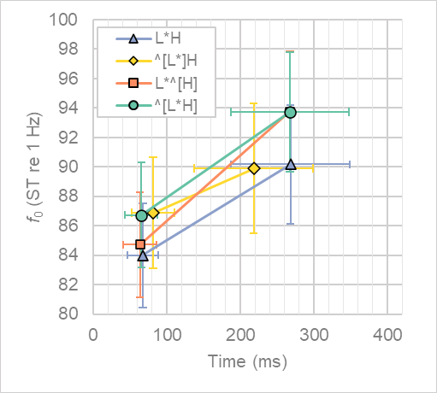

Figure .. Time-f0 plot of estimated means for L*H-like acc_phon tonal targets (mode+acc_phon models). Error bars indicate 95% CIs.

The targets for ^[L*]H are less like their counterparts in other pitch accents. Despite the similarities in *f*0 height of the raised L in ^[L*]H to that of ^[L*H] and of its unraised H to the H in L*H, clear differences in timing are evident. The H target is aligned much earlier in ^[L*]H, which suggests that it might more appropriately be identified as >H* (or even H*). Unfortunately, there are so few >H* and H* tokens over all (*n*=2, *n*=5 respectively), that it is difficult to make generalisations about them beyond there sparseness. In fact, there are only even six tokens for ^[L*]H, so any conclusions regarding ^[L*]H should be taken with a pinch of salt.

If we leave ^[L*]H aside and consider the pairwise analysis of slopes—illustrated in Figure 7.31—we see that the differences in mean are always close to zero. Differences in l_t slopes range from -4 to 2 ms, while h_t slopes hover between -1 and 0 ms. In all cases the CIs cross zero, and the differences in alignment are never statistically significant (p.adj = 0.452—0.729 for l_t slopes and 0.938—0.984 for h_t slopes).

The estimated mean differences in *f*0—as shown in Figure 7.31c—are much as anticipated. We expect h_f0 to be higher in both L*^[H] and ^[L*H] when compared to L*H, and we see just this. In both cases, the predicted mean difference is 3.6 ST (CIs = 2.7—4.4 ST and 2.9—4.2 ST respectively). Similarly, where we expect h_f0 to be the same—i.e., in L*^[H] re ^[L*H]—there is an estimated mean difference of 0 ST (CIs = ‑0.86—0.84 ST). For l_f0, the estimated mean difference between the low targets for L*[^H] and L*H is 0.7 ST (CIs = 0.11—1.32 ST), which is statistically significant (*p.adj =* .035). However, this is still much lower than the estimated mean differences for the raised L targets. The low target in ^[L*H] is an estimated 2.7 ST higher than that of L*H, while it is 2.0 ST higher in ^[L*H] than L*^[H] (CIs = 2.26—3.20 and 1.43—2.60 ST respectively)

|  |  |  |
| --- | --- | --- |
| a. l_t | b. h_t | c. l_f0 and h_f0 |

Figure .. Pairwise comparison of estimated means slopes and CIs for L*H, L*^[H], and ^[L*H].

#### Summary

There is little difference across acc_phon in terms of the temporal alignment of H and L targets for the three most common levels of acc_phon—i.e., L*H, L*^[H], and ^[L*H]—and no statistical differences between them. However, the main concern in this section is *f*0 scaling, and the essential question here is, “Does a statistical analysis of the tonal targets of different levels of acc_phon support evidence for the phonological distinction between them?” When it comes to the three common levels of acc_phon, the answer is clearly yes. The estimated *f*0 mean differences between identical pairs of tonal targets are remarkably similar, while those which we expect to be different are consistently different. At the same time, the differences and similarities in H targets are more precise than those for the L targets, suggesting more speaker pressure to achieve H targets more precisely. This forms an interesting corroboration in the previous chapter, where speakers appear to be under more pressure to retain H targets in PN pitch accents than L targets. Again, this speaks to the special status of H targets, even in a variety of English which has L*H pitch accents as the unmarked norm.

The results for ^[L*]H are less satisfying. The earlier alignment of the H target suggests that it might be more akin to >H* than L*H, although the *f*0 height of the raised L and the unraised H are consistent with their counterparts in other L*H-like nuclear pitch accents. Unfortunately, a viable comparison could not be made between ^[L*]H and >H*pitch accents, given the sparse number of tokens for either.

### Mode and Global Phonetic Parameters

Two utterance-wide parameters were evaluated, utterance mean *f*0 (utt_mean_f0) and *f*0 slope across the slope (utt_slope). utt_mean_f0 is the mean of the contour measured in semitones re 1 Hz while utt_slope is the slope of the linear regression of the *f*0 contour measured in semitones per second. As with the analysis of tonal targets parameters for mode, utterance-wide parameters were estimated using two types of models, i.e., a mode-only model and a mode-and-phonology model. Both models treat mode as a fixed factor with random slopes of mode per speaker, and random intercepts of speaker and prompt; however, the mode-and-phonology model adds random intercepts for phonological parameters, namely, acc_phon, fin_phon, and h_start. h_start is binary logical parameter which is true when an utterance begins with a H boundary or an initial prenuclear H* or >H* pitch accent associated with the first foot. Again, the aim was to assess how the addition of phonological features to the model might change the apparent paralinguistic effects of mode on the model.

Table .. Optimal working models for LMEM analysis of global phonetic parameters, where x is the response.

|  |  |  |
| --- | --- | --- |
|  | **Shared factors** | **mode-and-phonology model only** |
| x~ | mode + (1 + mode|speaker) + (1|prompt) |  |
| mode + (1 + mode|speaker) + (1|prompt) | + (1|h_start) + (1|acc_phon) + (1|fin_phon) |
|  |  |  |

An ANOVA of each model indicate that mode is significant at a level of *p* < 0.01 for utterance mean *f*0 (*p.adj =* 2.4×10‑04) and utterance slope (*p.adj =* .002).

#### Comparison of mode-only and mode-and-phonology models.

The mode-only model for utterance mean *f*0 has a marginal r2 of 0.03 and a conditional r2 of 0.95, while the corresponding mode-and-phonology model has a marginal r2 of 0.02 and a conditional r2 of 0.95. The mode-only model for utterance slope has a marginal r2 of 0.5 and a conditional r2 of 0.83. The corresponding mode-and-phonology model has a marginal r2 of 0.22 and a conditional r2 of 0.91.

Because the conditional r2 for each mean *f*0 model is the same (0.95), this suggests that the addition of random phonological effects in the mode-and-phonology model does not add contribute much in terms of the explanation of variance than the mode-only model. The slight decrease 0.01 in the marginal r2 for the mode-and-phonology model suggests, however, that 1% of the explanatory values of the fixed effect of mode in the mode-only model is effectively shifted from the fixed effect of mode-only model to the random effects of the mode-and-phonology model. However, a difference of 0.01 in the marginal r2  of the two models is very minor.

The decrease of 0.28 in the marginal r2 from the mode-only to the mode-and-phonology models is slightly perplexing. However, this again may indicate that once phonological affects have been added to the model, effects which were previously most likely attributable to mode become more appropriately attributable to random phonological effects. It should also be noted that the apparently small marginal r2 *f*0 models (both here and in general, as noted in section 7.6.1) are not because the effect of mode is unimportant, rather it is because *f*0 means are particularly susceptible to random speaker intercepts, within which gender effects are also embedded. This is illustrated in Figure 7.32, which shows the per-speaker random intercepts for the mode-and-phonology models. Panel a. shows the random per-speaker intercepts for mean *f*0 and panel b. shows the same for contour slope. Note that deviations from the mean are much larger for mean *f*0. This is particularly salient in the difference between M4, who has by far the lowest mean *f*0 (85 Hz), and F5, who has the highest (205 Hz).

|  |  |
| --- | --- |
| a. Random speaker intercepts for utt_mean_f0 | b. Random speaker intercepts for utt_slope |

Figure .. Random speaker intercepts for mode-and-phonology models of utterance-wide phonetic parameters.

A comparison of the mode-only and mode-and-phonology models indicates that there is very little difference between the two models for mean *f*0 estimates. Looking at Figure 7.33a, one can see that the estimated means for mean *f*0 for MDC and MWH are the same for both models (86.1 ST for MDC and 86.6 ST for MWH), with only small differences in MYN and MDQ. The estimated mean *f*0 for MYN is 86.7 in the mode-only model and 86.6 ST in the mode-and-phonology model, while for MDQ, it is 88.3 in the mode-only model and 88.0 ST in mode-and-phonology model. The β1 estimates across pairwise comparisons of levels of mode in the two models are also very similar. Figure 7.33b shows that, as with the analyses of the nuclear pitch accent, the difference between levels of mode is less pronounced in the mode-and-phonology model, but the differences are quite small. The change between two types of model ranges from a mean estimated difference of 0.01 ST between MWH and MDC, and 0.35 ST between MWH and MDQ.

|  |  |
| --- | --- |
| a. Estimated intercepts. | b. Estimated slopes for pairwise comparisons. |

Figure .. Estimated means and 95% CIs for utterance mean f0 per level of mode in the mode-only and mode-and-phonology models.

There is a more noticeable change in the *f*0 contour slopes between the two models. For contour slope, we see that the estimated means per level of mode are lower in the mode-and-phonology model than their mode-only counterparts (Figure 7.34 and Figure 7.35a). The difference becomes slightly more pronounced from MDC to MWH to MYN to MDQ, with the mode-and-phonology models being 1.4, 1.5, 1.8. and 2.8 ST/s lower respectively than their mode-only counterparts. This is most likely because of the acc_phon random slope compensates for the overall rise in the nuclear pitch accent region of the contour. In both models, MDC and MWH both have a negative slope (falling) while MYN and MDQ have positive slopes (rising). However, in the mode-only mode, it is only with MDC (CIs = -2—1.2 ST) that we cannot be confident the MDC does not have a zero slope (*p.adj =* .585). In the mode-and-phonology model, however, the CIs are much wider (all cross zero), so we actually lose confidence that overall trajectory is either positive or negative (*p.adj*ranges from 0.06 in MWH to 0.785 in MYN).

|  |  |  |  |
| --- | --- | --- | --- |
|  |  |  |  |

Figure .. Visual comparison of utterance-wide slope parameter in both models. Dotted lines indicate the mode-only model and solid lines the mode-and-phonology model.

The estimated slopes (β1) between each level of mode, however, do not change quite so much, as shown in Figure 7.35b. This is largely because the overall lowering of β0 in the mode-and-phonology models is largely irrelevant when considering the *relative* difference between each level. That is, we see that the β1 estimates for the mode-and-phonology model are generally only slightly closer to zero than in the mode only model. The one exception to this is in the MDC-MWH slope, where the mode β1 estimate is closer to zero. However, this is also the only estimate for which the CIs cross zero and we cannot be confident that there is any difference between the slope of MDC and MWH (*p.adj =* .115 and 0.117 for the mode-only and mode-and-phonology models respectively). Otherwise, the mode-and-phonology models have β1 values which are between 0.6 (MDC, MYN) and 1.69 ST/s (MWH, MDQ) closer to zero.

|  |  |
| --- | --- |
| a. Estimated means (β0) per level of mode. | b. Estimated slopes (β1) for pairwise comparisons. |

Figure .. Estimated means and 95% CIs for utterance-wide slope (ST/s) per level of mode in the mode-only and mode-and-phonology models.

As with the previous comparison of models, we can quantify the differences between the two types of model by looking at the mean and standard deviation of β1 estimates across pairwise comparisons. The mean difference between modes in the mode-only model is 1.17 ST with a standard deviation of 0.78. In the mode-and-phonology model, the mean difference is 0.2 ST lower at 0.97 ST, with a standard deviation of 0.67 (0.1 ST lower). This is a relatively minor change. The mean difference in slopes in the mode-only model is 4.3 ST/s, while it is 0.85 ST/s lower in the mode-and-phonology model at 3.45 ST/s. Thus, while there is an overall drop in slope in the mode-and-phonology model (as shown in Figure 7.35a), there is not much relative overall change in the differences between modes, which is what we are most interested in.

Table .. b1 mean and variance of all pairwise comparisons of mode for global parameters in both models.

|  |  |  |  |  |  |  |  |  |
| --- | --- | --- | --- | --- | --- | --- | --- | --- |
| b1 | mode-only | |  | mode-and-phonology | |  | change | |
|  | mean | std dev. |  | mean | std dev. |  | mean | std dev. |
| mean f0 (ST re speaker median *f*0) | 1.17 | 0.78 |  | 0.97 | 0.67 |  | -0.20 | -0.10 |
| slope (ST/s) | 4.30 | 3.95 |  | 3.45 | 3.29 |  | -0.85 | -0.66 |

What is clear from the comparison of the two kinds of model is that the effects of the intonational phonology on utterance-wide parameters are much less pronounced than their effects on nuclear pitch accent parameters. In fact, the lowering of the mean difference between levels of modes for utterance-wide parameters in the mode-and-phonology model is essentially negligible. It is only 0.2 ST for mean *f*0 and 0.85 ST/s for slope. Thus, while we do see an average lowering in β1 estimates across levels of mode, we can conclude that addition of phonology has a very limited effect on the global parameters evaluated here. In fact, the only noticeable change between models is the overall lowering of the mean estimates (β0) of utt_slope, although because this occurs for each level of mode, its relative effect is quite small.

#### Changes in global parameters across levels of mode.

As the effects of the intonational phonology on the global parameters are limited, we will only consider mean *f*0 and slope in terms of the mode-only models here.

There is a very gradual increase in mean *f*0 (utt_mean_f0)across modes (grey bars in Figure 7.33a). MDC has the lowest estimated mean, at 86.1 ST (CIs = 82.7—89.5 ST), followed by MWH, 0.5 ST higher at 86.6 ST (CIs = 83.5-89.6). MYN is only marginally higher, with a mean estimate of 86.8 ST (CIs = 83.8—89.9), while the estimated mean for MDQ is 1.5 ST higher again, at 88.3 ST (CIs = 84.8—91.8). Looking at the pairwise comparisons (grey diamonds in Figure 7.33b), we see that there is no significant difference between MDC and MWH (*p.adj =* .16) or between MYN and MWH (*p.adj =* .28). This is clear from the CIs, which stretch across the zero boundary. All other slopes in the pairwise comparisons are statistically significant at a level of *p* < 0.05, with the greatest differences being between MDQ and the other levels of mode. (Note, however, that in the mode-and-phonology model, only the slopes of MYN and MDQ against MDC as intercept achieved significance at a level of *p* < 0.05.)

For utt_slope (grey diamonds Figure 7.35a), MDC is closest to zero, at -1.0 ST/s (CIs = -0.25—0.57 ST/s). MWH is lower again, at -3.0 ST/s (CIs = -5.0—-1.0 ST/s), and it is the only level of mode which is reliably negative, even though there is always a rise in the nuclear pitch accent. MYN has an estimated mean positive slope of 2.4 ST/s (CIs = 0.8—4.0 ST/s) while MDQ has the highest at 5.4 ST/s (CIs = 3.0—7.9). Turning to the pairwise comparisons of levels of mode (grey diamonds Figure 7.35b), we see that only the MDC-MWH β1 of fails to reach significance at a level of *p* < 0.05 (*p.adj =* .115). This is reflected in CIs which cross zero (Figure 7.35b). All other pairwise comparisons achieve significance at *p* < 0.01. Given the very low utterance-wide slope of MWH, and the very high slope of MDQ, it is unsurprising that the greatest estimated mean difference is between these two these, i.e., 9.04 ST/s (CIs = 5.11—12.96).

#### Summary.

The phonological effect on utterance-wide *f*0 contour parameters is much weaker than on the nuclear pitch accent region of the utterance. This may simply reflect the fact that paralinguistic effects tend to stretch across the whole utterance / IP and that phonological effects are concentrated in the nuclear pitch accent. There is, however, an overall effect of mode on both utterance-wide mean *f*0 and slope. The changes across mean *f*0 by level of mode can be summarised as: MDC <= MWH <= MYN < MDQ, while changes across slope can be summarised as MWH < MDC ≈ 0 < MYN < MDQ. Note that MDC is clearly distinguished from MDQ, most notably in terms of slope. The mode-only utterance mean *f*0 and contour slope are plotted in Figure 7.36, with the mode-and-phonology results in grey behind them, We see that, in terms of global *f*0 parameters, there are clearly paralinguistic effects based on levels of mode which are not mitigated by the addition of phonology to the model.

Figure .. Estimated means and 95% CIs for utterance-wide mean f0 and slope for sentence mode in the phonology-only model. (Mode-and-phonology model estimates are plotted in grey in the background.)

## Summary and Discussion

The first aim of this chapter was to describe the phonological and phonetic characteristics of intonation as a function of sentence mode. The second, and arguable more important aim, was to assess the register-tier hypothesis. This hypothesis states that there is a phonological register tier which DCE speakers can utilize to help distinguish statements and wh-questions from yes-no and wh-questions. This contrasts with a more widely held view that changes in *f*0 scaling across question forms are not a matter of phonological choices but are rather part of paralinguistic effect which sees a gradual increase in *f*0 scaling from MWH to MYN to DCQ. It was proposed that such paralinguistic effects on tonal targets in the nuclear pitch accent would largely disappear once *f*0 parameters were estimated using a model which accounted for phonological choices re the implementation of the register tier. This issue was considered particularly important for northern Irish English since it is well known that the vast majority of nuclear contours in nIE are L*H % regardless of sentence mode. As it stands, if the majority of pitch accents are L*H regardless of mode, this would imply that NI speakers typically exploit only gradient paralinguistic effect rather than categorical phonological features. However, if there is a register tier, it is likely that nIE speakers—in this case speakers from Derry City—exploit this in absence of L*H / H*L contrast. It was also observed that this does not mean that nIE speakers only use the register tier, rather that it might be more apparent if a register tier is in use when the pitch accents are otherwise identical.

### Phonological Analysis

A methodological difficulty arose as soon the labelling of pitch accent began (using the IViE labelling system), because it was clear that it would be very difficult to label or describe discretely different nuclear pitch contours without recourse to the additional register-tier labelling. Thus, even before the analysis proper of the data began, it was necessary to make a decision regarding labelling which favoured the register-tier hypothesis. Section 7.4 presented examples of the kinds of contours and contrasts which made it difficult not to use a register-tier analysis *a priori*. From an auditory perspective as was as from visual inspection of the *f*0 contour, there were clear cases where speakers made a categorical utterance-wide shift upward shift in register in the realisation of MDQ in contrast to MDC. There were also cases where the upward shift only affected the domain of the nuclear pitch accent but not the final boundary or prenuclear components of the IP. This strongly suggested that speakers did have access to a phonological register tier and that could implement it across different domains in the IP, i.e., either across the whole IP, in the nuclear pitch accent only, and in some cases on individual tones. This last observation is probably only true of trailing H tones, but this only became apparent through more detailed statistical analysis.

Another component element of the labelling challenge was that—while there were potentially non-register-tier methods available for labelling the pitch accents and final boundary tones—any alternative labelling would require relocating pitch events which were clearly a component of the pitch accent to the boundary, and reinterpreting rises which began from a local *f*0 minimum in the stressed syllable as H* rather than L*. Both the re-allocation and inversion of targets felt methodologically unsound as workarounds to maintain a non-register-tier analysis. Therefore, register-tier marking was included in the labelling, with the caret (^) symbol used to identify the onset of high register and square brackets ([]) to identify its extent. As such, the expectation that patterns which are adequately explained only with reference to both the register and tonal tiers was already fulfilled before the labelling could be complete (expectation 4, section 7.1.1).

Once register-tier labelling was complete, the register-tier labelling was converted to non-register-tier labelling. To avoid completely hobbling the non-register-tier analysis, this did not simply remove all register-tier labelling. It also converted L*^[H] (L)% nuclear contours to L*H H(L)%. This was deemed to be the only phonological contour which was a viable non-register-tier label, i.e., it did not require relocation or inversion of tonal targets. The non-register-tier labelling was used to contrast it against the register-tier labelling to compare the descriptive effectiveness of the register-tier labelling. Admittedly, the non-register-tier labelled data acts somewhat of a strawman, as it is derived from and less well specified than the register-tier labelled data. However, I felt that could still serve to demonstrate the strength of register-tier analysis of the phonology which did not relocate tonal targets from the pitch accent to the boundary or interpret identifiably low targets as high.

The non-register-tier analysis indicated that the pitch accent itself was incapable of identifying contrasts as almost 99% of utterances has an L*H nucleus. This reflects the proposition of the first uncontroversial expectation that L*H would dominate across modes (section 7.1.1). However, this also meant that only the boundary would be associated with mode. A statistical analysis of the likelihood of H% as an effect of mode showed that there is a small possibility of H% in MYN (estimated mean 2% probability) and a slightly higher probability in MDQ (13%). To some extent, this confirmed the second (also uncontroversial) expectation that H% would be more closely associated with MYN and MDQ. However, the probabilities were much lower than expected, and they reflect an overall weak relationship between H% and MYN or MDQ in the non-register analysis. (Note also, that the third expectation of composite boundaries in a register-tier analysis was also met. However, this is ultimately uninteresting, as it was a requirement of the conversion from register-tier to non-register-tier labelling to move the H of the L*^[H] to the boundary. Therefore, if the boundary ended with an L%, it became HL% by default in the relabelling process.)

The register-tier analysis identified four different effects of high register on nuclear L*H pitch accents. They were L*H (no effect), ^[L*]H (raised L target only), L*^[H] (raised H target only), and ^[L*H] (pitch accent fully raised). A statistical analysis of the likelihood of high register in the nuclear pitch accent as an effect of gender and mode indicated there was roughly a 10% probability of high register in MYN and a 50% chance in MDQ (MDC and MWH were both estimated at 0%). The results also indicated a strong effect of gender (*p.adj =* .049), with male speakers more likely to use H% than female speakers, with an estimated mean probability of 39% in MYN and of 89% in MDQ.

When the two models labelling techniques were compared, mode and gender—as fixed factors—in the register-tier model accounted for 69% of the variance, while the whole model accounted for 79% of the variance. In the in the non-register-tier model, mode and gender accounted for 41% of the variance, while the whole model accounted for 75%. Given this, and the fact that the higher register tier much more readily associated with MDQ than the H% of the non-register-tier analysis, the register-tier analysis proved an explanatorily more effective approach. As noted previously, this does not demonstrate that the register-tier hypothesis is correct, and as also noted previously, the non-register-tier analysis is to some extent a foil against which to demonstrate the efficacy of assuming that there is a phonological register tier. In this way the fifth expectation, that the register tier-analysis would be more indicative of phonological change as an effect of mode than a non-register-tier analysis.

The phonological analysis of IP-wide phonology suggested that speakers were more likely to avoid prenuclear pitch accents in the MYN and MDQ than in MDC and MWH. A statistical analysis of the likelihood of nuclear-PA-only IPs as an effect of gender and mode indicated a 27.4% mean predicted probability of nuclear-PA-only IPs in MDC, but around 48.5% for both MYN and MDQ (although the confidence intervals for this were large). However, there was again an effect of gender, with female speakers much more likely than male speakers to use nuclear-PA-only IPs, with male speakers having only an estimated mean probability of nuclear-PA-only IPs of only 7% in MYN and MDQ.

The two strategies—use of high register and nuclear-PA-only IP—were pooled together, and a statistical analysis was conducted to assess the use of either strategy as an effect of mode and gender. This time, there was no effect of gender. This was unsurprising, as it incorporated one strategy with a male bias and the other with a female bias. However, the mean estimated probability of one of the two strategies in MYN was 59% and 87% for MDQ. While there was still a predicted probability of 16% for MDC (due to the presence of nuclear-PA-only IPs), the fact that both phonological strategies combined—one utterance-wide, the other associated with high register in the nuclear PA—were highly associated with MYN and especially MDQ was a very satisfying outcome. Moreover, it is worth noting that the register-tier analysis of the nuclear PA identified a strategy more closely with male speakers, while an IP-wide analysis (which didn’t require the register tier) identified a different strategy more closely associated with female speakers. Once again, this highlights the explanatory value of the register-tier hypothesis. That is, while it doesn’t demonstrate that it *exists*, such felicitous results indicate that by assuming it exists, we can gain insights into different ways in which the intonational phonology is leveraged to help distinguish between sentence modes rather than assuming that mode must be largely expressed through gradient changes in the *f*0 contour.

The final component of the phonological analysis related to the distribution of L%. As predicted—expectation 6, section 7.1.1—instances of L% did occur in each sentence mode, and most commonly in MDQ. A statistical analysis of the likelihood of L% as a function of mode and gender showed that there was little effect of gender (*p.adj =* .821) while the mean predicted probability of occurrence in MDQ was noticeably higher than other modes, 23% as opposed to 2%—5% for the other modes. However, there were very wide confidence intervals for each level of the model, indicating that the association with L% with mode was quite a weak one. In fact, the marginal r-squared of the model indicated that mode and gender together explained only 7% of the variance. This suggests that the previously stated view that L% is more likely in MDQ but is not itself a marker of interrogativity, holds quite well under statistical scrutiny. Of course, L% is associated with falls at the end of an IP and is therefore also associated with statements rather than questions in other varieties of English. In terms of form, there were a few nuclear contours which resembled the kind associated with declaratives on other varieties. They were H* L% and >H* L%, although they were few and all from the same speaker. What was most interesting about >H* L% was that the speaker used it in DCQ, YNQ, and DCQ. This reinforces the fact that L% is not associated with statement/question contrasts for these Derry speakers, and its frequent occurrence in MDQ—roughly two fifth of the adjusted count as opposed a fifths overall—reinforces the view, outlined in section 7.1.1, that L% serves a surprise-redundancy function rather than an interrogativity marking function. It is, however, worth remembering that tasks developed for these recordings aimed explicitly at eliciting colloquial speech. If one were to analyse more formal speech, such as by a news reader, one may well fine L% functioning as the end of a declarative fall.

### Phonetic Analysis

In a similar vein to the phonological analysis, which compared two systems of labelling, the phonetic analysis compared to kinds of model for assessing the extent to which a phonological register tier might account for apparent gradient changes in *f*0 scaling in the nuclear L*H pitch accent across sentences modes. Two *f*0 parameters were measured and evaluated, the *f*0 minimum and maximum in the nuclear pitch accent. The time points the *f*0 minimum and maximum were also evaluated (temporal alignment from the onset of the vowel in the stressed syllable). Together each time-*f*0 pairing was treated as a phonetic tonal target in the realisation of the underlying phonological tone of the pitch accent.

A statistical analysis of the tonal targets with mode-only as a fixed factor suggested that there was no difference in *f*0 scaling or alignment for MDC and MWH; however, there was a clear gradient increase from MWH to MYN and from MYN to MDQ, with the temporal alignment for MDQ alone being slightly earlier. As such, the mode-only analysis conformed with expectation about the paralinguistic effects of mode, summarised in expectation 7 (section 7.1.2) as:

1. *f0(*MDC) <= *f0(*MWH) < *f0(*MYN) < *f0(*MDQ)

The statistical analysis including mode *and* nuclear pitch accent phonology—i.e., the four different register-tier / L*H combinations—greatly reduced the apparent scaling of *f*0 targets as an effect of mode. That is, the paralinguistic effects of mode did not disappear completely. Therefore, the expectation that, “apparent paralinguistic effects… will disappear in a model incorporating the effects of the register tier” (p. 130 above) were clearly overstated. In fact, what this suggests is that use of register tier is not unlike what we see in other varieties of English with PA contrasts between declarative falls and question rises. That is, phonological contrasts are available, but they are not always implemented by speakers. (In the IViE data, for example, it was only the Cambridge speakers who consistently exploited contrasting PAs to differentiate MDC and MWH from MYN and MDQ [REF]). Similarly, the register tier may be used to signal a contrast between MDC/MWH and YNQ/MDQ. At the same time, however, just as in the other varieties (Grabe et al., 2003), there is still a gradient effect of question mode. In fact, when two global parameters were analysed—utterance mean *f*0 and linear regression of the slope of *f*0(t) of the utterance—the effects of phonology were still evident; however, changes in the differences between parameters across levels of mode were not greatly affected by the addition of phonological features to the model. This is most likely because the bulk of the phonological effect on mode occur, unsurprisingly, in the nuclear pitch accent. Therefore, when we look at the utterance as a whole, the phonological effects will be muted, and the gradient paralinguistic effects of mode will come to the fore. Therefore, we have to conclude that both gradient and categorical effects operate on the *f*0 contour, even if we can account for the phonological effects more fully.

The final phonetic evaluation was of the tonal targets as the targets of the pitch accents themselves because it was important to establish if the proposed register-tier effects on tonal targets were statistically identifiable. In this analysis it was found that the *f*0 scaling of non-raised H targets—those in L*H and ^[L*]H—were not only *not* statistically different from each other (9.adj = 0.907) but that their estimated means were only 0.3 ST different from one another. Similar results were found for the *f*0 scaling raised H targets—those in L*^[H] and ^[L*H]—but the mean estimates were identical (p.adj = 0.984). Again, raised L targets—those in ^[L*]H and ^[L*H]—were very similar, with a mean estimated difference of 0.1 ST (*p.adj =* .929). The only case where *f*0 scaling produced a statistically significant difference between targets was in the unraised L—those in L*H and L*^[H]—where the means estimate for the L of the L*^[H] was 0.7 ST higher than that of L*H (*p.adj =* .035). However, the mean estimated difference between each raised and unraised L target was always much higher (between 2 and 2.9 semitones, *p.adj*< 0.005 in each case). These results suggest that the interpretation of phonological raised/unraised register is overall very consistent, and the prediction that there would be significant differences in scaling due to register-tier effects (exception 9, section 7.1.2) appear to have been correct.

The results for the timing, however, suggest that the ^[L*]H target may be better interpreted as >H* or H*. This is because the H is aligned much earlier than any of the other H targets (an estimated 49-50 ms earlier), in a manner akin to the H* and >H* PAs of chapter six. However, as there very few tokens to compare on this matter, it was not possible to carry out a detailed analysis of this. That said, the ^[L*]H label did raise the most doubts during labelling, so, in retrospect, it might better have been labelled as >H* to let it lie in the ambiguous in-betweenness between L*H and H*.

## Conclusion

Overall, the analyses of mode in this chapter suggest that the register-tier hypothesis provides an effective means of describing the phonological and phonetic data. This was true, first of all, in the labelling process, where it was deemed that a non-register-tier labelling approach would have misrepresented the data and ignored salient distinctions. In the phonological analysis, the inclusion of the register tier helped identify two different (gendered) phonological strategies which speakers use to help signal the difference between sentence modes, most importantly between MDC and MDQ. The inclusion of register-tier phonology in the modelling of tonal targets greatly reduced the apparent paralinguistic effects of mode although it did not erase them completely. In fact, the phonetic analysis of utterance-wide parameters showed that outside the nuclear pitch accent, the gradient effects of mode on *f*0 are more readily apparent. Therefore, in offering a description of the phonological and phonetic characteristics of nuclear pitch contours in DCE across sentence modes (RQ2), we have also answered research question four, “Does a register tier provide a plausible phonological explanation for variation across sentence modes in DCE?” The answer to this question, I believe, has to be yes. It does not explain away all the paralinguistic / gradient effects of mode, but it does combine with other phonological features to explain how speakers sometimes signal sentence mode. It also allows us to see, perhaps more accurately, the extent of the paralinguistic effect of mode, as we can add phonological register-tier effects to our models to account for / remove residual phonological effects from the phonetic contour.

# From Phonology-First to Phonetics-First Analysis

## Critical Reflection on Chapter 6 (Maybe this belongs in chapter 6 itself!)

1. Prenuclear PAs are essentially a surface rendering of underlying tones.
   1. It looks like inherently underlying tones are almost always L*H but…
   2. Time pressures is likely to lead to the deletion of the L tone but not the H tone.
   3. This suggests that there is indeed a special status accorded to H tones.
   4. However, this is not consistent, one speaker appears to drop the H in favour of the L
   5. Regardless, the implication is that PAs as labelled based on surface structure imply a different underlying phonology.
   6. Labelling, as done here is essentially therefore problematic. Why?
      1. It suggests a phonological structure, but
      2. Each PA as labelled my really just be a surface realisation of an underlying phonology
      3. Thus, the labelled PA may well relate to the underlying phonological string much as a phoneme relates to an allophone.
      4. Moreover, it is possibly that some surface H* PAs are in fact realisations of an “true” phonological H*. Unfortunately, …
      5. It does not seem easy to distinguish between an underlying H* and an underlying L*H realised as H*
      6. Thus, >H* ends up being a kind of in-between, which is nether L*H nor H*
2. Solution to the problem:
   1. Adopt a strategy in which the contour itself is treated as a more highly specified sequence of SURFACE tones, which may (or may not) be clearly associated with the (assumed) underlying phonology.
3. In other words, put the phonetic component first, BUT assume that the underlying AM
4. In PN contours, where there is an L*H or an H*, sometimes:
   1. the plateau continues until:
      1. the edges of the word
      2. the edge of the foot
      3. the edge of the syntactic unit
   2. Sometimes the interpolation towards the next target simply begins after the peak.
   3. Sometimes, the peak is aligned with the word boundary, sometimes elsewhere
5. Each of these suggests that maybe:
   1. there is a degree of optionality in the selection of the tonal target
   2. there is a degree of optionality in how long the tone stretches for
6. We could adopt Gussenhoven’s “extra tone” to explain the falls (i.e., replace inter-accent interpolation with intra-accent), BUT we still need to explain why the plateaux have different lengths.
7. Solution?
   1. Interpolation is not intra- but inter-accentual
   2. Tonal targets can have both left and right alignment (as G suggests), BUT the extent of this alignment is optional. Also, the use of the secondary component (secondary tone) is optional. (more on this later.)
8. The CIs for peak timing are much wider than for L.
   1. Perhaps the peak-alignment strategy for measuring tonal targets is misguided (more of this later)
   2. concept of a string of L and H tones is still broadly true.

## Critical Reflection on Chapter 7

1. The tonal string itself is inadequate for explaining salient and meaningful changes in the *f*0 contour
2. While one could re-interpret the phonological string to provide a tonal-string-only account, this would require:
   1. Relacing some Ls with Hs.
   2. Shifting the structural position of some tones from the PA to the boundary, which is not in any way borne out by evidence in the contour.
   3. For example:
      1. If we change ^[L*H] % to H* H%, For example, we have to change the L to a H and shift the H to the boundary. However, the contour shows a fall-to-then-rise-out-of pattern in the stressed syllable, highly suggestive of a low target and not a high target. We shift the H to the boundary, but the peak of the contour is often earlier than in the unraised L*H %.
      2. If we change L*^[H] L% to L*H HL%, we need to add an H to the boundary to account for the relative rise from the nuclear H, even though the H peak is earlier than in L*H L%.
3. Thus, there is clear phonetic evidence that the tone-only model is NOT appropriate for the analysis of the data.
4. The tone-only approach was abandoned, and the tone plus register-tier analysis provided a more efficient, explanatorily effective, (honest,) and complete account of the data.
5. Had this alternative approach not been adopted, the more orthodox AM approach, based on a tonal-string-only-phonological approach, the register-tier insights would not have been possible
6. Thus, inherently, chapter 7, questions the phonology-first approach which it was based on.
7. The need for phonological decisions (even with the “phonetic” tier of IViE) regarding the status of the second PN pitch accent means that phonological categorical decisions are thrust upon data which is not so clearly categorical (this is not a new issue: ref to lots of other work):
   1. Is there a pitch accent associated with the stressed syllable or is it unaccented (*)?
   2. Is the lower PA an L* or a !H*?
8. In fact, a TP rather than a peak analysis is sometimes necessary for these PNs.
9. Some PNs, especially those labelled as L*, since there is a noticeable pitch event on the stressed syllable, don’t “sound” like independent pitch accents, rather they feel more like pre-emptive lowering before the main event, i.e., the nuclear L*H.
10. Thus, L* feels like it gives them too high a status!
11. L and H of MDQs are still aligned earlier than other forms:
    1. When we look at the phonetic data, we see that sometimes are two potential turning points, one near the onset of the vowel or syllable and one at the end of the vowel.
    2. Is it possible that a speaker simply more likely to begin the rise at the first points when the *f*0 rise is higher, thus giving the impression that the alignment is earlier when in fact:
       1. The *f*0 min **is** earlier
       2. There is still and elbow at the “typical” point
       3. Again, and elbow analysis may be better.
12. CIs for peak timing are much wider than for L.
    1. Perhaps, again, the peak-alignment strategy for measuring tonal targets is misguided (more of this later)
    2. It might be better to look at TPs to see if they are more stable than the peak alignment measurement.
    3. concept of a string of L and H tones is still broadly true.

## General Critique of Peaks and Valleys Analysis

1. Despite intuitive sense of high and low *f*0 = H and L tones, it may not really be the best approach after all (though it clearly serves a purpose)
2. Plateaux and troughs… min and max sometimes feels arbitrary (Stylise)
3. Yayla! (i.e. downstepped plateaux)

## A Phonetics First Analysis

### Elbows rather than minima and maxima

1. Despite intuitive sense of high and low *f*0 = H and L tones, it may not really be the best approach after all (though it clearly serves a purpose)
2. Elbows / turning points may be better… But what are they!
3. Roots of *of f*0′′(t) identifies the time of turning points.
   1. Point at which the acceleration of *f*0 changes direction
   2. In terms of proprioception, this is very salient (car braking, sudden acceleration of a car).
   3. Point at which acceleration changes from neg to pos, is point where acceleration begins to increase, 🡪 L
   4. Point at which acceleration pos to neg is point where acceleration begins to decrase, 🡪 H
4. It makes sense, therefore, that turning points are associated with L and H.
5. As mentioned way back in ch2, peaks and valleys are often just a subset of turning points.

### Secondary targets rather than single PA and boundary targets

1. Explains phenomena of:
   1. Plateaux of different duration.
   2. Valleys with two turning points
   3. Apparent existence of phrase accents.
2. If treated as non-obligatory and their implementation as speaker-oriented rather than grammar-oriented (expand on this):
   1. They may help account for phenomena when are not transparent when we begin with the phonological primitives first.

## Secondary Target Hypothesis

The secondary target approach requires the use of elbows, as this becomes the best way of identifying the edges of plateaux and valleys, as will become clearer in the analyses.

The assumptions are that:

1. Underlying phonological tones can be realised with a primary target and a secondary target
2. The secondary target is optional.
3. The secondary target can be understood as a generalisation of:
   1. secondary associations (Beckman and P/Humbert?)
   2. left and right alignment (Gussenhoven)
   3. phrase accents.
4. Tonal targets are more appropriately conceptualised as turning points in the contour. Mathematically, these can be defined as the roots of *f*0′′(t).
   1. True tonal targets are idealisations which are never realised in the contour due to physiological constraints, i.e.,
   2. speakers are required to change *f*0 trajectory for the next target before the ideal tonal target can be reached
5. Use and choice of (primary) and secondary target locations may be determined by pragmatic discourse functions:
   1. scope of reference for the pitch accent
   2. the amount of available space for realisation
   3. ??? (there is a third, but has slipped my mind).
6. Phonetic turning points should be identified first.
7. They should be reduced to a minimum number which can be used to adequately reproduce the contour (similar to IPO)
8. After reduction of turning points, they can be associated with phonological identities:
   1. T* -- primary target of PA associated with stressed syllable
   2. +T, T+ -- trailing or leading tone of PA ( the + is important as a marker for machine readability)
   3. _T, T_, secondary targets associated with T*, T+, or +T
   4. %T(_T) and (T_)T% for boundaries, with the T_/_T simply indicating the edge of the boundary tone effect (offset for %T and onset for T%, note % is the beginning/end of the IP, so all Tones must be inside the %).
   5. While agnostic on on-ramp, off-ramp issues, I think that an offramp analysis is better, with the secondary T_ targets replacing that might typically be read T+. e.g., L+H* may become L_H*
   6. _0 is used to show the edge of an H tone before it falls (i.e., 0 to show “nothing to do until here” of the privileged H tone. L_ is used to show the pre-emptive reflect for the L* AND a low TP before a downstepped !H*. In fact, we can see that the yayla requires the L_ reflex
   7. As each stressed syllable could potentially have a PA associated with it, it is possible that non pitch accentuated feet may have weak traces of L and H targets… these can be annotated as l and h, but it is assumed that they could be ignored, and the percept of the tonal sequence might not be lost in resynthesis
   8. Onset and domain of register tier can be shown via ^[] as before
   9. Tonal targets complexes can be reduced to minimalist PAs
9. This approach is explicitly phonetic and assumes that a resynthesis of the contour using ideal turning points with physiological constraints will generate a pitch contour that is perceptually indistinguishable from the original. (l and h could be excluded with no effect on the outcome)
10. The approach is compatible with AM, but it takes the explicit phonetic mapping of tonal targets and works backwards to infer the underlying phonology
11. Where do the secondary targets come in? Are they “injected” into the tonal string somewhere else? Is it later? Does the pragmatic / scope function come later???

### Implementing STH (K-max)

# STH experiments

## STH and TCoG

## PN Plateaux in the A- and H-Corpora

## Downstepped PNsL L_H*

## Nuclear L_L*H

## Focus

# Summary and Conclusion

References

’t Hart, J., Collier, R., Cohen, A., Hart, J. ’t, Collier, R., & Cohen, A. (1990). *A perceptual study of intonation*. Cambridge University Press.

Albers, C., & Lakens, D. (2018). When power analyses based on pilot data are biased: Inaccurate effect size estimators and follow-up bias. *Journal of Experimental Social Psychology*, *74*(April 2016), 187–195. https://doi.org/10.1016/j.jesp.2017.09.004

Albert, A., Cangemi, F., & Iƒl-phonetik, M. G. (2019). Can you draw me a question ? *International Congress of Phonetic Sciences*, *August*. https://doi.org/10.13140/RG.2.2.15700.14729

Arnold, J. D., & O’Connor, G. F. (1973). *Intonation of colloquial English* (2nd ed.). Longman.

Arvaniti, A., & Garding, G. (2007). Dialectal variation in the rising accents of American English. *Papers in Laboratory Phonology IX*, 547–576.

Arvaniti, A., Ladd, D. R., & Mennen, I. (1998). Stability of tonal alignment: the case of Greek prenuclear accents. *Journal of Phonetics*, *26*(1), 3–25. https://doi.org/10.1006/jpho.1997.0063

Arvaniti, A., Ladd, D. R., & Mennen, I. (2000). What is a starred tone? Evidence from Greek. *Papers in Laboratory Phonology V: Acquisition and the Lexicon*, 119–131.

Atterer, M., & Ladd, D. R. (2004). On the phonetics and phonology of ‘“segmental anchoring”’ of F0: evidence from German. *Journal of Phonetics*, *32*, 177–197.

Baayen, R. H. (2008). *Analyzing Linguistic Data*. Cambridge University Press. https://doi.org/10.1558/sols.v2i3.471

Baayen, R. H., Davidson, D. J., & Bates, D. M. (2008). *Memory and Language Mixed-effects modeling with crossed random effects for subjects and items*. *59*, 390–412. https://doi.org/10.1016/j.jml.2007.12.005

Barnes, J., Brugos, A., Veilleux, N., & Shattuck-hufnagel, S. (2021). On (and off) ramps in intonational phonology: Rises, falls, and the Tonal Center of Gravity. *Journal of Phonetics*, *85*, 101020. https://doi.org/10.1016/j.wocn.2020.101020

Barnes, J., Veilleux, N., Brugos, A., & Shattuck-Hufnagel, S. (2012). Tonal Center of Gravity: A global approach to tonal implementation in a level-based intonational phonology. *Laboratory Phonology*, *3*(2), 337–383. https://doi.org/10.1515/lp-2012-0017

Bates, D., Mächler, M., Bolker, B., & Walker, S. (2015). Fitting Linear Mixed-Effects Models using lme4. *Journal of Statistical Software*, *67*(1). https://doi.org/10.18637/jss.v067.i01

Beckman, M. E., & Gayle, A. E. (1997). *Guidelines for ToBI labelling (version 3.0)*. The Ohio State University Research Foundation.

Beckman, M. E., Hirschberg, J., & Shattuck-Hufnagel, S. (2005). The original ToBI system and the evolution of the ToBI framework. In S.-A. Jun (Ed.), *Prosodic models and transcription: Towards prosodic typology* (pp. 9–54). https://doi.org/10.1093/acprof:oso/9780199249633.003.0002

Beckman, M. E., & Pierrehumbert, J. B. (1986). Intonation structure in Japanese and English. In *Phonology* (Vol. 3, Issue 01, pp. 255–309). https://doi.org/10.1017/S095267570000066X

Ben-Shachar, M. S., Lüdecke, D., & Makowski, D. (2020). {e}ffectsize: Estimation of Effect Size Indices and Standardized Parameters. *Journal of Open Source Software*, *5*(56), 2815. https://doi.org/10.21105/joss.02815

Benjamini, Y., & Hochberg, Y. (1995). Controlling the False Discovery Rate: A Practical and Powerful Approach to Multiple Testing. *Journal of the Royal Statistical Society: Series B (Methodological)*, *57*(1), 289–300. https://doi.org/10.1111/j.2517-6161.1995.tb02031.x

Boersma, P., & Weenink, D. (2022). *Praat: doing phonetics by computer (v. 6.2.14)*. www.praat.org

Bolker, B. (2018). *GLMM worked examples*. http://bbolker.github.io/mixedmodels-misc/ecostats_chap.html

Brazil, D. (1995). *A Grammar of Speech*. Oxford University Press.

Bruce, G., & Thelander, I. (2001). A pitch accent journey in southern Sweden. *Working Papers, Lund University, Department of Lingustics*, *49*, 14–17.

Chung, Y., & Rabe-Hesketh, S. (2013). A nondegenerate penalized likelihood estimator for variance parameters in Chung, Y., Rabe-Hesketh, S., Dorie, V., Gelman, A., and Liu, J. (2013). A nondegenerate penalized likelihood estimator for variance parameters in multilevel models. *Psychometrika*, *1*(19), 331.

Corrigan, K. (2010). *Irish English, volume 1 - Northern Ireland*. Edinburgh University Press.

Cruttenden, A. (1995). Rises in English. In J. W. Lewis (Ed.), *Studies in General and English Phonetics* (pp. 155–173). Routledge.

Cruttenden, A. (1997). *Intonation*. Cambridge University Press.

Cruttenden, A. (2001). Mancunian intonation and intonational representation. *Phonetica*, *58*, 53–80. https://doi.org/10.1159/000028488

Cruttenden, A. (2007). Intonational diglossia: A case study of Glasgow. *Journal of the International Phonetic Association*, *37*(3), 257–274. https://doi.org/10.1017/S0025100307002915

D’Imperio, M. (2000). *The Role of Perception in Defining Tonal Targets and Their Alignment* [Ohio State University]. http://sfx.scholarsportal.info.proxy1.lib.uwo.ca/western?url_ver=Z39.88-2004&rft_val_fmt=info:ofi/fmt:kev:mtx:dissertation&genre=dissertations+%26+theses&sid=ProQ:Linguistics+and+Language+Behavior+Abstracts+%28LLBA%29&atitle=&title=The+Role+of+Perce

Dalton, M., & Ní Chasaide, A. (2005). Tonal alignment in Irish dialects. *Language and Speech*, *48*(Pt 4), 441–464. https://doi.org/10.1177/00238309050480040501

Dalton, M., & Ní Chasaide, A. (2007). Nuclear accents in four irish (gaelic) dialects. *Proceedings of the XVIth International Congress of Phonetic Sciences*, *August*, 965–968.

Dorn, A. (2006). *An Intonational Analysis of Donegal English (M.Phil disseration)*. Trinity College, Dublin.

Field, A., Miles, J., & Field, Z. (2012). *Discovering Statistics Using R*. Sage. https://doi.org/10.7326/M16-0968

Foley, M., Gibbon, F. E., & Peppé, S. (2010). Benchmarking Typically Developing Children’s Prosodic Performance on the Irish-English Version of the Profi ling Elements of Prosody in Speech-Communication (PEPS-C). *Journal of Clinical Speech and Language Studies*, *18*, 19–40.

Fujisaki, H. (2004). *Information , Prosody , and Modeling*.

Grabe, E. (1998a). *Comparative Intonational Phonology: English and German*. Max-Planck-Institut for Psycholinguistics and University of Nijmegen.

Grabe, E. (1998b). Pitch accent realisation in English and German. *Journal of Phonetics*, *26*(2), 129–143. https://doi.org/10.1006/jpho.1997.0072

Grabe, E. (2001). *The IViE Labelling Guide (Version 3)*. http://www.phon.ox.ac.uk/files/apps/IViE/guide.html

Grabe, E. (2004). Intonational Variation in Urban Dialects of English Spoken in the British Isles. In P. Gilles & J. Peters (Eds.), *Regional Variation in Intonation* (pp. 9–31). Niemeyer. http://www.phon.ox.ac.uk/files/people/grabe/Grabe_Niemeyer.pdf

Grabe, E., Kochanski, G., & Coleman, J. (2003). Quantitative modelling of intonational variation. *Speech Analysis and Recognition in Technology, Linguistics and Medicine*, 45–57. https://doi.org/10.1.1.97.4270

Grabe, E., Kochanski, G., & Coleman, J. (2005). The intonation of native accent varieties in the British Isles: potential for miscommunication? In K. Dziubalska-Kolaczyk & J. Przedlacka (Eds.), *English pronunciation models: a changing scene* (pp. 311–337). Peter Lang.

Grabe, E., Nolan, F., & Farrar, K. (1998). IViE-A comparative transcription system for intonational variation in English. *Proceedings of ICSLP 98*. http://www.mirlab.org/conference_papers/International_Conference/ICSLP 1998/PDF/SCAN/SL980099.PDF

Grabe, E., & Post, B. (2002). Intonational Variation in the British Isles. *Speech Prosody 2002*, 343–346.

Grice, M., Ritter, S., Niemann, H., & Roettger, T. B. (2017). Integrating the discreteness and continuity of intonational categories. *Journal of Phonetics*, *64*, 90–107. https://doi.org/10.1016/j.wocn.2017.03.003

Gussenhoven, C. (1983). A semantic analysis of the nuclear tones of English. In *On the Grammar and Semantics of Sentence Accents* (Issue August). Indiana University Linguistics Club. https://doi.org/10.1515/9783110859263.193

Gussenhoven, C. (1999). Discreteness and Gradience in Intonational Contrasts. *Language and Speech*, *42*(August), 283–305. https://doi.org/10.1177/00238309990420020701

Gussenhoven, C. (2004). The phonology of tone and intonation. In *The Phonology of Tone and Intonation*. Cambridge University Press. https://doi.org/10.1017/CBO9780511616983

Gussenhoven, C. (2016). Analysis of Intonation: the Case of MAE_ToBI. *Laboratory Phonology*, *7*(1), 10. https://doi.org/10.5334/labphon.30

Haan, J. (2002). *Speaking of Questions - An Exploration of Dutch Question Intonation*. LOT.

Halliday, M. A. (1967). *Intonation and Grammar In British English*. Mouton.

Harris, J. (1985). *Phonological Variation and Change: Studies in Hiberno-English*. Cambridge University Press.

Harris, J. (1994). *English Sound Structure*. Blackwell.

Hartigan, J. A., & Hartigan, P. M. (1985). The Dip Test of Unimodality. *Annals of Statistics*, *13*(1), 70–84. https://doi.org/doi:10.1214/aos/1176346577

Hayes, B. (2009). Syllabification in English (unpublished chapter). In *Introductory Phonology*. Blackwell.

Hickey, R. (2007). *Irish English: History and present-day forms*. Cambridge University Press. https://doi.org/10.1017/CBO9780511551048

Hirst, D. (1998). Intonation in British English. In *Intonation Systems. A survey of twenty languages* (Issue October, pp. 56–77).

Hirst, D. (2013). *UK declarative rises and the frequency code*. *April*, 149–160. https://doi.org/10.1075/ill.13.08hir

Inkelas, S., & Leben, W. R. (1990). Where phonology and phonetics intersect: the case of Hausa intonation. In G. N. Clements, J. Kingston, & M. E. Beckman (Eds.), *Papers in Laboratory Phonology I: Netween the grammar and physics of Speech*. Cambridge University Press. https://doi.org/10.1017/cbo9780511627736.002

Jarman, E., & Cruttenden, A. (1976). Belfast intonation and the myth of the fall. *Journal of the International Phonetic Association*, *6*(1), 4–12. https://doi.org/10.1017/S0025100300001432

Jespersen, A. B. (2018). Innovations in the Stylistic variation of nuclear tunes in Belfast English. *9th International Conference on Speech Prosody*, 527–531.

John J. Ohala. (1983). Cross-Language Use of Pitch: An Ethological View. In *Phonetica* (Vol. 40, pp. 1–18).

Kalaldeh, R., Dorn, A., & Ní Chasaide, A. (2009). Tonal alignment in three varieties of Hiberno-English. *INTERSPEECH 2009*, 2443–2446.

Kallen, J. L. (2013). *Irish English Volume 2: The Republic of Ireland*. De Gruyter Mouton.

Knight, R. A. (2008). The shape of nuclear falls and their effect on the perception of pitch and prominence: peaks vs. plateaux. *Lang Speech*, *51*(3), 223–244.

Knight, R. A., & Nolan, F. (2006). The effect of pitch span on intonational plateaux. *Journal of the International Phonetic Association*, *36*(2004), 21–38. https://doi.org/10.1017/S0025100306002349

Kuznetsova, A. (2017). *lmerTest Package : Tests in Linear Mixed Effects Models*. *82*(13). https://doi.org/10.18637/jss.v082.i13

Lacy, B., Cody, E., Cotter, C., Cuppage, J., Dunne, N., Hurley, V., O’Rahilly, C., Walsh, P., & NUalláin, S. Ó. (1983). *Archaeological Survey of County Donegal*. Donegal Couny Council.

Ladd, D. R. (1983). Phonological Features of Intonational Peaks. *Language*, *59*(4), 721–759. https://doi.org/10.2307/413371

Ladd, D. R. (2008). *Intonational Phonology*. Cambridge University Press.

Ladd, D. R., Mennen, I., & Schepman, A. (2000). Phonological conditioning of peak alignment in rising pitch accents in Dutch. *The Journal of the Acoustical Society of America*, *107*(5), 2685–2696. https://doi.org/10.1121/1.428654

Ladd, D. R., & Schepman, A. (2003). “Sagging transitions” between high pitch accents in English: Experimental evidence. In *Journal of Phonetics* (Vol. 31, Issue 1). https://doi.org/10.1016/S0095-4470(02)00073-6

Ladd, D. R., Schepman, A., White, L., Quarmby, L. M., & Stackhouse, R. (2009). Structural and dialectal effects on pitch peak alignment in two varieties of British English. *Journal of Phonetics*, *37*(2), 145–161. https://doi.org/10.1016/j.wocn.2008.11.001

Leben, W. R., Inkelas, S., & Cobler, M. (1989). Phrases and Phrase Tones in Hausa. In P. Newman & R. D. Botne (Eds.), *Current Approaches to African Linguistics (vol. 5)* (pp. 45–62). https://doi.org/10.1515/9783112420089-005

Liberman, M. (1975). The Intonational System of English. In *Department of Foreign Literature and Linguistics: Vol. Ph.D.* MIY.

Lowry, O. (2001). *Belfast intonation: testing the ToBI framework of intonational analysis.* University of Ulster.

Lowry, O. (2002). The Stylistic variation of nuclear patterns of Belfast English. *Journal of the International Phonetic Association*, *32*(32), 33–42. https://doi.org/10.1017/S0025100302000130

Lowry, O. (2011). Belfast intonation and speaker gender. *Journal of English Linguistics*, *39*(3), 209–232. https://doi.org/10.1177/0075424210380053

Lüdecke, D., Ben-Shachar, M. S., Patil, I., Waggoner, P., & Makowski, D. (2021). {performance}: An {R} Package for Assessment, Comparison and Testing of Statistical Models. *Journal of Open Source Software*, *6*(60), 3139. https://doi.org/10.21105/joss.03139

Maechler, M. (2021). *diptest: Hartigan’s Dip Test Statistic for Unimodality - Corrected*. https://cran.r-project.org/package=diptest

McCafferty, K. (2001). *Ethnicity and Language Change. English in (London)Derry, Northern Ireland*. Benjamins.

McElholm, D. D. (1986). Intonation in Derry English. In H. Kirkwood (Ed.), *Studies in intonation. Occasional Papers in Linguistics and Language Learning* (pp. 1–58). New University of Ulster.

Microsoft Corporation. (2020). *Microsoft Excel*. https://office.microsoft.com/excel

Moritz, N. (2016). Uptalk variation in three varieties of Northern Irish English. *Speech Prosody*, 119–122. https://doi.org/10.21437/SpeechProsody.2016-25

Nakagawa, S., Johnson, P. C. D., & Schielzeth, H. (2017). The coefficient of determination R2 and intra-class correlation coefficient from generalised linear mixed-effects models revisited and expanded. *Journal of the Royal Society Interface*, *14*(134). https://doi.org/10.1098/rsif.2017.0213

Nakagawa, S., & Schielzeth, H. (2013). A general and simple method for obtaining R2 from generalised linear mixed-effects models. *Methods in Ecology and Evolution*, *4*(2), 133–142. https://doi.org/https://doi.org/10.1111/j.2041-210x.2012.00261.x

NISRA. (2015). *Review of the Statistical Classification and Delineation of Settlements The Northern Ireland Statistics and Research Agency* (Issue March). https://www.nisra.gov.uk/sites/nisra.gov.uk/files/publications/review-of-the-statistical-classification-and-delineation-of-settlements-march-2015_0.pdf

Nolan, F. (2003). Intonational equivalence: an experimental evaluation of pitch scales. *Proceedings of the 15th International Congress of Phonetic Sciences*, 2–5. http://www.let.uu.nl/LOT/GraduateProgram/LotSchools/Summerschool2005/course descriptions/nolan_icphs2003.pdf

Nolan, F., & Farrar, K. (1999). Timing of F0 Peaks and Peak Lag. In J. J. Ohala, Y. Hasegawa, O. Manjari, G. Daniel, & A. C. Bailey (Eds.), *Proceedings of the XIVth International Congress of Phonetic Sciences* (pp. 961–964). Lingustics Department, University of California.

Northern Ireland Statistics and Research Agency. (2016). *Derry City (N11000243)*. http://www.ninis2.nisra.gov.uk/public/StaticMapViewer.aspx?geoCode=N11000243&geoLevel=SETT2015

Nugent, J. (2022). *Using allFit() with (g)lmer*. https://joshua-nugent.github.io/allFit/

O’Reilly, M., Dorn, A., & Ní Chasaide, A. (2010). Focus in Donegal Irish ( Gaelic ) and Donegal English bilinguals. *Speech Prosody*, 1–4.

Ohala, J. J. (1976). Explaining the intrinsic pitch of vowels. In *The Journal of the Acoustical Society of America* (Vol. 60, p. S44). https://doi.org/10.1121/1.2003351

Pierrehumbert. (1980a). *The phonology and phonetics of English intonation (PhD thesis)*. MIT.

Pierrehumbert, J. B. (1980b). *The Phonology and Phonetics of English Intonation*. MIT.

R Core Team. (2022). *R: A language and environment for statistical computing* (4.2.0). R Foundation for Statistical Computing.

Richardson, J. T. E. (2011). Eta squared and partial eta squared as measures of effect size in educational research. *Educational Research Review*, *6*(2), 135–147. https://doi.org/10.1016/j.edurev.2010.12.001

Rodgers, A. E. (2018). Prenuclear pitch accents and peak alignment in Derry~Londonderry English. *Colloquium of the British Association of Academic Phoneticians*.

Rodgers, A. E. (2019). The effects of anacrusis and foot size on prenuclear pitch accents in northern Irish English (Derry City). *ICPhS 2019*, 1307–1311.

Rodgers, A. E. (2020). K-Max: a tool for estimating, analysing, and evaluating tonal targets. *Proc. 10th International Conference on Speech Prosody 2020*, *May*, 225–229. https://doi.org/10.21437/SpeechProsody.2020-46

Roettger, T. B. (2019). Researcher degrees of freedom in phonetic research. *Laboratory Phonology*, *10*(1), 1–27. https://doi.org/10.5334/labphon.147

Sag, I., & Liberman, M. (1975). The Intonational Disambiguation of Indirect Speech Acts. *Papers from the Eleventh Regional Meeting, April 18-20*, 487–497.

Shosted, R., Giudice, A. Del, & Arvaniti, A. (2006). Comparing Methods for Measuring Pitch “ Elbows .” *152nd Meeting of the ASA*.

Silverman, K., & Pierrehumbert, J. B. (1990). The timing of prenuclear high accents in English. In J. Kingston & M. Beckman (Eds.), *Papers in Laboratory Phonology I: Betweeen the grammar and physics of speech* (pp. 72–108). Cambridge University Press.

Smiljaníc, R., & Hualde, J. I. (2000). Lexical and pragmatic functions of tonal alignments in two Serbo-Croation dialects. *Proceedings from the Main Session of the 36th Regional Meeting of the Chicago Linguistics Society*, *36*(1), 469–482.

Sullivan, J. N. (2007). Variability of F0 Valleys: The Case of Belfast English. In N. Hilton, R. Arscott, K. Barden, A. Krishna, S. Shah, & M. Zellers (Eds.), *CamLing 2007: Proceedings of the Fifth University of Cambridge Postgraduate Conference in Language Research* (Issue L, pp. 245–252). Cambridge Institute of Language Research.

Sullivan, J. N. (2010). *Approaching intonational distance and change* (Issue September).

Sullivan, J. N. (2012). The why of Belfast rises. In *New Perspectives on Irish English* (pp. 68–73). John Benjamins.

Taylor, P. A. (1992). *A Phonetic Model of English Intonation*. University of Edinburgh.

Tench, P. (1996). *The intonation systems of English*. Cassell Academic.

Welby, P. (2003). *The slaying of Lady Mondegreen, being a study of French tonal association and alignment and their role in speech segmentation*. Ohio State University.

Wickham, H. (2016). *ggplot2: Elegant Graphics for Data Analysis*. Springer-Verlag New York. https://ggplot2.tidyverse.org

Winter, B. (2019). *Statistics for Linguists: An Introduction Using R* (1st ed.). Routledge. https://doi.org/https://doi.org/10.4324/9781315165547

Xu, Y. (1999). Effects of tone and focus on the formation and alignment of f 0 contours. *Journal of Phonetics*, *5*, 55–105.

Xu, Y., & Sun, X. (2000). How fast can we really change pitch? maximum speed of pitch change revisited. *Proceedings of ICSLP 2000*, 666–669. http://www.haskins.yale.edu/yixu/00571.pdf

Xu, Y., & Sun, X. (2002). Maximum speed of pitch change and how it may relate to speech. *The Journal of the Acoustical Society of America*, *111*(3), 1399–1413. https://doi.org/10.1121/1.1445789

Zwickl, S. (2002). *Language Attitudes, Ethnic Identity and Dialect Use across the Northern Ireland Border: Armagh and Monaghan*. Cló Ollscoil na Banríona.

1. Ethics and Consent Documentation
   1. Phonetics and Speech Laboratory Ethics Application, 2016



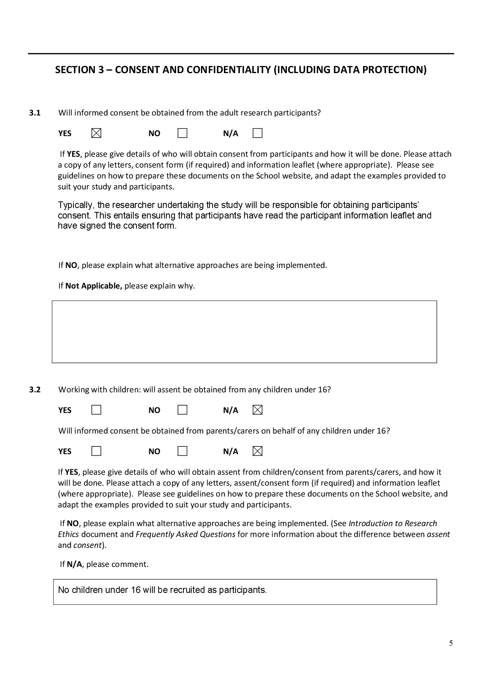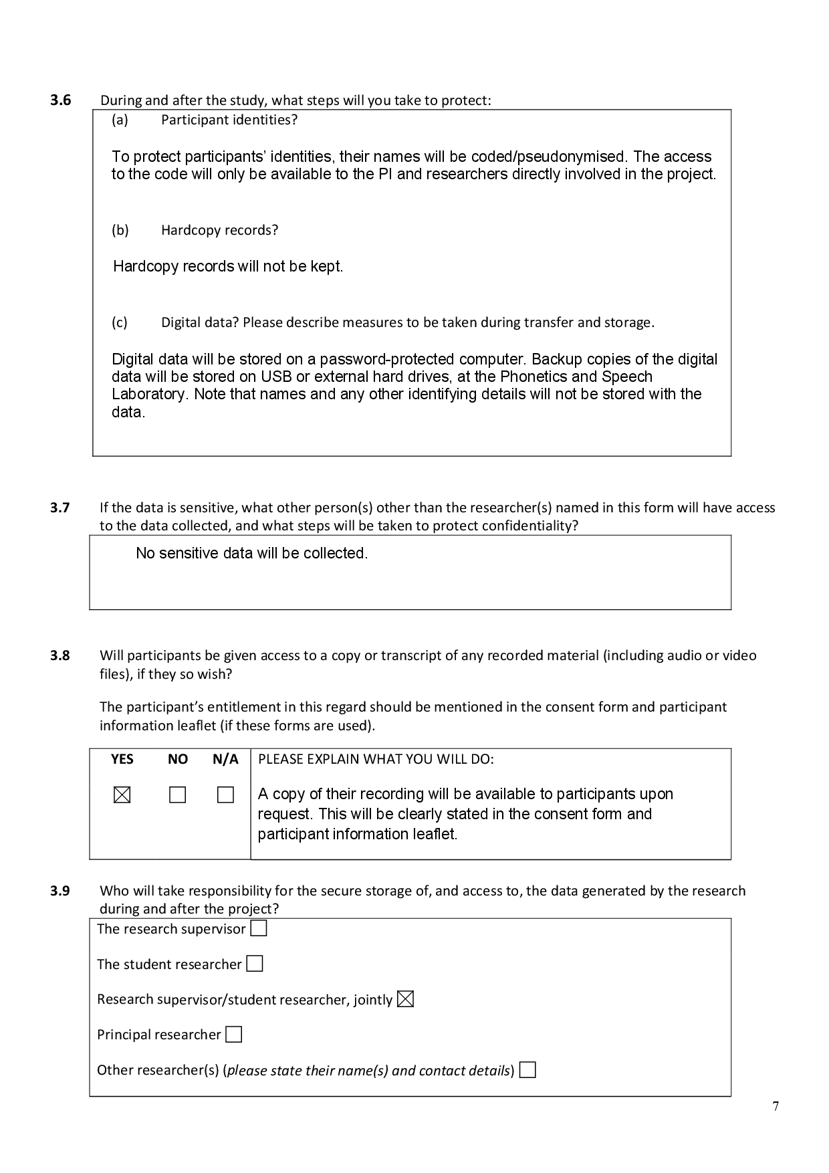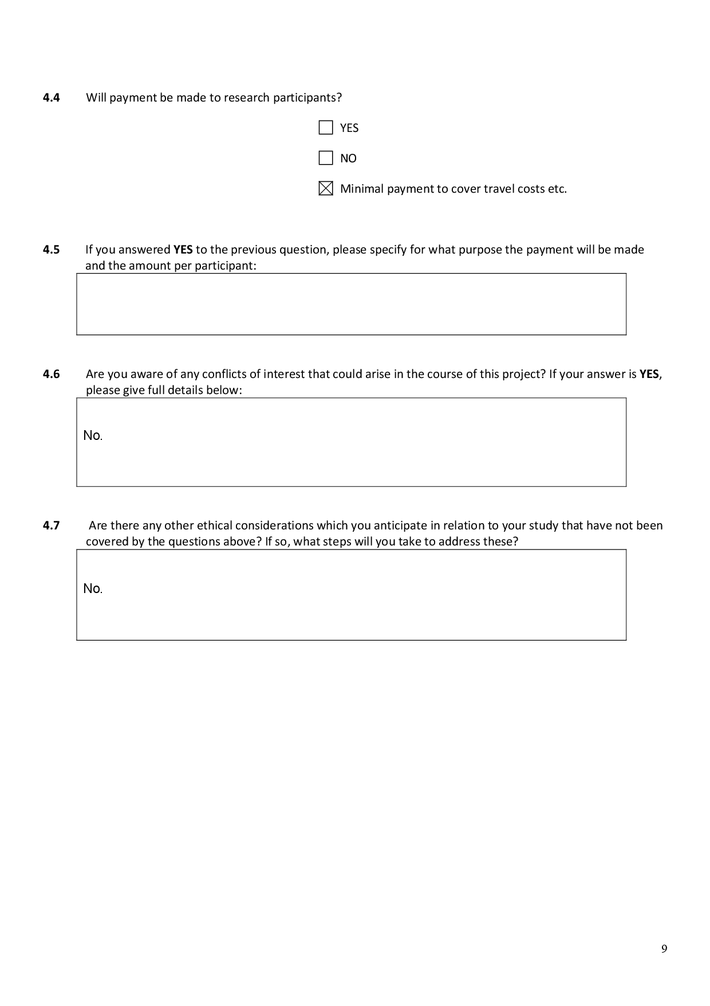

* 1. Participant Information Leaflet



* 1. Participant Consent Form



1. Corpus Stimuli
   1. Read Speech Tasks
   2. Picture Prompts
   3. Nonsense Sentence prompts
2. BAAP2018 Poster Presentation (Rodgers, 2018)



1. AERodgers GitHub PhD Repository Structure

<https://github.com/AERodgers/PhD>

│

├───1_Praat_scripts

│ ├───2017-2018 TextGrid Scripts

│ |

│ ├───plugin_AERoPlot

│ │ ├───example

│ │ └───plotScripts

│ ├───plugin_KMax

│ │ ├───example

│ │ │ ├───backup

│ │ │ ├───image

│ │ │ ├───manipulation

│ │ │ ├───output

│ │ │ ├───pitch

│ │ │ └───resynth

│ │ ├───Functions

│ │ │ ├───contourProcessing

│ │ │ ├───graphical

│ │ │ │ └───c3Pogram

│ │ │ ├───management

│ │ │ ├───maths

│ │ │ └───phonoTierGeneration

│ │ └───subroutines

│ └───plugin_PHD

│ └───procs

│

├───2_R_Functions

│

├───3_Recordings

│ |

│ ├───Analysis_1_standard

│ │ ├───F12

│ │ │ ├───alignment and H_Placement

│ │ │ │ └───pitch

│ │ │ └───sentence_modes

│ │ │ └───pitch

│ │ ├───F15

│ │ │ ├───alignment and H_Placement

│ │ . │ └───pitch

│ │ . └───sentence_modes

│ | .

│ │ └───M9

│ │ ├───alignment and H_Placement

│ │ │ └───pitch

│ │ └───sentence_modes

│ │ └───pitch

│ │

│ └───Analysis_2_STH

│

├───4_Data

│

├───5_Analysis_of_form

│ ├───1_output

│ ├───2_output

│ ├───3_output

│ ├───4_pn_output

│ └───5_nuc_output

│

├───6_Analysis_of_sentence_mode

│ ├───1. Phonology and Mode

│ ├───2. Utterance and phonetic params

│ ├───3. Mode and phonetic params

│ ├───4. Mode and Nuc PA phonetic params

│ ├───output

│ └───output_model_anovas

│

└───7_Analysis_with_STH

├───1_PN_peak_alignment

├───2_PN_plateaux

├───3_Nuc_alignment

└───4_Downstep

1. A-Corpus, Summary of Raw Counts
   * 1. PN pitch accents by number of syllables in the foot (foot_syls) in pn_foot subcorpus.

|  |  |  |  |  |  |
| --- | --- | --- | --- | --- | --- |
| foot_syls | (*) | L* | H* | >H* | L*H |
| 1 | 9 | 5 | 19 | 2 | 20 |
| 2 | 2 | 2 | 21 | 3 | 27 |
| 3 | 1 | 0 | 13 | 6 | 35 |
| 4 | 0 | 0 | 0 | 3 | 35 |
|  |  |  |  |  |  |

* + 1. PN pitch accents by syllables of anacrusis (ana_syls) in pn_ana subcorpus.

|  |  |  |  |
| --- | --- | --- | --- |
| ana_syls | H* | >H* | L*H |
| 0 | 0 | 3 | 35 |
| 1 | 9 | 5 | 42 |
| 2 | 0 | 4 | 52 |
| 3 | 0 | 4 | 51 |
|  |  |  |  |

* + 1. Prenuclear pitch accents by speaker.

|  |  |  |  |  |  |
| --- | --- | --- | --- | --- | --- |
| **speaker** | **(*)** | **L\*** | **H\*** | **>H\*** | **L*H** |
| F5 | 4 | 0 | 5 | 2 | 24 |
| F6 | 3 | 0 | 0 | 1 | 31 |
| F12 | 0 | 1 | 0 | 0 | 32 |
| F15 | 0 | 0 | 2 | 2 | 32 |
| F16 | 0 | 0 | 0 | 0 | 35 |
| F17 | 1 | 6 | 0 | 0 | 25 |
| M4 | 4 | 0 | 10 | 4 | 13 |
| M5 | 0 | 0 | 17 | 0 | 18 |
| M8 | 0 | 0 | 2 | 9 | 22 |
| M9 | 0 | 0 | 20 | 8 | 2 |
| M10 | 0 | 0 | 6 | 1 | 28 |
|  |  |  |  |  |  |

* + 1. Nuclear contours by syllables in the foot (foot_syls) in nuc_foot subcorpus.

|  |  |  |
| --- | --- | --- |
| foot_syls | L*H % | L*H L% |
| 1 | 50 | 1 |
| 2 | 55 | 0 |
| 3 | 30 | 5 |
| 4 | 52 | 3 |
|  |  |  |

* + 1. Nuclear PAs by preceding unstressed syllables (pre_syls) in nuc_pre subcorpus.

|  |  |  |
| --- | --- | --- |
| pre_syls | L*H % | L*H L% |
| 0 | 50 | 4 |
| 1 | 55 | 0 |
| 2 | 55 | 0 |
| 3 | 37 | 1 |
|  |  |  |

* + 1. Nuclear contours by speaker.

|  |  |  |
| --- | --- | --- |
| speaker | L*H % | L*H L% |
| F5 | 34 | 0 |
| F6 | 35 | 0 |
| F12 | 23 | 10 |
| F15 | 30 | 0 |
| F16 | 35 | 0 |
| F17 | 28 | 0 |
| M4 | 31 | 0 |
| M5 | 33 | 0 |
| M8 | 21 | 3 |
| M9 | 25 | 1 |
| M10 | 34 | 0 |
|  |  |  |

1. Syllable-normalised and Grand Mean-syllable Normalised Time
   1. Calculating syllable-normalised time

Syllable normalised time is calculated in two stages.

1. The timing of each target is converted to a ratio of the syllable in which it occurred. This is shown in Equation F1.1, where *t* refers to time while *on* and *off* refer to the onset and offset of the target syllable.

|  |  |
| --- | --- |
| $${ratio}_{target}= \frac{t_{target}- t_{on}}{t_{off}- t_{on}}$$ | (F1.1) |

1. ${ratio}_{target}$ is converted to an utterance-wide value by adding the number of the syllable in which the target occurred and subtracting it by one, as shown in Equation 8. Here, *t.syl.norm* refers to the syllable-normalised time while $n_{syl}$ refers to the number of the syllable containing the target, shown here in Equation F1.2.

|  |  |
| --- | --- |
|  | (F1.) |

In this way, the value on the left of the decimal point is the number of complete syllables while the number on its right is a proportion of the current syllable.

To calculate syllable-normalised time in the first foot, the number of syllables in anacrusis is subtracted from .

* 1. Calculating grand syllable-normalised time

Grand syllable-mean normalised time requires that the grand mean duration of each syllable in a target utterance must first be calculated from each repetition in the corpus. Each repetition used in the calculation must be of the same target phrase and use the same meter.

Once the grand-mean duration of each syllable in the target is calculated, each target time can be converted to grand syllable-mean normalised time. This is achieved by multiplying by grand-mean duration of the syllable in which the target occurs and adding it the sum of all preceding grand-mean-syllable durations. This is summarised in Equation F1.3. Here, ${t.GM}_{target}$ is the grand mean-normalised time of the target, $n_{syl}$ is number of the syllable containing the target, and $\overline{dur}$ is mean duration of a syllable.

|  |  |
| --- | --- |
| $${t.GM}_{target}=\sum_{n = 0}^{n_{syl}-1}{{\overline{dur}}_{n}}+{ratio}_{target}×{\overline{dur}}_{n_{syl}}$$ | (F1.3) |

1. BGLMM Models for PN Phonology in A- and H-Corpora.
   1. Likelihood of L*H (isLH) in PNs in A- and H-Corpora.
      1. Summary of model testing likelihood of PN L*H.

Cov prior : foot_dur ~ wishart(df = 3.5, scale = Inf, posterior.scale = cov, common.scale = TRUE)

: nuc_pre_text ~ wishart(df = 3.5, scale = Inf, posterior.scale = cov, common.scale = TRUE)

: speaker ~ wishart(df = 3.5, scale = Inf, posterior.scale = cov, common.scale = TRUE)

: pn_str_syl ~ wishart(df = 3.5, scale = Inf, posterior.scale = cov, common.scale = TRUE)

: ana_text ~ wishart(df = 3.5, scale = Inf, posterior.scale = cov, common.scale = TRUE) Prior dev : 40.0403

Generalised linear mixed model fit by maximum likelihood (Laplace

Approximation) [bglmerMod]

Family: binomial ( logit )

Formula: isLH ~ foot_syls + wrd_end_syl + speech_rate + gender + (1 |

ana_text) + (1 | nuc_pre_text) + (1 | pn_str_syl) + (1 |

speaker) + (1 | foot_dur)

Data: pn

Control: glmerControl(optimizer = "bobyqa")

AIC BIC logLik deviance df.resid

567.9 628.6 -271.0 541.9 775

Scaled residuals:

Min 1Q Median 3Q Max

-4.2870 -0.2641 0.0966 0.3050 10.4705

Random effects:

Groups Name Variance Std.Dev.

foot_dur (Intercept) 0.2922 0.5406

nuc_pre_text (Intercept) 0.1254 0.3541

speaker (Intercept) 3.4428 1.8555

pn_str_syl (Intercept) 0.2110 0.4593

ana_text (Intercept) 7.2906 2.7001

Number of obs: 788, groups:

foot_dur, 419; nuc_pre_text, 12; speaker, 11; pn_str_syl, 8; ana_text, 7

Fixed effects:

Estimate Std. Error z value Pr(>|z|)

(Intercept) 4.6524 1.8536 2.510 0.012076 *

foot_syls2 1.1062 0.7149 1.547 0.121764

foot_syls3 2.4144 0.7217 3.346 0.000821 ***

foot_syls4 2.5151 0.9089 2.767 0.005656 **

wrd_end_syl2 2.6426 0.6171 4.282 1.85e-05 ***

wrd_end_syl3 2.9584 1.0445 2.832 0.004619 **

speech_rate -1.0070 0.2597 -3.878 0.000105 ***

genderM -1.5951 1.0607 -1.504 0.132647

---

Signif. codes: 0 '***' 0.001 '**' 0.01 '*' 0.05 '.' 0.1 ' ' 1

* + 1. ANOVA of model of PN L*H likelihood.

|  |  |  |  |  |  |  |
| --- | --- | --- | --- | --- | --- | --- |
| factor | npar | AIC | LRT | Pr(Chi) | p.adj (BH) | signif. |
| foot_syls | 3 | 575.27 | 13.36 | .004 | .006 | *p* < .05 |
| wrd_end_syl | 2 | 579.03 | 15.12 | <.001 | .001 | *p* < .05 |
| speech_rate | 1 | 582.01 | 16.1 | <.001 | <.001 | *p* < .05 |
| gender | 1 | 568.78 | 2.86 | .091 | .104 |  |
|  |  |  |  |  |  |  |

* + 1. R2 of PN L*H likelihood model.

|  |  |
| --- | --- |
| R2_conditional | R2_marginal |
| .83 | .25 |
|  |  |

* + 1. Predicted likelihood of PN L*H as an effect of foot_syls.

|  |  |  |  |  |
| --- | --- | --- | --- | --- |
| foot_syls | predicted | conf.low | conf.high | std.error |
| 1 | 0.22 | 0.02 | 0.82 | 1.41 |
| 2 | 0.46 | 0.06 | 0.92 | 1.33 |
| 3 | 0.76 | 0.18 | 0.98 | 1.36 |
| 4 | 0.78 | 0.17 | 0.98 | 1.45 |
|  |  |  |  |  |

* + 1. Predicted likelihood of PN L*H as an *effect of wrd_end_syl.*

|  |  |  |  |  |
| --- | --- | --- | --- | --- |
| wrd_end_syl | predicted | conf.low | conf.high | std.error |
| 1 | 0.22 | 0.02 | 0.82 | 1.41 |
| 2 | 0.8 | 0.17 | 0.99 | 1.49 |
| 3 | 0.84 | 0.16 | 0.99 | 1.71 |
|  |  |  |  |  |

* + 1. Predicted likelihood of PN L*H as an effect of speech_rate.

|  |  |  |  |  |
| --- | --- | --- | --- | --- |
| speech_rate | predicted | conf.low | conf.high | std.error |
| 2 | 0.93 | 0.4 | 1 | 1.56 |
| 3 | 0.84 | 0.23 | 0.99 | 1.45 |
| 4 | 0.65 | 0.11 | 0.97 | 1.39 |
| 5 | 0.41 | 0.04 | 0.91 | 1.38 |
| 6 | 0.2 | 0.02 | 0.8 | 1.42 |
| 7 | 0.08 | 4.8e-03 | 0.63 | 1.5 |
| 8 | 0.03 | 1.4e-03 | 0.44 | 1.61 |
| 9 | 0.01 | 3.8e-04 | 0.28 | 1.76 |
| 10 | 4.4e-03 | 1.0e-04 | 0.16 | 1.94 |
|  |  |  |  |  |

* + 1. Predicted likelihood of PN L*H as an effect of gender.

|  |  |  |  |  |
| --- | --- | --- | --- | --- |
| gender | predicted | conf.low | conf.high | std.error |
| F | 0.22 | 0.02 | 0.82 | 1.41 |
| M | 0.05 | 3.4e-03 | 0.49 | 1.44 |
|  |  |  |  |  |

* + 1. Estimated intercepts of each level of each factor (b0) re likelihood of PN L*H (odds ratio).

|  |  |  |  |  |  |  |
| --- | --- | --- | --- | --- | --- | --- |
| intercept | estimate | conf.low | conf.high | std.error | z.value | p.value |
| foot_syls1 | 104.8 | 2.772 | 3965.9 | 194.34 | 2.51 | 0.012 |
| foot_syls2 | 483.5 | 8.266 | 28275.4 | 1003.63 | 2.98 | 0.003 |
| foot_syls3 | 1462.5 | 24.5 | 87197.7 | 3050.37 | 3.49 | < .001 |
| foot_syls4 | 1354.1 | 19.8 | 92840 | 2920.92 | 3.34 | < .001 |
| wrd_end_syl1 | 104.8 | 2.772 | 3965.9 | 194.34 | 2.51 | 0.012 |
| wrd_end_syl2 | 1746.7 | 36.4 | 83789.6 | 3449.38 | 3.78 | < .001 |
| wrd_end_syl3 | 1895.9 | 26.6 | 1.4e+05 | 4127.88 | 3.47 | < .001 |
|  |  |  |  |  |  |  |
|  |  |  |  |  |  |  |

* + 1. Pairwise comparisons of each level of each factor (b1) re likelihood of PN L*H (odds ratio).

|  |  |  |  |  |  |  |  |
| --- | --- | --- | --- | --- | --- | --- | --- |
| intercept | slope | estimate | conf.low | conf.high | std.error | z.value | p.value |
| foot_syls1 | foot_syls2 | 3.02 | 0.745 | 12.3 | 2.16 | 1.55 | 0.122 |
| foot_syls1 | foot_syls3 | 11.2 | 2.718 | 46 | 8.07 | 3.35 | < .001 |
| foot_syls1 | foot_syls4 | 12.4 | 2.083 | 73.4 | 11.24 | 2.77 | 0.006 |
| foot_syls2 | foot_syls3 | 3.7 | 1.128 | 12.2 | 2.25 | 2.16 | 0.031 |
| foot_syls2 | foot_syls4 | 4.42 | 0.9 | 21.7 | 3.58 | 1.83 | 0.067 |
| foot_syls3 | foot_syls4 | 1.34 | 0.335 | 5.334 | 0.94 | 0.41 | 0.681 |
| wrd_end_syl1 | wrd_end_syl2 | 14.1 | 4.192 | 47.1 | 8.67 | 4.28 | < .001 |
| wrd_end_syl1 | wrd_end_syl3 | 19.3 | 2.487 | 149.2 | 20.12 | 2.83 | 0.005 |
| wrd_end_syl2 | wrd_end_syl3 | 1.93 | 0.34 | 11 | 1.71 | 0.74 | 0.458 |
| intercept | speech_rate | 0.367 | 0.22 | 0.611 | 0.1 | -3.85 | < .001 |
| intercept | genderM | 0.204 | 0.025 | 1.654 | 0.21 | -1.49 | 0.137 |
|  |  |  |  |  |  |  |  |

* 1. Likelihood of H* (isHStar) in PNs in A- and H-Corpora.
     1. Summary of model testing likelihood of PN H*.

Cov prior : foot_dur ~ wishart(df = 3.5, scale = Inf, posterior.scale = cov, common.scale = TRUE)

: speaker ~ wishart(df = 3.5, scale = Inf, posterior.scale = cov, common.scale = TRUE)

: pn_str_syl ~ wishart(df = 3.5, scale = Inf, posterior.scale = cov, common.scale = TRUE)

Fixef prior: normal(sd = c(10, 2.5, ...), corr = c(0 ...), common.scale = FALSE)

Prior dev : 38.096

Generalised linear mixed model fit by maximum likelihood (Laplace

Approximation) [bglmerMod]

Family: binomial ( logit )

Formula: isHStar ~ foot_syls + wrd_end_syl + speech_rate + gender + (1 |

pn_str_syl) + (1 | speaker) + (1 | foot_dur)

Data: pn

Control: glmerControl(optimizer = "bobyqa")

AIC BIC logLik deviance df.resid

518.1 569.5 -248.1 496.1 777

Scaled residuals:

Min 1Q Median 3Q Max

-4.1269 -0.2801 -0.1015 0.0698 3.4829

Random effects:

Groups Name Variance Std.Dev.

foot_dur (Intercept) 0.7346 0.8571

speaker (Intercept) 2.4348 1.5604

pn_str_syl (Intercept) 0.3177 0.5637

Number of obs: 788, groups: foot_dur, 419; speaker, 11; pn_str_syl, 8

Fixed effects:

Estimate Std. Error z value Pr(>|z|)

(Intercept) -2.1577 1.1583 -1.863 0.06248 .

foot_syls2 0.5475 0.5114 1.071 0.28436

foot_syls3 -1.1537 0.5435 -2.123 0.03377 *

foot_syls4 -1.8376 0.8625 -2.131 0.03312 *

wrd_end_syl2 -2.9156 0.6279 -4.644 3.42e-06 ***

wrd_end_syl3 -3.4096 1.3421 -2.540 0.01107 *

speech_rate 0.1416 0.1886 0.750 0.45300

genderM 2.5507 0.9434 2.704 0.00686 **

---

Signif. codes: 0 '***' 0.001 '**' 0.01 '*' 0.05 '.' 0.1 ' ' 1

* + 1. ANOVA of model testing likelihood of PN H*.

|  |  |  |  |  |  |  |
| --- | --- | --- | --- | --- | --- | --- |
| factor | npar | AIC | LRT | Pr(Chi) | p.adj (BH) | signif. |
| foot_syls | 3 | 526.11 | 13.99 | .003 | .006 |  |
| wrd_end_syl | 2 | 545.71 | 31.59 | < .001 | < .001 | *p* <.05 |
| speech_rate | 1 | 516.86 | 0.74 | .391 | .391 |  |
| gender | 1 | 523.5 | 7.38 | .007 | .009 | *p* < .05 |
|  |  |  |  |  |  |  |

* + 1. R2 of PN H* likelihood model.

|  |  |
| --- | --- |
| R2_conditional | R2_marginal |
| .76 | .51 |
|  |  |

* + 1. Predicted likelihood of PN H* as an effect of foot_syls.

|  |  |  |  |  |
| --- | --- | --- | --- | --- |
| foot_syls | predicted | conf.low | conf.high | std.error |
| 1 | 0.21 | 0.05 | 0.56 | 0.81 |
| 2 | 0.31 | 0.1 | 0.65 | 0.72 |
| 3 | 0.08 | 0.02 | 0.28 | 0.79 |
| 4 | 0.04 | 5.8e-03 | 0.23 | 1.01 |
|  |  |  |  |  |

* + 1. Predicted likelihood of PN H* as an effect wrd_end_syl.

|  |  |  |  |  |
| --- | --- | --- | --- | --- |
| wrd_end_syl | predicted | conf.low | conf.high | std.error |
| 1 | 0.21 | 0.05 | 0.56 | 0.81 |
| 2 | 0.01 | 2.0e-03 | 0.09 | 1 |
| 3 | 8.7e-03 | 4.1e-04 | 0.16 | 1.57 |
|  |  |  |  |  |

* + 1. Predicted likelihood of PN H* as an effect of speech_rate.

|  |  |  |  |  |
| --- | --- | --- | --- | --- |
| speech_rate | predicted | conf.low | conf.high | std.error |
| 2 | 0.13 | 0.03 | 0.48 | 0.91 |
| 3 | 0.15 | 0.03 | 0.47 | 0.83 |
| 4 | 0.17 | 0.04 | 0.48 | 0.78 |
| 5 | 0.19 | 0.05 | 0.52 | 0.77 |
| 6 | 0.21 | 0.05 | 0.57 | 0.81 |
| 7 | 0.24 | 0.05 | 0.64 | 0.89 |
| 8 | 0.26 | 0.05 | 0.72 | 1 |
| 9 | 0.29 | 0.04 | 0.79 | 1.13 |
| 10 | 0.32 | 0.04 | 0.85 | 1.28 |
|  |  |  |  |  |

* + 1. Predicted likelihood of PN H* as an effect of gender.

|  |  |  |  |  |
| --- | --- | --- | --- | --- |
| gender | predicted | conf.low | conf.high | std.error |
| F | 0.21 | 0.05 | 0.56 | 0.81 |
| M | 0.77 | 0.4 | 0.94 | 0.82 |
|  |  |  |  |  |

* + 1. Estimated intercepts of each level of each factor (b0) re likelihood of PN H* (odds ratio).

|  |  |  |  |  |  |  |
| --- | --- | --- | --- | --- | --- | --- |
| intercept | estimate | conf.low | conf.high | std.error | z.value | p.value |
| foot_syls1 | 0.12 | 0.012 | 1.119 | 0.13 | -1.86 | .062 |
| foot_syls2 | 0.17 | 0.013 | 2.281 | 0.23 | -1.34 | .181 |
| foot_syls3 | 0.04 | 0.002 | 0.497 | 0.05 | -2.48 | .013 |
| foot_syls4 | 0.02 | 0.001 | 0.471 | 0.04 | -2.46 | .014 |
| wrd_end_syl1 | 0.12 | 0.012 | 1.119 | 0.13 | -1.86 | .062 |
| wrd_end_syl2 | 0.01 | 4.1e-04 | 0.076 | 0.01 | -3.90 | < .001 |
| wrd_end_syl3 | 0 | 0.002 | 0.002 | 0.00 | -3607.79 | < .001 |
|  |  |  |  |  |  |  |

* + 1. Pairwise comparisons of each level of each factor (b1) re likelihood of PN H* (odds ratio).

|  |  |  |  |  |  |  |  |
| --- | --- | --- | --- | --- | --- | --- | --- |
| intercept | slope | estimate | conf.low | conf.high | std.error | z.value | p.value |
| foot_syls1 | foot_syls2 | 1.73 | 0.635 | 4.711 | 0.88 | 1.07 | 0.284 |
| foot_syls1 | foot_syls3 | 0.32 | 0.109 | 0.915 | 0.17 | -2.12 | 0.034 |
| foot_syls1 | foot_syls4 | 0.16 | 0.029 | 0.863 | 0.14 | -2.13 | 0.033 |
| foot_syls2 | foot_syls3 | 0.2 | 0.075 | 0.522 | 0.10 | -3.28 | 0.001 |
| foot_syls2 | foot_syls4 | 0.1 | 0.021 | 0.501 | 0.08 | -2.81 | 0.005 |
| foot_syls3 | foot_syls4 | 0.46 | 0.113 | 1.853 | 0.33 | -1.1 | 0.273 |
| wrd_end_syl1 | wrd_end_syl2 | 0.05 | 0.016 | 0.185 | 0.03 | -4.64 | < .001 |
| wrd_end_syl1 | wrd_end_syl3 | 0.03 | 0.002 | 0.459 | 0.04 | -2.54 | 0.011 |
| wrd_end_syl2 | wrd_end_syl3 | 0.23 | 0.009 | 5.83 | 0.38 | -0.89 | 0.376 |
| intercept | speech_rate | 1.265 | 1.261 | 1.269 | 0.002 | 140.90 | < .001 |
| intercept | genderM | 13.4 | 13.4 | 13.5 | 0.022 | 1556.47 | < .001 |
|  |  |  |  |  |  |  |  |

1. LMEMs of PN Phonetic Parameters in A- and H-Corpora
   1. Effect sizes (partial omega-squared) of fixed effects on PN pitch accents.
      1. Effect size ($ω_{p}^{2}$) of each lexical and metrical fixed effect in PN tonal target LME models.

|  |  |  |  |  |  |  |  |  |
| --- | --- | --- | --- | --- | --- | --- | --- | --- |
|  | l_t | | l_f0 | | h_t | | h_f0 | |
| **Parameter** | $$ω_{p}^{2}$$ | **95% CI** | $$ω_{p}^{2}$$ | **95% CI** | $$ω_{p}^{2}$$ | **95% CI** | $$ω_{p}^{2}$$ | **95% CI** |
| acc_phon | .01 | [0, .04] | .00 | [0, .04] | .43 | [.36, .49] | 0 | [0, 0] |
| ana_syls | .2 | [0, .49] | .07 | [.03, .12] | .76 | [.42, .87] | .35 | [0, .68] |
| foot_syls | .01 | [0, .02] | -.21 | [0, 0] | .52 | [.21, .68] | .25 | [0, .46] |
| wrd_end_syl | .04 | [.01, .09] | 0 | [0, 0] | -.01 | [0, 0] | -.05 | [0, 0] |
| pn_new_word | -.1 | [0, 0] | .02 | [0, .05] | -.02 | [0, 0] | .1 | [0, .66] |
| gender | .89 | [.69, .95] | .59 | [.01, .83] | .17 | [0, .54] | .77 | [.38, .89] |
|  |  |  |  |  |  |  |  |  |

* 1. Temporal Alignment of L Target (l_t) in PN Pitch Accents
     1. Summary of PN l_t model.

Formula:

l_t ~ acc_phon + ana_syls + foot_syls + wrd_end_syl + pn_new_word + gender + (1 | speaker) + (1 | pn_str_syl)

Linear mixed model fit by REML. t-tests use Satterthwaite's method ['lmerModLmerTest']

Formula: l_t_equation

Data: pn_l_t_data.trimmed

Control: lmerControl(optimizer = optimizer, calc.derivs = FALSE, optCtrl = list(method = "nlminb", starttests = FALSE, kkt = FALSE))

REML criterion at convergence: 4481.8

Scaled residuals:

Min 1Q Median 3Q Max

-3.2322 -0.5633 0.0551 0.6304 2.7388

Random effects:

Groups Name Variance Std.Dev.

speaker (Intercept) 112.6 10.61

pn_str_syl (Intercept) 1396.5 37.37

Residual 627.9 25.06

Number of obs: 486, groups: speaker, 11; pn_str_syl, 8

Fixed effects:

Estimate Std. Error df t value Pr(>|t|)

(Intercept) 46.205 18.135 11.746 2.548 0.0259 *

acc_phonL* 24.379 9.659 471.180 2.524 0.0119 *

ana_syls1 -32.515 41.203 5.458 -0.789 0.4629

ana_syls2 -31.099 41.265 5.518 -0.754 0.4820

ana_syls3 -20.607 41.304 5.536 -0.499 0.6370

foot_syls2 1.519 6.944 457.231 0.219 0.8270

foot_syls3 6.501 6.841 465.647 0.950 0.3425

foot_syls4 18.287 8.530 453.503 2.144 0.0326 *

wrd_end_syl2 23.556 5.715 456.381 4.122 4.46e-05 ***

wrd_end_syl3 14.533 12.585 312.103 1.155 0.2491

pn_new_wordTRUE 23.163 40.540 5.204 0.571 0.5915

genderM -70.145 7.005 9.774 -10.013 1.88e-06 ***

---

Signif. codes: 0 ‘***’ 0.001 ‘**’ 0.01 ‘*’ 0.05 ‘.’ 0.1 ‘ ’ 1

* + 1. ANOVA of PN l_t model.

|  |  |  |  |  |  |  |  |  |
| --- | --- | --- | --- | --- | --- | --- | --- | --- |
| term | sumsq | meansq | NumDF | DenDF | F value | p.value | p.adj (BH) | signif. |
| acc_phon | 4000 | 4000 | 1 | 471.18 | 6.37 | .012 | .023 | *p < .*05 |
| ana_syls | 4447 | 1482 | 3 | 12.19 | 2.36 | .122 | .184 |  |
| foot_syls | 3980 | 1327 | 3 | 453.9 | 2.11 | .098 | .161 |  |
| wrd_end_syl | 11103 | 5552 | 2 | 350.73 | 8.84 | <.001 | <.001 | *p < .*05 |
| pn_new_word | 204.99 | 204.99 | 1 | 5.2 | 0.33 | .592 | .630 |  |
| gender | 62954 | 62954 | 1 | 9.77 | 100.26 | <.001 | <.001 | *p < .*05 |
|  |  |  |  |  |  |  |  |  |

* + 1. R2 of PN l_t model.

|  |  |
| --- | --- |
| R2_conditional | R2_marginal |
| .83 | .42 |
|  |  |

* + 1. Predicted values of PN l_t re acc_phon (ms).

|  |  |  |  |  |
| --- | --- | --- | --- | --- |
| acc_phon | predicted | conf.low | conf.high | std.error |
| L*H | 46.2 | 10.66 | 81.75 | 18.14 |
| L* | 70.58 | 32.21 | 108.95 | 19.58 |
|  |  |  |  |  |

* + 1. Predicted values of PN l_t re ana_syls (ms).

|  |  |  |  |  |
| --- | --- | --- | --- | --- |
| ana_syls | predicted | conf.low | conf.high | std.error |
| 0 | 46.2 | 10.66 | 81.75 | 18.14 |
| 1 | 13.69 | -61.78 | 89.16 | 38.51 |
| 2 | 15.11 | -61.12 | 91.33 | 38.89 |
| 3 | 25.6 | -50.63 | 101.82 | 38.89 |
|  |  |  |  |  |

* + 1. Predicted values of PN l_t re foot_syls (ms).

|  |  |  |  |  |
| --- | --- | --- | --- | --- |
| foot_syls | predicted | conf.low | conf.high | std.error |
| 1 | 46.2 | 10.66 | 81.75 | 18.14 |
| 2 | 47.72 | 13.05 | 82.4 | 17.69 |
| 3 | 52.71 | 18.08 | 87.33 | 17.67 |
| 4 | 64.49 | 29.08 | 99.9 | 18.07 |
|  |  |  |  |  |

* + 1. Predicted values of PN l_t re wrd_end_syl (ms).

|  |  |  |  |  |
| --- | --- | --- | --- | --- |
| wrd_end_syl | predicted | conf.low | conf.high | std.error |
| 1 | 46.2 | 10.66 | 81.75 | 18.14 |
| 2 | 69.76 | 33.57 | 105.96 | 18.47 |
| 3 | 60.74 | 26.9 | 94.58 | 17.27 |
|  |  |  |  |  |

* + 1. Predicted values of PN l_t re pn_new_wrd (ms).

|  |  |  |  |  |  |
| --- | --- | --- | --- | --- | --- |
| pn_new_word | predicted | conf.low | conf.high |  | std.error |
| FALSE | 46.2 | 10.66 | 81.75 |  | 18.14 |
| TRUE | 69.37 | -24.87 | 163.6 |  | 48.08 |
|  |  |  |  |  |  |

* + 1. Predicted values of PN l_t re gender (ms).

|  |  |  |  |  |
| --- | --- | --- | --- | --- |
| gender | predicted | conf.low | conf.high | std.error |
| F | 46.2 | 10.66 | 81.75 | 18.14 |
| M | -23.94 | -59.95 | 12.07 | 18.37 |
|  |  |  |  |  |

* + 1. Pairwise comparison of effects of levels of fixed effects (b1) on PN l_t (ms).

|  |  |  |  |  |  |  |  |  |
| --- | --- | --- | --- | --- | --- | --- | --- | --- |
| Intercept | slope | estimate | conf.low | conf.high | std.error | t.value | df | p.value |
| ana_syls0 | ana_syls1 | -32.5 | -135.8 | 70.8 | 41.20 | -0.79 | 5.46 | .463 |
| ana_syls0 | ana_syls2 | -31.1 | -134.2 | 72 | 41.26 | -0.75 | 5.52 | .482 |
| ana_syls0 | ana_syls3 | -20.6 | -123.8 | 82.5 | 41.30 | -0.5 | 5.54 | .637 |
| ana_syls1 | ana_syls2 | 1.42 | -8.91 | 11.7 | 5.25 | 0.27 | 466.33 | .788 |
| ana_syls1 | ana_syls3 | 11.9 | 1.57 | 22.3 | 5.26 | 2.26 | 466.47 | .024 |
| ana_syls2 | ana_syls3 | 10.5 | 0.78 | 20.2 | 4.94 | 2.12 | 459.49 | .034 |
| foot_syls1 | foot_syls2 | 1.52 | -12.1 | 15.2 | 6.94 | 0.22 | 457.23 | .827 |
| foot_syls1 | foot_syls3 | 6.5 | -6.94 | 19.9 | 6.84 | 0.95 | 465.65 | .342 |
| foot_syls1 | foot_syls4 | 18.3 | 1.52 | 35.1 | 8.53 | 2.14 | 453.50 | .033 |
| foot_syls2 | foot_syls3 | 4.98 | -7.46 | 17.4 | 6.32 | 0.79 | 458.11 | .431 |
| foot_syls2 | foot_syls4 | 16.8 | 0.833 | 32.7 | 8.11 | 2.07 | 437.12 | .039 |
| foot_syls3 | foot_syls4 | 11.8 | 1.63 | 21.9 | 5.17 | 2.28 | 466.10 | .023 |
| wrd_end_syl1 | wrd_end_syl2 | 23.6 | 12.3 | 34.8 | 5.71 | 4.12 | 456.38 | < .001 |
| wrd_end_syl1 | wrd_end_syl3 | 14.5 | -10.2 | 39.3 | 12.58 | 1.15 | 312.10 | .249 |
| wrd_end_syl2 | wrd_end_syl3 | -9.02 | -31 | 13 | 11.18 | -0.81 | 237.39 | .42 |
| intercept | acc_phonL* | 24.4 | 5.4 | 43.4 | 9.66 | 2.52 | 471.18 | .012 |
| intercept | pn_new_wordT | 23.2 | -79.8 | 126.2 | 40.54 | 0.57 | 5.20 | .592 |
| intercept | genderM | -70.1 | -85.8 | -54.5 | 7 | -10.01 | 9.77 | < .001 |
|  |  |  |  |  |  |  |  |  |

* 1. Temporal alignment of L target (l_f0) in PN pitch accents
     1. Summary of PN l_f0 model.

Formula:

l_f0 ~ acc_phon + ana_syls + foot_syls + wrd_end_syl + pn_new_word + gender + (1 + foot_syls | speaker)

Linear mixed model fit by REML. t-tests use Satterthwaite's method [

lmerModLmerTest]

Formula: l_f0 ~ acc_phon + ana_syls + foot_syls + wrd_end_syl + pn_new_word +

gender + (1 + foot_syls | speaker)

Data: pn_l_f0.trimmedControl:

lmerControl(optimizer = optimizer, calc.derivs = FALSE, optCtrl = list(method = "nlminb",

starttests = FALSE, kkt = FALSE))

REML criterion at convergence: 1597.9

Scaled residuals:

Min 1Q Median 3Q Max

-3.2154 -0.6221 -0.0179 0.5683 3.3374

Random effects:

Groups Name Variance Std.Dev. Corr

speaker (Intercept) 1.22694 1.1077

foot_syls2 0.06781 0.2604 -0.57

foot_syls3 0.86240 0.9287 -0.82 0.78

foot_syls4 0.78958 0.8886 -0.87 0.49 0.59

Residual 1.31776 1.1479

Number of obs: 496, groups: speaker, 11

Fixed effects:

Estimate Std. Error df t value Pr(>|t|)

(Intercept) -0.71571 0.43054 6.31720 -1.662 0.1450

acc_phonL* -0.62192 0.49554 157.29452 -1.255 0.2113

ana_syls1 0.87102 0.17983 450.04182 4.844 1.76e-06 ***

ana_syls2 0.19498 0.28433 452.76339 0.686 0.4932

ana_syls3 0.06817 0.28547 452.80563 0.239 0.8114

foot_syls2 -0.25526 0.25462 4.58383 -1.002 0.3660

foot_syls3 -0.16476 0.40027 8.76796 -0.412 0.6905

foot_syls4 -0.06302 0.40306 13.05163 -0.156 0.8781

wrd_end_syl2 -0.20359 0.18229 458.76717 -1.117 0.2646

wrd_end_syl3 -0.36455 0.28948 457.94374 -1.259 0.2085

pn_new_wordTRUE -0.73239 0.24798 459.69223 -2.953 0.0033 **

genderM 0.97467 0.27163 6.15808 3.588 0.0110 *

---

Signif. codes: 0 ‘***’ 0.001 ‘**’ 0.01 ‘*’ 0.05 ‘.’ 0.1 ‘ ’ 1

* + 1. ANOVA of PN l_f0 model.

|  |  |  |  |  |  |  |  |  |
| --- | --- | --- | --- | --- | --- | --- | --- | --- |
| term | sumsq | meansq | NumDF | DenDF | F value | p.value | p.adj (BH) | signif. |
| acc_phon | 2.08 | 2.08 | 1 | 157.29 | 1.57 | .211 | .303 |  |
| ana_syls | 51.26 | 17.09 | 3 | 451.06 | 12.97 | <.001 | <.001 | *p < .*05 |
| foot_syls | 1.44 | 0.48 | 3 | 7.02 | 0.36 | .781 | .806 |  |
| wrd_end_syl | 2.32 | 1.16 | 2 | 458.78 | 0.88 | .415 | .507 |  |
| pn_new_word | 11.49 | 11.49 | 1 | 459.69 | 8.72 | .003 | .008 | *p < .*01 |
| gender | 16.97 | 16.97 | 1 | 6.16 | 12.88 | .011 | .023 | *p < .*05 |
|  |  |  |  |  |  |  |  |  |

* + 1. R2 of PN l_f0 model.

|  |  |
| --- | --- |
| R2_conditional | R2_marginal |
| .41 | .19 |
|  |  |

* + 1. Predicted values of PN l_f0 re acc_phon (ST re speaker median).

|  |  |  |  |  |
| --- | --- | --- | --- | --- |
| acc_phon | predicted | conf.low | conf.high | std.error |
| L*H | -0.72 | -1.56 | 0.13 | 0.43 |
| L* | -1.34 | -2.54 | -0.14 | 0.61 |
|  |  |  |  |  |

* + 1. Predicted values of PN l_f0 re ana_syls (ST re speaker median).

|  |  |  |  |  |
| --- | --- | --- | --- | --- |
| ana_syls | predicted | conf.low | conf.high | std.error |
| 0 | -0.72 | -1.56 | 0.13 | 0.43 |
| 1 | 0.16 | -0.76 | 1.07 | 0.47 |
| 2 | -0.52 | -1.57 | 0.53 | 0.54 |
| 3 | -0.65 | -1.7 | 0.41 | 0.54 |
|  |  |  |  |  |

* + 1. Predicted values of PN l_f0 re foot_syls (ST re speaker median).

|  |  |  |  |  |
| --- | --- | --- | --- | --- |
| foot_syls | predicted | conf.low | conf.high | std.error |
| 1 | -0.72 | -1.56 | 0.13 | 0.43 |
| 2 | -0.97 | -1.73 | -0.21 | 0.39 |
| 3 | -0.88 | -1.43 | -0.33 | 0.28 |
| 4 | -0.78 | -1.38 | -0.18 | 0.3 |
|  |  |  |  |  |

* + 1. Predicted values of PN l_f0 re wrd_end_syl (ST re speaker median).

|  |  |  |  |  |
| --- | --- | --- | --- | --- |
| wrd_end_syl | predicted | conf.low | conf.high | std.error |
| 1 | -0.72 | -1.56 | 0.13 | 0.43 |
| 2 | -0.92 | -1.84 | -2.5e-03 | 0.47 |
| 3 | -1.08 | -2.07 | -0.09 | 0.51 |
|  |  |  |  |  |

* + 1. Predicted values of PN l_f0 re pn_new_wrd (ST re speaker median).

|  |  |  |  |  |
| --- | --- | --- | --- | --- |
| pn_new_word | predicted | conf.low | conf.high | std.error |
| FALSE | -0.72 | -1.56 | 0.13 | 0.43 |
| TRUE | -1.45 | -2.35 | -0.55 | 0.46 |
|  |  |  |  |  |

* + 1. Predicted values of PN l_f0 re gender (ST re speaker median).

|  |  |  |  |  |
| --- | --- | --- | --- | --- |
| gender | predicted | conf.low | conf.high | std.error |
| F | -0.72 | -1.56 | 0.13 | 0.43 |
| M | 0.26 | -0.59 | 1.11 | 0.43 |
|  |  |  |  |  |

* + 1. Pairwise comparison of effects of levels of fixed effects (b1) on PN l_f0 (ST re speaker median).

|  |  |  |  |  |  |  |  |  |
| --- | --- | --- | --- | --- | --- | --- | --- | --- |
| Intercept | slope | estimate | conf.low | conf.high | std.error | t.value | df | p.value |
| ana_syls0 | ana_syls1 | 0.87 | 0.52 | 1.22 | 0.18 | 4.84 | 450.04 | < .001 |
| ana_syls0 | ana_syls2 | 0.19 | -0.36 | 0.75 | 0.28 | 0.69 | 452.76 | .493 |
| ana_syls0 | ana_syls3 | 0.07 | -0.49 | 0.63 | 0.29 | 0.24 | 452.81 | .811 |
| ana_syls1 | ana_syls2 | -0.68 | -1.12 | -0.24 | 0.22 | -3.07 | 453.85 | .002 |
| ana_syls1 | ana_syls3 | -0.8 | -1.24 | -0.37 | 0.22 | -3.62 | 453.71 | < .001 |
| ana_syls2 | ana_syls3 | -0.13 | -0.57 | 0.32 | 0.23 | -0.56 | 445.73 | .576 |
| foot_syls1 | foot_syls2 | -0.26 | -0.93 | 0.42 | 0.25 | -1.00 | 4.58 | .366 |
| foot_syls1 | foot_syls3 | -0.16 | -1.07 | 0.74 | 0.40 | -0.41 | 8.77 | .691 |
| foot_syls1 | foot_syls4 | -0.06 | -0.93 | 0.81 | 0.40 | -0.16 | 13.05 | .878 |
| foot_syls2 | foot_syls3 | 0.09 | -0.83 | 1.01 | 0.35 | 0.26 | 4.61 | .806 |
| foot_syls2 | foot_syls4 | 0.19 | -0.6 | 0.98 | 0.38 | 0.51 | 17.94 | .616 |
| foot_syls3 | foot_syls4 | 0.1 | -0.58 | 0.79 | 0.33 | 0.31 | 17.65 | .759 |
| wrd_end_syl1 | wrd_end_syl2 | -0.2 | -0.56 | 0.16 | 0.18 | -1.12 | 458.77 | .265 |
| wrd_end_syl1 | wrd_end_syl3 | -0.36 | -0.93 | 0.2 | 0.29 | -1.26 | 457.94 | .209 |
| wrd_end_syl2 | wrd_end_syl3 | -0.16 | -0.60 | 0.28 | 0.23 | -0.71 | 455.86 | .475 |
| intercept | acc_phonL* | -0.62 | -1.60 | 0.36 | 0.5 | -1.26 | 157.30 | .211 |
| intercept | pn_new_wordTR | -0.73 | -1.22 | -0.24 | 0.25 | -2.95 | 459.69 | .003 |
| intercept | genderM | 0.98 | 0.31 | 1.64 | 0.27 | 3.59 | 6.16 | .011 |
|  |  |  |  |  |  |  |  |  |

* 1. Alternative model of L target temporal alignment (l_t) in PN pitch accents
     1. Summary of alternative PN l_t model with has_ana_syls + wrd_end_syl_late.

Formula:

l_t ~ acc_phon + has_ana_syls + wrd_end_syl_late + gender + (1 + foot_syls | speaker) + (1 | pn_str_syl)

Linear mixed model fit by REML. t-tests use Satterthwaite's method ['lmerModLmerTest']

Formula: l_t_equation_lateControl:

lmerControl(optimizer = "nloptwrap", optCtrl = list(algorithm = "NLOPT_LN_NEWUOA_BOUND",

maxfun = 1e+09, maxeval = 1e+07, xtol_abs = 1e-09, ftol_abs = 1e-09))

REML criterion at convergence: 4558.5

Scaled residuals:

Min 1Q Median 3Q Max

-3.3776 -0.5695 0.0189 0.6205 2.8647

Random effects:

Groups Name Variance Std.Dev. Corr

speaker (Intercept) 752.5 27.43

foot_syls2 104.9 10.24 -0.86

foot_syls3 1270.3 35.64 -0.83 0.84

foot_syls4 481.7 21.95 -0.95 0.97 0.85

pn_str_syl (Intercept) 1660.3 40.75

Residual 574.2 23.96

Number of obs: 490, groups: speaker, 11; pn_str_syl, 8

Fixed effects:

Estimate Std. Error df t value Pr(>|t|)

(Intercept) 39.640 15.788 9.127 2.511 0.032933 *

acc_phonL* 43.587 11.014 171.953 3.957 0.000111 ***

has_ana_sylsTRUE 3.552 4.513 455.902 0.787 0.431715

wrd_end_syl_lateTRUE 26.740 5.375 454.908 4.975 9.27e-07 ***

genderM -71.810 6.078 9.375 -11.816 6.10e-07 ***

---

Signif. codes: 0 ‘***’ 0.001 ‘**’ 0.01 ‘*’ 0.05 ‘.’ 0.1 ‘ ’ 1

Correlation of Fixed Effects:

(Intr) acc_L* h__TRU w___TR

acc_phonL* -0.031

hs_*n*_syTRUE -0.202 0.008

wrd_*n*__TRUE -0.121 0.062 0.008

genderM -0.159 -0.008 -0.027 0.000

optimizer (nloptwrap) convergence code: 0 (OK)

* + 1. ANOVA of PN l_t alternative model using has_ana_syls + wrd_end_syl_late.

|  |  |  |  |  |  |  |  |  |
| --- | --- | --- | --- | --- | --- | --- | --- | --- |
| term | sumsq | meansq | NumDF | DenDF | F value | p.value | p.adj (BH) | signif. |
| acc_phon | 8992 | 8992 | 1 | 171.95 | 15.66 | <.001 | <.001 | *p < .*05 |
| has_ana_syls | 355.6 | 355.6 | 1 | 455.9 | 0.62 | .432 | .506 |  |
| wrd_end_syl_late | 14211 | 14211 | 1 | 454.91 | 24.75 | <.001 | <.001 | *p < .*05 |
| gender | 80163 | 80163 | 1 | 9.38 | 139.61 | <.001 | <.001 | *p < .*05 |
|  |  |  |  |  |  |  |  |  |

* + 1. R2 of PN alternative PN l_t model.

|  |  |
| --- | --- |
| R2_conditional | R2_marginal |
| .86 | .29 |
|  |  |

* + 1. Alternative model predicted values of PN l_t re acc_phon (ms).

|  |  |  |  |  |
| --- | --- | --- | --- | --- |
| acc_phon | predicted | conf.low | conf.high | std.error |
| L*H | 39.64 | 8.7 | 70.58 | 15.79 |
| L* | 83.23 | 46.05 | 120.4 | 18.97 |
|  |  |  |  |  |

* + 1. Alternative model predicted values of PN l_t re has_has_syls (ms).

|  |  |  |  |  |
| --- | --- | --- | --- | --- |
| ana_syls | predicted | conf.low | conf.high | std.error |
| FALSE | 39.64 | 8.7 | 70.58 | 15.79 |
| TRUE | 43.19 | 12.77 | 73.61 | 15.52 |
|  |  |  |  |  |

* + 1. Alternative model predicted values of PN l_t re foot_syls (ms).

|  |  |  |  |  |
| --- | --- | --- | --- | --- |
| has_ana_syls | predicted | conf.low | conf.high | std.error |
| 1 | 46.2 | 10.66 | 81.75 | 18.14 |
| 2 | 47.72 | 13.05 | 82.4 | 17.69 |
| 3 | 52.71 | 18.08 | 87.33 | 17.67 |
| 4 | 64.49 | 29.08 | 99.9 | 18.07 |
|  |  |  |  |  |

* + 1. Alternative model predicted values of PN l_t re wrd_end_syl_late (ms).

|  |  |  |  |  |
| --- | --- | --- | --- | --- |
| wrd_end_syl_late | predicted | conf.low | conf.high | std.error |
| FALSE | 39.64 | 8.7 | 70.58 | 15.79 |
| TRUE | 66.38 | 34.92 | 97.84 | 16.05 |
|  |  |  |  |  |

* + 1. Alternative model predicted values of PN l_t re gender (ms).

|  |  |  |  |  |
| --- | --- | --- | --- | --- |
| gender | predicted | conf.low | conf.high | std.error |
| F | 39.64 | 8.7 | 70.58 | 15.79 |
| M | -32.17 | -63.51 | -0.83 | 15.99 |
|  |  |  |  |  |

* + 1. Summary and CIs of alternative PN l_t model using wrd_end_syl_late + has_ana_syls.

|  |  |  |  |  |  |  |  |
| --- | --- | --- | --- | --- | --- | --- | --- |
| term | estimate | conf.low | conf.high | std.error | t.value | df | p.value |
| (Intercept) | 39.64 | 4 | 75.28 | 15.79 | 2.51 | 9.13 | 0.033 |
| acc_phonL* | 43.59 | 21.85 | 65.33 | 11.01 | 3.96 | 171.95 | < .001 |
| has_ana_sylsT | 3.55 | -5.32 | 12.42 | 4.51 | 0.79 | 455.9 | 0.432 |
| wrd_end_syl_lateT | 26.74 | 16.18 | 37.3 | 5.38 | 4.97 | 454.91 | < .001 |
| genderM | -71.81 | -85.47 | -58.14 | 6.08 | -11.82 | 9.37 | < .001 |
|  |  |  |  |  |  |  |  |

* 1. Temporal alignment of H target (h_t) in PN pitch accents
     1. Summary of PN h_t model.

Formula:

h_t ~ acc_phon + ana_syls + foot_syls + wrd_end_syl + pn_new_word + gender + (1 + foot_syls | speaker) + (1 | pn_str_syl)

Linear mixed model fit by REML. t-tests use Satterthwaite's method ['lmerModLmerTest']

Formula: h_t_equation

Data: pn_h_t.trimmedControl: lmerControl(optimizer = "nloptwrap", optCtrl = list(algorithm = "NLOPT_LN_PRAXIS",

maxfun = 1e+09, maxeval = 1e+07, xtol_abs = 1e-09, ftol_abs = 1e-09))

REML criterion at convergence: 7182.3

Scaled residuals:

Min 1Q Median 3Q Max

-2.4934 -0.6360 -0.0906 0.5600 3.1807

Random effects:

Groups Name Variance Std.Dev. Corr

speaker (Intercept) 265.5 16.29

foot_syls2 252.3 15.88 0.41

foot_syls3 1126.6 33.56 0.91 0.23

foot_syls4 608.8 24.67 0.80 0.77 0.79

pn_str_syl (Intercept) 446.7 21.13

Residual 1298.3 36.03

Number of obs: 718, groups: speaker, 11; pn_str_syl, 8

Fixed effects:

Estimate Std. Error df t value Pr(>|t|)

(Intercept) 184.0255 15.5110 18.5473 11.864 4.22e-10 ***

acc_phon>H* -32.2362 5.9861 614.8998 -5.385 1.03e-07 ***

acc_phonH* -79.8318 4.6497 287.6566 -17.169 < 2e-16 ***

ana_syls1 -37.3458 24.9283 5.9002 -1.498 0.1856

ana_syls2 0.7885 25.4247 6.6438 0.031 0.9762

ana_syls3 12.2865 25.4991 6.6825 0.482 0.6453

foot_syls2 39.6293 8.7665 29.0933 4.521 9.53e-05 ***

foot_syls3 66.6114 12.5780 16.7271 5.296 6.25e-05 ***

foot_syls4 67.7866 12.3095 37.3050 5.507 2.85e-06 ***

wrd_end_syl2 6.3148 6.6093 393.2917 0.955 0.3399

wrd_end_syl3 16.3784 14.7875 54.6311 1.108 0.2729

pn_new_wordTRUE -21.5277 23.8696 5.7616 -0.902 0.4032

genderM -19.9582 10.5187 10.2622 -1.897 0.0862 .

---

Signif. codes: 0 ‘***’ 0.001 ‘**’ 0.01 ‘*’ 0.05 ‘.’ 0.1 ‘ ’ 1

* + 1. ANOVA of PN h_t model.

|  |  |  |  |  |  |  |  |  |
| --- | --- | --- | --- | --- | --- | --- | --- | --- |
| term | sumsq | meansq | NumDF | DenDF | F value | p.value | p.adj (BH) | signif. |
| acc_phon | 3.8×1005 | 1.9×1005 | 2 | 381.45 | 147.4 | <.001 | <.001 | *p < .*05 |
| ana_syls | 77283 | 25761 | 3 | 14.15 | 19.84 | <.001 | <.001 | *p < .*05 |
| foot_syls | 48696 | 16232 | 3 | 28.44 | 12.5 | <.001 | <.001 | *p < .*05 |
| wrd_end_syl | 1887 | 943.41 | 2 | 87.34 | 0.73 | .486 | .554 |  |
| pn_new_word | 1056 | 1056 | 1 | 5.76 | 0.81 | .403 | .507 |  |
| gender | 4674 | 4674 | 1 | 10.26 | 3.6 | .086 | .150 |  |
|  |  |  |  |  |  |  |  |  |

* + 1. R2 of PN h_t model.

|  |  |
| --- | --- |
| R2_conditional | R2_marginal |
| .83 | .59 |
|  |  |

* + 1. Predicted values of PN h_t re acc_phon (ms).

|  |  |  |  |  |
| --- | --- | --- | --- | --- |
| acc_phon | predicted | conf.low | conf.high | std.error |
| L*H | 184.03 | 153.62 | 214.43 | 15.51 |
| >H* | 151.79 | 119.89 | 183.69 | 16.27 |
| H* | 104.19 | 73.37 | 135.02 | 15.73 |
|  |  |  |  |  |

* + 1. Predicted values of PN h_t re ana_syls (ms).

|  |  |  |  |  |
| --- | --- | --- | --- | --- |
| ana_syls | predicted | conf.low | conf.high | std.error |
| 0 | 184.03 | 153.62 | 214.43 | 15.51 |
| 1 | 146.68 | 99.79 | 193.57 | 23.92 |
| 2 | 184.81 | 135.96 | 233.66 | 24.92 |
| 3 | 196.31 | 147.46 | 245.17 | 24.93 |
|  |  |  |  |  |

* + 1. Predicted values of PN h_t re foot_syls (ms).

|  |  |  |  |  |
| --- | --- | --- | --- | --- |
| foot_syls | predicted | conf.low | conf.high | std.error |
| 1 | 184.03 | 153.62 | 214.43 | 15.51 |
| 2 | 223.65 | 191.55 | 255.76 | 16.38 |
| 3 | 250.64 | 210.88 | 290.4 | 20.29 |
| 4 | 251.81 | 214.85 | 288.78 | 18.86 |
|  |  |  |  |  |

* + 1. Predicted values of PN h_t re wrd_end_syl (ms).

|  |  |  |  |  |
| --- | --- | --- | --- | --- |
| wrd_end_syl | predicted | conf.low | conf.high | std.error |
| 1 | 184.03 | 153.62 | 214.43 | 15.51 |
| 2 | 190.34 | 159.38 | 221.3 | 15.8 |
| 3 | 200.4 | 171.62 | 229.19 | 14.69 |
|  |  |  |  |  |

* + 1. Predicted values of PN h_t re pn_new_wrd (ms).

|  |  |  |  |  |
| --- | --- | --- | --- | --- |
| pn_new_word | predicted | conf.low | conf.high | std.error |
| FALSE | 184.03 | 153.62 | 214.43 | 15.51 |
| TRUE | 162.5 | 105.26 | 219.74 | 29.2 |
|  |  |  |  |  |

* + 1. Predicted values of PN h_t re gender (ms).

|  |  |  |  |  |
| --- | --- | --- | --- | --- |
| gender | predicted | conf.low | conf.high | std.error |
| F | 184.03 | 153.62 | 214.43 | 15.51 |
| M | 164.07 | 132.96 | 195.17 | 15.87 |
|  |  |  |  |  |

* + 1. Pairwise comparison of effects of levels of fixed effects (b1) on PN h_t (ms).

|  |  |  |  |  |  |  |  |  |
| --- | --- | --- | --- | --- | --- | --- | --- | --- |
| Intercept | slope | estimate | conf.low | conf.high | std.error | t.value | df | p.value |
| acc_phonL*H | acc_phon>H* | -32.2 | -44 | -20.5 | 5.99 | -5.39 | 614.90 | < .001 |
| acc_phonL*H | acc_phonH* | -79.8 | -89 | -70.7 | 4.65 | -17.17 | 287.66 | < .001 |
| acc_phon>H* | acc_phonH* | -47.6 | -60 | -35.2 | 6.30 | -7.56 | 399.87 | < .001 |
| ana_syls0 | ana_syls1 | -37.4 | -98.6 | 23.9 | 24.93 | -1.50 | 5.90 | 0.186 |
| ana_syls0 | ana_syls2 | 0.79 | -60 | 61.6 | 25.42 | 0.03 | 6.64 | 0.976 |
| ana_syls0 | ana_syls3 | 12.3 | -48.6 | 73.2 | 25.50 | 0.48 | 6.68 | 0.645 |
| ana_syls1 | ana_syls2 | 38.1 | 24.8 | 51.5 | 6.78 | 5.62 | 645.44 | < .001 |
| ana_syls1 | ana_syls3 | 49.6 | 36.3 | 63 | 6.81 | 7.28 | 657.99 | < .001 |
| ana_syls2 | ana_syls3 | 11.5 | -1.94 | 24.9 | 6.84 | 1.68 | 672.00 | 0.093 |
| foot_syls1 | foot_syls2 | 39.6 | 21.7 | 57.6 | 8.77 | 4.52 | 29.09 | < .001 |
| foot_syls1 | foot_syls3 | 66.6 | 40 | 93.2 | 12.58 | 5.30 | 16.73 | < .001 |
| foot_syls1 | foot_syls4 | 67.8 | 42.9 | 92.7 | 12.31 | 5.51 | 37.31 | < .001 |
| foot_syls2 | foot_syls3 | 27 | 0.89 | 53.1 | 12.36 | 2.18 | 16.94 | 0.043 |
| foot_syls2 | foot_syls4 | 28.2 | 7.071 | 49.2 | 10.59 | 2.66 | 75.54 | 0.01 |
| foot_syls3 | foot_syls4 | 1.18 | -17.7 | 20 | 9.21 | 0.13 | 28.31 | 0.899 |
| wrd_end_syl1 | wrd_end_syl2 | 6.31 | -6.68 | 19.3 | 6.61 | 0.96 | 393.29 | 0.34 |
| wrd_end_syl1 | wrd_end_syl3 | 16.4 | -13.3 | 46 | 14.79 | 1.11 | 54.63 | 0.273 |
| wrd_end_syl2 | wrd_end_syl3 | 10.1 | -16.1 | 36.3 | 12.93 | 0.78 | 36.15 | 0.441 |
| intercept | pn_new_wordT | -21.5 | -80.5 | 37.5 | 23.87 | -0.90 | 5.76 | 0.403 |
| intercept | genderM | -20 | -43.3 | 3.398 | 10.52 | -1.9 | 10.26 | 0.086 |
|  |  |  |  |  |  |  |  |  |

* 1. *f*0 of H target (h_f0) in PN pitch accents
     1. Summary of PN h_f0 model.

Formula:

h_f0 ~ acc_phon + ana_syls + foot_syls + wrd_end_syl + pn_new_word + gender + (1 + foot_syls | speaker) + (1 | pn_str_syl)

Linear mixed model fit by REML. t-tests use Satterthwaite's method ['lmerModLmerTest']

Formula: h_f0_equation

Data: pn_h_dataControl:

lmerControl(optCtrl = list(maxit = 1e+09, maxfun = 1e+09, xtol_abs = 1e-09,

ftol_abs = 1e-09))

REML criterion at convergence: 2647.9

Scaled residuals:

Min 1Q Median 3Q Max

-2.6550 -0.6674 -0.0881 0.6258 3.6964

Random effects:

Groups Name Variance Std.Dev. Corr

speaker (Intercept) 0.6130 0.7829

foot_syls2 0.4397 0.6631 0.00

foot_syls3 0.1125 0.3354 -0.78 0.30

foot_syls4 0.9690 0.9844 -0.86 -0.12 0.48

pn_str_syl (Intercept) 0.3203 0.5660

Residual 1.9406 1.3931

Number of obs: 737, groups: speaker, 11; pn_str_syl, 8

Fixed effects:

Estimate Std. Error df t value Pr(>|t|)

(Intercept) 1.49572 0.50524 12.19988 2.960 0.011725 *

acc_phon>H* 0.23633 0.22898 614.72866 1.032 0.302438

acc_phonH* 0.03689 0.18036 540.08757 0.205 0.837994

ana_syls1 0.29501 0.69493 3.15757 0.425 0.698466

ana_syls2 0.36983 0.72834 4.05226 0.508 0.638006

ana_syls3 -0.32741 0.73109 4.07293 -0.448 0.677060

foot_syls2 0.74429 0.33802 21.08722 2.202 0.038940 *

foot_syls3 1.02835 0.29662 31.26625 3.467 0.001554 **

foot_syls4 0.67842 0.46586 32.14443 1.456 0.155016

wrd_end_syl2 0.10564 0.24323 171.77696 0.434 0.664614

wrd_end_syl3 0.13951 0.50846 20.25873 0.274 0.786579

pn_new_wordTRUE -0.83767 0.66641 3.40474 -1.257 0.288074

genderM 1.41568 0.22636 9.42318 6.254 0.000122 ***

---

Signif. codes: 0 '***' 0.001 '**' 0.01 '*' 0.05 '.' 0.1 ' ' 1

* + 1. ANOVA of PN h_f0 model.

|  |  |  |  |  |  |  |  |  |
| --- | --- | --- | --- | --- | --- | --- | --- | --- |
| term | sumsq | meansq | NumDF | DenDF | F value | p.value | p.adj (BH) | signif. |
| acc_phon | 2.08 | 1.04 | 2 | 596.16 | 0.54 | .586 | .630 |  |
| ana_syls | 16.6 | 5.53 | 3 | 6.28 | 2.85 | .123 | .185 |  |
| foot_syls | 25.33 | 8.44 | 3 | 26.42 | 4.35 | .013 | .024 | *p < .*05 |
| wrd_end_syl | 0.37 | 0.19 | 2 | 33.21 | 0.1 | .909 | .909 |  |
| pn_new_word | 3.07 | 3.07 | 1 | 3.4 | 1.58 | .288 | .396 |  |
| gender | 75.9 | 75.9 | 1 | 9.42 | 39.11 | <.001 | <.001 | *p < .*05 |
|  |  |  |  |  |  |  |  |  |

* + 1. R2 of PN h_f0 model.

|  |  |
| --- | --- |
| R2_conditional | R2_marginal |
| .46 | .23 |
|  |  |

* + 1. Predicted values of PN h_f0 re acc_phon (ST re speaker median).

|  |  |  |  |  |
| --- | --- | --- | --- | --- |
| acc_phon | predicted | conf.low | conf.high | std.error |
| *H | 1.5 | 0.51 | 2.49 | 0.51 |
| >H* | 1.73 | 0.67 | 2.8 | 0.54 |
| H* | 1.53 | 0.54 | 2.53 | 0.51 |
|  |  |  |  |  |

* + 1. Predicted values of PN h_f0 re ana_syls (ST re speaker median).

|  |  |  |  |  |
| --- | --- | --- | --- | --- |
| ana_syls | predicted | conf.low | conf.high | std.error |
| 0 | 1.5 | 0.51 | 2.49 | 0.51 |
| 1 | 1.79 | 0.41 | 3.17 | 0.7 |
| 2 | 1.87 | 0.39 | 3.34 | 0.75 |
| 3 | 1.17 | -0.31 | 2.64 | 0.75 |
|  |  |  |  |  |

* + 1. Predicted values of PN h_f0 re foot_syls (ST re speaker median).

|  |  |  |  |  |
| --- | --- | --- | --- | --- |
| foot_syls | predicted | conf.low | conf.high | std.error |
| 1 | 1.5 | 0.51 | 2.49 | 0.51 |
| 2 | 2.24 | 1.21 | 3.27 | 0.53 |
| 3 | 2.52 | 1.65 | 3.39 | 0.44 |
| 4 | 2.17 | 1.25 | 3.1 | 0.47 |
|  |  |  |  |  |

* + 1. Predicted values of PN h_f0 re wrd_end_syl (ST re speaker median).

|  |  |  |  |  |
| --- | --- | --- | --- | --- |
| wrd_end_syl | predicted | conf.low | conf.high | std.error |
| 1 | 1.5 | 0.51 | 2.49 | 0.51 |
| 2 | 1.6 | 0.59 | 2.61 | 0.52 |
| 3 | 1.64 | 0.64 | 2.63 | 0.51 |
|  |  |  |  |  |

* + 1. Predicted values of PN h_f0 re pn_new_wrd (ST re speaker median).

|  |  |  |  |  |
| --- | --- | --- | --- | --- |
| pn_new_word | predicted | conf.low | conf.high | std.error |
| FALSE | 1.5 | 0.51 | 2.49 | 0.51 |
| TRUE | 0.66 | -0.98 | 2.3 | 0.84 |
|  |  |  |  |  |

* + 1. Predicted values of PN h_f0 re gender (ST re speaker median).

|  |  |  |  |  |
| --- | --- | --- | --- | --- |
| gender | predicted | conf.low | conf.high | std.error |
| F | 1.5 | 0.51 | 2.49 | 0.51 |
| M | 2.91 | 1.89 | 3.93 | 0.52 |
|  |  |  |  |  |

* + 1. Pairwise comparison of levels of fixed effects (b1) on PN h_f0 re gender (ST re speaker median).

|  |  |  |  |  |  |  |  |  |
| --- | --- | --- | --- | --- | --- | --- | --- | --- |
| Intercept | slope | estimate | conf.low | conf.high | std.error | t.value | df | p.value |
| acc_phonL*H | acc_phon>H* | 0.24 | -0.21 | 0.69 | 0.23 | 1.03 | 614.73 | 0.302 |
| acc_phonL*H | acc_phonH* | 0.04 | -0.33 | 0.39 | 0.18 | 0.20 | 540.09 | 0.838 |
| acc_phon>H* | acc_phonH* | -0.2 | -0.69 | 0.29 | 0.25 | -0.80 | 686.56 | 0.426 |
| ana_syls0 | ana_syls1 | 0.3 | -1.86 | 2.44 | 0.69 | 0.42 | 3.16 | 0.698 |
| ana_syls0 | ana_syls2 | 0.37 | -1.64 | 2.38 | 0.73 | 0.51 | 4.05 | 0.638 |
| ana_syls0 | ana_syls3 | -0.33 | -2.34 | 1.69 | 0.73 | -0.45 | 4.07 | 0.677 |
| ana_syls1 | ana_syls2 | 0.07 | -0.43 | 0.58 | 0.26 | 0.29 | 604.75 | 0.772 |
| ana_syls1 | ana_syls3 | -0.62 | -1.13 | -0.11 | 0.26 | -2.39 | 625.76 | 0.017 |
| ana_syls2 | ana_syls3 | -0.7 | -1.22 | -0.18 | 0.26 | -2.64 | 677.79 | 0.009 |
| foot_syls1 | foot_syls2 | 0.74 | 0.04 | 1.45 | 0.34 | 2.20 | 21.09 | 0.039 |
| foot_syls1 | foot_syls3 | 1.03 | 0.42 | 1.63 | 0.30 | 3.47 | 31.27 | 0.002 |
| foot_syls1 | foot_syls4 | 0.68 | -0.27 | 1.63 | 0.47 | 1.46 | 32.14 | 0.155 |
| foot_syls2 | foot_syls3 | 0.28 | -0.37 | 0.94 | 0.32 | 0.88 | 29.25 | 0.384 |
| foot_syls2 | foot_syls4 | -0.07 | -1.11 | 0.98 | 0.51 | -0.13 | 24.28 | 0.898 |
| foot_syls3 | foot_syls4 | -0.35 | -1.10 | 0.40 | 0.36 | -0.96 | 23.85 | 0.346 |
| wrd_end_syl1 | wrd_end_syl2 | 0.11 | -0.37 | 0.59 | 0.24 | 0.43 | 171.78 | 0.665 |
| wrd_end_syl1 | wrd_end_syl3 | 0.14 | -0.92 | 1.2 | 0.51 | 0.27 | 20.26 | 0.787 |
| wrd_end_syl2 | wrd_end_syl3 | 0.03 | -0.9 | 0.97 | 0.43 | 0.08 | 14.01 | 0.939 |
| intercept | pn_new_wordT | -0.84 | -2.82 | 1.15 | 0.67 | -1.25 | 3.40 | 0.288 |
| intercept | genderM | 1.42 | 0.91 | 1.92 | 0.23 | 6.25 | 9.42 | 1.2e-04 |
|  |  |  |  |  |  |  |  |  |

* 1. Stress clash effects on prenuclear H alignment (h_t)
     1. Summary of alternative PN h_t model testing stress_clash effects.

Formula:

h_t ~ stress_clash + acc_phon + (1 + stress_clash | speaker) + (1 | gender) + (1 | pn_str_syl)

Linear mixed model fit by REML. t-tests use Satterthwaite's method ['lmerModLmerTest']

Formula: h_t_equation

Data: pn_h_t_alt.trimmedControl:

lmerControl(optimizer = optimizer, calc.derivs = FALSE, optCtrl = list(method = "nlminb",

starttests = FALSE, kkt = FALSE))

REML criterion at convergence: 7436.7

Scaled residuals:

Min 1Q Median 3Q Max

-2.53411 -0.65821 -0.08324 0.60228 2.89139

Random effects:

Groups Name Variance Std.Dev. Corr

speaker (Intercept) 1229.1 35.06

stress_clashTRUE 500.2 22.37 -0.99

pn_str_syl (Intercept) 2157.6 46.45

gender (Intercept) 416.7 20.41

Residual 1626.5 40.33

Number of obs: 722, groups: speaker, 11; pn_str_syl, 8; gender, 2

Fixed effects:

Estimate Std. Error df t value Pr(>|t|)

(Intercept) 109.653 24.552 2.996 4.466 0.021 *

stress_clashTRUE -53.997 10.052 20.569 -5.372 2.68e-05 ***

acc_phon>H* 46.472 6.814 642.595 6.820 2.10e-11 ***

acc_phonL*H 83.608 4.907 305.713 17.038 < 2e-16 ***

---

Signif. codes: 0 ‘***’ 0.001 ‘**’ 0.01 ‘*’ 0.05 ‘.’ 0.1 ‘ ’ 1

* + 1. ANOVA of PN h_t alternative model testing stress_clash effects.

|  |  |  |  |  |  |  |  |  |
| --- | --- | --- | --- | --- | --- | --- | --- | --- |
| term | sumsq | meansq | NumDF | DenDF | F value | p.value | p.adj (BH) | signif. |
| stress_clash | 46932 | 46932 | 1 | 20.57 | 28.86 | <.001 | <.001 | *p < .*05 |
| acc_phon | 4.7×1005 | 2.4×1005 | 2 | 527.01 | 145.26 | <.001 | <.001 | *p < .*05 |
|  |  |  |  |  |  |  |  |  |

* + 1. R2 of PN h_t stress_clash model.

|  |  |
| --- | --- |
| R2_conditional | R2_marginal |
| .74 | .26 |
|  |  |

* + 1. Predicted values of PN h_t re acc_phon (ms) in model testing stress_clash effects.

|  |  |  |  |  |
| --- | --- | --- | --- | --- |
| acc_phon | predicted | conf.low | conf.high | std.error |
| H* | 109.65 | 61.53 | 157.77 | 24.55 |
| >H* | 156.13 | 107.03 | 205.22 | 25.05 |
| L*H | 193.26 | 145.26 | 241.27 | 24.49 |
|  |  |  |  |  |

* + 1. Predicted values of PN h_t re stress_clash (ms) in model testing stress_clash effects.

|  |  |  |  |  |
| --- | --- | --- | --- | --- |
| stress_clash | predicted | conf.low | conf.high | std.error |
| FALSE | 109.65 | 61.53 | 157.77 | 24.55 |
| TRUE | 55.66 | 10.06 | 101.25 | 23.26 |
|  |  |  |  |  |

* + 1. Pairwise comparison of fixed effects (b1) on PN l_t (ms) in model testing stress_clash..

|  |  |  |  |  |  |  |  |  |
| --- | --- | --- | --- | --- | --- | --- | --- | --- |
| intercept | slope | est. | conf. low | conf. high | std. error | t. value | df | p. value |
| acc_phonH* | acc_phon>H* | 46.5 | 33.1 | 59.9 | 6.81 | 6.82 | 643 | < .001 |
| acc_phonH* | acc_phonL*H | 83.6 | 74 | 93.3 | 4.91 | 17.04 | 306 | < .001 |
| acc_phon>H* | acc_phonL*H | 37.1 | 24.4 | 49.9 | 6.49 | 5.72 | 698 | < .001 |
| intercept | stress_clashT | -54 | -74.9 | -33.1 | 10.05 | -5.37 | 21 | < .001 |
|  |  |  |  |  |  |  |  |  |

* 1. Stress clash effects on prenuclear H *f*0 (h_f0)
     1. Summary of alternative PN h_f0 model testing stress_clash effects.

Formula:

h_f0 ~ stress_clash + (1 + stress_clash | speaker) + (1 | gender) + (1 | pn_str_syl)

Linear mixed model fit by REML. t-tests use Satterthwaite's method ['lmerModLmerTest']

Formula: h_f0_equation

Data: pn_h_f0_alt.trimmedControl:

lmerControl(optimizer = optimizer, calc.derivs = FALSE, optCtrl = list(method = "nlminb",

starttests = FALSE, kkt = FALSE))

REML criterion at convergence: 2613.9

Scaled residuals:

Min 1Q Median 3Q Max

-2.76007 -0.68945 -0.04213 0.64059 3.02344

Random effects:

Groups Name Variance Std.Dev. Corr

speaker (Intercept) 0.2015 0.4489

stress_clashTRUE 0.4122 0.6421 0.40

pn_str_syl (Intercept) 0.2412 0.4911

gender (Intercept) 1.0341 1.0169

Residual 1.9777 1.4063

Number of obs: 728, groups: speaker, 11; pn_str_syl, 8; gender, 2

Fixed effects:

Estimate Std. Error df t value Pr(>|t|)

(Intercept) 2.7707 0.7557 1.1197 3.666 0.14823

stress_clashTRUE -0.9179 0.3104 17.2863 -2.957 0.00871 **

---

Signif. codes: 0 ‘***’ 0.001 ‘**’ 0.01 ‘*’ 0.05 ‘.’ 0.1 ‘ ’ 1

* + 1. ANOVA of PN h_f0 alternative model testing PN stress_clash effects.

|  |  |  |  |  |  |  |  |  |
| --- | --- | --- | --- | --- | --- | --- | --- | --- |
| term | sumsq | meansq | NumDF | DenDF | F value | p.value | p.adj (BH) | signif. |
| stress_clash | 17.29 | 17.29 | 1 | 17.29 | 8.74 | .009 | .02 | *p < .*05 |
|  |  |  |  |  |  |  |  |  |

* + 1. R2 of PN h_f0 stress_clash model.

|  |  |
| --- | --- |
| R2_conditional | R2_marginal |
| .44 | .02 |
|  |  |

* + 1. Predicted values of h_f0 re PN stress_clash (ms) in alternative model.

|  |  |  |  |  |
| --- | --- | --- | --- | --- |
| stress_clash | predicted | conf.low | conf.high | std.error |
| FALSE | 2.83 | 1.26 | 4.4 | 0.8 |
| TRUE | 1.94 | 0.28 | 3.61 | 0.85 |
|  |  |  |  |  |

* + 1. Summary and CIs of alternative PN h_f0 model testing stress_clash effects.

|  |  |  |  |  |  |  |  |
| --- | --- | --- | --- | --- | --- | --- | --- |
| term | estimate | conf.low | conf.high | std.error | t.value | df | p.value |
| (Intercept) | 2.83 | -5.17 | 10.82 | 0.8 | 3.54 | 1.11 | 0.155 |
| stress_clashTRUE | -0.88 | -1.49 | -0.28 | 0.29 | -3.01 | 23.57 | 0.006 |
|  |  |  |  |  |  |  |  |

* 1. *f*0 excursion in prenuclear L*H
     1. Summary of PN f0_exc model.

Formula:

f0_exc ~ foot_syls + (1 | ana_syls) + (1 | speaker) + (1 | gender) + (1 | pn_str_syl)

Linear mixed model fit by REML. t-tests use Satterthwaite's method ['lmerModLmerTest']

Formula: f0_exc_equation

Data: pn_f0_exc.trimmedControl:

lmerControl(optimizer = optimizer, calc.derivs = FALSE, optCtrl = list(method = "nlminb",

starttests = FALSE, kkt = FALSE))

REML criterion at convergence: 1321.3

Scaled residuals:

Min 1Q Median 3Q Max

-2.7738 -0.6537 -0.0548 0.5866 3.3266

Random effects:

Groups Name Variance Std.Dev.

speaker (Intercept) 0.1681 0.4100

pn_str_syl (Intercept) 0.5206 0.7215

ana_syls (Intercept) 0.1643 0.4053

gender (Intercept) 0.1091 0.3302

Residual 0.8003 0.8946

Number of obs: 484, groups: speaker, 11; pn_str_syl, 8; ana_syls, 4; gender, 2

Fixed effects:

Estimate Std. Error df t value Pr(>|t|)

(Intercept) 2.3543 0.4739 7.0995 4.968 0.001558 **

foot_syls2 0.5798 0.2549 331.4416 2.274 0.023578 *

foot_syls3 0.8813 0.2445 320.7600 3.605 0.000362 ***

foot_syls4 0.6131 0.2991 256.6059 2.050 0.041413 *

---

Signif. codes: 0 ‘***’ 0.001 ‘**’ 0.01 ‘*’ 0.05 ‘.’ 0.1 ‘ ’ 1

Correlation of Fixed Effects:

(Intr) ft_sy2 ft_sy3

foot_syls2 -0.345

foot_syls3 -0.365 0.624

foot_syls4 -0.344 0.513 0.797

* + 1. ANOVA of PN f0_exc model.

|  |  |  |  |  |  |  |  |  |
| --- | --- | --- | --- | --- | --- | --- | --- | --- |
| term | sumsq | meansq | NumDF | DenDF | F value | p.value | p.adj (BH) | signif. |
| foot_syls | 11.89 | 3.96 | 3 | 306.15 | 4.95 | .002 | .006 | *p < .*05 |
|  |  |  |  |  |  |  |  |  |

* + 1. R2 of PN f0_exc.

|  |  |
| --- | --- |
| R2_conditional | R2_marginal |
| .46 | .23 |
|  |  |

* + 1. Predicted values of PN f0_exc re foot_syls (ST re speaker median).

|  |  |  |  |  |
| --- | --- | --- | --- | --- |
| foot_syls | predicted | conf.low | conf.high | std.error |
| 1 | 2.35 | 1.43 | 3.28 | 0.47 |
| 2 | 2.93 | 2.04 | 3.82 | 0.45 |
| 3 | 3.24 | 2.36 | 4.11 | 0.45 |
| 4 | 2.97 | 2.06 | 3.88 | 0.47 |
|  |  |  |  |  |

* + 1. Pairwise comparison of effects of levels of foot_syls (b1) on PN f0_exc (ST re speaker median).

|  |  |  |  |  |  |  |  |  |
| --- | --- | --- | --- | --- | --- | --- | --- | --- |
| intercept | slope | estimate | conf.low | conf.high | std.error | t.value | df | p.value |
| foot_syls1 | foot_syls2 | 0.58 | 0.078 | 1.081 | 0.25 | 2.27 | 331.44 | 0.024 |
| foot_syls1 | foot_syls3 | 0.88 | 0.4 | 1.362 | 0.24 | 3.60 | 320.76 | < .001 |
| foot_syls1 | foot_syls4 | 0.61 | 0.024 | 1.202 | 0.30 | 2.05 | 256.61 | 0.041 |
| foot_syls2 | foot_syls3 | 0.3 | -0.125 | 0.728 | 0.22 | 1.39 | 274.89 | 0.166 |
| foot_syls2 | foot_syls4 | 0.03 | -0.511 | 0.577 | 0.28 | 0.12 | 216.89 | 0.904 |
| foot_syls3 | foot_syls4 | -0.27 | -0.624 | 0.087 | 0.18 | -1.48 | 403.29 | 0.139 |
|  |  |  |  |  |  |  |  |  |

* 1. Log slope between L and H targets (log_lh_slope) in prenuclear L*H
     1. Summary of PN log_lh_slope model.

Formula:

log_lh_slope ~ foot_syls + (1 | ana_syls) + (1 | wrd_end_syl) + (1 | speaker) + (1 | gender) + (1 | pn_str_syl)

Linear mixed model fit by REML. t-tests use Satterthwaite's method ['lmerModLmerTest']

Formula: lh_slope_equation

Data: pn_lh_slope.trimmedControl:

lmerControl(optimizer = optimizer, calc.derivs = FALSE, optCtrl = list(method = "nlminb",

starttests = FALSE, kkt = FALSE))

REML criterion at convergence: 487.2

Scaled residuals:

Min 1Q Median 3Q Max

-3.2743 -0.6077 0.0234 0.6262 3.2717

Random effects:

Groups Name Variance Std.Dev.

speaker (Intercept) 0.021199 0.14560

pn_str_syl (Intercept) 0.054258 0.23293

ana_syls (Intercept) 0.003308 0.05751

wrd_end_syl (Intercept) 0.007067 0.08406

gender (Intercept) 0.032796 0.18110

Residual 0.142094 0.37695

Number of obs: 488, groups: speaker, 11; pn_str_syl, 8; ana_syls, 4; wrd_end_syl, 3; gender, 2

Fixed effects:

Estimate Std. Error df t value Pr(>|t|)

(Intercept) 3.0281 0.1923 3.5949 15.747 0.000191 ***

foot_syls2 -0.1802 0.1050 191.3782 -1.716 0.087761 .

foot_syls3 -0.1661 0.1006 177.0656 -1.651 0.100445

foot_syls4 -0.1807 0.1222 130.3603 -1.478 0.141837

---

Signif. codes: 0 ‘***’ 0.001 ‘**’ 0.01 ‘*’ 0.05 ‘.’ 0.1 ‘ ’ 1

* + 1. ANOVA of PN log_lh_slope model.

|  |  |  |  |  |  |  |  |  |
| --- | --- | --- | --- | --- | --- | --- | --- | --- |
| term | sumsq | meansq | NumDF | DenDF | F value | p.value | p.adj (BH) | signif. |
| foot_syls | 0.5 | 0.17 | 3 | 184.88 | 1.19 | .317 | .418 |  |
|  |  |  |  |  |  |  |  |  |

* + 1. R2 of PN log_lh_slope model.

|  |  |
| --- | --- |
| R2_conditional | R2_marginal |
| .46 | .23 |
|  |  |

* + 1. Predicted values of PN log_lh_slope re foot_syls (log[syls/sec]).

|  |  |  |  |  |
| --- | --- | --- | --- | --- |
| foot_syls | predicted | conf.low | conf.high | std.error |
| 1 | 3.03 | 2.65 | 3.41 | 0.19 |
| 2 | 2.85 | 2.48 | 3.21 | 0.19 |
| 3 | 2.86 | 2.51 | 3.22 | 0.18 |
| 4 | 2.85 | 2.48 | 3.21 | 0.19 |
|  |  |  |  |  |

* + 1. Pairwise comparison of effects of each level of foot_syls (b1) on PN log_lh_slope (log[syls/sec]).

|  |  |  |  |  |  |  |  |  |
| --- | --- | --- | --- | --- | --- | --- | --- | --- |
| intercept | slope | estimate | conf.low | conf.high | std.error | t.value | df | p.value |
| foot_syls1 | foot_syls2 | -0.18 | -0.387 | 0.027 | 0.11 | -1.72 | 191.38 | 0.088 |
| foot_syls1 | foot_syls3 | -0.17 | -0.365 | 0.032 | 0.10 | -1.65 | 177.07 | 0.1 |
| foot_syls1 | foot_syls4 | -0.18 | -0.423 | 0.061 | 0.12 | -1.48 | 130.36 | 0.142 |
| foot_syls2 | foot_syls3 | 0.01 | -0.162 | 0.19 | 0.09 | 0.16 | 179.65 | 0.875 |
| foot_syls2 | foot_syls4 | 0 | -0.224 | 0.223 | 0.11 | 0.00 | 127.43 | 0.997 |
| foot_syls3 | foot_syls4 | -0.01 | -0.161 | 0.132 | 0.07 | -0.19 | 290.30 | 0.846 |
|  |  |  |  |  |  |  |  |  |

1. LMEMs of Nuclear Phonetic Parameters in A- and H-Corpora
   1. Effect sizes (partial omega-squared) of fixed effects on nuclear pitch accents
      1. Effect size ($ω_{p}^{2}$) of each lexical and metrical fixed effect in nuclear PA tonal target LME models.

|  |  |  |  |  |  |  |  |  |
| --- | --- | --- | --- | --- | --- | --- | --- | --- |
|  | l_t | | l_f0 | | h_t | | h_f0 | |
| **Parameter** | $$ω_{p}^{2}$$ | **95% CI** | $$ω_{p}^{2}$$ | **95% CI** | $$ω_{p}^{2}$$ | **95% CI** | $$ω_{p}^{2}$$ | **95% CI** |
| foot_syls | 0 | [0, 0] | 0.04 | [.01, .07] | 0.7 | [.6, .73] | 0.14 | [.09, .18] |
| pre_syls | 0.01 | [0, .03] | 0.1 | [0, .26] | 0.09 | [.06, .13] | 0.02 | [0, .05] |
| fin_phon | 0 | [0, 0] | 0 | [0, 0] | 0.07 | [.04, .11] | 0 | [0, .02] |
| nuc_new_word | 0 | [0, .01] | 0.03 | [0, .18] | 0.01 | [0, .03] | 0.01 | [0, .02] |
| gender | 0.84 | [.52, .92] | -0.05 | [0, 0] | 0.62 | [.13, .82] | 0.14 | [.09, .18] |
|  |  |  |  |  |  |  |  |  |

* + 1. Effect size () of foot_syls in nuclear L*H f0 excursion and slope LME models.

|  |  |  |  |  |
| --- | --- | --- | --- | --- |
|  | f0_exc | | log_lh_slope | |
| **Parameter** | $$ω_{p}^{2}$$ | **95% CI** | $$ω_{p}^{2}$$ | **95% CI** |
| foot_syls | .81 | [.53, .9] | .9 | [.75, .94] |
|  |  |  |  |  |

* 1. Temporal alignment of L target (l_t) in nuclear L*H
     1. Summary of nuclear l_t model.

Formula:

l_t ~ foot_syls + pre_syls + fin_phon + nuc_new_word + gender + (1 | speaker) + (1 | nuc_str_syl)

Linear mixed model fit by REML. t-tests use Satterthwaite's method ['lmerModLmerTest']

Formula: l_t_equation

Data: nuc_l_t_data.trimmed

Control: lmerControl(optimizer = optimizer, calc.derivs = FALSE, optCtrl = list(method = "nlminb", starttests = FALSE, kkt = FALSE))

REML criterion at convergence: 7076.9

Scaled residuals:

Min 1Q Median 3Q Max

-3.07196 -0.66993 0.01925 0.63383 2.95894

Random effects:

Groups Name Variance Std.Dev.

speaker (Intercept) 132.8 11.52

nuc_str_syl (Intercept) 533.0 23.09

Residual 517.6 22.75

Number of obs: 780, groups: speaker, 11; nuc_str_syl, 3

Fixed effects:

Estimate Std. Error df t value Pr(>|t|)

(Intercept) 92.2265 15.1578 3.2340 6.084 0.00715 **

foot_syls2 -0.4425 4.2340 759.4160 -0.105 0.91678

foot_syls3 0.9313 3.3107 759.2965 0.281 0.77856

foot_syls4 -1.6680 5.3078 760.9706 -0.314 0.75342

pre_syls1 -4.8925 3.3465 759.9802 -1.462 0.14416

pre_syls2 -1.4337 5.3172 761.2515 -0.270 0.78751

pre_syls3 -11.6185 5.4877 761.6638 -2.117 0.03457 *

fin_phonL% 3.3729 5.1187 767.0586 0.659 0.51013

nuc_new_wordTRUE -3.3704 3.2429 760.6453 -1.039 0.29897

genderM -54.9250 7.1692 8.9565 -7.661 3.21e-05 ***

---

Signif. codes: 0 ‘***’ 0.001 ‘**’ 0.01 ‘*’ 0.05 ‘.’ 0.1 ‘ ’ 1

* + 1. ANOVA of nuclear l_t model.

|  |  |  |  |  |  |  |  |  |
| --- | --- | --- | --- | --- | --- | --- | --- | --- |
| term | sumsq | meansq | NumDF | DenDF | F value | p.value | p.adj (BH) | signif. |
| foot_syls | 128.29 | 42.76 | 3 | 760.16 | 0.08 | .969 | .969 |  |
| pre_syls | 6264 | 2088 | 3 | 757.92 | 4.03 | .007 | .014 | p<.05 |
| fin_phon | 224.72 | 224.72 | 1 | 767.06 | 0.43 | .510 | .569 |  |
| nuc_new_word | 559.08 | 559.08 | 1 | 760.64 | 1.08 | .299 | .372 |  |
| gender | 30378 | 30378 | 1 | 8.96 | 58.7 | <.001 | <.001 | p<.05 |
|  |  |  |  |  |  |  |  |  |

* + 1. R2 of nuclear l_t model.

|  |  |
| --- | --- |
| R2_conditional | R2_marginal |
| .71 | .37 |
|  |  |

* + 1. Predicted values of nuclear l_t re foot_syls (ms).

|  |  |  |  |  |
| --- | --- | --- | --- | --- |
| foot_syls | predicted | conf.low | conf.high | std.error |
| 1 | 93.6 | 63.01 | 124.19 | 15.61 |
| 2 | 95.69 | 64.2 | 127.18 | 16.07 |
| 3 | 96.52 | 65.94 | 127.11 | 15.6 |
| 4 | 94.23 | 63.99 | 124.47 | 15.43 |
|  |  |  |  |  |

* + 1. Predicted values of nuclear l_t re pre_syls (ms).

|  |  |  |  |  |
| --- | --- | --- | --- | --- |
| pre_syls | predicted | conf.low | conf.high | std.error |
| 0 | 93.6 | 63.01 | 124.19 | 15.61 |
| 1 | 85.8 | 55.19 | 116.4 | 15.61 |
| 2 | 87.55 | 56.98 | 118.12 | 15.6 |
| 3 | 80.12 | 49.66 | 110.59 | 15.54 |
|  |  |  |  |  |

* + 1. Predicted values of nuclear l_t re fin_phon (ms).

|  |  |  |  |  |
| --- | --- | --- | --- | --- |
| fin_phon | predicted | conf.low | conf.high | std.error |
| % | 93.6 | 63.01 | 124.19 | 15.61 |
| L% | 97.32 | 65.05 | 129.59 | 16.47 |
|  |  |  |  |  |

* + 1. Predicted values of nuclear l_t re nuc_new_wrd (ms).

|  |  |  |  |  |
| --- | --- | --- | --- | --- |
| nuc_new_word | predicted | conf.low | conf.high | std.error |
| FALSE | 93.6 | 63.01 | 124.19 | 15.61 |
| TRUE | 88.62 | 59.31 | 117.92 | 14.95 |
|  |  |  |  |  |

* + 1. Predicted values of nuclear l_t re gender (ms).

|  |  |  |  |  |
| --- | --- | --- | --- | --- |
| gender | predicted | conf.low | conf.high | std.error |
| F | 93.6 | 63.01 | 124.19 | 15.61 |
| M | 39.46 | 8.58 | 70.35 | 15.76 |
|  |  |  |  |  |

* + 1. Pairwise comparison of effects of levels of fixed effects (b1) on nuclear l_t (ms).

|  |  |  |  |  |  |  |  |  |
| --- | --- | --- | --- | --- | --- | --- | --- | --- |
| Intercept | slope | estimate | conf.low | conf.high | std.error | t.value | df | p.value |
| foot_syls1 | foot_syls2 | 2 | -7 | 11 | 4.4 | 0.47 | 767.35 | .635 |
| foot_syls1 | foot_syls3 | 3 | -4 | 10 | 3.48 | 0.84 | 767.36 | .402 |
| foot_syls1 | foot_syls4 | 1 | -10 | 12 | 5.55 | 0.11 | 768.93 | .910 |
| foot_syls2 | foot_syls3 | 1 | -8 | 10 | 4.68 | 0.18 | 767.81 | .859 |
| foot_syls2 | foot_syls4 | -1 | -13 | 10 | 5.72 | -0.26 | 768.8 | .799 |
| foot_syls3 | foot_syls4 | -2 | -14 | 9 | 5.76 | -0.4 | 769.05 | .691 |
| pre_syls0 | pre_syls1 | -8 | -15 | -1 | 3.5 | -2.23 | 767.76 | .026 |
| pre_syls0 | pre_syls2 | -6 | -17 | 5 | 5.56 | -1.09 | 769.22 | .277 |
| pre_syls0 | pre_syls3 | -14 | -25 | -2 | 5.75 | -2.34 | 769.54 | .019 |
| pre_syls1 | pre_syls2 | 2 | -7 | 10 | 4.31 | 0.41 | 768.91 | .685 |
| pre_syls1 | pre_syls3 | -6 | -15 | 3 | 4.56 | -1.24 | 767.98 | .214 |
| pre_syls2 | pre_syls3 | -7 | -14 | -1 | 3.38 | -2.2 | 751.77 | .028 |
| intercept | fin_phonL% | 4 | -7 | 14 | 5.41 | 0.69 | 775.05 | .492 |
| intercept | nuc_new_wordT | -5 | -12 | 2 | 3.4 | -1.47 | 768.4 | .143 |
| intercept | genderM | -54 | -71 | -37 | 7.61 | -7.12 | 8.97 | <.001 |
|  |  |  |  |  |  |  |  |  |

* 1. *f*0 of L target (l_f0) in nuclear L*H
     1. Summary of nuclear l_f0 model.

Formula:

l_f0 ~ foot_syls + pre_syls + fin_phon + nuc_new_word + gender + (1 | speaker) + (1 | nuc_str_syl)

Linear mixed model fit by REML. t-tests use Satterthwaite's method [

lmerModLmerTest]

Formula: l_f0_equation

Data: nuc_l_f0.trimmed

Control:

lmerControl(optimizer = optimizer, calc.derivs = F, optCtrl = list(method = "nlminb",

starttests = F, kkt = F))

REML criterion at convergence: 2055.7

Scaled residuals:

Min 1Q Median 3Q Max

-2.39360 -0.67453 -0.01464 0.63447 2.87877

Random effects:

Groups Name Variance Std.Dev.

speaker (Intercept) 0.38301 0.6189

nuc_str_syl (Intercept) 0.01128 0.1062

Residual 0.79008 0.8889

Number of obs: 770, groups: speaker, 11; nuc_str_syl, 3

Fixed effects:

Estimate Std. Error df t value Pr(>|t|)

(Intercept) -3.20444 0.32159 17.41030 -9.964 1.30e-08 ***

foot_syls2 0.50679 0.16479 749.67597 3.075 0.00218 **

foot_syls3 0.46211 0.12919 749.70143 3.577 0.00037 ***

foot_syls4 0.80844 0.20004 279.87196 4.041 6.87e-05 ***

pre_syls1 0.12279 0.13027 749.90887 0.943 0.34622

pre_syls2 -0.27655 0.19945 260.78119 -1.387 0.16676

pre_syls3 -0.19659 0.20298 138.42171 -0.969 0.33447

fin_phonL% -0.08214 0.20027 755.56247 -0.410 0.68180

nuc_new_wordTRUE 0.18113 0.11522 44.15525 1.572 0.12310

genderM -0.25456 0.38029 8.98291 -0.669 0.52008

---

Signif. codes: 0 '***' 0.001 '**' 0.01 '*' 0.05 '.' 0.1 ' ' 1ANOVA of nuclear l_f0 model.

|  |  |  |  |  |  |  |  |  |
| --- | --- | --- | --- | --- | --- | --- | --- | --- |
| term | sumsq | meansq | NumDF | DenDF | F value | p.value | p.adj (BH) | signif. |
| foot_syls | 19.14 | 6.38 | 3 | 543.12 | 8.07 | <.001 | <.001 | p<.05 |
| pre_syls | 6.24 | 2.08 | 3 | 40.99 | 2.63 | .063 | .096 |  |
| fin_phon | 0.13 | 0.13 | 1 | 755.56 | 0.17 | .682 | .723 |  |
| nuc_new_word | 1.95 | 1.95 | 1 | 44.16 | 2.47 | .123 | .172 |  |
| gender | 0.35 | 0.35 | 1 | 8.98 | 0.45 | .520 | .569 |  |
|  |  |  |  |  |  |  |  |  |

* + 1. R2 of nuclear l_f0 model.

|  |  |
| --- | --- |
| R2_conditional | R2_marginal |
| .36 | .05 |
|  |  |

* + 1. Predicted values of nuclear l_f0 re foot_syls (ST re speaker median).

|  |  |  |  |  |
| --- | --- | --- | --- | --- |
| foot_syls | predicted | conf.low | conf.high | std.error |
| 1 | -3.2 | -3.83 | -2.57 | 0.32 |
| 2 | -2.7 | -3.39 | -2.01 | 0.35 |
| 3 | -2.74 | -3.37 | -2.11 | 0.32 |
| 4 | -2.4 | -3.03 | -1.77 | 0.32 |
|  |  |  |  |  |

* + 1. Predicted values of nuclear l_f0 re pre_syls (ST re speaker median).

|  |  |  |  |  |
| --- | --- | --- | --- | --- |
| pre_syls | predicted | conf.low | conf.high | std.error |
| 0 | -3.2 | -3.83 | -2.57 | 0.32 |
| 1 | -3.1 | -3.71 | -2.45 | 0.32 |
| 2 | -3.5 | -4.13 | -2.83 | 0.33 |
| 3 | -3.4 | -4.04 | -2.76 | 0.33 |
|  |  |  |  |  |

* + 1. Predicted values of nuclear l_f0 re fin_phon (ST re speaker median).

|  |  |  |  |  |
| --- | --- | --- | --- | --- |
| fin_phon | predicted | conf.low | conf.high | std.error |
| % | -3.2 | -3.83 | -2.57 | 0.32 |
| L% | -3.29 | -4.02 | -2.55 | 0.38 |
|  |  |  |  |  |

* + 1. Predicted values of nuclear l_f0 re nuc_new_wrd (ST re speaker median).

|  |  |  |  |  |
| --- | --- | --- | --- | --- |
| nuc_new_word | predicted | conf.low | conf.high | std.error |
| FALSE | -3.2 | -3.83 | -2.57 | 0.32 |
| TRUE | -3.02 | -3.59 | -2.46 | 0.29 |
|  |  |  |  |  |

* + 1. Predicted values of nuclear l_f0 re gender (ST re speaker median).

|  |  |  |  |  |
| --- | --- | --- | --- | --- |
| gender | predicted | conf.low | conf.high | std.error |
| F | -3.2 | -3.83 | -2.57 | 0.32 |
| M | -3.46 | -4.13 | -2.79 | 0.34 |
|  |  |  |  |  |

* + 1. Pairwise comparison of levels of fixed effects (b1) on nuclear l_f0 (ST).

|  |  |  |  |  |  |  |  |  |
| --- | --- | --- | --- | --- | --- | --- | --- | --- |
| Intercept | slope | estimate | conf.low | conf.high | std.error | t.value | df | p.value |
| foot_syls1 | foot_syls2 | 0.5 | 0.2 | 0.8 | 0.16 | 3.08 | 749.68 | .002 |
| foot_syls1 | foot_syls3 | 0.5 | 0.2 | 0.7 | 0.13 | 3.58 | 749.7 | <.001 |
| foot_syls1 | foot_syls4 | 0.8 | 0.4 | 1.2 | 0.2 | 4.04 | 279.87 | <.001 |
| foot_syls2 | foot_syls3 | 0 | -0.4 | 0.3 | 0.17 | -0.26 | 749.95 | .797 |
| foot_syls2 | foot_syls4 | 0.3 | -0.1 | 0.7 | 0.21 | 1.46 | 303.32 | .144 |
| foot_syls3 | foot_syls4 | 0.3 | -0.1 | 0.8 | 0.21 | 1.67 | 305.73 | .095 |
| pre_syls0 | pre_syls1 | 0.1 | -0.1 | 0.4 | 0.13 | 0.94 | 749.91 | .346 |
| pre_syls0 | pre_syls2 | -0.3 | -0.7 | 0.1 | 0.2 | -1.39 | 260.78 | .167 |
| pre_syls0 | pre_syls3 | -0.2 | -0.6 | 0.2 | 0.2 | -0.97 | 138.42 | .334 |
| pre_syls1 | pre_syls2 | -0.4 | -0.7 | -0.1 | 0.15 | -2.65 | 108.97 | .009 |
| pre_syls1 | pre_syls3 | -0.3 | -0.6 | 0 | 0.16 | -2.06 | 53.18 | .045 |
| pre_syls2 | pre_syls3 | 0.1 | -0.1 | 0.3 | 0.1 | 0.76 | 15.53 | .456 |
| intercept | fin_phonL% | -0.1 | -0.5 | 0.3 | 0.2 | -0.41 | 755.56 | .682 |
| intercept | nuc_new_wordT | 0.2 | -0.1 | 0.4 | 0.12 | 1.57 | 44.16 | .123 |
| intercept | genderM | -0.3 | -1.1 | 0.6 | 0.38 | -0.67 | 8.98 | .520 |
|  |  |  |  |  |  |  |  |  |

* 1. Temporal alignment of H target (h_t) in nuclear L*H
     1. Summary of nuclear h_t model.

Formula:

h_t ~ foot_syls + pre_syls + fin_phon + nuc_new_word + gender + (1 | speaker) + (1 | nuc_str_syl)

Linear mixed model fit by REML. t-tests use Satterthwaite's method [

lmerModLmerTest]

Formula: h_t_equation

Data: nuc_data %>% filter(abs(scale(resid(nuc_h_t_mdl))) <= 3)

Control:

lmerControl(optimizer = optimizer, calc.derivs = F, optCtrl = list(method = "nlminb",

starttests = F, kkt = F))

REML criterion at convergence: 7363.6

Scaled residuals:

Min 1Q Median 3Q Max

-2.98998 -0.67401 -0.05753 0.59246 2.88175

Random effects:

Groups Name Variance Std.Dev.

speaker (Intercept) 591.7 24.32

nuc_str_syl (Intercept) 689.1 26.25

Residual 688.5 26.24

Number of obs: 786, groups: speaker, 11; nuc_str_syl, 3

Fixed effects:

Estimate Std. Error df t value Pr(>|t|)

(Intercept) 292.368 19.173 4.746 15.249 3.26e-05 ***

foot_syls2 21.226 4.808 765.110 4.415 1.16e-05 ***

foot_syls3 95.949 3.810 765.105 25.185 < 2e-16 ***

foot_syls4 218.552 6.062 766.738 36.053 < 2e-16 ***

pre_syls1 -33.472 3.830 765.247 -8.740 < 2e-16 ***

pre_syls2 -37.785 6.072 766.966 -6.223 8.02e-10 ***

pre_syls3 -44.687 6.286 767.187 -7.109 2.69e-12 ***

fin_phonL% -45.810 5.919 768.383 -7.740 3.14e-14 ***

nuc_new_wordTRUE -12.681 3.712 766.455 -3.416 0.000668 ***

genderM -64.322 14.850 9.006 -4.331 0.001898 **

---

Signif. codes: 0 '***' 0.001 '**' 0.01 '*' 0.05 '.' 0.1 ' ' 1

* + 1. ANOVA of nuclear h_t model.

|  |  |  |  |  |  |  |  |  |
| --- | --- | --- | --- | --- | --- | --- | --- | --- |
| term | sumsq | meansq | NumDF | DenDF | F value | p.value | p.adj (BH) | signif. |
| foot_syls | 1.2e+06 | 4.0e+05 | 3 | 765.88 | 586.86 | <.001 | <.001 | p<.05 |
| pre_syls | 56659 | 18886 | 3 | 763.69 | 27.43 | <.001 | <.001 | p<.05 |
| fin_phon | 41246 | 41246 | 1 | 768.38 | 59.9 | <.001 | <.001 | p<.05 |
| nuc_new_word | 8036 | 8036 | 1 | 766.46 | 11.67 | <.001 | .002 | p<.05 |
| gender | 12918 | 12918 | 1 | 9.01 | 18.76 | .002 | .004 | p<.05 |
|  |  |  |  |  |  |  |  |  |

* + 1. R2 of nuclear h_t model.

|  |  |
| --- | --- |
| R2_conditional | R2_marginal |
| .90 | .71 |
|  |  |

* + 1. Predicted values of nuclear h_t re foot_syls (ms).

|  |  |  |  |  |
| --- | --- | --- | --- | --- |
| foot_syls | predicted | conf.low | conf.high | std.error |
| 1 | 292.37 | 254.79 | 329.95 | 19.17 |
| 2 | 313.59 | 275.14 | 352.05 | 19.62 |
| 3 | 388.32 | 350.74 | 425.9 | 19.17 |
| 4 | 510.92 | 473.68 | 548.16 | 19 |
|  |  |  |  |  |

* + 1. Predicted values of nuclear h_t re pre_syls (ms).

|  |  |  |  |  |
| --- | --- | --- | --- | --- |
| pre_syls | predicted | conf.low | conf.high | std.error |
| 0 | 292.37 | 254.79 | 329.95 | 19.17 |
| 1 | 258.9 | 221.3 | 296.49 | 19.18 |
| 2 | 254.58 | 217.03 | 292.14 | 19.16 |
| 3 | 247.68 | 210.22 | 285.15 | 19.11 |
|  |  |  |  |  |

* + 1. Predicted values of nuclear h_t re fin_phon (ms).

|  |  |  |  |  |
| --- | --- | --- | --- | --- |
| fin_phon | predicted | conf.low | conf.high | std.error |
| % | 292.37 | 254.79 | 329.95 | 19.17 |
| L% | 246.56 | 207.33 | 285.79 | 20.01 |
|  |  |  |  |  |

* + 1. Predicted values of nuclear h_t re nuc_new_wrd (ms).

|  |  |  |  |  |
| --- | --- | --- | --- | --- |
| nuc_new_word | predicted | conf.low | conf.high | std.error |
| FALSE | 292.37 | 254.79 | 329.95 | 19.17 |
| TRUE | 279.69 | 243.35 | 316.02 | 18.54 |
|  |  |  |  |  |

* + 1. Predicted values of nuclear h_t re gender (ms).

|  |  |  |  |  |
| --- | --- | --- | --- | --- |
| gender | predicted | conf.low | conf.high | std.error |
| F | 292.37 | 254.79 | 329.95 | 19.17 |
| M | 228.05 | 189.49 | 266.6 | 19.67 |
|  |  |  |  |  |

* + 1. Pairwise comparison of effects of levels of fixed effects (b1) on nuclear h_t (ms).

|  |  |  |  |  |  |  |  |  |
| --- | --- | --- | --- | --- | --- | --- | --- | --- |
| Intercept | slope | estimate | conf.low | conf.high | std.error | t.value | df | p.value |
| foot_syls1 | foot_syls2 | 21 | 12 | 31 | 4.81 | 4.41 | 765.11 | <.001 |
| foot_syls1 | foot_syls3 | 96 | 88 | 103 | 3.81 | 25.18 | 765.1 | <.001 |
| foot_syls1 | foot_syls4 | 219 | 207 | 230 | 6.06 | 36.05 | 766.74 | <.001 |
| foot_syls2 | foot_syls3 | 75 | 65 | 85 | 5.11 | 14.63 | 765.25 | <.001 |
| foot_syls2 | foot_syls4 | 197 | 185 | 210 | 6.24 | 31.6 | 766.66 | <.001 |
| foot_syls3 | foot_syls4 | 123 | 110 | 135 | 6.29 | 19.5 | 766.72 | <.001 |
| pre_syls0 | pre_syls1 | -34 | -41 | -26 | 3.83 | -8.74 | 765.25 | <.001 |
| pre_syls0 | pre_syls2 | -38 | -50 | -26 | 6.07 | -6.22 | 766.97 | <.001 |
| pre_syls0 | pre_syls3 | -45 | -57 | -32 | 6.29 | -7.11 | 767.19 | <.001 |
| pre_syls1 | pre_syls2 | -4 | -14 | 5 | 4.71 | -0.92 | 766.95 | .360 |
| pre_syls1 | pre_syls3 | -11 | -21 | -1 | 4.98 | -2.25 | 766 | .024 |
| pre_syls2 | pre_syls3 | -7 | -14 | 0 | 3.7 | -1.86 | 751.16 | .063 |
| intercept | fin_phonL% | -46 | -57 | -34 | 5.92 | -7.74 | 768.38 | <.001 |
| intercept | nuc_new_wordT | -13 | -20 | -5 | 3.71 | -3.42 | 766.46 | <.001 |
| intercept | genderM | -64 | -98 | -31 | 14.85 | -4.33 | 9.01 | .002 |
|  |  |  |  |  |  |  |  |  |

* 1. *f*0 of H target (h_f0) in nuclear L*H
     1. Summary of nuclear h_f0 model.

Formula:

h_f0 ~ foot_syls + pre_syls + fin_phon + nuc_new_word + gender + (1 | speaker) + (1 | nuc_str_syl)

Linear mixed model fit by REML. t-tests use Satterthwaite's method [

lmerModLmerTest]

Formula: h_f0_equation

Data: nuc_data %>% filter(abs(scale(resid(nuc_h_f0_mdl))) <= 4)

Control:

lmerControl(optimizer = optimizer, calc.derivs = FALSE, optCtrl = list(method = "nlminb",

starttests = FALSE, kkt = FALSE))

REML criterion at convergence: 2915.8

Scaled residuals:

Min 1Q Median 3Q Max

-2.6221 -0.6663 -0.1041 0.6423 3.1530

Random effects:

Groups Name Variance Std.Dev.

speaker (Intercept) 0.9098 0.9538

nuc_str_syl (Intercept) 0.4128 0.6425

Residual 2.2501 1.5000

Number of obs: 787, groups: speaker, 11; nuc_str_syl, 3

Fixed effects:

Estimate Std. Error df t value Pr(>|t|)

(Intercept) 0.72839 0.64398 11.81951 1.131 0.280457

foot_syls2 0.84635 0.27474 766.16016 3.081 0.002140 **

foot_syls3 2.29420 0.21723 766.17035 10.561 < 2e-16 ***

foot_syls4 2.00642 0.34513 758.92204 5.813 9.01e-09 ***

pre_syls1 0.82007 0.21852 766.43100 3.753 0.000188 ***

pre_syls2 0.74566 0.34543 752.93859 2.159 0.031191 *

pre_syls3 1.14703 0.35690 725.27573 3.214 0.001367 **

fin_phonL% -0.64126 0.33787 772.26023 -1.898 0.058077 .

nuc_new_wordTRUE 0.44109 0.20998 667.70898 2.101 0.036047 *

genderM 0.09731 0.58757 8.98828 0.166 0.872129

---

Signif. codes: 0 '***' 0.001 '**' 0.01 '*' 0.05 '.' 0.1 ' '

* + 1. ANOVA of nuclear h_f0 model.

|  |  |  |  |  |  |  |  |  |
| --- | --- | --- | --- | --- | --- | --- | --- | --- |
| term | sumsq | meansq | NumDF | DenDF | F value | p.value | p.adj (BH) | signif. |
| foot_syls | 278.32 | 92.77 | 3 | 766.63 | 41.23 | <.001 | <.001 | p<.05 |
| pre_syls | 40.36 | 13.45 | 3 | 607.56 | 5.98 | <.001 | .001 | p<.05 |
| fin_phon | 8.11 | 8.11 | 1 | 772.26 | 3.6 | .058 | .092 |  |
| nuc_new_word | 9.93 | 9.93 | 1 | 667.71 | 4.41 | .036 | .060 |  |
| gender | 0.06 | 0.06 | 1 | 8.99 | 0.03 | .872 | .898 |  |
|  |  |  |  |  |  |  |  |  |

* + 1. R2 of nuclear h_f0 model.

|  |  |
| --- | --- |
| R2_conditional | R2_marginal |
| .44 | .11 |
|  |  |

* + 1. Predicted values of nuclear h_f0 re foot_syls (ST re speaker median).

|  |  |  |  |  |
| --- | --- | --- | --- | --- |
| foot_syls | predicted | conf.low | conf.high | std.error |
| 1 | 0.73 | -0.53 | 1.99 | 0.64 |
| 2 | 1.57 | 0.23 | 2.92 | 0.69 |
| 3 | 3.02 | 1.76 | 4.28 | 0.64 |
| 4 | 2.73 | 1.5 | 3.97 | 0.63 |
|  |  |  |  |  |

* + 1. Predicted values of nuclear h_f0 re pre_syls (ST re speaker median).

|  |  |  |  |  |
| --- | --- | --- | --- | --- |
| pre_syls | predicted | conf.low | conf.high | std.error |
| 0 | 0.73 | -0.53 | 1.99 | 0.64 |
| 1 | 1.55 | 0.28 | 2.81 | 0.64 |
| 2 | 1.47 | 0.21 | 2.74 | 0.64 |
| 3 | 1.88 | 0.62 | 3.13 | 0.64 |
|  |  |  |  |  |

* + 1. Predicted values of nuclear h_f0 re fin_phon (ST re speaker median).

|  |  |  |  |  |
| --- | --- | --- | --- | --- |
| fin_phon | predicted | conf.low | conf.high | std.error |
| % | 0.73 | -0.53 | 1.99 | 0.64 |
| L% | 0.09 | -1.33 | 1.5 | 0.72 |
|  |  |  |  |  |

* + 1. Predicted values of nuclear h_f0 re nuc_new_wrd (ST re speaker median).

|  |  |  |  |  |
| --- | --- | --- | --- | --- |
| nuc_new_word | predicted | conf.low | conf.high | std.error |
| FALSE | 0.73 | -0.53 | 1.99 | 0.64 |
| TRUE | 1.17 | 0.03 | 2.31 | 0.58 |
|  |  |  |  |  |

* + 1. Predicted values of nuclear h_f0 re gender (ST re speaker median).

|  |  |  |  |  |
| --- | --- | --- | --- | --- |
| gender | predicted | conf.low | conf.high | std.error |
| F | 0.73 | -0.53 | 1.99 | 0.64 |
| M | 0.83 | -0.48 | 2.13 | 0.67 |
|  |  |  |  |  |

* + 1. Pairwise comparison of levels of fixed effects (b1) on nuclear h_f0 ST re speaker median

|  |  |  |  |  |  |  |  |  |
| --- | --- | --- | --- | --- | --- | --- | --- | --- |
| Intercept | slope | estimate | conf.low | conf.high | std.error | t.value | df | p.value |
| foot_syls1 | foot_syls2 | 0.8 | 0.3 | 1.4 | 0.27 | 3.08 | 766.16 | .002 |
| foot_syls1 | foot_syls3 | 2.3 | 1.9 | 2.7 | 0.22 | 10.56 | 766.17 | <.001 |
| foot_syls1 | foot_syls4 | 2 | 1.3 | 2.7 | 0.35 | 5.81 | 758.92 | <.001 |
| foot_syls2 | foot_syls3 | 1.4 | 0.9 | 2 | 0.29 | 4.96 | 766.46 | <.001 |
| foot_syls2 | foot_syls4 | 1.2 | 0.5 | 1.9 | 0.36 | 3.26 | 760.43 | .001 |
| foot_syls3 | foot_syls4 | -0.3 | -1 | 0.4 | 0.36 | -0.8 | 760.9 | .422 |
| pre_syls0 | pre_syls1 | 0.8 | 0.4 | 1.2 | 0.22 | 3.75 | 766.43 | <.001 |
| pre_syls0 | pre_syls2 | 0.8 | 0.1 | 1.4 | 0.35 | 2.16 | 752.94 | .031 |
| pre_syls0 | pre_syls3 | 1.1 | 0.4 | 1.8 | 0.36 | 3.21 | 725.28 | .001 |
| pre_syls1 | pre_syls2 | -0.1 | -0.6 | 0.4 | 0.27 | -0.28 | 715.34 | .781 |
| pre_syls1 | pre_syls3 | 0.3 | -0.2 | 0.9 | 0.28 | 1.16 | 652.07 | .246 |
| pre_syls2 | pre_syls3 | 0.4 | 0 | 0.8 | 0.21 | 1.94 | 392.25 | .053 |
| intercept | fin_phonL% | -0.6 | -1.3 | 0 | 0.34 | -1.9 | 772.26 | .058 |
| intercept | nuc_new_wordT | 0.4 | 0 | 0.9 | 0.21 | 2.1 | 667.71 | .036 |
| intercept | genderM | 0.1 | -1.2 | 1.4 | 0.59 | 0.17 | 8.99 | .872 |
|  |  |  |  |  |  |  |  |  |

* 1. Temporal alignment of L target (e_t) in nuclear L*H
     1. Summary of nuclear e_t model.

Formula:

e_t ~ foot_syls + pre_syls + fin_phon + nuc_new_word + gender + (1 | speaker) + (1 | nuc_str_syl)

Linear mixed model fit by REML. t-tests use Satterthwaite's method [

lmerModLmerTest]

Formula: e_t_equation

Data: nuc_data %>% filter(abs(scale(resid(nuc_e_t_mdl))) <= 4)

Control:

lmerControl(optimizer = optimizer, calc.derivs = FALSE, optCtrl = list(method = "nlminb",

starttests = FALSE, kkt = FALSE))

REML criterion at convergence: 7539.7

Scaled residuals:

Min 1Q Median 3Q Max

-3.1237 -0.6307 -0.0471 0.5892 3.1918

Random effects:

Groups Name Variance Std.Dev.

speaker (Intercept) 699.1 26.44

nuc_str_syl (Intercept) 1039.9 32.25

Residual 853.4 29.21

Number of obs: 787, groups: speaker, 11; nuc_str_syl, 3

Fixed effects:

Estimate Std. Error df t value Pr(>|t|)

(Intercept) 330.004 22.625 4.134 14.586 0.000104 ***

foot_syls2 11.413 5.355 766.108 2.131 0.033373 *

foot_syls3 117.127 4.247 766.110 27.582 < 2e-16 ***

foot_syls4 248.909 6.747 767.541 36.894 < 2e-16 ***

pre_syls1 -31.242 4.273 766.237 -7.312 6.65e-13 ***

pre_syls2 -31.400 6.766 767.775 -4.641 4.08e-06 ***

pre_syls3 -36.048 7.006 768.183 -5.146 3.39e-07 ***

fin_phonL% -6.716 6.589 769.521 -1.019 0.308423

nuc_new_wordTRUE -5.961 4.127 767.913 -1.445 0.148995

genderM -47.861 16.147 9.000 -2.964 0.015857 *

---

Signif. codes: 0 ‘***’ 0.001 ‘**’ 0.01 ‘*’ 0.05 ‘.’ 0.1 ‘ ’ 1

* + 1. ANOVA of nuclear e_t model.

|  |  |  |  |  |  |  |  |  |
| --- | --- | --- | --- | --- | --- | --- | --- | --- |
| term | sumsq | meansq | NumDF | DenDF | F value | p.value | p.adj (BH) | signif. |
| foot_syls | 1.7×1006 | 5.7×1005 | 3 | 766.77 | 670.13 | <.001 | <.001 | *p < .*05 |
| pre_syls | 46809 | 15603 | 3 | 766.07 | 18.28 | <.001 | <.001 | *p < .*05 |
| fin_phon | 886.52 | 886.52 | 1 | 769.52 | 1.04 | .308 | .372 |  |
| nuc_new_word | 1781 | 1781 | 1 | 767.91 | 2.09 | .149 | .201 |  |
| gender | 7497 | 7497 | 1 | 9 | 8.79 | .016 | .029 | *p < .*05 |
|  |  |  |  |  |  |  |  |  |

* + 1. R2 of nuclear e_t model.

|  |  |
| --- | --- |
| R2_conditional | R2_marginal |
| .90 | .68 |
|  |  |

* + 1. Predicted values of nuclear e_t re foot_syls (ms).

|  |  |  |  |  |
| --- | --- | --- | --- | --- |
| foot_syls | predicted | conf.low | conf.high | std.error |
| 1 | 330 | 285.66 | 374.35 | 22.63 |
| 2 | 341.42 | 296.15 | 386.69 | 23.1 |
| 3 | 447.13 | 402.8 | 491.47 | 22.62 |
| 4 | 578.91 | 534.92 | 622.91 | 22.45 |
|  |  |  |  |  |

* + 1. Predicted values of nuclear e_t re pre_syls (ms).

|  |  |  |  |  |
| --- | --- | --- | --- | --- |
| pre_syls | predicted | conf.low | conf.high | std.error |
| 0 | 330 | 285.66 | 374.35 | 22.63 |
| 1 | 298.76 | 254.4 | 343.12 | 22.63 |
| 2 | 298.6 | 254.29 | 342.92 | 22.61 |
| 3 | 293.96 | 249.74 | 338.17 | 22.56 |
|  |  |  |  |  |

* + 1. Predicted values of nuclear e_t re fin_phon (ms).

|  |  |  |  |  |
| --- | --- | --- | --- | --- |
| fin_phon | predicted | conf.low | conf.high | std.error |
| % | 330 | 285.66 | 374.35 | 22.63 |
| L% | 323.29 | 277.21 | 369.37 | 23.51 |
|  |  |  |  |  |

* + 1. Predicted values of nuclear e_t re nuc_new_wrd (ms).

|  |  |  |  |  |
| --- | --- | --- | --- | --- |
| nuc_new_word | predicted | conf.low | conf.high | std.error |
| FALSE | 330 | 285.66 | 374.35 | 22.63 |
| TRUE | 324.04 | 281 | 367.09 | 21.96 |
|  |  |  |  |  |

* + 1. Predicted values of nuclear e_t re gender (ms).

|  |  |  |  |  |
| --- | --- | --- | --- | --- |
| gender | predicted | conf.low | conf.high | std.error |
| F | 330 | 285.66 | 374.35 | 22.63 |
| M | 282.14 | 236.82 | 327.47 | 23.12 |
|  |  |  |  |  |

* + 1. Pairwise comparison of effects of levels of fixed effects (b1) on nuclear e_t (ms).

|  |  |  |  |  |  |  |  |  |
| --- | --- | --- | --- | --- | --- | --- | --- | --- |
| Intercept | slope | estimate | conf.low | conf.high | std.error | t.value | df | p.value |
| foot_syls1 | foot_syls2 | 11 | 1 | 22 | 5.35 | 2.13 | 766.11 | .033 |
| foot_syls1 | foot_syls3 | 117 | 109 | 126 | 4.25 | 27.58 | 766.11 | <.001 |
| foot_syls1 | foot_syls4 | 249 | 236 | 262 | 6.75 | 36.89 | 767.54 | <.001 |
| foot_syls2 | foot_syls3 | 106 | 94 | 117 | 5.71 | 18.51 | 766.25 | <.001 |
| foot_syls2 | foot_syls4 | 238 | 224 | 251 | 6.95 | 34.18 | 767.46 | <.001 |
| foot_syls3 | foot_syls4 | 132 | 118 | 146 | 7.02 | 18.78 | 767.51 | <.001 |
| pre_syls0 | pre_syls1 | -31 | -40 | -23 | 4.27 | -7.31 | 766.24 | <.001 |
| pre_syls0 | pre_syls2 | -31 | -45 | -18 | 6.77 | -4.64 | 767.78 | <.001 |
| pre_syls0 | pre_syls3 | -36 | -50 | -22 | 7.01 | -5.15 | 768.18 | <.001 |
| pre_syls1 | pre_syls2 | 0 | -10 | 10 | 5.24 | -0.03 | 768.01 | .976 |
| pre_syls1 | pre_syls3 | -5 | -16 | 6 | 5.54 | -0.87 | 767.74 | .386 |
| pre_syls2 | pre_syls3 | -5 | -13 | 3 | 4.11 | -1.13 | 758.91 | .259 |
| intercept | fin_phonL% | -7 | -20 | 6 | 6.59 | -1.02 | 769.52 | .308 |
| intercept | nuc_new_wordT | -6 | -14 | 2 | 4.13 | -1.45 | 767.91 | .149 |
| intercept | genderM | -48 | -84 | -11 | 16.15 | -2.96 | 9 | .016 |
|  |  |  |  |  |  |  |  |  |

* 1. *f*0 of H target (e_f0) in nuclear L*H
     1. Summary of nuclear e_f0 model.

Formula:

e_f0 ~ foot_syls + pre_syls + fin_phon + nuc_new_word + gender + (1 | speaker) + (1 | nuc_str_syl)

Linear mixed model fit by REML. t-tests use Satterthwaite's method [

lmerModLmerTest]

Formula: e_f0_equation

Data: nuc_data %>% filter(abs(scale(resid(nuc_e_f0_mdl))) <= 3.5)

Control:

lmerControl(optimizer = optimizer, calc.derivs = FALSE, optCtrl = list(method = "nlminb",

starttests = FALSE, kkt = FALSE))

REML criterion at convergence: 3055.8

Scaled residuals:

Min 1Q Median 3Q Max

-3.08780 -0.66934 -0.03013 0.59134 3.10446

Random effects:

Groups Name Variance Std.Dev.

speaker (Intercept) 1.8468 1.359

nuc_str_syl (Intercept) 0.2275 0.477

Residual 2.7100 1.646

Number of obs: 785, groups: speaker, 11; nuc_str_syl, 3

Fixed effects:

Estimate Std. Error df t value Pr(>|t|)

(Intercept) 0.2233 0.7283 17.5324 0.307 0.7627

foot_syls2 1.3654 0.3015 763.9825 4.528 6.90e-06 ***

foot_syls3 1.6618 0.2384 763.9879 6.970 6.84e-12 ***

foot_syls4 1.6544 0.3785 705.2020 4.371 1.42e-05 ***

pre_syls1 0.4996 0.2398 764.1468 2.083 0.0376 *

pre_syls2 0.2307 0.3772 679.2374 0.612 0.5411

pre_syls3 0.5730 0.3887 579.6235 1.474 0.1410

fin_phonL% -5.6016 0.3712 768.3282 -15.092 < 2e-16 ***

nuc_new_wordTRUE 0.2754 0.2278 420.4949 1.209 0.2273

genderM -0.7209 0.8314 8.9850 -0.867 0.4084

---

Signif. codes: 0 '***' 0.001 '**' 0.01 '*' 0.05 '.' 0.1 ' '

* + 1. ANOVA of nuclear e_f0 model.

|  |  |  |  |  |  |  |  |  |
| --- | --- | --- | --- | --- | --- | --- | --- | --- |
| term | sumsq | meansq | NumDF | DenDF | F value | p.value | p.adj (BH) | signif. |
| foot_syls | 159.34 | 53.12 | 3 | 754.12 | 19.6 | <.001 | <.001 | *p* < 0.05 |
| pre_syls | 18.81 | 6.27 | 3 | 330.09 | 2.31 | .076 | .111 |  |
| fin_phon | 617.26 | 617.26 | 1 | 768.33 | 227.77 | <.001 | <.001 | *p* < 0.05 |
| nuc_new_word | 3.96 | 3.96 | 1 | 420.5 | 1.46 | .227 | .295 |  |
| gender | 2.04 | 2.04 | 1 | 8.98 | 0.75 | .408 | .477 |  |
|  |  |  |  |  |  |  |  |  |

* + 1. R2 of nuclear e_f0 model.

|  |  |
| --- | --- |
| R2_conditional | R2_marginal |
| .53 | .22 |
|  |  |

* + 1. Predicted values of nuclear e_f0 re foot_syls (ST re speaker median).

|  |  |  |  |  |
| --- | --- | --- | --- | --- |
| foot_syls | predicted | conf.low | conf.high | std.error |
| 1 | 0.22 | -1.2 | 1.65 | 0.73 |
| 2 | 1.59 | 0.07 | 3.11 | 0.77 |
| 3 | 1.89 | 0.46 | 3.31 | 0.73 |
| 4 | 1.88 | 0.48 | 3.28 | 0.72 |
|  |  |  |  |  |

* + 1. Predicted values of nuclear e_f0 re pre_syls (ST re speaker median).

|  |  |  |  |  |
| --- | --- | --- | --- | --- |
| pre_syls | predicted | conf.low | conf.high | std.error |
| 0 | 0.22 | -1.2 | 1.65 | 0.73 |
| 1 | 0.72 | -0.71 | 2.15 | 0.73 |
| 2 | 0.45 | -0.98 | 1.88 | 0.73 |
| 3 | 0.8 | -0.63 | 2.22 | 0.73 |
|  |  |  |  |  |

* + 1. Predicted values of nuclear e_f0 re fin_phon (ST re speaker median).

|  |  |  |  |  |
| --- | --- | --- | --- | --- |
| fin_phon | predicted | conf.low | conf.high | std.error |
| % | 0.22 | -1.2 | 1.65 | 0.73 |
| L% | -5.38 | -6.97 | -3.79 | 0.81 |
|  |  |  |  |  |

* + 1. Predicted values of nuclear e_f0 re nuc_new_wrd (ST re speaker median).

|  |  |  |  |  |
| --- | --- | --- | --- | --- |
| nuc_new_word | predicted | conf.low | conf.high | std.error |
| FALSE | 0.22 | -1.2 | 1.65 | 0.73 |
| TRUE | 0.5 | -0.81 | 1.8 | 0.67 |
|  |  |  |  |  |

* + 1. Predicted values of nuclear e_f0 re gender (ST re speaker median).

|  |  |  |  |  |
| --- | --- | --- | --- | --- |
| gender | predicted | conf.low | conf.high | std.error |
| F | 0.22 | -1.2 | 1.65 | 0.73 |
| M | -0.5 | -2 | 1.01 | 0.77 |
|  |  |  |  |  |

* + 1. Pairwise comparison of levels of fixed effects (b1) on nuclear e_f0 ST re speaker median

|  |  |  |  |  |  |  |  |  |
| --- | --- | --- | --- | --- | --- | --- | --- | --- |
| Intercept | slope | estimate | conf.low | conf.high | std.error | t.value | df | p.value |
| foot_syls1 | foot_syls2 | 1.4 | 0.8 | 2 | 0.3 | 4.53 | 763.98 | <.001 |
| foot_syls1 | foot_syls3 | 1.7 | 1.2 | 2.1 | 0.24 | 6.97 | 763.99 | <.001 |
| foot_syls1 | foot_syls4 | 1.6 | 0.9 | 2.4 | 0.38 | 4.37 | 705.2 | <.001 |
| foot_syls2 | foot_syls3 | 0.3 | -0.3 | 0.9 | 0.32 | 0.93 | 764.17 | .355 |
| foot_syls2 | foot_syls4 | 0.3 | -0.5 | 1.1 | 0.39 | 0.74 | 712.92 | .459 |
| foot_syls3 | foot_syls4 | 0 | -0.8 | 0.8 | 0.39 | -0.02 | 714.71 | .985 |
| pre_syls0 | pre_syls1 | 0.5 | 0 | 1 | 0.24 | 2.08 | 764.15 | .038 |
| pre_syls0 | pre_syls2 | 0.2 | -0.5 | 1 | 0.38 | 0.61 | 679.24 | .541 |
| pre_syls0 | pre_syls3 | 0.6 | -0.2 | 1.3 | 0.39 | 1.47 | 579.62 | .141 |
| pre_syls1 | pre_syls2 | -0.3 | -0.8 | 0.3 | 0.29 | -0.92 | 546.41 | .356 |
| pre_syls1 | pre_syls3 | 0.1 | -0.5 | 0.7 | 0.31 | 0.24 | 402.46 | .810 |
| pre_syls2 | pre_syls3 | 0.3 | -0.1 | 0.8 | 0.22 | 1.55 | 142.39 | .123 |
| intercept | fin_phonL% | -5.6 | -6.3 | -4.9 | 0.37 | -15.09 | 768.33 | <.001 |
| intercept | nuc_new_wordT | 0.3 | -0.2 | 0.7 | 0.23 | 1.21 | 420.49 | .227 |
| intercept | genderM | -0.7 | -2.6 | 1.2 | 0.83 | -0.87 | 8.99 | .408 |
|  |  |  |  |  |  |  |  |  |

* 1. *f*0 excursion (f0_exc) in nuclear L*H pitch accent
     1. Summary of nuclear f0_exc model.

Formula:

f0_exc ~ foot_syls + (1 + foot_syls | speaker) + (1 | nuc_str_syl) + (1 | pre_syls) + (1 | fin_phon)

Linear mixed model fit by REML. t-tests use Satterthwaite's method [

lmerModLmerTest]

Formula: f0_exc_equation

Data: nuc_data %>% filter(abs(scale(resid(nuc_f0_exc_mdl))) <= 2.5)

Control:

lmerControl(optCtrl = list(maxit = 1e+09, maxfun = 1e+09, xtol_abs = 1e-09,

ftol_abs = 1e-09))

REML criterion at convergence: 2400.3

Scaled residuals:

Min 1Q Median 3Q Max

-2.64645 -0.61665 -0.09058 0.62767 2.92312

Random effects:

Groups Name Variance Std.Dev. Corr

speaker (Intercept) 0.8088 0.8993

foot_syls2 0.6290 0.7931 -0.32

foot_syls3 0.3285 0.5732 0.26 0.54

foot_syls4 0.7987 0.8937 0.26 0.75 0.89

pre_syls (Intercept) 0.1522 0.3901

nuc_str_syl (Intercept) 0.3974 0.6304

fin_phon (Intercept) 0.2901 0.5386

Residual 1.1757 1.0843

Number of obs: 770, groups:

speaker, 11; pre_syls, 4; nuc_str_syl, 3; fin_phon, 2

Fixed effects:

Estimate Std. Error df t value Pr(>|t|)

(Intercept) 4.6624 0.6481 4.6392 7.194 0.00110 **

foot_syls2 0.4520 0.3046 15.9083 1.484 0.15734

foot_syls3 1.9307 0.2348 9.9915 8.223 9.29e-06 ***

foot_syls4 1.0535 0.3345 11.1244 3.149 0.00913 **

---

Signif. codes: 0 '***' 0.001 '**' 0.01 '*' 0.05 '.' 0.1 ' '

* + 1. ANOVA of nuclear f0_exc model.

|  |  |  |  |  |  |  |  |  |
| --- | --- | --- | --- | --- | --- | --- | --- | --- |
| term | sumsq | meansq | NumDF | DenDF | F value | p.value | p.adj (BH) | signif. |
| foot_syls | 91.68 | 30.56 | 3 | 13.72 | 25.99 | <.001 | <.001 | *p* < .05 |
|  |  |  |  |  |  |  |  |  |

* + 1. R2 of nuclear f0_exc model.

|  |  |
| --- | --- |
| R2_conditional | R2_marginal |
| .65 | .08 |
|  |  |

* + 1. Predicted values of nuclear f0_exc re foot_syls (ST).

|  |  |  |  |  |
| --- | --- | --- | --- | --- |
| foot_syls | predicted | conf.low | conf.high | std.error |
| 1 | 4.66 | 3.39 | 5.93 | 0.65 |
| 2 | 5.11 | 3.83 | 6.4 | 0.65 |
| 3 | 6.59 | 5.24 | 7.95 | 0.69 |
| 4 | 5.72 | 4.27 | 7.16 | 0.74 |
|  |  |  |  |  |

* + 1. Pairwise comparison of levels of fixed effects (b1) on nuclear f0_exc ST

|  |  |  |  |  |  |  |  |  |
| --- | --- | --- | --- | --- | --- | --- | --- | --- |
| Intercept | slope | estimate | conf.low | conf.high | std.error | t.value | df | p.value |
| foot_syls1 | foot_syls2 | 0.4 | -0.2 | 1.1 | 0.3 | 1.48 | 15.91 | .157 |
| foot_syls1 | foot_syls3 | 1.9 | 1.4 | 2.5 | 0.23 | 8.22 | 9.99 | <.001 |
| foot_syls1 | foot_syls4 | 1 | 0.3 | 1.8 | 0.33 | 3.15 | 11.12 | .009 |
| foot_syls2 | foot_syls3 | 1.5 | 0.9 | 2.1 | 0.29 | 5.14 | 18.94 | <.001 |
| foot_syls2 | foot_syls4 | 0.6 | 0 | 1.2 | 0.27 | 2.21 | 16.65 | .041 |
| foot_syls3 | foot_syls4 | -0.9 | -1.4 | -0.3 | 0.25 | -3.48 | 14.3 | .004 |
|  |  |  |  |  |  |  |  |  |

* 1. Log of *f*0(t) slope between L and H targets (log_lh_slope) in nuclear L*H
     1. Summary of nuclear lh_slope model.

Formula:

log_lh_slope ~ foot_syls + (1 + foot_syls | speaker) + (1 | nuc_str_syl) + (1 | pre_syls) + (1 | fin_phon)

Linear mixed model fit by REML. t-tests use Satterthwaite's method [

lmerModLmerTest]

Formula: lh_slope_equation

Data: nuc_data %>% filter(abs(scale(resid(nuc_lh_slope_mdl))) <= 3.5)

Control: ctrl

REML criterion at convergence: 73.8

Scaled residuals:

Min 1Q Median 3Q Max

-3.3482 -0.6252 0.0239 0.5796 3.1611

Random effects:

Groups Name Variance Std.Dev. Corr

speaker (Intercept) 0.025094 0.15841

foot_syls2 0.011466 0.10708 0.39

foot_syls3 0.031261 0.17681 0.70 0.49

foot_syls4 0.035279 0.18783 0.93 0.22 0.84

pre_syls (Intercept) 0.026331 0.16227

nuc_str_syl (Intercept) 0.006024 0.07761

fin_phon (Intercept) 0.005383 0.07337

Residual 0.056511 0.23772

Number of obs: 785, groups:

speaker, 11; pre_syls, 4; nuc_str_syl, 3; fin_phon, 2

Fixed effects:

Estimate Std. Error df t value Pr(>|t|)

(Intercept) 3.597522 0.122316 6.797174 29.412 2.03e-08 ***

foot_syls2 -0.007161 0.053636 30.549433 -0.134 0.8947

foot_syls3 -0.124250 0.063771 10.258383 -1.948 0.0792 .

foot_syls4 -0.766358 0.071365 12.471752 -10.739 1.16e-07 ***

---

Signif. codes: 0 '***' 0.001 '**' 0.01 '*' 0.05 '.' 0.1 ' '

* + 1. ANOVA of nuclear lh_slope model.

|  |  |  |  |  |  |  |  |  |
| --- | --- | --- | --- | --- | --- | --- | --- | --- |
| term | sumsq | meansq | NumDF | DenDF | F value | p.value | p.adj (BH) | signif. |
| foot_syls | 9.37 | 3.12 | 3 | 14.82 | 55.28 | <.001 | <.001 | *p* < 0.05 |
|  |  |  |  |  |  |  |  |  |

* + 1. R2 of nuclear lh_slope model.

|  |  |
| --- | --- |
| R2_conditional | R2_marginal |
| .70 | .20 |
|  |  |

* + 1. Predicted values of nuclear lh_slope re foot_syls (log [ST/s]).

|  |  |  |  |  |
| --- | --- | --- | --- | --- |
| foot_syls | predicted | conf.low | conf.high | std.error |
| 1 | 3.6 | 3.36 | 3.84 | 0.12 |
| 2 | 3.59 | 3.34 | 3.84 | 0.13 |
| 3 | 3.47 | 3.19 | 3.76 | 0.15 |
| 4 | 2.83 | 2.53 | 3.13 | 0.15 |
|  |  |  |  |  |

* + 1. Pairwise comparison of levels of fixed effects (b1) on nuclear lh_slope ST

|  |  |  |  |  |  |  |  |  |
| --- | --- | --- | --- | --- | --- | --- | --- | --- |
| intercept | slope | estimate | conf.low | conf.high | std.error | t.value | df | p.value |
| foot_syls1 | foot_syls2 | -0.01 | -0.12 | 0.1 | 0.05 | -0.13 | 30.55 | .895 |
| foot_syls1 | foot_syls3 | -0.12 | -0.27 | 0.02 | 0.06 | -1.95 | 10.26 | .079 |
| foot_syls1 | foot_syls4 | -0.77 | -0.92 | -0.61 | 0.07 | -10.74 | 12.47 | <.001 |
| foot_syls2 | foot_syls3 | -0.12 | -0.25 | 0.02 | 0.07 | -1.78 | 20.82 | .09 |
| foot_syls2 | foot_syls4 | -0.76 | -0.92 | -0.6 | 0.07 | -10.26 | 14.4 | <.001 |
| foot_syls3 | foot_syls4 | -0.64 | -0.76 | -0.52 | 0.06 | -11.41 | 15.54 | <.001 |
|  |  |  |  |  |  |  |  |  |

* 1. Additional model: H alignment as a proportion of voicing in nuclear L*H
     1. Summary of h_t_as_prop_of_voicing model.

Formula:

h_t_as_prop_of_voicing ~ foot_syls + (1 + foot_syls + fin_phon | speaker) + (1 | gender) + (1 | nuc_str_syl)

Linear mixed model fit by REML. t-tests use Satterthwaite's method [

lmerModLmerTest]

Formula: h_t_as_prop_of_voicing_equation

Data: nuc_h_t_as_prop_of_voicing.trimmed

Control: ctrl

REML criterion at convergence: -2085.6

Scaled residuals:

Min 1Q Median 3Q Max

-3.1338 -0.6030 -0.0536 0.6156 3.1765

Random effects:

Groups Name Variance Std.Dev. Corr

speaker (Intercept) 0.0019744 0.04443

foot_syls2 0.0003568 0.01889 -0.24

foot_syls3 0.0011566 0.03401 -0.10 0.84

foot_syls4 0.0009756 0.03123 -0.73 0.45 0.41

fin_phonL% 0.0067750 0.08231 0.87 -0.69 -0.49 -0.77

nuc_str_syl (Intercept) 0.0024451 0.04945

gender (Intercept) 0.0026958 0.05192

Residual 0.0035415 0.05951

Number of obs: 779, groups: speaker, 11; nuc_str_syl, 3; gender, 2

Fixed effects:

Estimate Std. Error df t value Pr(>|t|)

(Intercept) 0.801318 0.048368 1.970032 16.567 0.00387 **

foot_syls2 0.025956 0.008712 18.355541 2.980 0.00791 **

foot_syls3 -0.008524 0.013029 11.700914 -0.654 0.52563

foot_syls4 0.011007 0.012875 13.157975 0.855 0.40790

---

## Signif. codes: 0 '***' 0.001 '**' 0.01 '*' 0.05 '.' 0.1 ' ' 1

* + 1. ANOVA h_t_as_prop_of_voicing model.

|  |  |  |  |  |  |  |  |  |
| --- | --- | --- | --- | --- | --- | --- | --- | --- |
| term | sumsq | meansq | NumDF | DenDF | F value | p.value | p.adj (BH) | signif. |
| foot_syls | 0.08 | 0.03 | 3 | 13.1 | 7.18 | .004 | .009 | p<.05 |
|  |  |  |  |  |  |  |  |  |

* + 1. R2 of nuclear h_t_as_prop_of_voicing model.

|  |  |
| --- | --- |
| R2_conditional | R2_marginal |
| .67 | .02 |
|  |  |

* + 1. Predicted values of nuclear h_t_as_prop_of_voicing model (ratio).

|  |  |  |  |  |
| --- | --- | --- | --- | --- |
| foot_syls | predicted | conf.low | conf.high | std.error |
| 1 | 0.8 | 0.71 | 0.9 | 0.05 |
| 2 | 0.83 | 0.73 | 0.92 | 0.05 |
| 3 | 0.79 | 0.7 | 0.89 | 0.05 |
| 4 | 0.81 | 0.72 | 0.91 | 0.05 |
|  |  |  |  |  |

* + 1. Pairwise comparisons of foot_syls levels (b1) on nuclear h_t_as_prop_of_voicing model.

|  |  |  |  |  |  |  |  |  |
| --- | --- | --- | --- | --- | --- | --- | --- | --- |
| intercept | slope | estimate | conf.low | conf.high | std.error | t.value | df | p.value |
| foot_syls1 | foot_syls2 | 0.03 | 0.01 | 0.04 | 0.01 | 2.98 | 18.36 | .008 |
| foot_syls1 | foot_syls3 | -0.01 | -0.04 | 0.02 | 0.01 | -0.65 | 11.7 | .526 |
| foot_syls1 | foot_syls4 | 0.01 | -0.02 | 0.04 | 0.01 | 0.86 | 13.16 | .408 |
| foot_syls2 | foot_syls3 | -0.03 | -0.06 | -0.01 | 0.01 | -3.56 | 12.31 | .004 |
| foot_syls2 | foot_syls4 | -0.01 | -0.04 | 0.01 | 0.01 | -1.24 | 10.51 | .242 |
| foot_syls3 | foot_syls4 | 0.02 | -0.01 | 0.05 | 0.01 | 1.32 | 10.03 | .216 |

1. Summary of Sentence Mode and Pitch Accent Phonology in M-Corpus
   1. Summary based on non-register-tier analysis
   2. Summary based on register-tier analysis
2. BGLMM Models of Phonology and Sentence Mode in M-Corpus.
3. LMEMs of Nuclear Phonetic Parameters in M-Corpus
   1. Mode-only models
   2. Mode and Phonology models
4. LMEMs of Global Phonetic Parameters in M-Corpus
   1. Mode-only models
   2. Mode and Phonology models

1. The term tonal event is used to refer to pitch accents, phrase accents, and boundary tones, which are all landmark events within the intonational phrase.
2. I am not totally convinced that global downstep can wholly account for declination. I think that declination effects are frequently seen in plateaux and valleys in the contour unless overridden by a phonological imperative.
3. I do not wish to suggest that this is not possible in other approaches, particularly in the British tradition; however, I do think the AM approach is more amenable to this kind of study.
4. Gussenhoven makes the relationship between tone and the metrical hierarchy explicit by using subscript Greek letters to indicate tiers within the metrical structure. Thus, IP is represented as ι and boundary tones associated with the IP are identified using a subscript ι, as can be seen in the formal summary of the grammar in (1). Gussenhoven also avoids the + sign for trailing accents, as he feels it wrongly implies that the two tones must be realised close together, when in fact they are subject to rightward displacement (2004, p. 134).
5. In order to highlight how the effort code may not be reflected in or may contradict the phonology, Gussenhoven points to a study of German [REF] in which opposite results were found.
6. MAE_ToBI (Mainstream American English ToBI) is the current iteration of ToBI analysis of General American English. However, for the sake of convenience—and because there are not several variants of ToBI within English and across other languages—ToBI is used here. It should also be noted that the “Break Index” component of ToBI is not covered here, as it is more closely connected to the identification of *ip* and IP boundaries, which are less of a concern for the research reported in the subsequent chapters.
7. Sullivan appears to use the tern anacrusis to describe any sequence unstressed syllables preceding a stressed syllable not just those preceding the first stress in the IP. Thus, for example, trailing syllables in the first foot are termed as anacrusis in the relation to the stress in the second foot. However, here, I define anacrusis strictly as the sequence of unstressed syllables before the first stressed syllable in the phrase.
8. fix_pitch can be found in the GitHub repository for this thesis, [github.com/AERodgers/PhD](https://github.com/AERodgers/PhD), in the folder /1_Praat_scripts/plugin_KMax/Functions/contourProcessing/ (Appendix D)
9. process_textgrids can be found in the GitHub repository for this thesis, [github.com/AERodgers/PhD](https://github.com/AERodgers/PhD), in the folder /1_Praat_scripts/plugin_PHD/ of the GitHub repository (Appendix D)
10. All R functions written for this thesis can be found in myFunctions.R in the folder 2_R_Functions in the GitHub repository for this thesis, [github.com/AERodgers/PhD](https://github.com/AERodgers/PhD). See also Appendix D.
11. All R functions written for this thesis can be found in myFunctions.R in the folder 2_R_Functions in the GitHub repository for this thesis, [github.com/AERodgers/PhD](https://github.com/AERodgers/PhD). See also Appendix D.
12. For each prediction plot, the first level of a categorical factor indicates the intercept of the model. Each prediction for subsequent levels shows a value which is only true while effects of other factors are held constant. For example, therefore, in the plots in panels a, b, and d of the isLH model above, the prediction for the first term is the same but differs for subsequent term. This may seem redundant, but I believe that plots of predicted values are often easier to understand than alternatives, especially for factors with multiple levels.
13. A model with an ana_syls:acc_phon interaction was tested but would not converge, so it was removed.
14. It is possible for $ω_{p}^{2}$ to be negative; however, the proportion of variance should be between zero and one. For the tables here and for the calculation of averages, negative values have been replaced with zero. The unmodified tables, including negative values, can be found in Appendices H1and I1.
15. The duration of the rise is only reported here for comparison with the Xu and Sun (2000, 2002) study. Appendix XX contains full results of the duration of nuclear rise.
16. log values for slope have not been exponentiated.
17. Xu and Sun (2002) convert the findings of Ladd, Schepman and Mennen’s (2000) study to ST/s for comparison.
18. In this study, the IP is always the same as the utterance in this data, so the terms *utterance* and *IP* are used interchangeably here. This does not imply that the IP and the utterance are coequal in general.
19. Note that the term *accent phonology* is used hereon in to indicate phonological events associated with the pitch accent, which also includes register tier effects in the register-tier analysis. In statistical analysis, as previously, this is abbreviated to acc_phon as in the previous chapter.
20. None of these is truly a zero probability, but zero values appear in the plots and tables due to rounding and will be described as zero from the sake of convenience.
21. As there was only one fixed effect in these models, the drop1() function does not work. Therefore, an ANOVA was conducted against the null model in each case.
22. For the sake of convenience and to save space, ST is shorthand for ST re speaker median *f*0 unless stated otherwise.